

**restaurant platform system**

**Software Design Specification**

– DaNang, 2025 –

# Team Member

| Họ và Tên | Mã SV |
| --- | --- |
| Nguyễn Hồng Phúc | DE190234 |
| Trần Kim Thắng | DE180020 |
| Phan Thành Tài | DE190491 |
| Đặng Văn Công Danh | DE180814 |

**Record of changeS**

| **Date** | **A* M, D** | **In charge** | **Change Description** |
| --- | --- | --- | --- |
| 29/10/2025 |  | All | Initial |

*A - Added M - Modified D - Deleted

**I. Overview** **9**

1. Code Packages 9

2. Database Design 10

a. Database Schema 10

b. Table Description 10

**II. Code Designs** **12**

1. Authentication 12

1.1. Register 12

a. Class Diagram 12

b. Class Specifications 13

c. Sequence Diagram(s) 14

d. Database Queries 15

1.2 Login 15

a. Class Diagram 15

b. Class Specifications 15

c. Sequence Diagram(s) 16

d. Database Queries 16

1.3 Logout 17

a. Class Diagram 17

b. Class Specifications 17

c. Sequence Diagram(s) 17

d. Database Queries 18

1.4 View Profile 18

a. Class Diagram 18

b. Class Specifications 18

c. Sequence Diagram(s) 19

d. Database Queries 19

1.5 Edit Profile 20

a. Class Diagram 20

b. Class Specifications 20

c. Sequence Diagram(s) 22

d. Database Queries 22

1.6 Change Password 23

a. Class Diagram 23

b. Class Specifications 23

c. Sequence Diagram(s) 24

d. Database Queries 24

1.7 Forgot/Reset Password 25

a. Class Diagram 25

b. Class Specifications 25

c. Sequence Diagram(s) 26

d. Database Queries 27

1.8 Email Verification 27

a. Class Diagram 27

b. Class Specifications 27

c. Sequence Diagram(s) 28

d. Database Queries 29

1.9 OAuth/Google Login 30

a. Class Diagram 30

b. Class Specifications 30

c. Sequence Diagram(s) 32

d. Database Queries 32

1.10 Session & Remember-me 33

a. Class Diagram 33

b. Class Specifications 33

c. Sequence Diagram(s) 34

d. Database Queries 35

**2. Booking** **35**

2.1 Create Booking 35

a. Class Diagram 35

b. Class Specifications 36

c. Sequence Diagram(s) 37

d. Database Queries 37

2.2 Check Availability 39

a. Class Diagram 39

b. Class Specifications 39

c. Sequence Diagram(s) 41

d. Database Queries 41

2.3 Resolve Booking Conflict 42

a. Class Diagram 42

b. Class Specifications 42

c. Sequence Diagram(s) 44

d. Database Queries 45

2.4 Update/Cancel Booking 46

a. Class Diagram 46

b. Class Specifications 46

c. Sequence Diagram(s) 47

d. Database Queries 48

2.5 Booking Timeline & Status 50

a. Class Diagram 50

b. Class Specifications 50

c. Sequence Diagram(s) 52

d. Database Queries 53

**3. Restaurant Management** **53**

3.1 Restaurant Profile 53

b. Class Specifications 53

c. Sequence Diagram(s) 55

d. Database Queries 55

3.2 Owner Onboarding 56

a. Class Diagram 56

b. Class Specifications 56

c. Sequence Diagram(s) 59

d. Database Queries 60

3.3 Table Management 61

a. Class Diagram 61

b. Class Specifications 61

c. Sequence Diagram(s) 63

d. Database Queries 65

3.4 Menu/Dish Management 65

a. Class Diagram 65

b. Class Specifications 66

c. Sequence Diagram(s) 68

d. Database Queries 70

3.5 Media & Gallery 71

a. Class Diagram 71

b. Class Specifications 71

c. Sequence Diagram(s) 72

d. Database Queries 74

**4. Waitlist** **74**

4.1 Join/Leave Waitlist 74

a. Class Diagram 74

b. Class Specifications 74

c. Sequence Diagram(s) 76

d. Database Queries 77

4.2 Waitlist Prioritization 78

a. Class Diagram 78

b. Class Specifications 78

c. Sequence Diagram(s) 80

d. Database Queries 83

4.3 Notify When Ready 83

a. Class Diagram 83

b. Class Specifications 84

c. Sequence Diagram(s) 85

d. Database Queries 86

4.4 Seat Assignment 87

a. Class Diagram 87

b. Class Specifications 87

c. Sequence Diagram(s) 89

d. Database Queries 91

**5. Payment & Withdrawal** **92**

5.1 Create Payment (PayOS) 92

a. Class Diagram 92

b. Class Specifications 92

c. Sequence Diagram(s) 94

d. Database Queries 97

5.2 Payment Callback/Webhook 97

a. Class Diagram 97

b. Class Specifications 97

c. Sequence Diagram(s) 99

d. Database Queries 101

5.3 Refund Handling 102

a. Class Diagram 102

b. Class Specifications 102

c. Sequence Diagram(s) 104

d. Database Queries 107

5.4 Withdrawal Request 108

a. Class Diagram 108

b. Class Specifications 108

c. Sequence Diagram(s) 109

d. Database Queries 109

5.5 Reconciliation Scheduler 110

a. Class Diagram 110

b. Class Specifications 111

c. Sequence Diagram(s) 112

d. Database Queries 115

**6. Notification & Chat** **115**

6.1 In-app Notifications 115

a. Class Diagram 115

b. Class Specifications 116

c. Sequence Diagram(s) 117

d. Database Queries 119

6.2 Email Notifications 120

a. Class Diagram 120

b. Class Specifications 120

c. Sequence Diagram(s) 122

d. Database Queries 126

6.3 Chat Messaging 127

a. Class Diagram 127

b. Class Specifications 127

c. Sequence Diagram(s) 129

d. Database Queries 132

**7. Review & Reporting** **133**

7.1 Write Review 133

a. Class Diagram 133

b. Class Specifications 133

c. Sequence Diagram(s) 133

d. Database Queries 133

7.2 Report Review 133

a. Class Diagram 133

b. Class Specifications 133

c. Sequence Diagram(s) 133

d. Database Queries 133

**8. AI Recommendation** **133**

8.1 Personalized Dish/Restaurant Recommendation 133

a. Class Diagram 133

b. Class Specifications 133

c. Sequence Diagram(s) 141

d. Database Queries 145

**9. Security & Rate Limiting** **148**

9.1 Authentication & Authorization 148

a. Class Diagram 148

b. Class Specifications 148

c. Sequence Diagram(s) 155

d. Database Queries 157

**10. Admin Management** **159**

10.1 Manage Users 159

a. Class Diagram 159

b. Class Specifications 159

c. Sequence Diagram(s) 163

d. Database Queries 166

10.2 Manage Restaurants 168

a. Class Diagram 168

b. Class Specifications 169

c. Sequence Diagram(s) 173

d. Database Queries 177

10.3 Dashboard & KPIs 178

a. Class Diagram 178

b. Class Specifications 179

c. Sequence Diagram(s) 183

d. Database Queries 185

# I. Overview

## 1. Code Packages

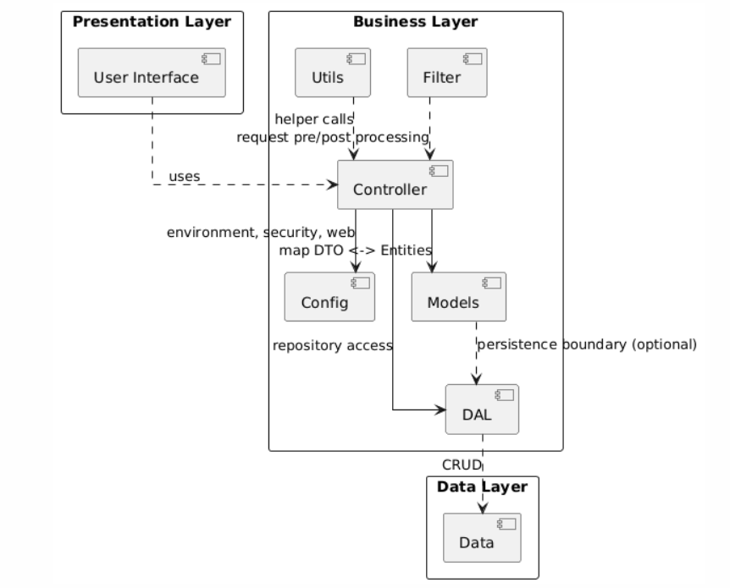

***Package descriptions***

| **No** | **Package** | **Description** |
| --- | --- | --- |
| 1 | Presentation Layer | Contains the UI endpoints and views; handles user interaction and responses. |
| 2 | Business Layer | Core business logic, orchestration, validation, schedulers, aspects. |
| 3 | Data Layer | Data access abstraction to the database. |
| 4 | Controller | Bridge between UI and Business: routing, DTO mapping. |
| 5 | Utils | Common helpers used across layers. |
| 6 | Config | App/security/web/JPA/integrations configuration. |
| 7 | Filter | Filters for validation/auth/rate‑limit/IP block. |
| 8 | Models | Domain entities and transport models. |
| 9 | DAL (Data Access Layer) | Concrete CRUD/query repositories. |
| 10 | Data | Underlying data and schema/config/seeding. |

## 2. Database Design

### a. Database Schema

*[Provide the tables relationship like example below – following MySQL database naming convention]*

### b. Table Description

| **No** | **Table** | **Description** |
| --- | --- | --- |
| 1 | users | Application users (login credential, profile, role, flags, email verification token). |
| 2 | audit_log | Audit trail of actions (actor, action, target, metadata, timestamp). |
| 3 | blocked_ip | Permanently or temporarily blocked IPs for security. |
| 4 | suspicious_activity | Recorded suspicious requests for investigation/rate-limit. |
| 5 | restaurant_owner | Owner KYC profile bound to a user (full name, phone, national id, status). |
| 6 | restaurant_profile | Public profile of a restaurant (name, address, city, phone, opening hours, min/max party size, avg price, status). |
| 7 | restaurant_media | Media gallery for a restaurant (url, type, caption, display order). |
| 8 | restaurant_table | Dining tables (name/code, capacity, location/zone, status). |
| 9 | dish | Menu items (name, description, price, category, status, image). |
| 10 | booking | Customer bookings (restaurant, customer, table, start/end time, party size, status, notes). |
| 11 | booking_event | Booking timeline events (type, message, created_at). |
| 12 | waitlist | Waitlist entries (restaurant, customer, party size, position, status, ready_notified, last_notified_at). |
| 13 | message | Chat messages (room, sender, content, type, sent_at). |
| 14 | chat_room | Conversation rooms (type: ORDER/BOOKING/SUPPORT; created_at). |
| 15 | chat_room_participant | Room membership (room_id, user_id). |
| 16 | notification | In‑app notifications (user, type, title, body, ref_id, status, read_at). |
| 17 | payment | Payments via provider (order_id, order_code, amount, status, provider, checkout_url, refunded_amount). |
| 18 | payment_audit | Raw provider callbacks/audits for payment events (order_code, event, payload). |
| 19 | refund_request | Refund requests (payment/order_code, amount, reason, status, provider_ref). |
| 20 | withdrawal_request | Owner payout requests (restaurant_id, amount, status, note, provider_ref). |
| 21 | restaurant_bank_account | Bank account for payouts (bank_code, account_number, holder, verified). |
| 22 | restaurant_balance | Balance tracking (available, pending_payout) per restaurant. |
| 23 | voucher | Voucher master (code, type, value, min order, validity window, status). |
| 24 | voucher_redemption | Voucher redemption usage by customer (voucher_id, user_id, booking/payment ref). |
| 25 | review | Customer reviews for restaurants (rating, content, created_at). |
| 26 | review_report | Reports against reviews (reporter, reason, status). |
| 27 | review_report_evidence | Evidence items for a review report (url/text). |
| 28 | communication_history | Outbound comms (email/SMS) history with payload and status. |
| 29 | internal_note | Internal admin notes tied to entities (booking, restaurant, user). |
| 30 | rate_limit_statistics | Aggregated counters for rate limiting (key, period, count). |
| 31 | rate_limit_block | Active rate-limit blocks (key, until). |
| 32 | request_pattern | Stored request signatures (path, method, fingerprint) for analytics. |
| 33 | restaurant_contract | Owner contract records (type, status, signed_at). |
| 34 | bank_directory | Static bank catalog (code, name) for validation. |
| 35 | notification_queue (optional) | Outbox for async notification dispatch if needed. |
| 36 | persistent_logins (optional) | Remember‑me tokens (series, token, last_used) if using Spring persistent remember‑me. |

# II. Code Designs

## 1. Authentication

## 1.1. Register

### a. Class Diagram

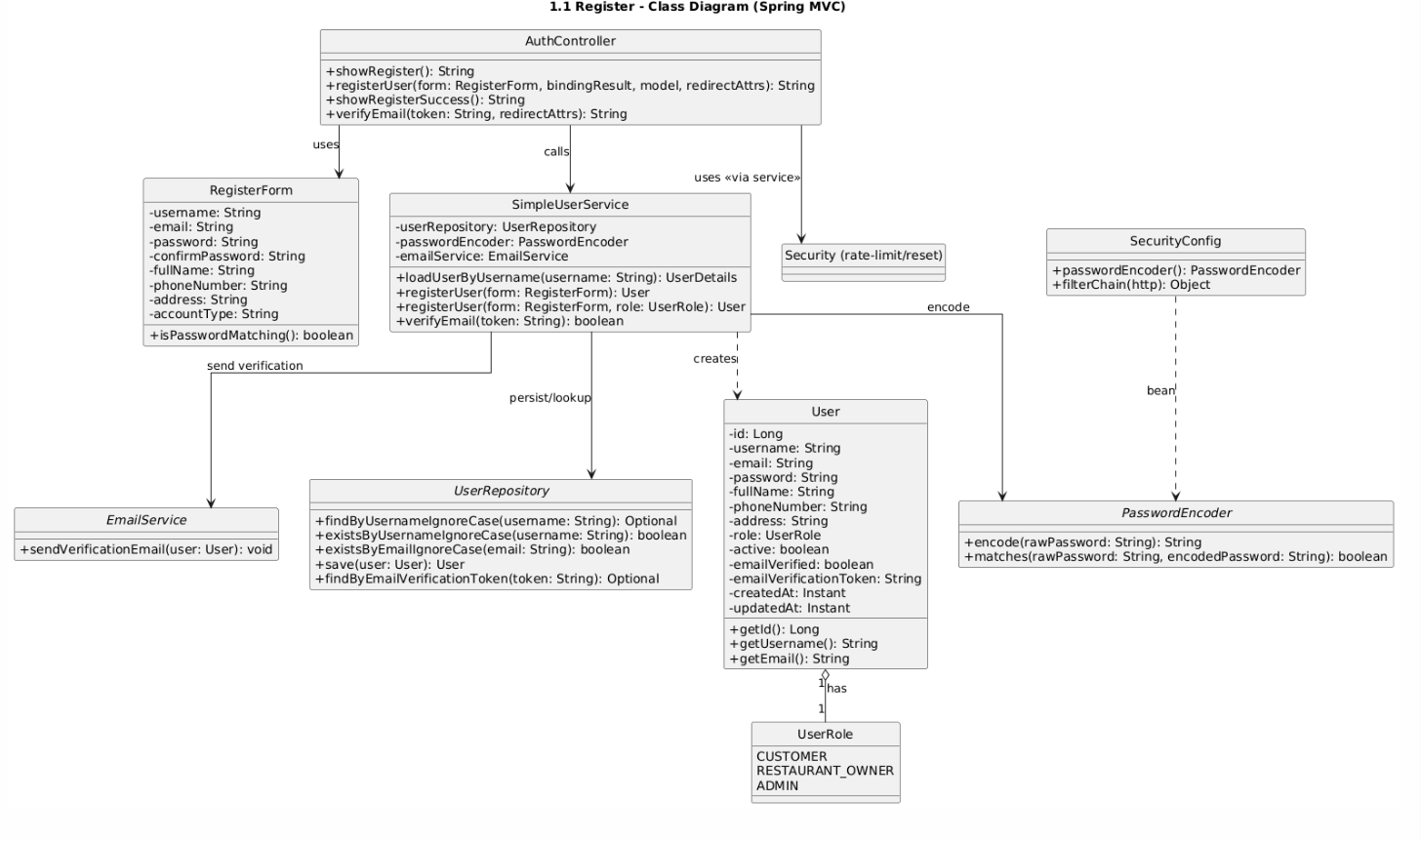

### b. Class Specifications

| **AuthController** | | |
| --- | --- | --- |
| **No** | **Method** | **Description** |
| 1 | showRegister() | Returns the registration form page (GET /auth/register). |
| 2 | registerUser(registerForm, bindingResult, model, redirectAttrs) | Handles POST /auth/register: validates input, calls service to register, resets rate-limit, redirects on success. |
| 3 | showRegisterSuccess() | Returns the success page after registration. |
| 4 | registerRestaurant(registerForm, …) | Registers a user with RESTAURANT_OWNER role and creates the owner record. |
| 5 | verifyEmail(token) | Verifies email by token, sets flash message, and redirects accordingly. |
| **SimpleUserService** | | |
| **No** | **Method** | **Description** |
| 1 | loadUserByUsername(username) | Loads user details for Spring Security authentication. |
| 2 | registerUser(form: RegisterForm) | Registers default-role user: validates, encodes password, sets flags/token, persists, sends verification email. |
| 3 | registerUser(form: RegisterForm, role: UserRole) | Registers user with a specific role; restaurant owners are created inactive (awaiting approval). |
| 4 | verifyEmail(token) | Marks emailVerified=true if the token is valid. |

| **UserRepository** | | |
| --- | --- | --- |
| **No** | **Method** | **Description** |
| 1 | findByUsernameIgnoreCase(username) | Finds a user by username (case-insensitive). |
| 2 | existsByUsernameIgnoreCase(username) | Checks if username already exists. |
| 3 | existsByEmailIgnoreCase(email) | Checks if email already exists. |
| 4 | save(user) | Persists a user. |
| **EmailService** | | |
| **No** | **Method** | **Description** |
| 1 | sendVerificationEmail(user) | Sends an email containing the verification link/token. |
| **PasswordEncoder (Spring Security)** | | |
| **No** | **Method** | **Description** |
| 1 | encode(rawPassword) | Encodes a raw password. |
| 2 | matches(raw, encoded) | Verifies a raw password against the encoded hash. |

### c. Sequence Diagram(s)

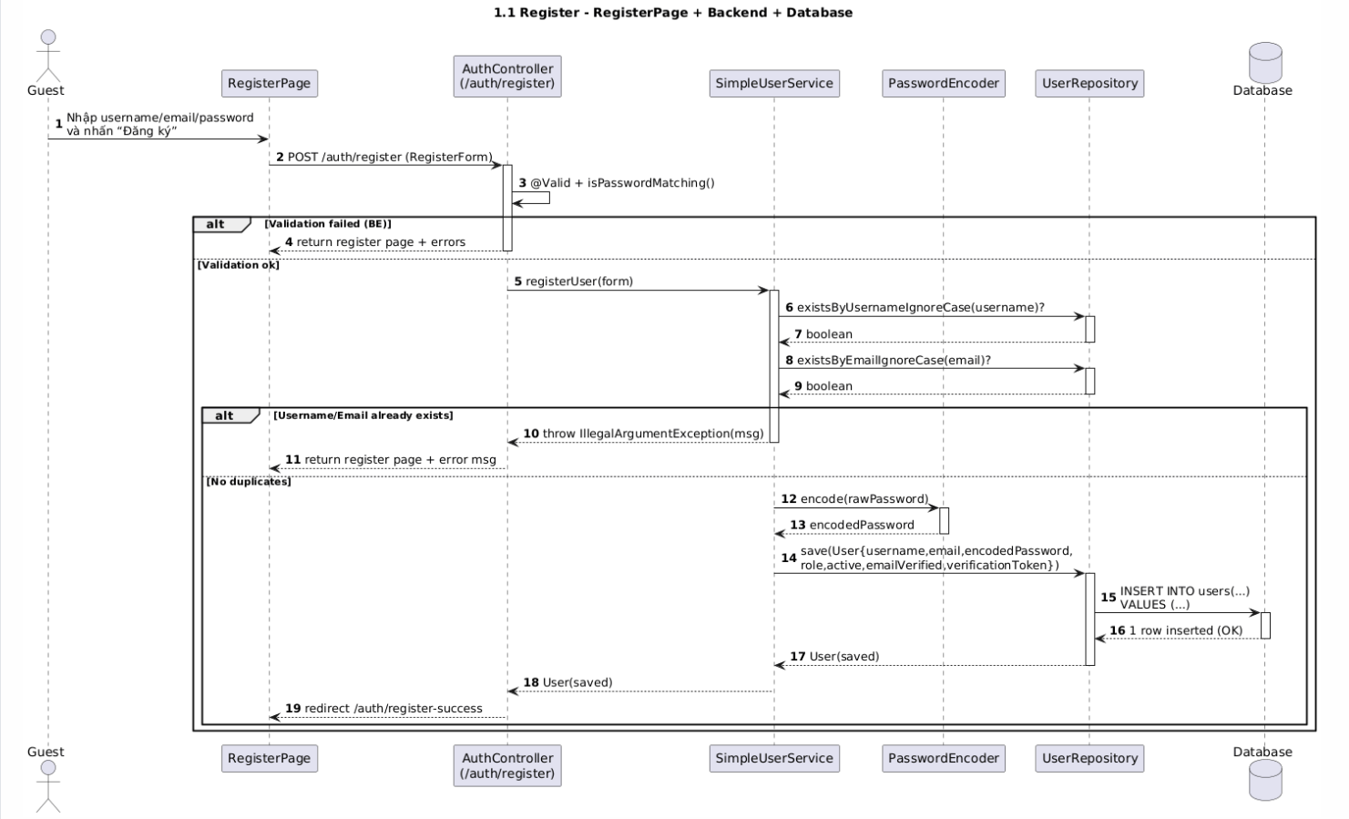

### d. Database Queries

*Check exist email*

*SELECT 1 FROM users WHERE lower(email) = lower(?) LIMIT 1;*

*Check exist username*

*SELECT 1 FROM users WHERE lower(username) = lower(?) LIMIT 1;*

*Insert new user (khái quát, JPA sẽ sinh SQL tương ứng)*

*INSERT INTO users (username, email, password, full_name, phone_number, address, role, active, email_verified, email_verification_token, created_at, updated_at) VALUES (?,?,?,?,?,?,?,?,?,?,?,?);*

*Verify email by token*

*SELECT * FROM users WHERE email_verification_token = ?;*

*UPDATE users SET email_verified = true, email_verification_token = NULL WHERE id = ?;*

## 1.2 Login

### a. Class Diagram

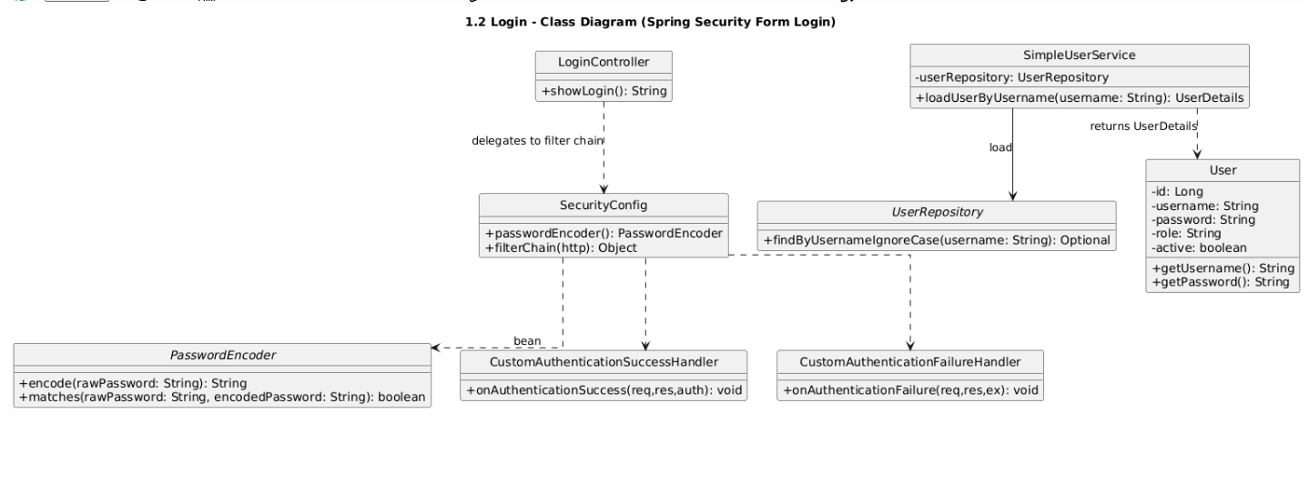

### b. Class Specifications

| **LoginController** | | |
| --- | --- | --- |
| **No** | **Method** | **Description** |
| 1 | showLogin() | Returns the login page (GET /login). |
| 2 | postLogin() | Delegated to Spring Security filter chain (form login). |
| **SimpleUserService** | | |
| **No** | **Method** | **Description** |
| 1 | loadUserByUsername(username) | Loads UserDetails from UserRepository; throws if not found. |
| **SecurityConfig** | | |
| **No** | **Method** | **Description** |
| 1 | passwordEncoder() | Provides BCrypt (or configured) PasswordEncoder bean. |
| 2 | configure(HttpSecurity) | Configures form login, success/failure handlers, CSRF/CORS, session. |
| **UserRepository (login-related)** | | |
| **No** | **Method** | **Description** |
| 1 | findByUsernameIgnoreCase(username) | Fetches user for authentication. |
| **User (UserDetails)** | | |
| **No** | **Method/Field** | **Description** |
| 1 | getUsername()/getPassword() | Credentials for auth. |
| 2 | getAuthorities()/isEnabled() | Roles and status. |

### c. Sequence Diagram(s)

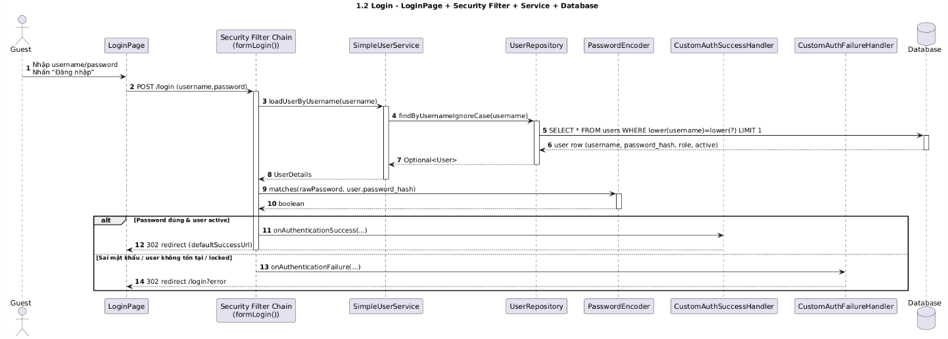

### d. Database Queries

Check exist email: SELECT 1 FROM users WHERE lower(email) = lower(?) LIMIT 1;

Check exist username: SELECT 1 FROM users WHERE lower(username) = lower(?) LIMIT 1;

Insert new user: INSERT INTO users (username, email, password, full_name, phone_number, address, role, active, email_verified, email_verification_token, created_at, updated_at) VALUES (?,?,?,?,?,?,?,?,?,?,?,?);

Verify email by token (select): SELECT * FROM users WHERE email_verification_token = ?;

Verify email by token (update): UPDATE users SET email_verified = TRUE, email_verification_token = NULL WHERE id = ?;

## 1.3 Logout

### a. Class Diagram

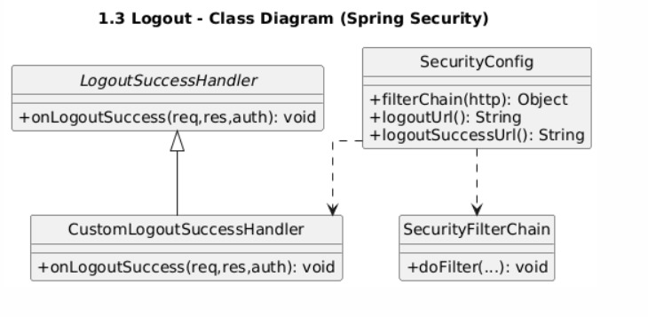

### b. Class Specifications

| **SecurityConfig** | | |
| --- | --- | --- |
| **No** | **Method** | **Description** |
| 1 | logoutUrl() | Configures the logout endpoint (e.g., POST /logout). |
| 2 | logoutSuccessUrl() | Default redirect after logout (if no handler is used). |
| 3 | configure(HttpSecurity) | Enables logout, CSRF, and wires the LogoutSuccessHandler. |
| **CustomLogoutSuccessHandler** | | |
| **No** | **Method** | **Description** |
| 1 | onLogoutSuccess(request, response, authentication) | Clears cookies/headers if needed and redirects to a friendly page (e.g., /login?logout). |
| **SecurityFilterChain (Spring)** | | |
| **No** | **Method** | **Description** |
| 1 | doFilter(...) | Intercepts POST /logout, invalidates session, clears SecurityContext, then delegates to LogoutSuccessHandler. |
| AnyController |  |  |
| **No** | **Method** | **Description** |
| 1 | — | Logout is handled by Spring Security; controllers typically do not implement it |

### c. Sequence Diagram(s)

### d. Database Queries

No database queries are required for logout; the operation is handled at the session and security context level.

Optional audit (if implemented): insert an audit record like “USER_LOGOUT” with userId and timestamp.

## 1.4 View Profile

### a. Class Diagram

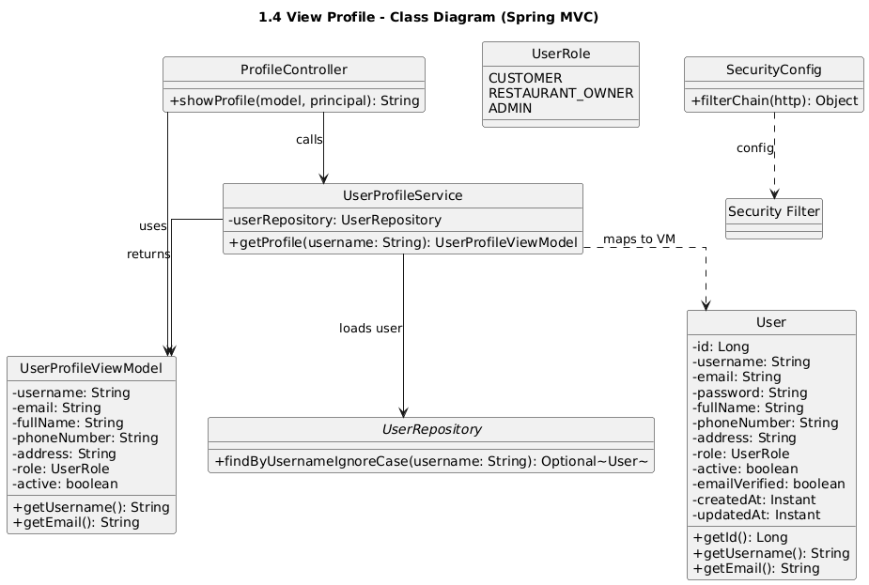

### b. Class Specifications

| ProfileController | | |
| --- | --- | --- |
| **No** | **Method** | **Description** |
| 1 | viewProfile(model) | Returns the current user’s profile page; fetches data via service and binds to model. |
| 2 | viewProfileById(id, model) | Returns another user’s profile (admin or permitted context) via service and binds to model. |
| UserProfileService | | |
| **No** | **Method** | **Description** |
| 1 | getCurrentUserProfile() | Uses SecurityUtil to get the logged-in username, loads User from repository, throws if not found. |
| 2 | getUserProfileById(id) | Loads User by id for admin/owner flow; throws if not found. |
| UserRepository (profile-related) | | |
| **No** | **Method** | **Description** |
| 1 | findByUsernameIgnoreCase(username) | Finds current user by username (case-insensitive). |
| 2 | findById(id) | Finds user by id. |
| SecurityUtil | | |
| **No** | **Method** | **Description** |
| 1 | getCurrentUsername() | Returns username from SecurityContext (Principal), or throws if unauthenticated. |

### c. Sequence Diagram(s)

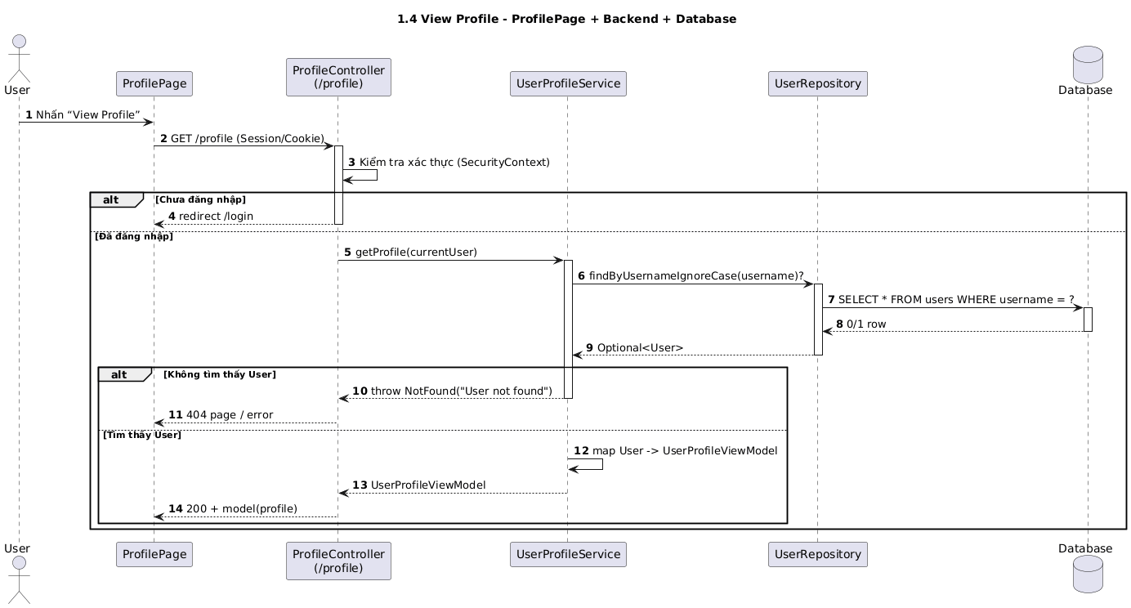

### d. Database Queries

Find current user by username: SELECT * FROM users WHERE lower(username) = lower(?) LIMIT 1;

Find user by id: SELECT * FROM users WHERE id = ? LIMIT 1;

## 1.5 Edit Profile

### a. Class Diagram

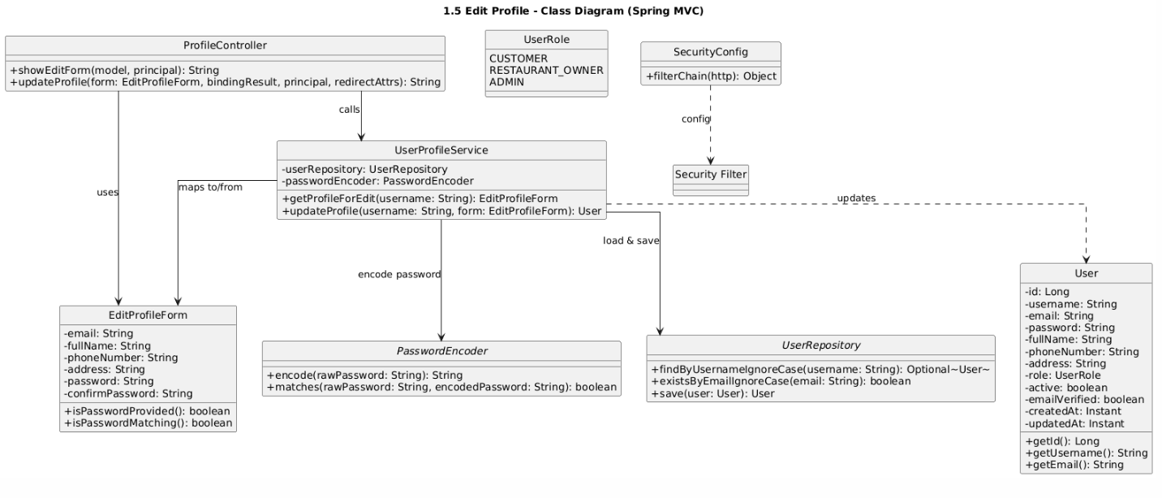

### b. Class Specifications

| ProfileController | | |
| --- | --- | --- |
| **No** | **Method** | **Description** |
| 1 | editForm(model) | Returns the edit profile page pre-filled with current user data. |
| 2 | updateProfile(form, bindingResult, redirectAttrs) | Validates input; delegates update to service; adds flash message and redirects back to profile/edit page. |

| UserProfileService | | |
| --- | --- | --- |
| **No** | **Method** | **Description** |
| 1 | getCurrentUserProfile() | Uses SecurityUtil to fetch current username and loads User. |
| 2 | updateCurrentUserProfile(form) | Loads current User; validates unique username/email when changed; updates fields; encodes and sets new password if provided; persists via repository; returns updated User. |
| UserRepository (edit-related) | | |
| **No** | **Method** | **Description** |
| 1 | findByUsernameIgnoreCase(username) | Loads the current user. |
| 2 | existsByUsernameIgnoreCase(username) | Checks username uniqueness when changing. |
| 3 | existsByEmailIgnoreCase(email) | Checks email uniqueness when changing. |
| 4 | save(user) | Persists updated user. |
| SecurityUtil | | |
| **No** | **Method** | **Description** |
| 1 | getCurrentUsername() | Gets username from SecurityContext. |
| PasswordEncoder | | |
| **No** | **Method** | **Description** |
| 1 | encode(rawPassword) | Encodes a new password before saving. |
| 2 | matches(raw, encoded) | Used if you require the old password check before changing (optional). |

### c. Sequence Diagram(s)

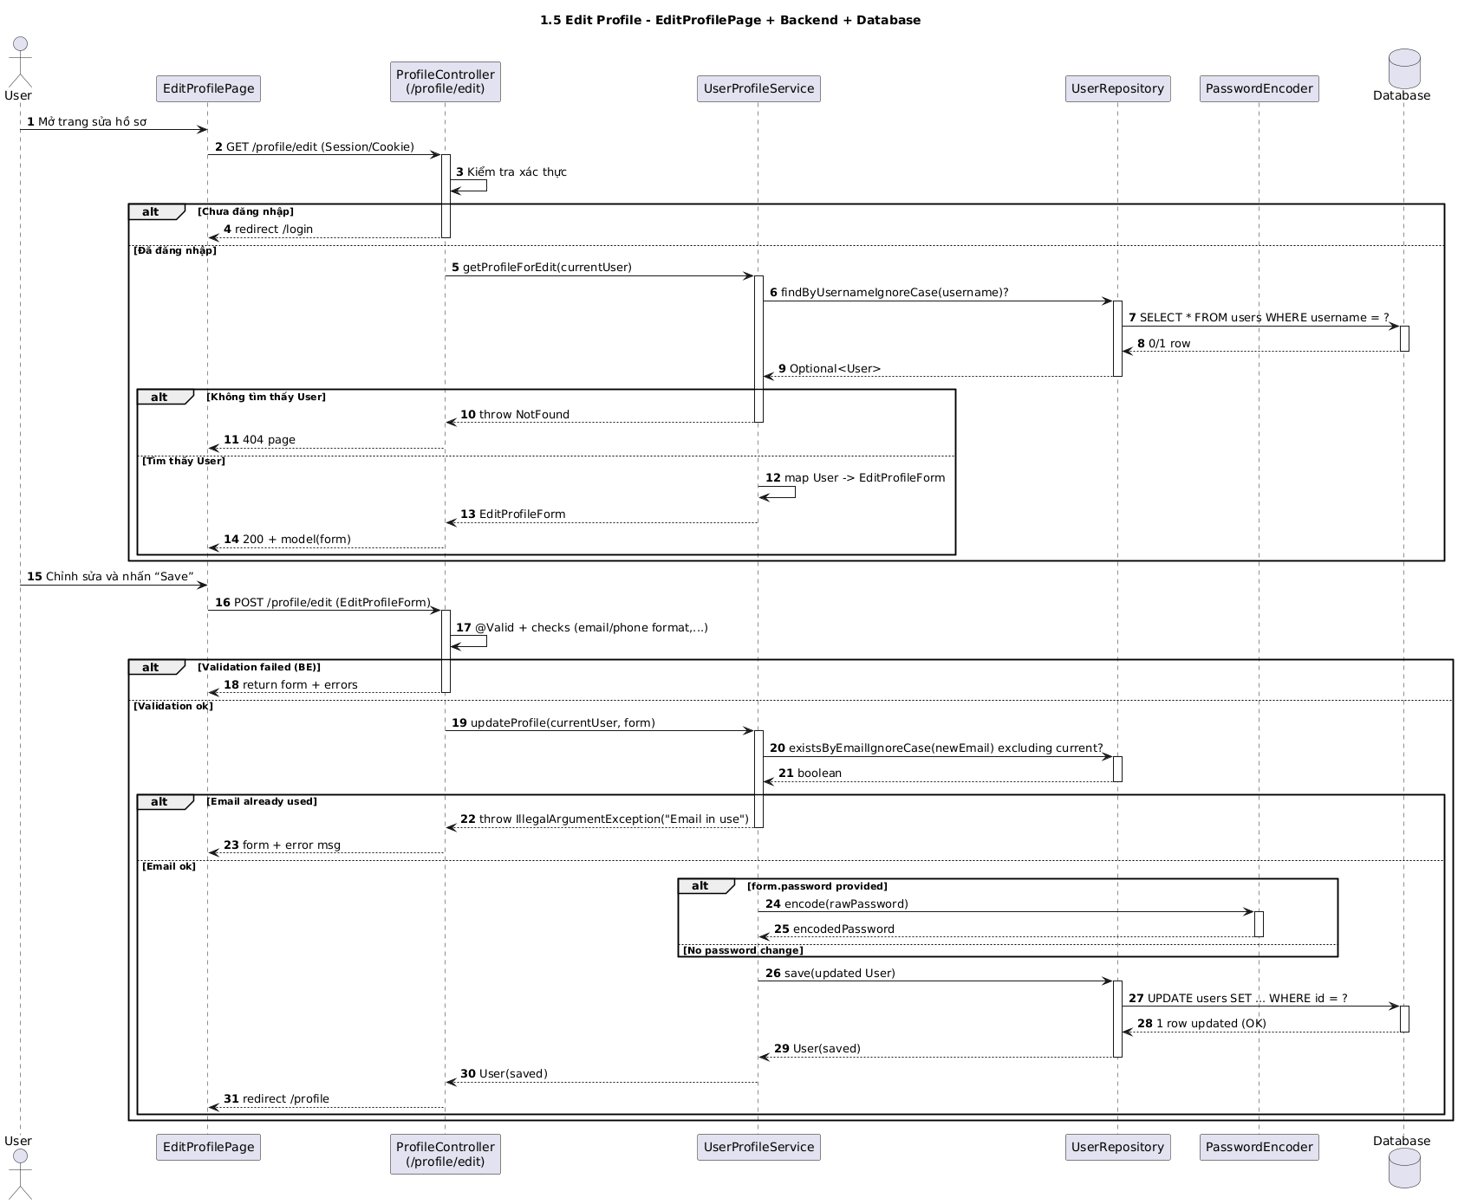

### d. Database Queries

Load current user by username: SELECT * FROM users WHERE lower(username) = lower(?) LIMIT 1;

Check new username uniqueness: SELECT 1 FROM users WHERE lower(username) = lower(?) AND id <> ? LIMIT 1;

Check new email uniqueness: SELECT 1 FROM users WHERE lower(email) = lower(?) AND id <> ? LIMIT 1;

Update user profile (logical form; JPA generates SQL):

UPDATE users SET username = ?, email = ?, full_name = ?, phone_number = ?, address = ?, updated_at = NOW() WHERE id = ?;

Update password (when provided):

UPDATE users SET password = ?, updated_at = NOW() WHERE id = ?;

## 1.6 Change Password

### a. Class Diagram

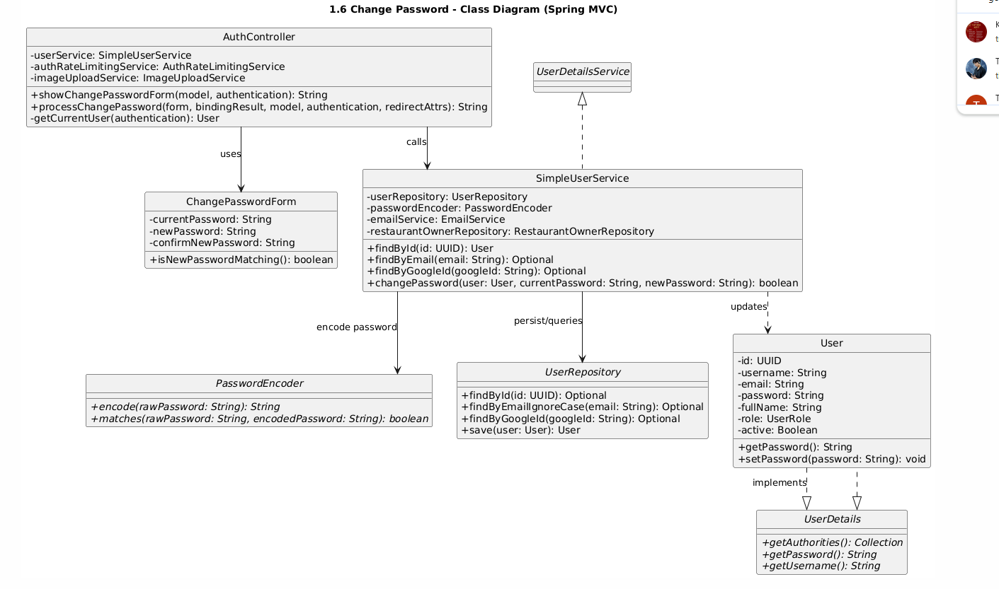

### b. Class Specifications

| ProfileController | | |
| --- | --- | --- |
| **No** | **Method** | **Description** |
| 1 | changePasswordForm(model) | Returns the change password page with an empty form. |
| 2 | changePassword(form, bindingResult, redirectAttrs) | Validates input; calls service to perform password change; adds flash message; redirects. |

| UserProfileService | | |
| --- | --- | --- |
| **No** | **Method** | **Description** |
| 1 | changePassword(form) | Gets current user (by username), verifies currentPassword via PasswordEncoder.matches, encodes and sets new password, persists via repository. Throws on mismatch or user not found. |
| UserRepository | | |
| **No** | **Method** | **Description** |
| 1 | findByUsernameIgnoreCase(username) | Loads the current user record. |
| 2 | save(user) | Persists the updated password hash. |
| SecurityUtil | | |
| **No** | **Method** | **Description** |
| 1 | getCurrentUsername() | Retrieves username from SecurityContext. |
| PasswordEncoder | | |
| **No** | **Method** | **Description** |
| 1 | matches(raw, encoded) | Verifies current password against stored hash. |
| 2 | encode(raw) | Encodes the new password before saving. |

### c. Sequence Diagram(s)

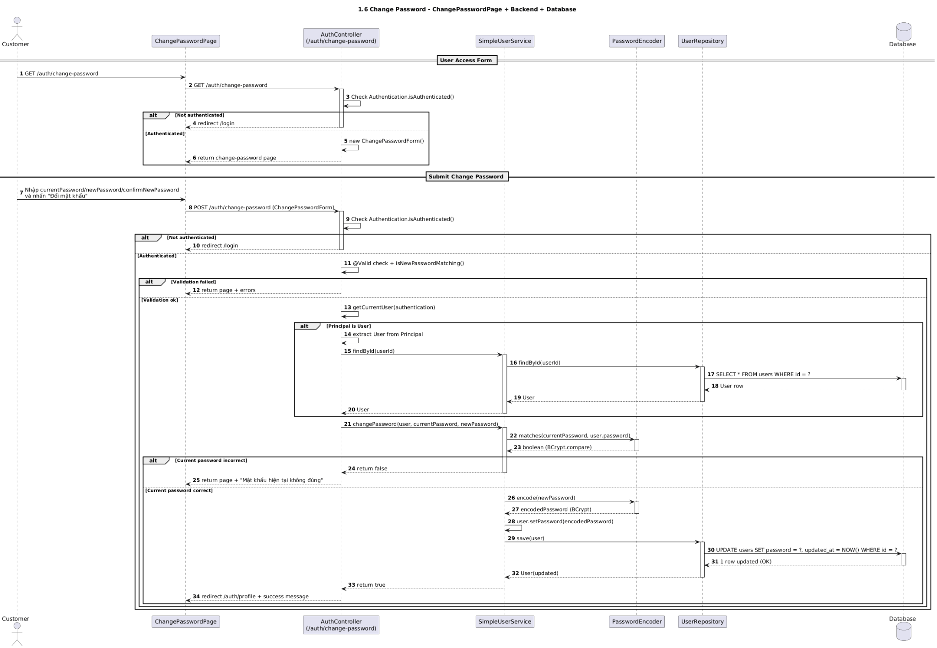

### d. Database Queries

Load user by username: SELECT * FROM users WHERE lower(username) = lower(?) LIMIT 1;

Update password (logical form; JPA generates SQL): UPDATE users SET password = ?, updated_at = NOW() WHERE id = ?;

## 1.7 Forgot/Reset Password

### a. Class Diagram

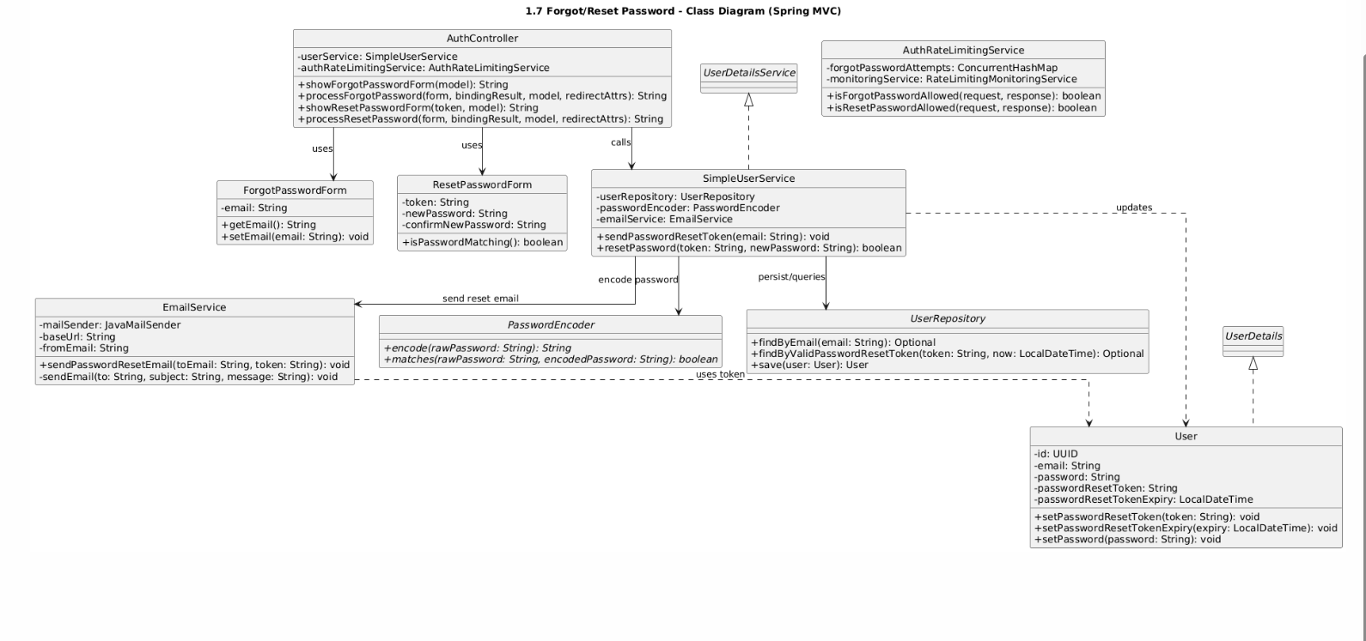

### b. Class Specifications

| PasswordRecoveryController | | |
| --- | --- | --- |
| **No** | **Method** | **Description** |
| 1 | showForgotForm(model) | Returns the “forgot password” page. |
| 2 | sendResetLink(form, bindingResult, redirectAttrs) | Validates email; delegates to service to create token and send reset email; flashes message. |
| 3 | showResetForm(token, model) | Displays reset form if token is valid; otherwise shows error. |
| 4 | performReset(form, bindingResult, redirectAttrs) | Validates form; delegates to service to verify token and set new password; flashes success message. |

| PasswordRecoveryService | | |
| --- | --- | --- |
| **No** | **Method** | **Description** |
| 1 | requestReset(email) | Finds user by email; generates token and expiry; saves; sends reset email. |
| 2 | validateToken(token) | Validates token exists and not expired. |
| 3 | resetPassword(token, newPassword) | Validates token; encodes new password; clears token/expiry; saves user. |
| EmailService | | |
| **No** | **Method** | **Description** |
| 1 | sendPasswordResetEmail(user, token) | Sends email with reset link containing token. |
| UserRepository | | |
| **No** | **Method** | **Description** |
| 1 | findByEmailIgnoreCase(email) | Loads user for reset request. |
| 2 | findById(id) | Optional, if token stores userId. |
| 3 | save(user) | Persists token/expiry and new password. |
| PasswordEncoder | | |
| **No** | **Method** | **Description** |
| 1 | encode(raw) | Encodes new password. |
| 2 | matches(raw, encoded) | Not typically used in reset flow. |

### c. Sequence Diagram(s)

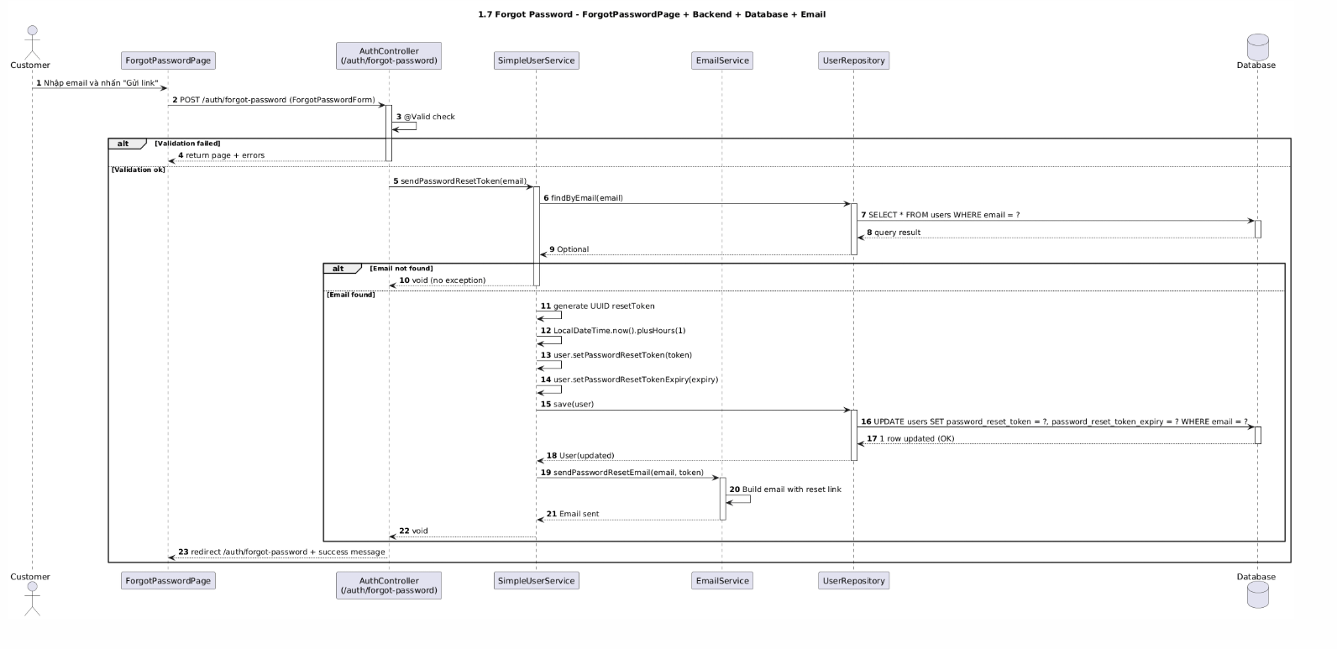

### d. Database Queries

Find user by email: SELECT * FROM users WHERE lower(email) = lower(?) LIMIT 1;

Save reset token and expiry: UPDATE users SET password_reset_token = ?, password_reset_expires_at = ? WHERE id = ?;

Find by reset token (if stored on user): SELECT * FROM users WHERE password_reset_token = ? AND password_reset_expires_at > NOW() LIMIT 1;

Set new password and clear token: UPDATE users SET password = ?, password_reset_token = NULL, password_reset_expires_at = NULL, updated_at = NOW() WHERE id = ?;

## 1.8 Email Verification

### a. Class Diagram

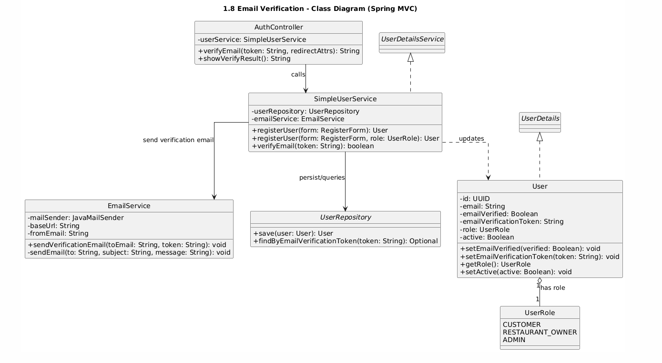

### b. Class Specifications

| AuthController | | |
| --- | --- | --- |
| **No** | **Method** | **Description** |
| 1 | verifyEmail(token, redirectAttrs) | Handles GET /auth/verify-email?token=...; calls service; sets flash message; redirects to login or result page. |
| 2 | showVerifyResult() | Returns verify-result page (success/error). |
| SimpleUserService | | |
| **No** | **Method** | **Description** |
| 1 | verifyEmail(token) | Finds user by token; sets emailVerified=true; clears token; saves user; returns true if successful, false otherwise. |
| 2 | resendVerificationEmail(email) | Finds user by email; generates new token; saves; sends verification email. |
| EmailService | | |
| **No** | **Method** | **Description** |
| 1 | sendVerificationEmail(user) | Sends email with verification link containing token. |
| UserRepository | | |
| **No** | **Method** | **Description** |
| 1 | findByEmailVerificationToken(token) | Finds user by verification token. |
| 2 | save(user) | Persists emailVerified=true and clears token. |

### c. Sequence Diagram(s)

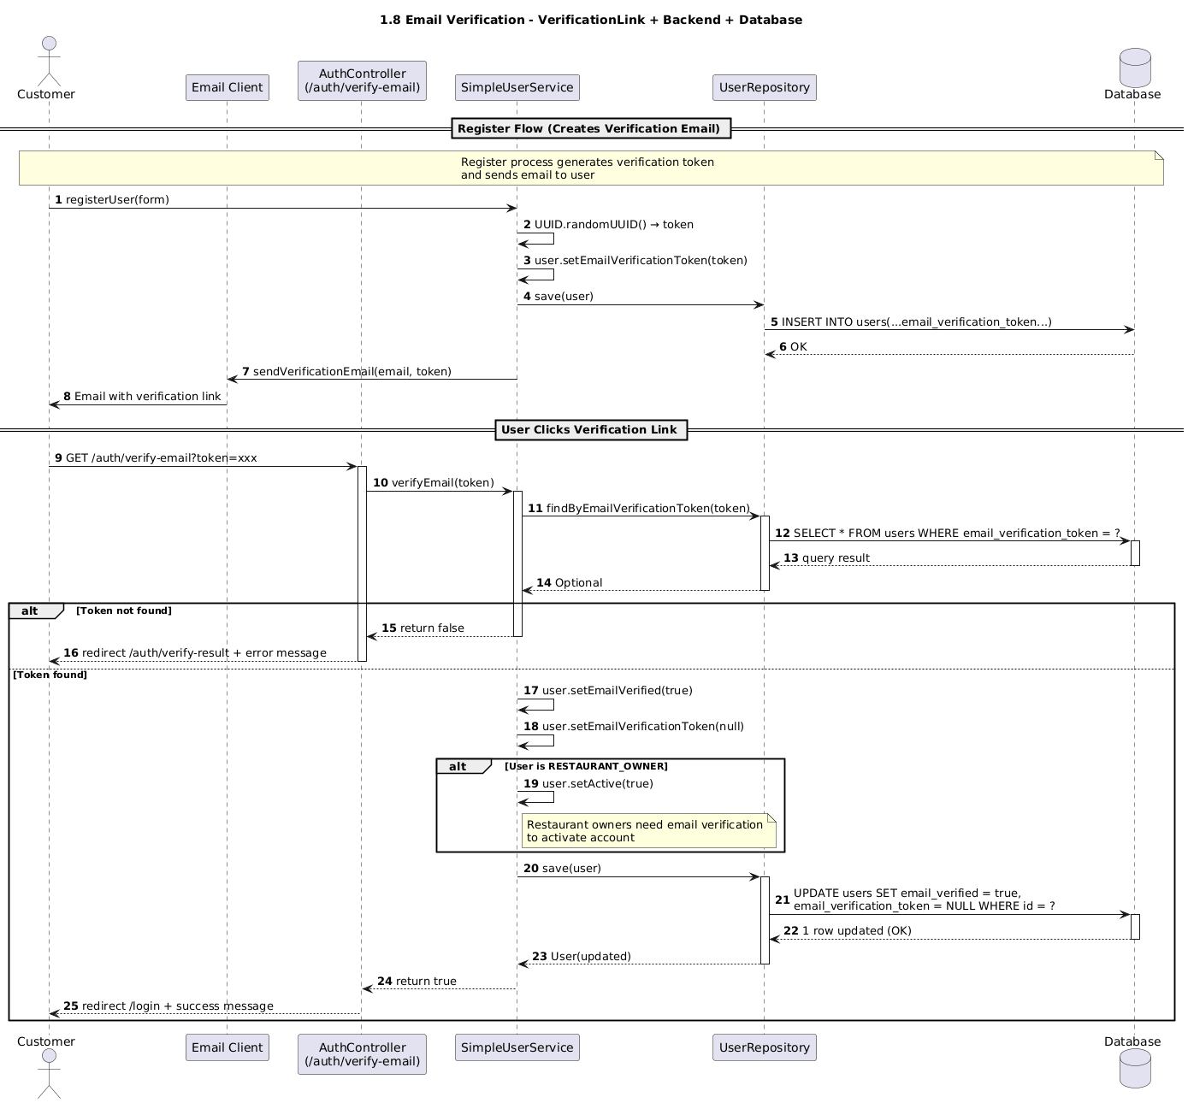

### d. Database Queries

Find user by verification token: SELECT * FROM users WHERE email_verification_token = ? LIMIT 1;

Update user - mark email verified: UPDATE users SET email_verified = TRUE, email_verification_token = NULL, updated_at = NOW() WHERE id = ?;

Resend - generate new token: UPDATE users SET email_verification_token = ?, updated_at = NOW() WHERE email = ?;

## 1.9 OAuth/Google Login

### a. Class Diagram

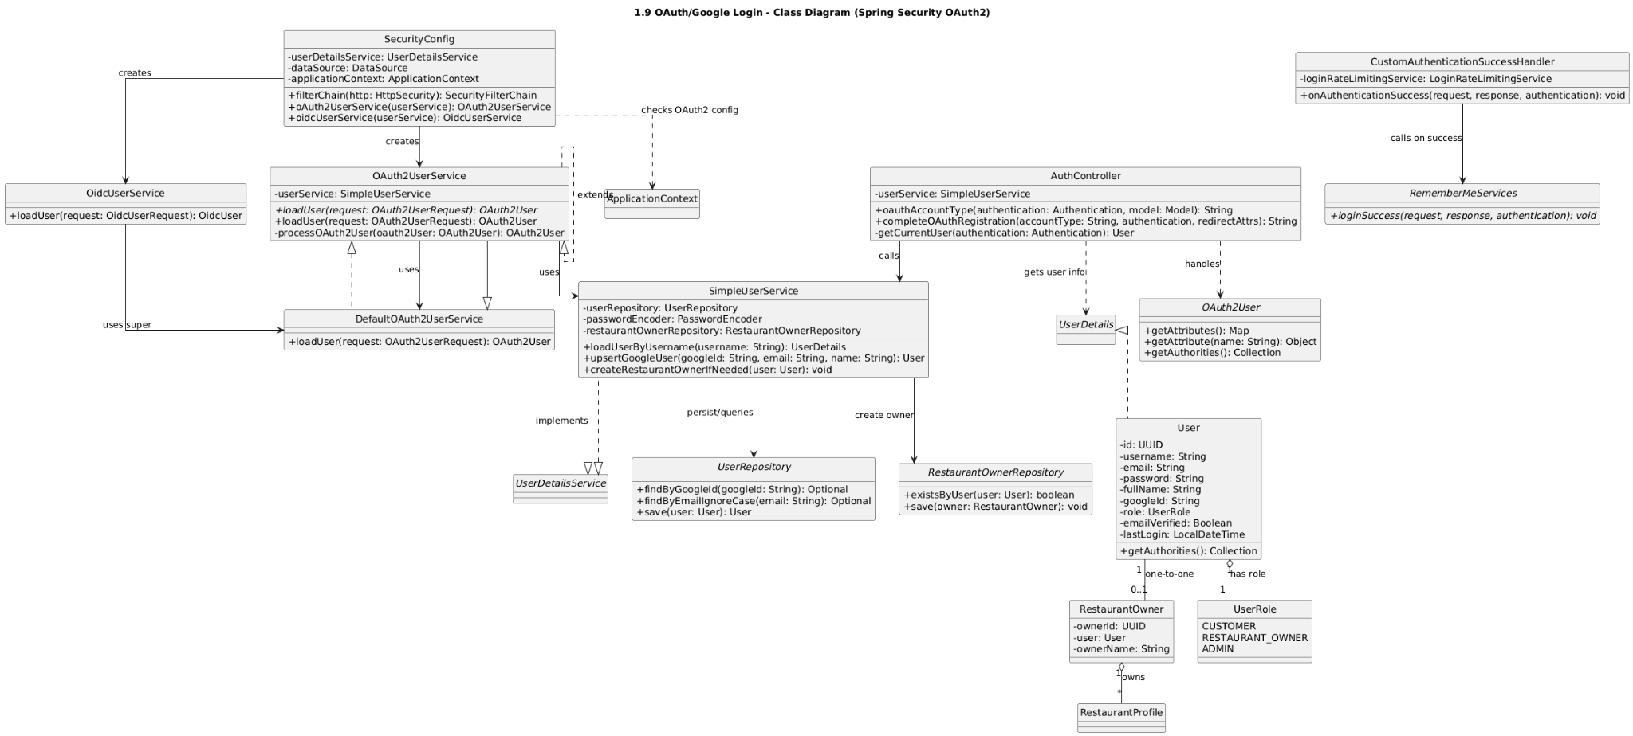

### b. Class Specifications

| SecurityConfig | | |
| --- | --- | --- |
| **No** | **Method** | **Description** |
| 1 | filterChain(HttpSecurity) | Enables oauth2Login() with success/failure handlers and CustomOAuth2UserService. |
| 2 | passwordEncoder() | Provides encoder (for fallback flows if needed). |
| 3 | clientRegistrationRepository() | Loads Google client config (clientId/secret/scopes). |
| 4 | authorizedClientService() | Manages authorized client tokens (optional). |
| OAuth2LoginSuccessHandler | | |
| **No** | **Method** | **Description** |
| 1 | onAuthenticationSuccess(req, res, auth) | Redirects to post-login URL after successful OAuth. |
| OAuth2LoginFailureHandler | | |
| **No** | **Method** | **Description** |
| 1 | onAuthenticationFailure(req, res, ex) | Redirects to login page with error details. |
| CustomOAuth2UserService | | |
| **No** | **Method** | **Description** |
| 1 | loadUser(oauth2UserRequest) | Fetches Google user info; maps fields; delegates to SimpleUserService.createOrUpdateUserFromOAuth(...); returns OAuth2User. |
| SimpleUserService (OAuth-related) | | |
| **No** | **Method** | **Description** |
| 1 | createOrUpdateUserFromOAuth(oauthId, email, name, avatarUrl, provider) | Upserts a local User by (provider, oauthId) or email; sets defaults (role, status), saves, returns user. |
| UserRepository (OAuth-related) | | |
| **No** | **Method** | **Description** |
| 1 | findByOauthProviderAndOauthId(provider, oauthId) | Finds existing OAuth-linked user. |
| 2 | findByEmailIgnoreCase(email) | Reuses existing account by email (linking). |
| 3 | save(user) | Persists new or updated user. |

### c. Sequence Diagram(s)

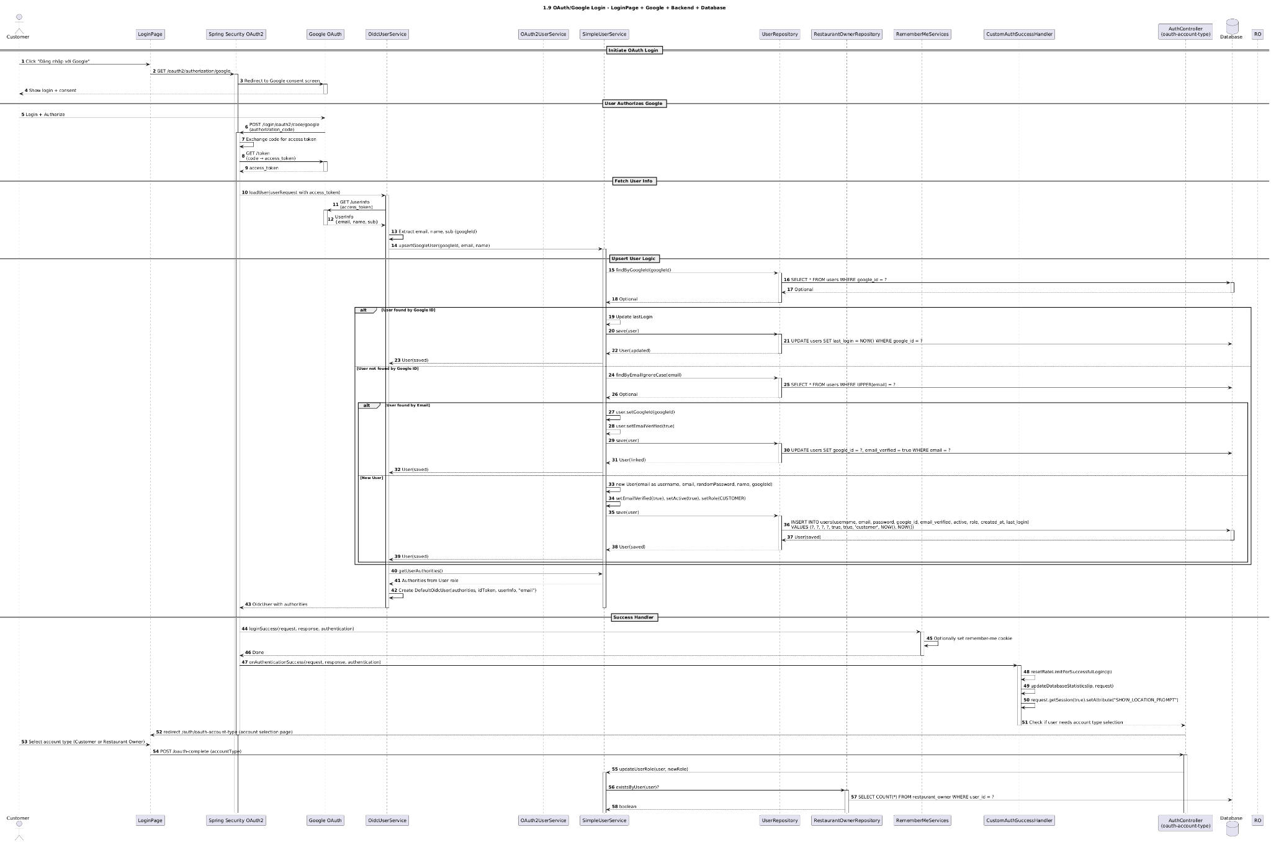

### d. Database Queries

Find by provider+oauth id: SELECT * FROM users WHERE oauth_provider = ? AND oauth_id = ? LIMIT 1;

Find by email: SELECT * FROM users WHERE lower(email) = lower(?) LIMIT 1;

Insert new OAuth user:

INSERT INTO users (user_name, email, oauth_provider, oauth_id, avatar_url, status, role, created_at, updated_at)

VALUES (?, ?, ?, ?, ?, ?, ?, NOW(), NOW());

Link existing user with OAuth:

UPDATE users SET oauth_provider = ?, oauth_id = ?, avatar_url = ?, updated_at = NOW() WHERE id = ?;

Optional update on login (avatar/name refresh):

UPDATE users SET avatar_url = ?, user_name = ?, updated_at = NOW() WHERE id = ?;

## 1.10 Session & Remember-me

### a. Class Diagram

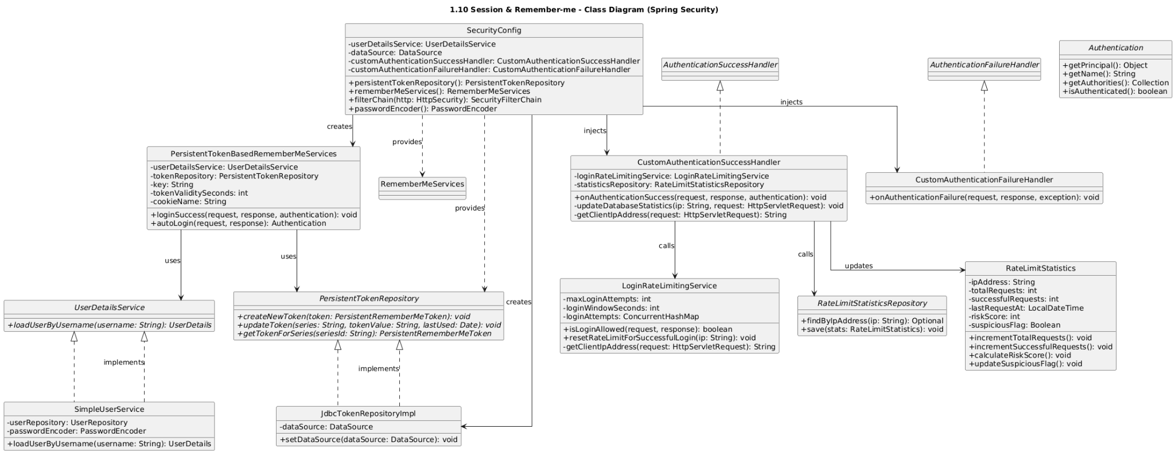

### b. Class Specifications

| SecurityConfig | | |
| --- | --- | --- |
| **No** | **Method** | **Description** |
| 1 | filterChain(HttpSecurity) | Configures session management and remember‑me (key, cookie, parameter, validity, services). |
| 2 | passwordEncoder() | Provides encoder for auth and remember‑me hashing. |
| 3 | rememberMeServices() | Builds PersistentTokenBasedRememberMeServices with key, repo, and cookie settings. |
| 4 | persistentTokenRepository() | Provides JdbcTokenRepositoryImpl (or JPA impl) pointing to persistent_logins table. |
| SessionManagement (via HttpSecurity) | | |
| **No** | **Property** | **Description** |
| 1 | sessionCreationPolicy | ALWAYS/IF_REQUIRED/NEVER/STATELESS; typically IF_REQUIRED. |
| 2 | invalidSessionUrl | Redirect when session is invalid/expired. |
| 3 | maximumSessions | Limits concurrent sessions per user. |
| 4 | sessionFixationProtection | Enables session fixation protection on login. |
| PersistentTokenBasedRememberMeServices | | |
| **No** | **Field** | **Description** |
| 1 | tokenRepository | Reads/writes persistent tokens to DB. |
| 2 | key | Secret used to sign/verify remember‑me cookies. |
| 3 | cookieName | Name of remember‑me cookie (default remember-me). |
| 4 | parameter | Form parameter name (default remember-me). |
| 5 | tokenValiditySeconds | Cookie lifetime in seconds. |
| PersistentTokenRepository (JdbcTokenRepositoryImpl) | | |
| **No** | **Method** | **Description** |
| 1 | createNewToken(token) | Inserts a new series/token row. |
| 2 | updateToken(series, tokenValue, lastUsed) | Updates token value/lastUsed for a series. |
| 3 | getTokenForSeries(seriesId) | Retrieves a token row for series. |
| 4 | removeUserTokens(username) | Deletes all tokens for user (on logout/password change). |
| LoginController | | |
| **No** | **Method** | **Description** |
| 1 | showLogin() | Returns login page with remember‑me checkbox parameter. |

### c. Sequence Diagram(s)

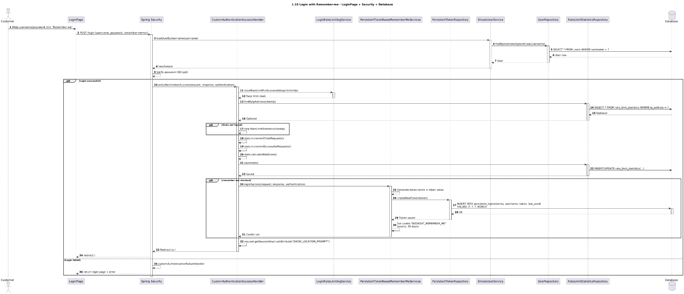

### d. Database Queries

Create new token (on login success): INSERT INTO persistent_logins (username, series, token, last_used) VALUES (?, ?, ?, ?);

Update token (on auto-login refresh): UPDATE persistent_logins SET token = ?, last_used = ? WHERE series = ?;

Get token by series (on auto-login): SELECT username, series, token, last_used FROM persistent_logins WHERE series = ?;

Remove tokens for user (on logout/password change): DELETE FROM persistent_logins WHERE username = ?;

# 2. Booking

## 2.1 Create Booking

### a. Class Diagram

### 

### b. Class Specifications

| BookingController | | |
| --- | --- | --- |
| **No** | **Method** | **Description** |
| 1 | createForm(model) | Returns booking form page with defaults (date/time/party size). |
| 2 | createBooking(req, bindingResult, redirectAttrs) | Validates input; delegates to service; sets flash message; redirects to success or shows errors. |

| BookingService | | |
| --- | --- | --- |
| **No** | **Method** | **Description** |
| 1 | createBooking(req) | Validates open hours, conflicts, capacity; finds a table; persists booking; returns response. |
| BookingConflictService | | |
| **No** | **Method** | **Description** |
| 1 | ensureNoConflict(restaurantId, start, end, partySize) | Throws if overlap exists or restaurant closed for that window. |
| Repositories (key methods) | | |
| **Repo** | **Method** | **Description** |
| BookingRepository | existsOverlapping(restaurantId, start, end) | Checks any existing non-cancelled bookings overlap. |
| BookingRepository | save(booking) | Persists new booking. |
| RestaurantTableRepository | findAvailableTable(restaurantId, partySize, start, end) | Returns suitable free table with enough capacity. |
| RestaurantAvailabilityRepository | isOpen(restaurantId, start, end) | Returns true if restaurant open during the window. |
| CustomerRepository | findById(id) | Checks customer exists. |

### c. Sequence Diagram(s)

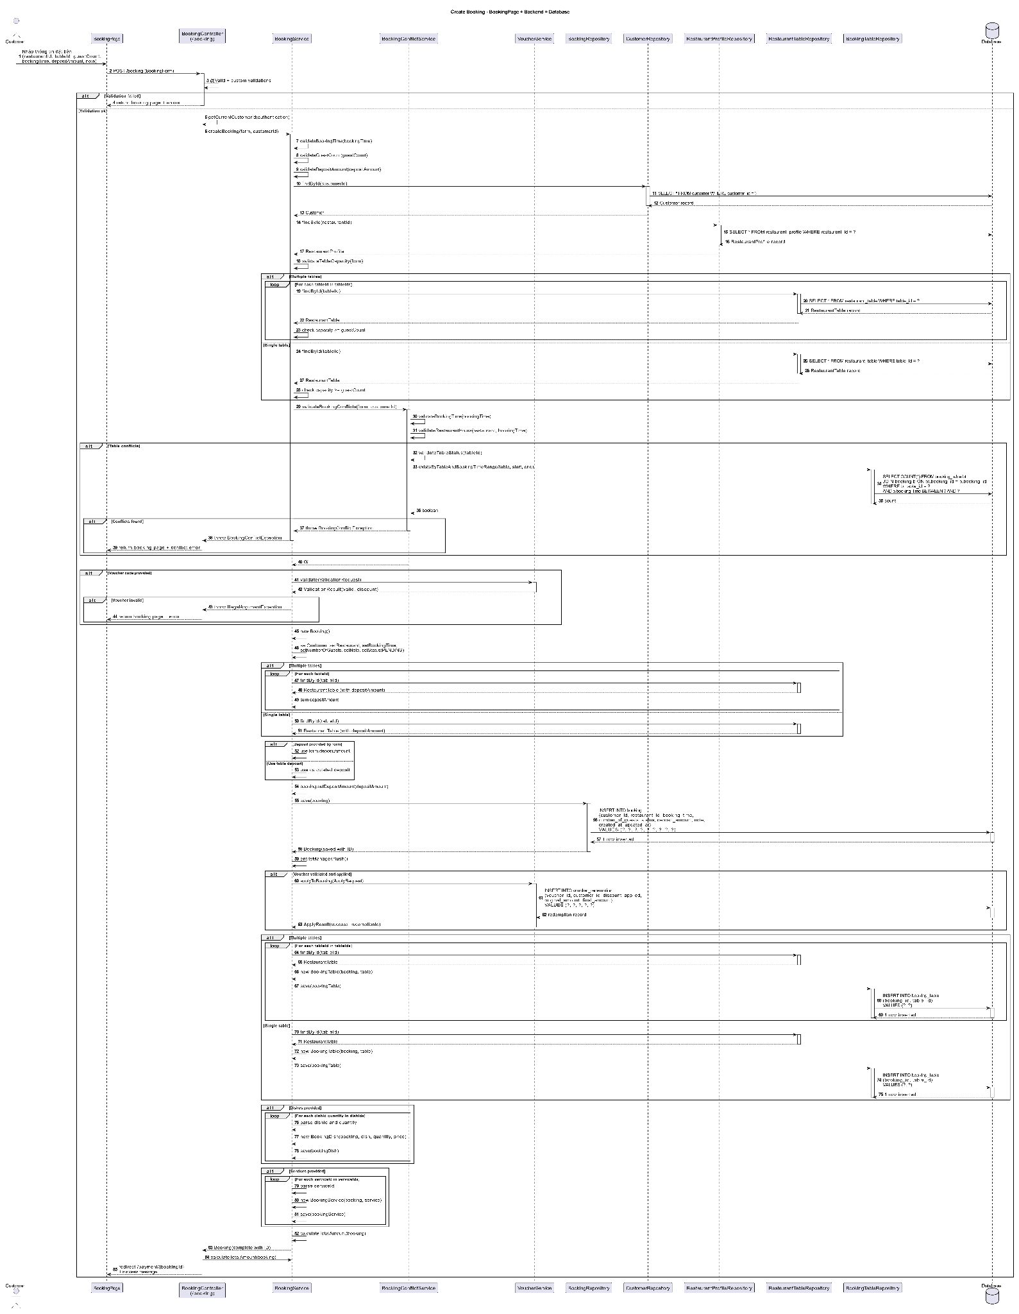

### d. Database Queries

Check restaurant open window (if stored in availability table):

SELECT 1 FROM restaurant_availability WHERE restaurant_id = ? AND open_time <= ? AND close_time >= ? LIMIT 1;

Check overlapping bookings (simplified; exclude cancelled):

SELECT 1 FROM bookings WHERE restaurant_id = ? AND status <> 'CANCELLED' AND (start_time < ? AND end_time > ?) LIMIT 1;

Find available table by capacity and free window (one approach):

SELECT t.id FROM restaurant_table t

WHERE t.restaurant_id = ? AND t.capacity >= ?

AND NOT EXISTS (

SELECT 1 FROM bookings b

WHERE b.table_id = t.id AND b.status <> 'CANCELLED'

AND (b.start_time < ? AND b.end_time > ?)

)

ORDER BY t.capacity ASC

LIMIT 1;

Insert booking:

INSERT INTO bookings (restaurant_id, customer_id, table_id, start_time, end_time, party_size, status, notes, created_at)

VALUES (?, ?, ?, ?, ?, ?, 'PENDING', ?, NOW());

Optional pessimistic lock (to avoid race on table selection):

SELECT id, capacity FROM restaurant_table WHERE restaurant_id = ? AND capacity >= ? FOR UPDATE;

## 2.2 Check Availability

### a. Class Diagram

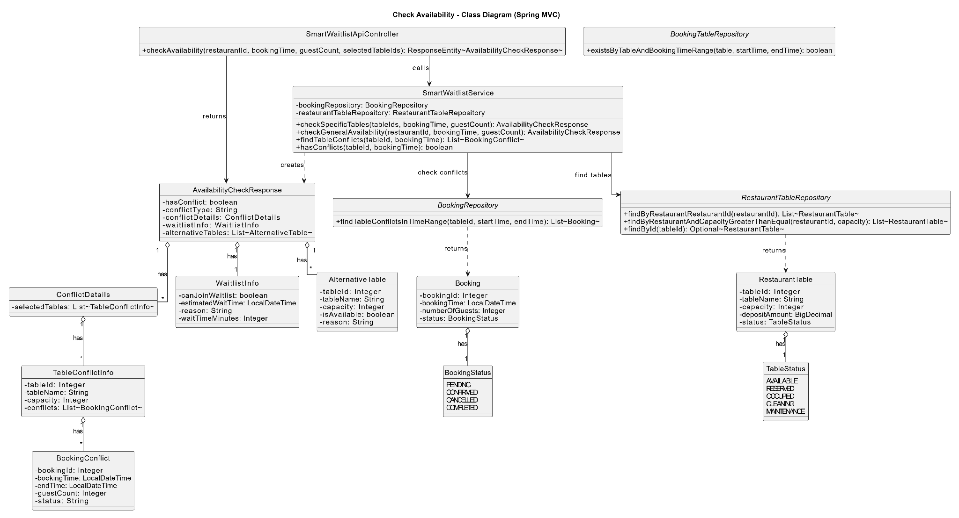

### b. Class Specifications

| AvailabilityController | | |
| --- | --- | --- |
| **No** | **Method** | **Description** |
| 1 | checkAvailability(req, bindingResult, model) | Validates input; delegates to service; binds result to model and returns view or JSON. |

| AvailabilityService | | |
| --- | --- | --- |
| **No** | **Method** | **Description** |
| 1 | check(req) | Computes end time; checks open hours; checks conflicts; fetches free tables; returns response with suggestions if needed. |
| BookingConflictService | | |
| **No** | **Method** | **Description** |
| 1 | hasConflict(restaurantId, start, end) | Returns true if any overlapping non-cancelled booking exists. |
| Repositories (key methods) | | |
| **Repo** | **Method** | **Description** |
| RestaurantAvailabilityRepository | isOpen(restaurantId, start, end) | Open-hours/blackout check. |
| BookingRepository | existsOverlapping(restaurantId, start, end) | Overlap presence. |
| RestaurantTableRepository | findFreeTables(restaurantId, partySize, start, end) | List tables large enough and free. |

### c. Sequence Diagram(s)

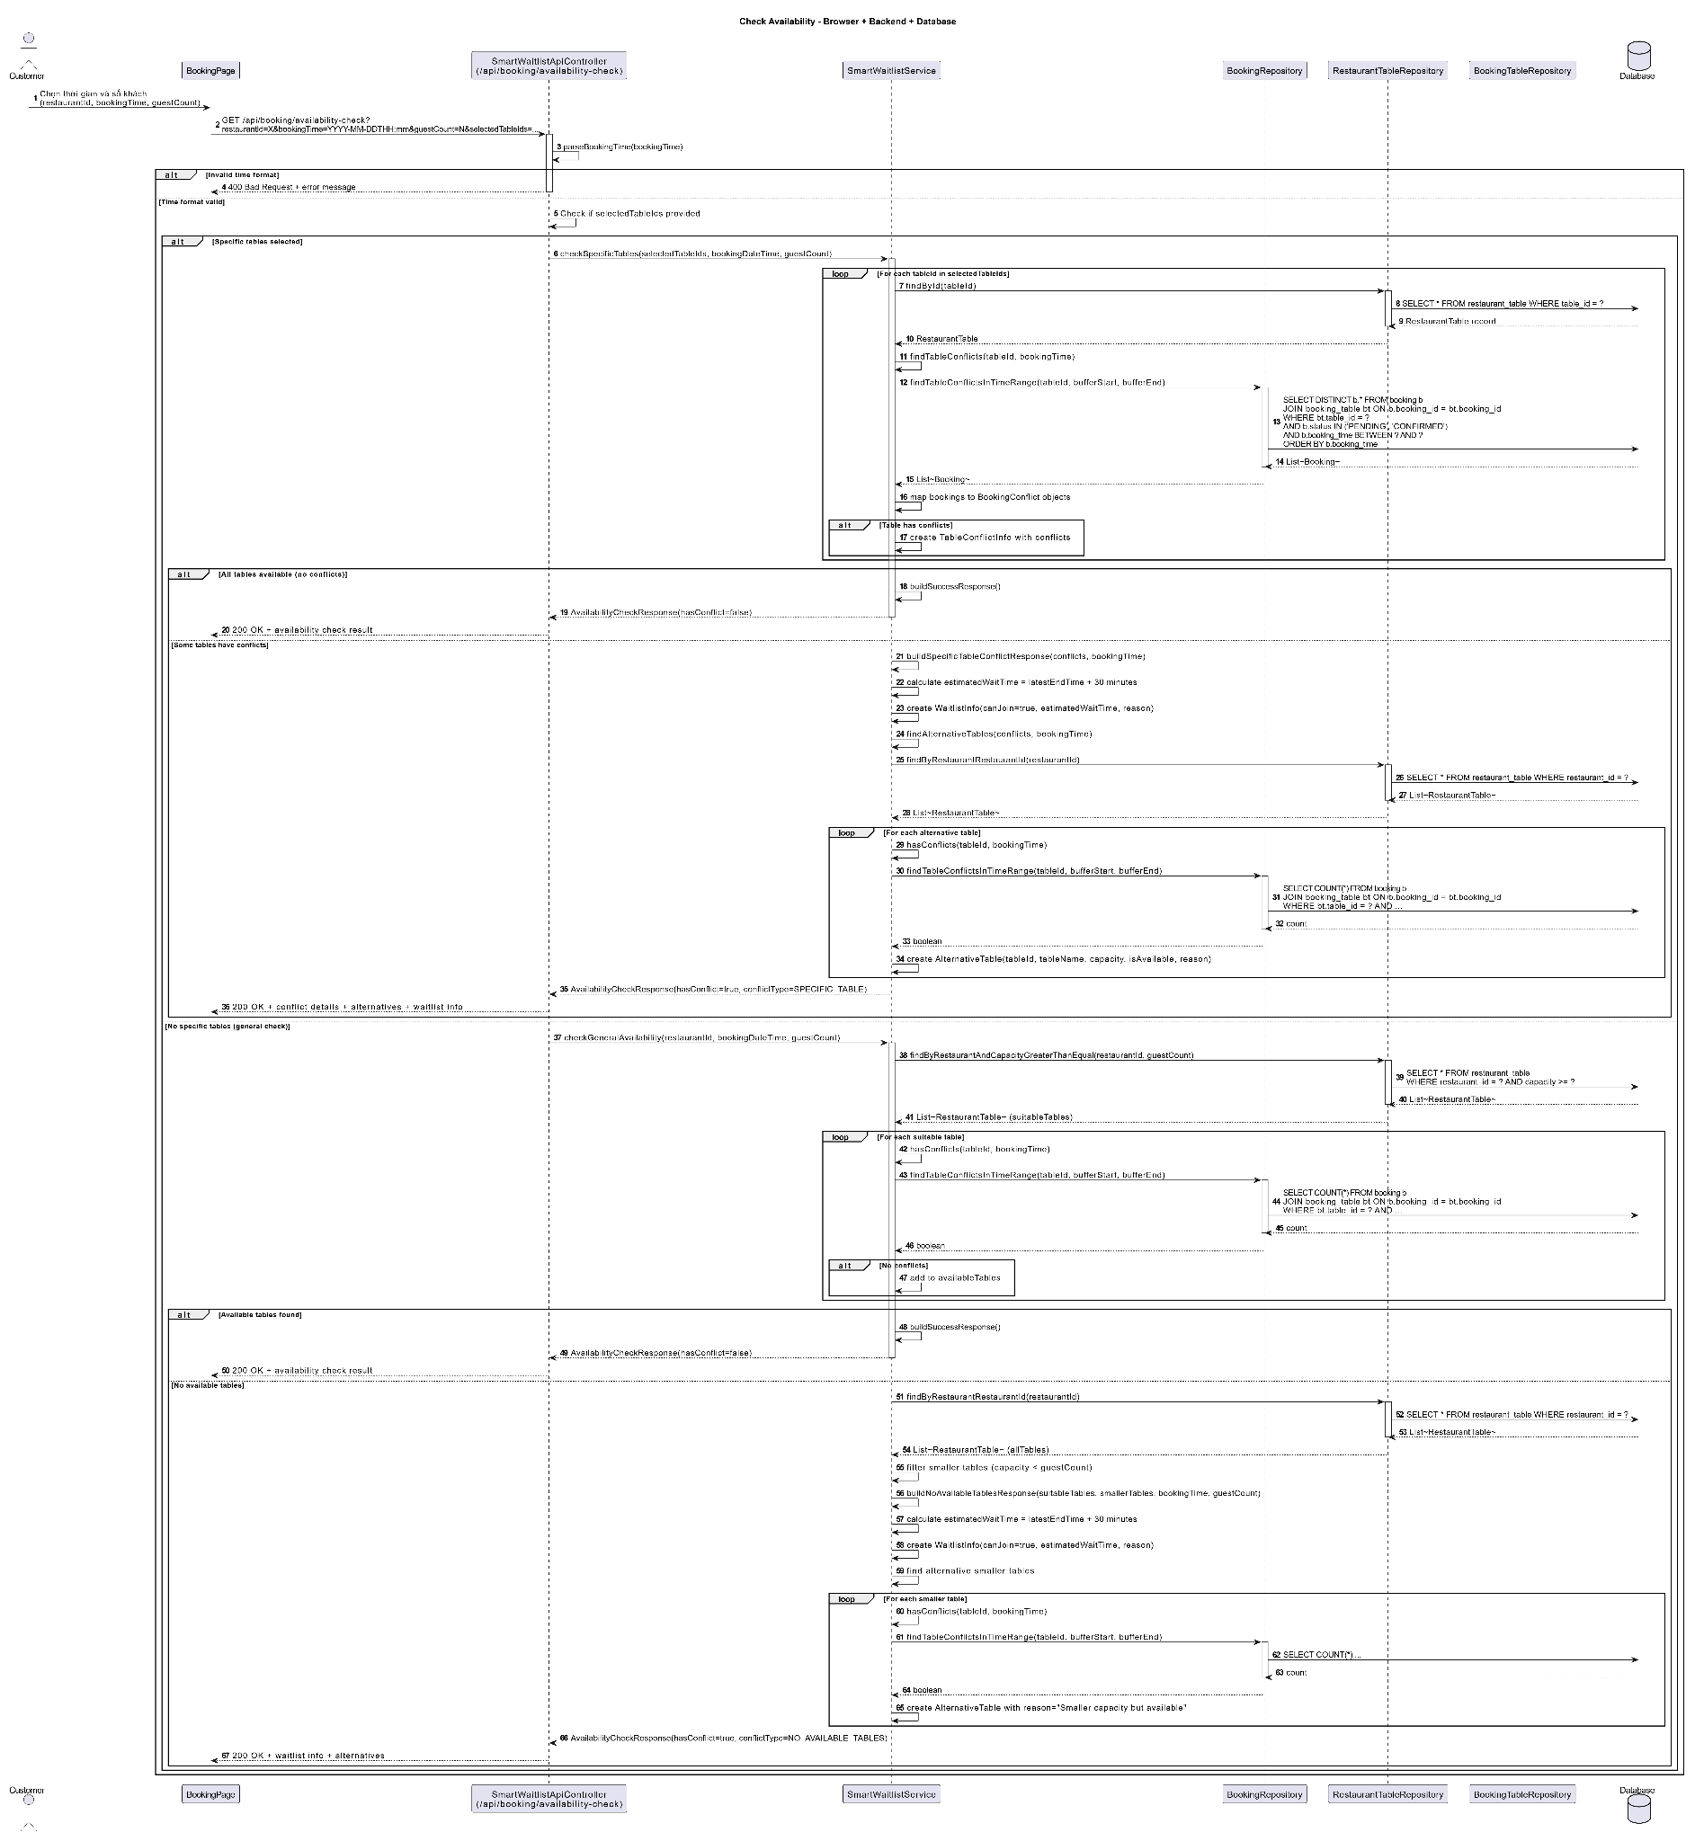

### d. Database Queries

Check restaurant open window:

SELECT 1 FROM restaurant_availability WHERE restaurant_id = ? AND open_time <= ? AND close_time >= ? LIMIT 1;

Check overlapping bookings (exclude cancelled):

SELECT 1 FROM bookings WHERE restaurant_id = ? AND status <> 'CANCELLED' AND (start_time < ? AND end_time > ?) LIMIT 1;

Find free tables by capacity and window:

SELECT t.id FROM restaurant_table t

WHERE t.restaurant_id = ? AND t.capacity >= ?

AND NOT EXISTS (

SELECT 1 FROM bookings b

WHERE b.table_id = t.id AND b.status <> 'CANCELLED'

AND (b.start_time < ? AND b.end_time > ?)

)

ORDER BY t.capacity ASC;

Optional alternative suggestions (next slots):

Generate candidate start times in app; re-run EXISTS/NOT EXISTS checks to propose up to N alternatives.

## 2.3 Resolve Booking Conflict

### a. Class Diagram

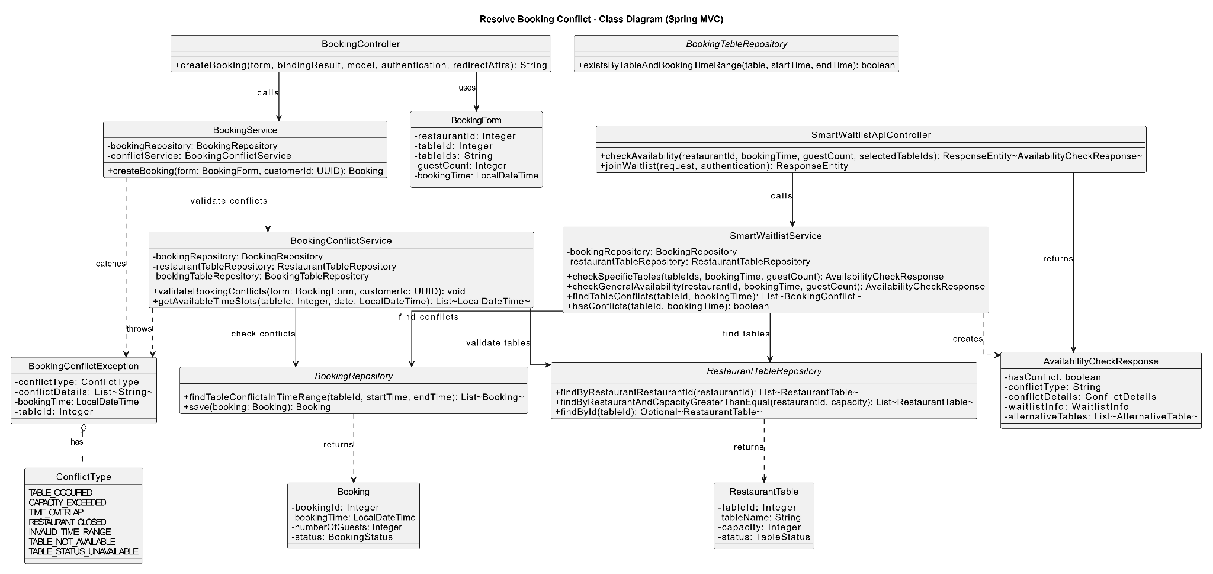

### b. Class Specifications

| BookingConflictService | | |
| --- | --- | --- |
| **No** | **Method** | **Description** |
| 1 | detectConflicts(restaurantId, start, end) | Returns overlapping non-cancelled bookings for the window. |
| 2 | ensureNoConflict(restaurantId, start, end, partySize) | Throws BookingConflictException if overlap exists or capacity cannot be met. |
| 3 | suggestAlternatives(restaurantId, start, durationMin, partySize) | Generates up to N alternative start times with no conflicts and capacity available. |
| BookingService (conflict-related) | | |
| **No** | **Method** | **Description** |
| 1 | createBooking(req) | Calls ensureNoConflict; allocates a table; saves booking; on conflict, bubbles error with suggestions if available. |
| TableAllocationService | | |
| **No** | **Method** | **Description** |
| 1 | findAvailableTable(restaurantId, partySize, start, end) | Finds a free table by capacity and time window. |

| BookingRepository (conflict-related) | | |
| --- | --- | --- |
| **No** | **Method** | **Description** |
| 1 | existsOverlapping(restaurantId, start, end) | True if any booking overlaps the window. |
| 2 | findOverlapping(restaurantId, start, end) | Returns all overlapping bookings to explain conflicts. |

### c. Sequence Diagram(s)

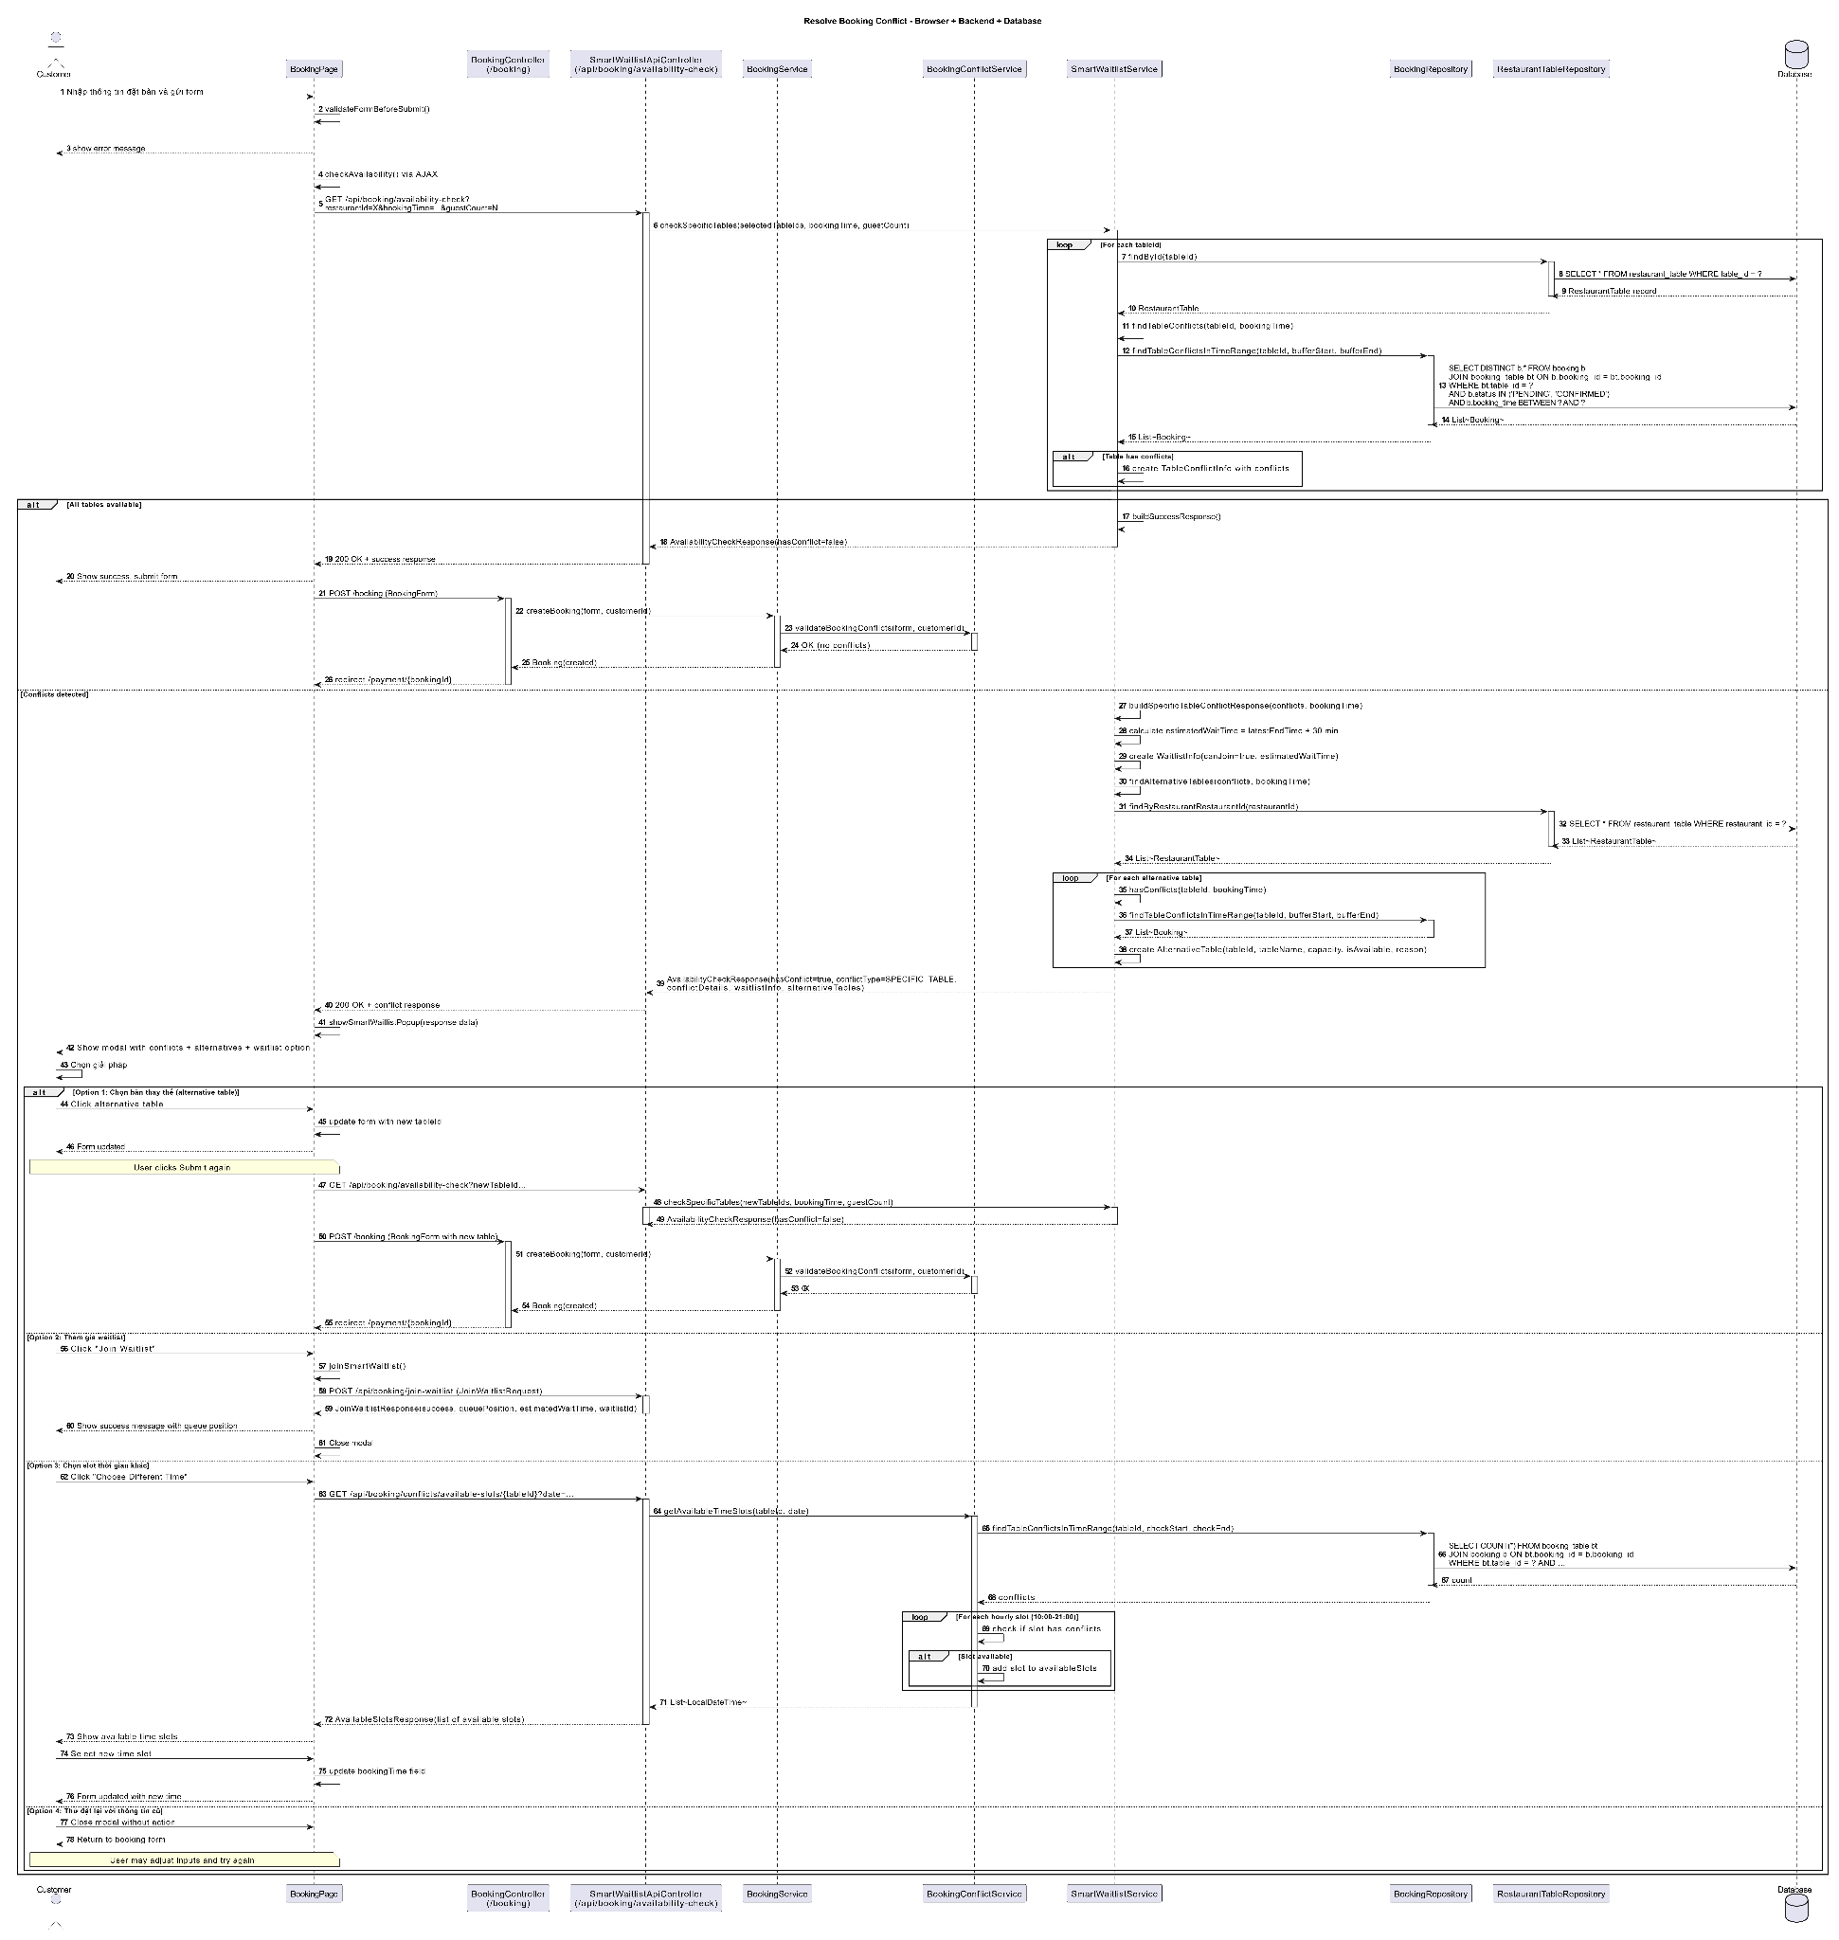

### 

### d. Database Queries

Detect overlap (exclude cancelled):

SELECT 1 FROM bookings

WHERE restaurant_id = ?

AND status <> 'CANCELLED'

AND (start_time < ? AND end_time > ?)

LIMIT 1;

Find overlapping bookings detail:

SELECT id, table_id, start_time, end_time, party_size, status

FROM bookings

WHERE restaurant_id = ?

AND status <> 'CANCELLED'

AND (start_time < ? AND end_time > ?)

ORDER BY start_time ASC;

Find free tables for a candidate slot:

SELECT t.id, t.capacity

FROM restaurant_table t

WHERE t.restaurant_id = ? AND t.capacity >= ?

AND NOT EXISTS (

SELECT 1 FROM bookings b

WHERE b.table_id = t.id

AND b.status <> 'CANCELLED'

AND (b.start_time < ? AND b.end_time > ?)

)

ORDER BY t.capacity ASC;

Insert booking after conflict-free allocation:

INSERT INTO bookings (restaurant_id, customer_id, table_id, start_time, end_time, party_size, status, notes, created_at)

VALUES (?, ?, ?, ?, ?, ?, 'PENDING', ?, NOW());

## 2.4 Update/Cancel Booking

### a. Class Diagram

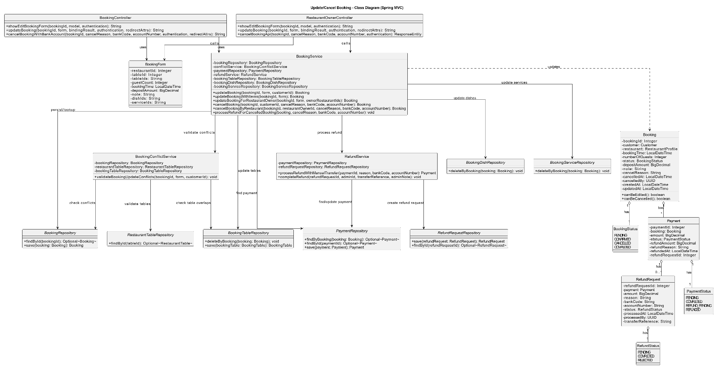

### b. Class Specifications

| BookingController | | |
| --- | --- | --- |
| **No** | **Method** | **Description** |
| 1 | showUpdateForm(id, model) | Loads current booking and shows the update form. |
| 2 | updateBooking(id, req, bindingResult, redirectAttrs) | Validates and requests service to update time/partySize/notes; flashes success/error. |
| 3 | cancelBooking(id, redirectAttrs) | Requests service to mark booking as CANCELLED; flashes success/error. |

| BookingService | | |
| --- | --- | --- |
| **No** | **Method** | **Description** |
| 1 | getBookingForEdit(id) | Loads booking or throws ResourceNotFoundException. |
| 2 | updateBooking(req) | Validates new window; ensures no conflict excluding current booking; re-allocates table if necessary; saves changes. |
| 3 | cancelBooking(id) | Sets status=CANCELLED; persists; idempotent if already cancelled. |
| BookingConflictService | | |
| **No** | **Method** | **Description** |
| 1 | ensureNoConflict(restaurantId, start, end, partySize, excludedBookingId) | Throws if any overlap exists excluding this booking id. |
| TableAllocationService | | |
| **No** | **Method** | **Description** |
| 1 | reallocateTable(restaurantId, partySize, start, end, preferredTableId) | Keeps current table if still free; otherwise picks a free table; throws if none. |
| BookingRepository | | |
| **No** | **Method** | **Description** |
| 1 | findById(id) | Loads booking entity. |
| 2 | existsOverlappingExcluding(...) | Checks overlap excluding the same booking. |
| 3 | save(b) | Persists updates. |
| 4 | updateStatus(id, status) | Updates status (CANCELLED). |

### c. Sequence Diagram(s)

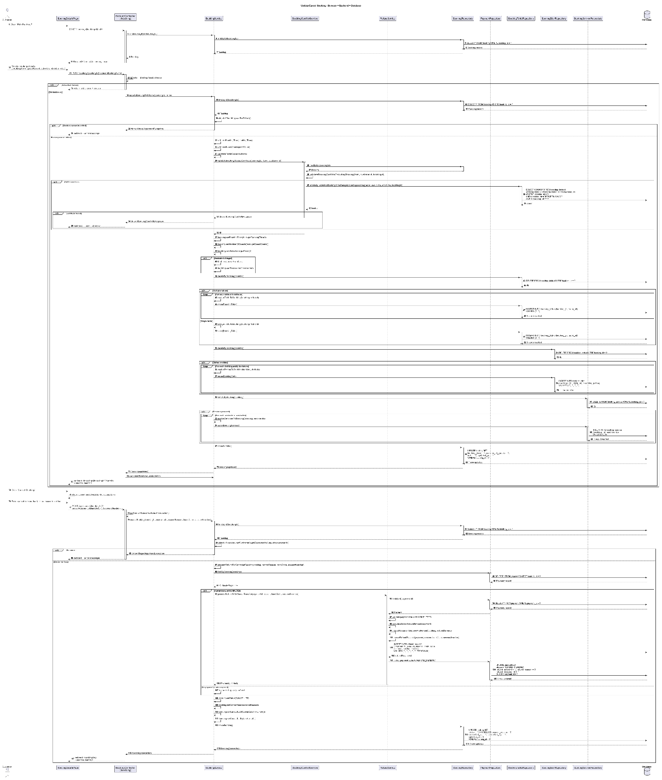

### d. Database Queries

Load booking by id:

SELECT id, restaurant_id, customer_id, table_id, start_time, end_time, party_size, status, notes FROM bookings WHERE id = ? LIMIT 1;

Check overlap excluding current booking:

SELECT 1 FROM bookings

WHERE restaurant_id = ?

AND id <> ?

AND status <> 'CANCELLED'

AND (start_time < ? AND end_time > ?)

LIMIT 1;

Find free tables for new window:

SELECT t.id, t.capacity

FROM restaurant_table t

WHERE t.restaurant_id = ? AND t.capacity >= ?

AND NOT EXISTS (

SELECT 1 FROM bookings b

WHERE b.table_id = t.id

AND b.status <> 'CANCELLED'

AND (b.start_time < ? AND b.end_time > ?)

)

ORDER BY t.capacity ASC;

Update booking fields:

UPDATE bookings

SET start_time = ?, end_time = ?, party_size = ?, table_id = ?, notes = ?, updated_at = NOW()

WHERE id = ?;

Cancel booking:

UPDATE bookings SET status = 'CANCELLED', updated_at = NOW() WHERE id = ?;

## 2.5 Booking Timeline & Status

### a. Class Diagram

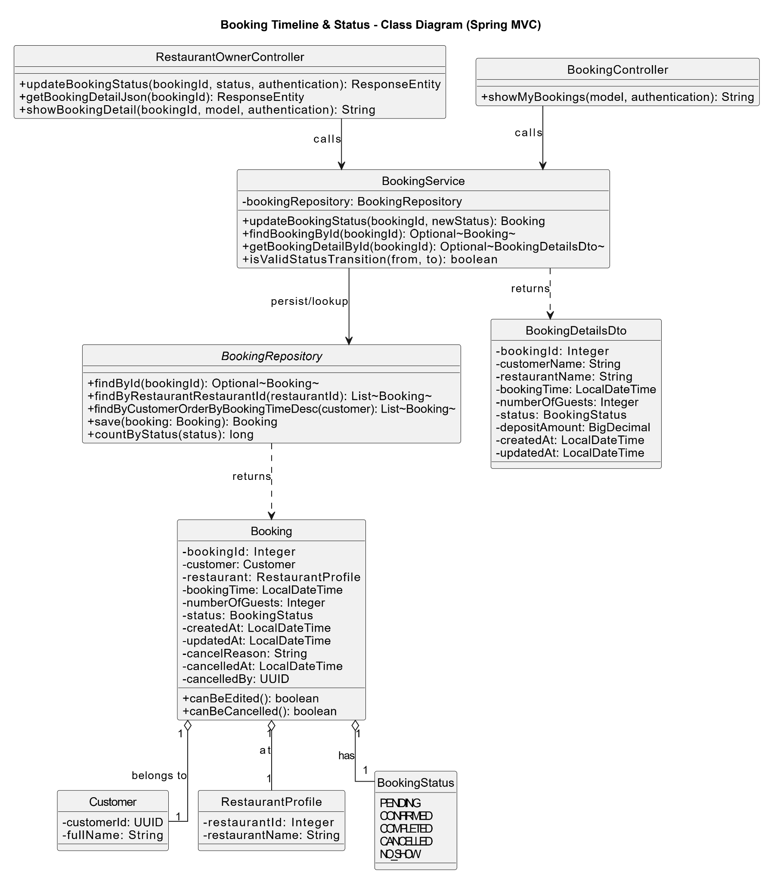

### b. Class Specifications

| BookingTimelineController | | |
| --- | --- | --- |
| **No** | **Method** | **Description** |
| 1 | viewTimeline(bookingId, model) | Loads BookingTimeline and returns the UI page. |
| 2 | advanceStatus(id, action, redirectAttrs) | Maps action to state transition; calls service; flashes result. |
| BookingTimelineService | | |
| **No** | **Method** | **Description** |
| 1 | getTimeline(bookingId) | Loads booking, loads ordered events, builds BookingTimeline. |
| 2 | transition(bookingId, action) | Validates current status; computes next status; persists status and appends BookingEvent. |
| BookingService | | |
| **No** | **Method** | **Description** |
| 1 | getById(id) | Loads a booking or throws if not found. |
| 2 | updateStatus(id, status) | Updates status and saves booking. |
| BookingRepository | | |
| **No** | **Method** | **Description** |
| 1 | findById(id) | Fetches booking. |
| 2 | save(b) | Persists booking status changes. |
| BookingEventRepository | | |
| **No** | **Method** | **Description** |
| 1 | findByBookingIdOrderByCreatedAtAsc(bookingId) | Reads timeline events by booking. |
| 2 | save(e) | Appends a new event. |

### c. Sequence Diagram(s)

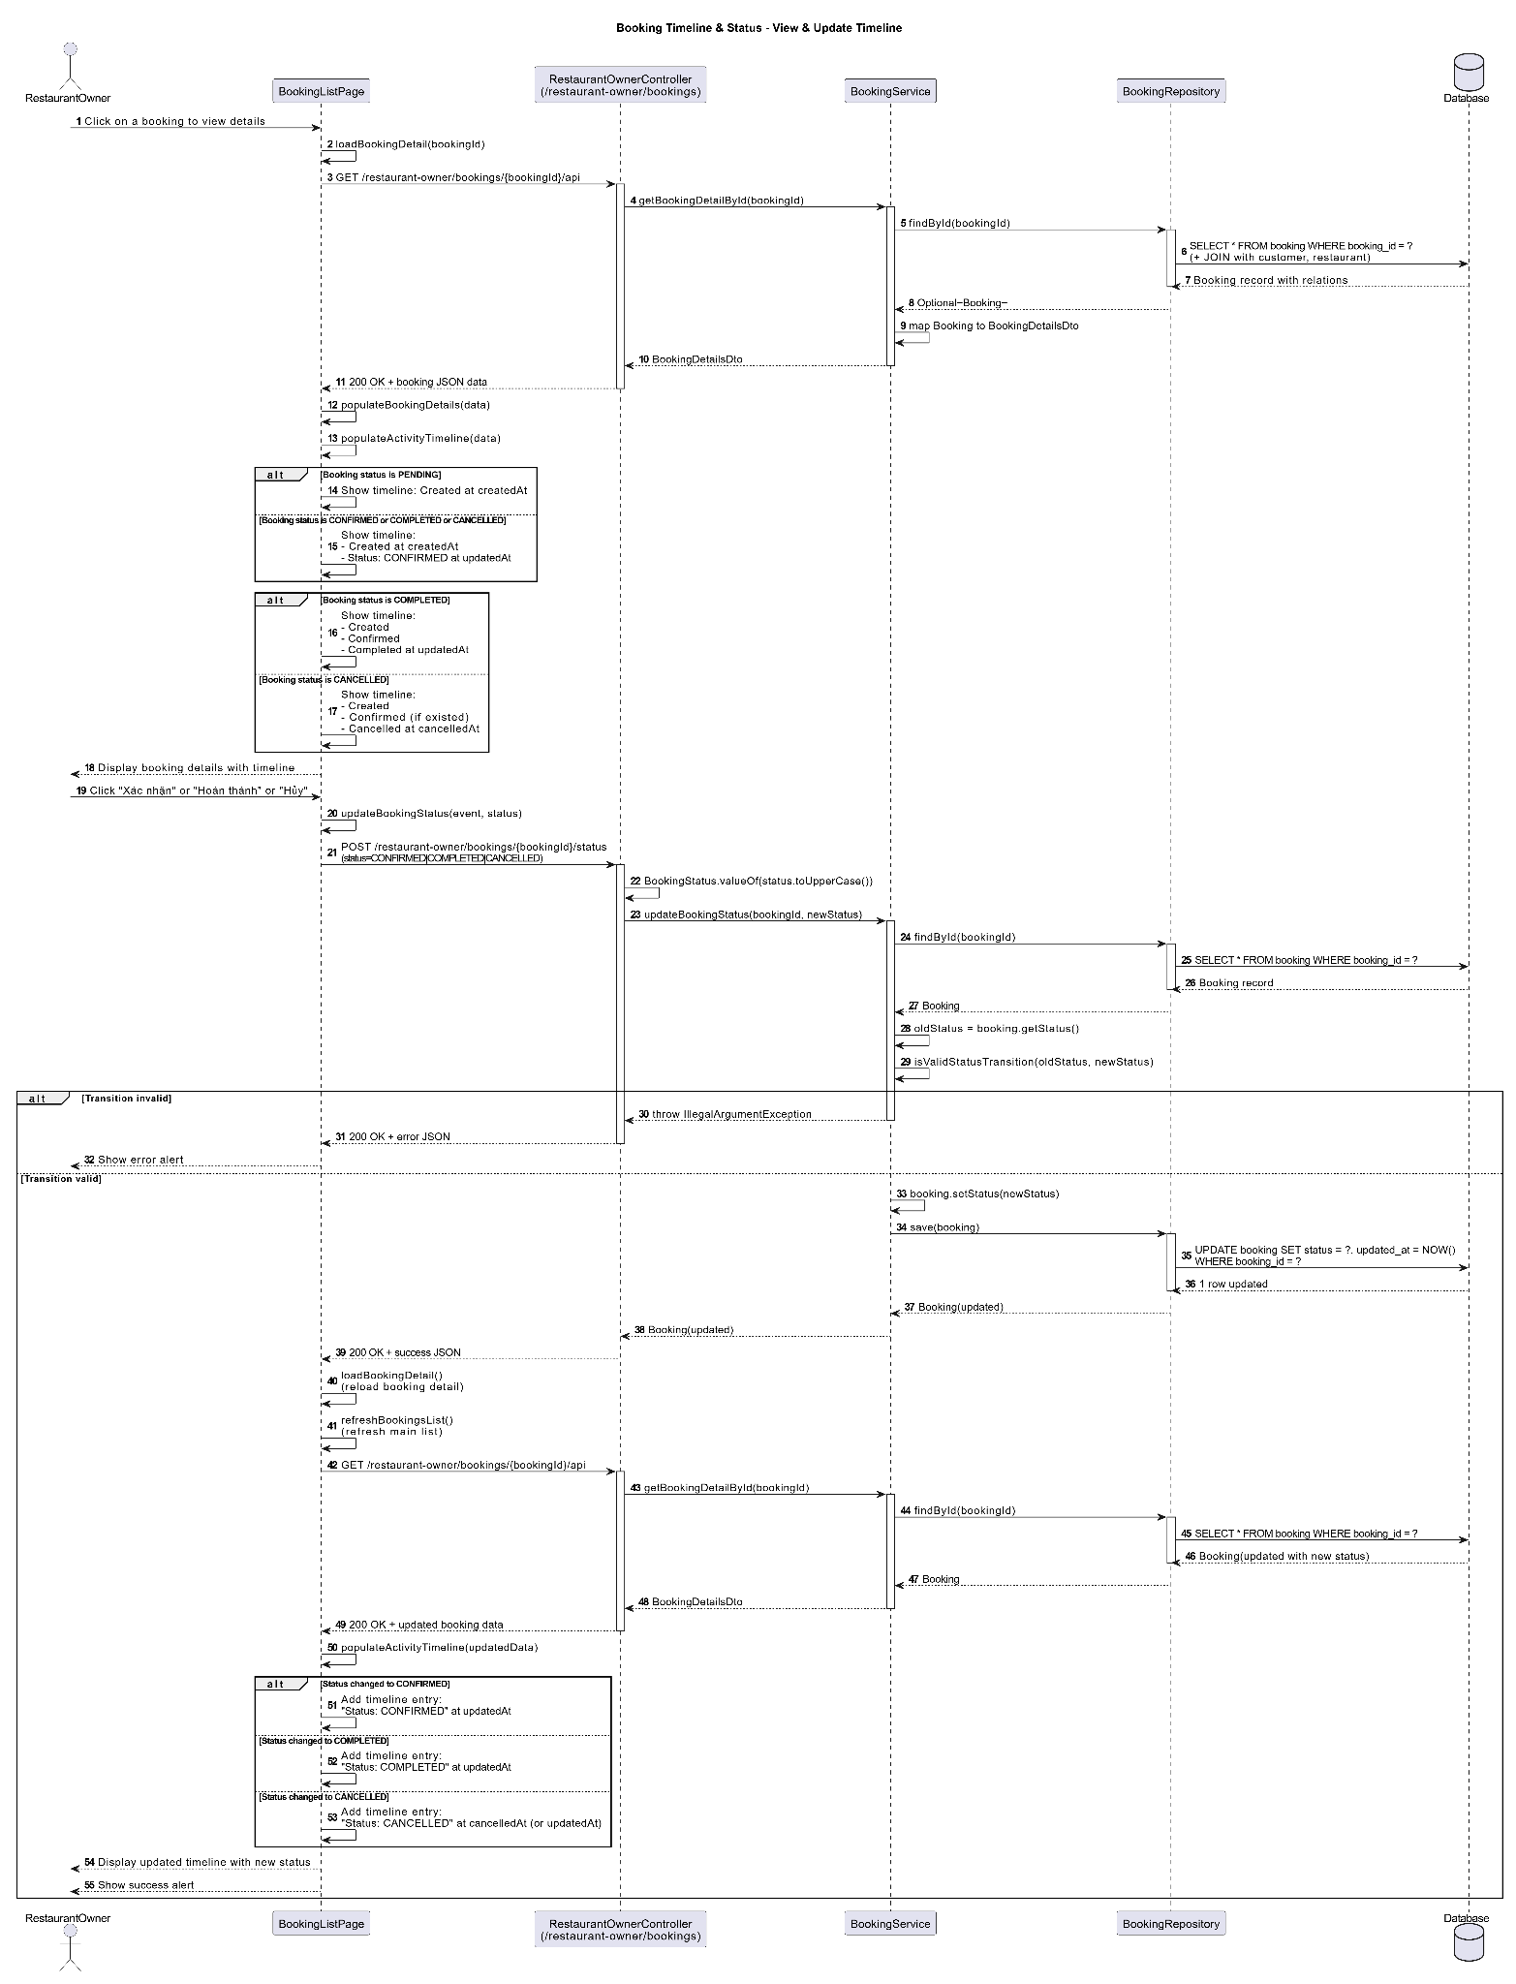

### d. Database Queries

Load booking:

SELECT id, restaurant_id, customer_id, table_id, start_time, end_time, party_size, status, notes FROM bookings WHERE id = ? LIMIT 1;

Read timeline events:

SELECT id, booking_id, type, message, created_at FROM booking_events WHERE booking_id = ? ORDER BY created_at ASC;

Append event:

INSERT INTO booking_events (booking_id, type, message, created_at) VALUES (?, ?, ?, NOW());

Update status:

UPDATE bookings SET status = ?, updated_at = NOW() WHERE id = ?;

# 3. Restaurant Management

## 3.1 Restaurant Profile

***a. Class Diagram***

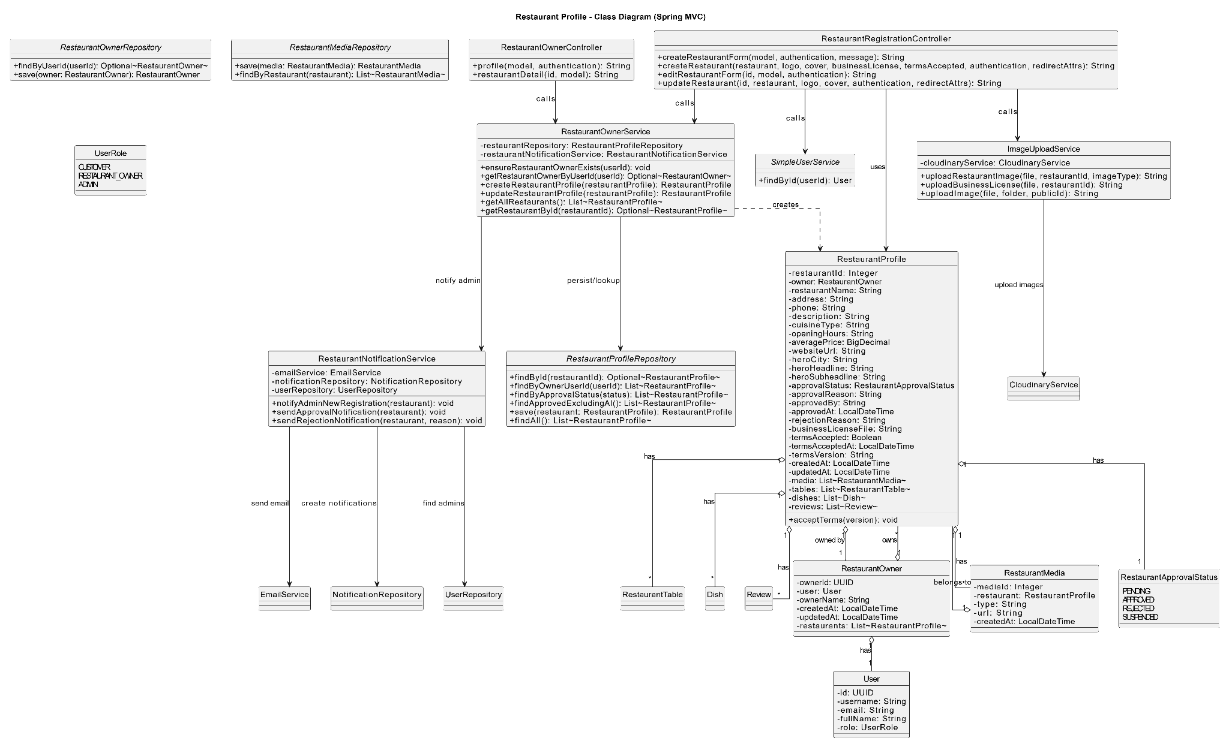

### b. Class Specifications

| RestaurantProfileController | | |
| --- | --- | --- |
| **No** | **Method** | **Description** |
| 1 | viewProfile(id, model) | Loads RestaurantProfile (+media) and returns the profile view. |
| 2 | editForm(id, model) | Loads current profile, maps to form, returns edit page. |
| 3 | updateProfile(id, form, bindingResult, redirectAttrs) | Validates input; delegates update; flashes success/error; redirects. |

| RestaurantService | | |
| --- | --- | --- |
| **No** | **Method** | **Description** |
| 1 | getProfileById(id) | Loads profile or throws if not found. |
| 2 | updateProfile(id, form) | Applies validated changes; saves profile; calls media sync. |
| RestaurantMediaService | | |
| **No** | **Method** | **Description** |
| 1 | syncMedia(restaurantId, urls) | Keeps URLs provided, adds new, deletes removed; persists via repo. |
| Repositories | | |
| **Repo** | **Method** | **Description** |
| RestaurantProfileRepository | findById, save | CRUD profile. |
| RestaurantMediaRepository | findByRestaurantId, saveAll, deleteByRestaurantIdExcept | Manage media set. |

### c. Sequence Diagram(s)

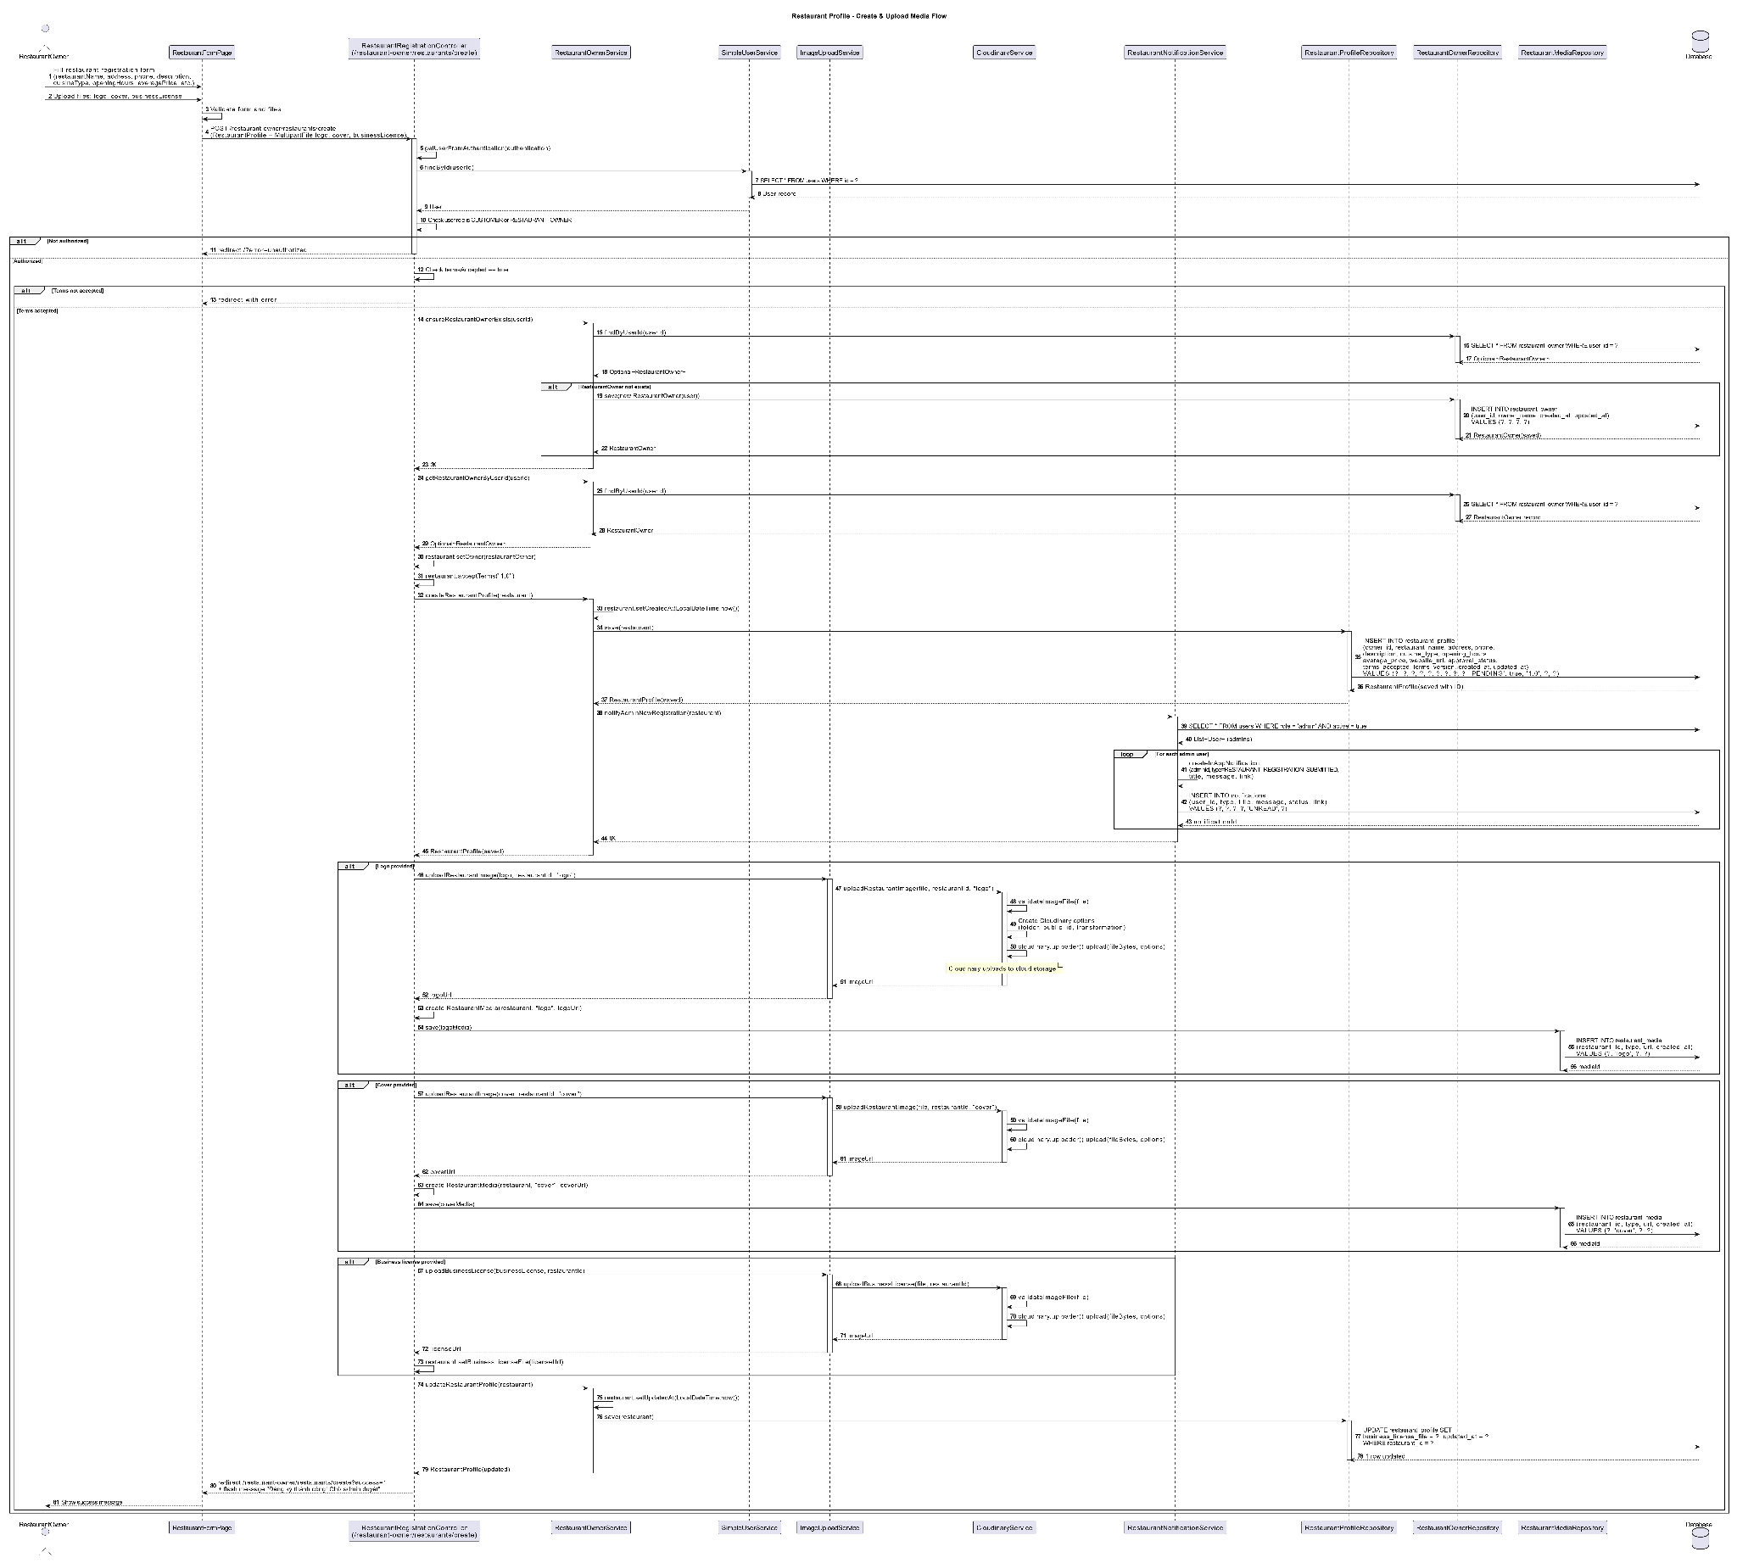

### d. Database Queries

Load profile by id:

SELECT id, owner_id, name, description, address, city, phone, opening_hours, min_party_size, max_party_size, avg_price, status, created_at, updated_at FROM restaurant_profile WHERE id = ? LIMIT 1;

Save profile (update basic fields):

UPDATE restaurant_profile SET name = ?, description = ?, address = ?, city = ?, phone = ?, opening_hours = ?, min_party_size = ?, max_party_size = ?, avg_price = ?, updated_at = NOW() WHERE id = ?;

Read media by restaurant:

SELECT id, restaurant_id, url, type, created_at FROM restaurant_media WHERE restaurant_id = ? ORDER BY id ASC;

Add new media:

INSERT INTO restaurant_media (restaurant_id, url, type, created_at) VALUES (?, ?, ?, NOW());

Delete removed media (keep only provided IDs/URLs):

DELETE FROM restaurant_media WHERE restaurant_id = ? AND id NOT IN (…list of kept ids…);

## 3.2 Owner Onboarding

### a. Class Diagram

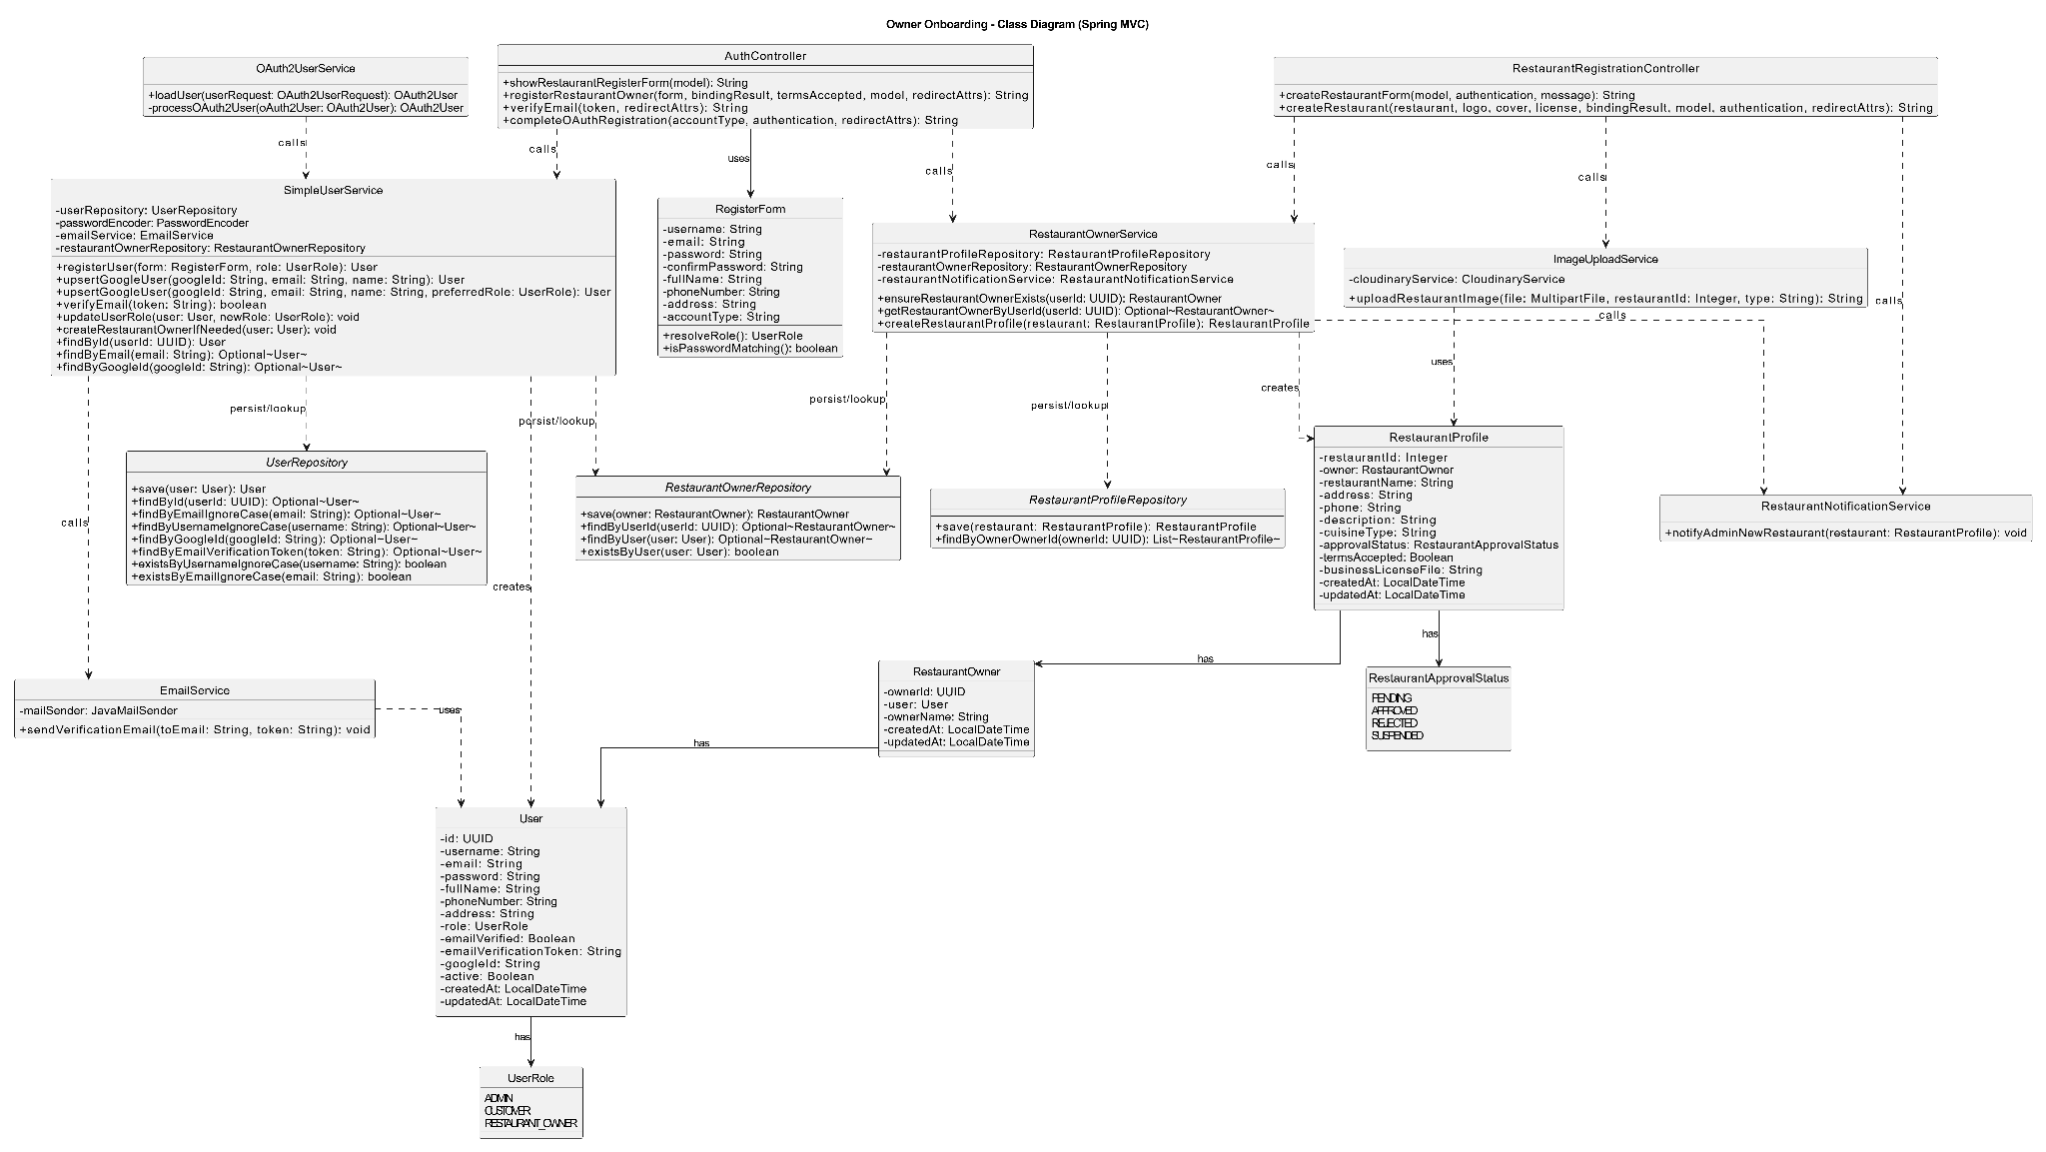

### b. Class Specifications

| OwnerOnboardingController | | |
| --- | --- | --- |
| **No** | **Method** | **Description** |
| 1 | start(id, model) | Initializes onboarding for user; ensures RestaurantOwner exists with DRAFT status. |
| 2 | submitOwnerInfo(form, bindingResult, redirectAttrs) | Saves owner personal info; stays in DRAFT. |
| 3 | submitRestaurantProfile(form, bindingResult, redirectAttrs) | Creates/updates RestaurantProfile bound to owner. |
| 4 | submitBankAccount(form, bindingResult, redirectAttrs) | Links/updates RestaurantBankAccount for payouts. |
| 5 | reviewAndSubmit(restaurantId, redirectAttrs) | Marks Owner status to SUBMITTED for admin approval. |
| RestaurantOwnerService | | |
| **No** | **Method** | **Description** |
| 1 | ensureRestaurantOwnerExists(userId) | Creates a RestaurantOwner with DRAFT if not exists. |
| 2 | updateOwnerInfo(userId, form) | Updates fullName/phone/nationalId. |
| 3 | markSubmittedForApproval(userId, restaurantId) | Sets Owner status SUBMITTED; creates/updates a PENDING contract. |
| RestaurantService | | |
| **No** | **Method** | **Description** |
| 1 | createOrUpdateProfile(ownerId, form) | Upserts RestaurantProfile with provided info. |
| RestaurantBankAccountService | | |
| **No** | **Method** | **Description** |
| 1 | linkBankAccount(restaurantId, form) | Upserts bank account; sets verified=false until KYC. |
| AdminApprovalService | | |
| **No** | **Method** | **Description** |
| 1 | approveOwner(restaurantId) | Sets Owner=APPROVED, Contract=ACTIVE.signedAt=now(). |
| 2 | rejectOwner(restaurantId, reason) | Sets Owner=REJECTED, Contract=REJECTED. |
| Repositories (key methods) | | |
| **Repo** | **Method** | **Description** |
| RestaurantOwnerRepository | findByUserId/save | Load & persist owner record. |
| RestaurantProfileRepository | findByOwnerId/save | Load & persist profile. |
| RestaurantBankAccountRepository | findByRestaurantId/save | Load & persist bank account. |
| RestaurantContractRepository | save | Create/activate contract. |

### c. Sequence Diagram(s)

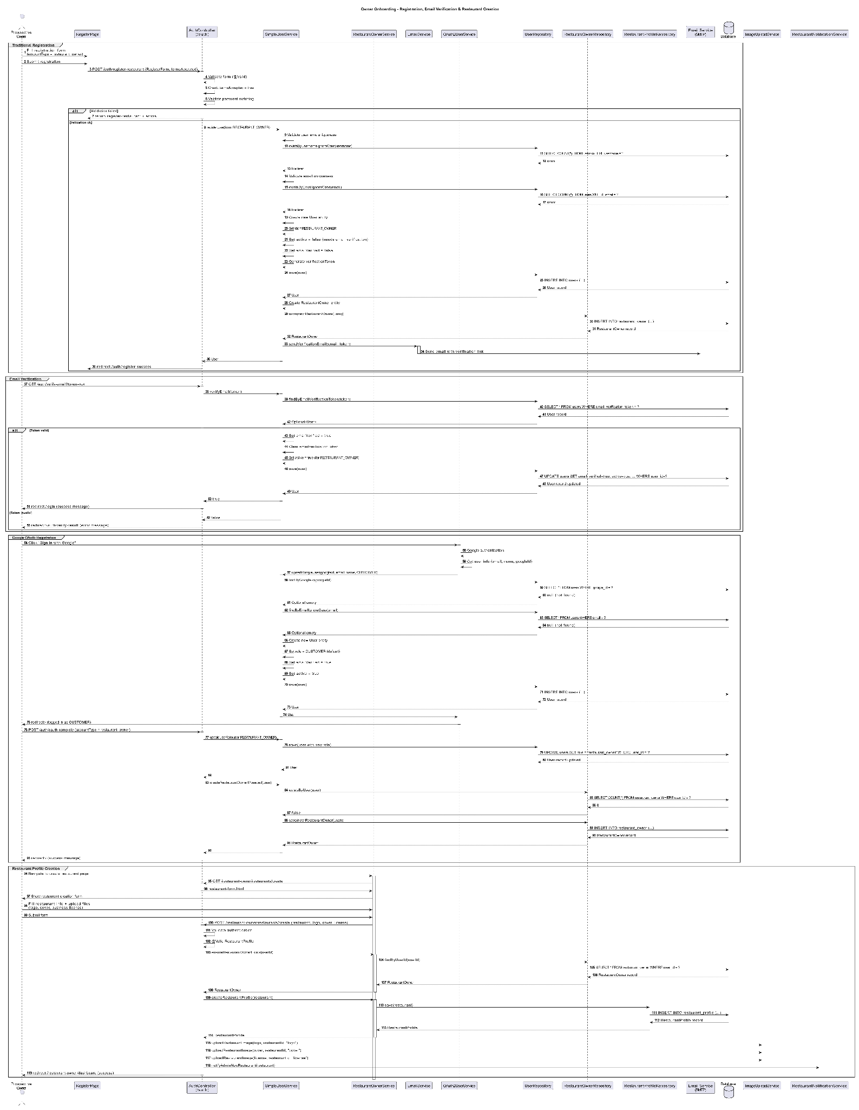

### d. Database Queries

Ensure owner exists (load/create):

SELECT id, user_id, full_name, phone, national_id, status FROM restaurant_owner WHERE user_id = ? LIMIT 1;

INSERT INTO restaurant_owner (user_id, full_name, phone, national_id, status, created_at, updated_at)

VALUES (?, ?, ?, ?, 'DRAFT', NOW(), NOW());

Update owner info:

UPDATE restaurant_owner SET full_name = ?, phone = ?, national_id = ?, updated_at = NOW() WHERE user_id = ?;

Upsert restaurant profile:

SELECT id FROM restaurant_profile WHERE owner_id = ? LIMIT 1;

INSERT INTO restaurant_profile (owner_id, name, description, address, city, phone, opening_hours, min_party_size, max_party_size, avg_price, status, created_at, updated_at)

VALUES (?, ?, ?, ?, ?, ?, ?, ?, ?, ?, 'DRAFT', NOW(), NOW());

UPDATE restaurant_profile SET name = ?, description = ?, address = ?, city = ?, phone = ?, opening_hours = ?, min_party_size = ?, max_party_size = ?, avg_price = ?, updated_at = NOW()

WHERE id = ?;

Upsert bank account:

SELECT id FROM restaurant_bank_account WHERE restaurant_id = ? LIMIT 1;

INSERT INTO restaurant_bank_account (restaurant_id, bank_code, account_number, account_holder, verified, created_at, updated_at)

VALUES (?, ?, ?, ?, FALSE, NOW(), NOW());

UPDATE restaurant_bank_account SET bank_code = ?, account_number = ?, account_holder = ?, verified = FALSE, updated_at = NOW()

WHERE restaurant_id = ?;

Submit for approval (owner status + contract):

UPDATE restaurant_owner SET status = 'SUBMITTED', updated_at = NOW() WHERE user_id = ?;

INSERT INTO restaurant_contract (restaurant_id, type, status, signed_at, created_at, updated_at)

VALUES (?, 'STANDARD', 'PENDING', NULL, NOW(), NOW());

Admin approve/reject:

UPDATE restaurant_owner SET status = 'APPROVED', updated_at = NOW() WHERE user_id = ?;

UPDATE restaurant_contract SET status = 'ACTIVE', signed_at = NOW(), updated_at = NOW() WHERE restaurant_id = ?;

(Reject) UPDATE restaurant_owner SET status = 'REJECTED', updated_at = NOW() WHERE user_id = ?;

(Reject) UPDATE restaurant_contract SET status = 'REJECTED', updated_at = NOW() WHERE restaurant_id = ?;

## 3.3 Table Management

### a. Class Diagram

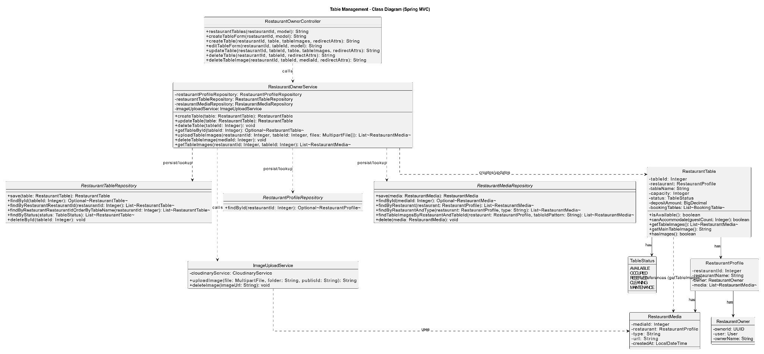

### b. Class Specifications

| TableController | | |
| --- | --- | --- |
| **No** | **Method** | **Description** |
| 1 | list(restaurantId, model) | Shows list of tables for a restaurant. |
| 2 | createForm(restaurantId, model) | Returns create form. |
| 3 | create(restaurantId, form, …) | Validates, delegates create, flashes message, redirects. |
| 4 | editForm(id, model) | Loads table and returns edit form. |
| 5 | update(id, form, …) | Validates, updates table info, redirects with message. |
| 6 | delete(id, …) | Deletes table if no future bookings; otherwise shows error. |

| TableForm (DTO) | | | |
| --- | --- | --- | --- |
| **No** | **Field** | **Type** | **Description** |
| 1 | name | String | Unique per restaurant (case-insensitive). |
| 2 | capacity | int | Seat capacity (>0). |
| 3 | location | String | Zone/area (e.g., “Indoor A”). |
| 4 | status | String | ACTIVE/INACTIVE; INACTIVE not used for assignment. |

| TableService | | |
| --- | --- | --- |
| **No** | **Method** | **Description** |
| 1 | listByRestaurant(restaurantId) | Returns all tables for the restaurant. |
| 2 | create(restaurantId, form) | Checks unique name; creates table. |
| 3 | getById(id) | Loads table or throws. |
| 4 | update(id, form) | Checks unique name on rename; updates capacity/location/status. |
| 5 | delete(id) | Blocks delete if future bookings exist; otherwise deletes. |
| RestaurantTableRepository | | |
| **No** | **Method** | **Description** |
| 1 | findByRestaurantId(r) | Lists tables by restaurant. |
| 2 | findById(id) | Load table. |
| 3 | existsByRestaurantIdAndNameIgnoreCase(r, name) | Enforce unique table name within restaurant. |
| 4 | save(t) | Persist create/update. |
| 5 | deleteById(id) | Remove table (if allowed). |
| BookingRepository (safety checks) | | |
| **No** | **Method** | **Description** |
| 1 | existsOnTable(tableId, start, end) | Check overlap window if needed (update). |
| 2 | existsFutureOnTable(tableId, now) | Prevent delete if future booking exists. |

### c. Sequence Diagram(s)

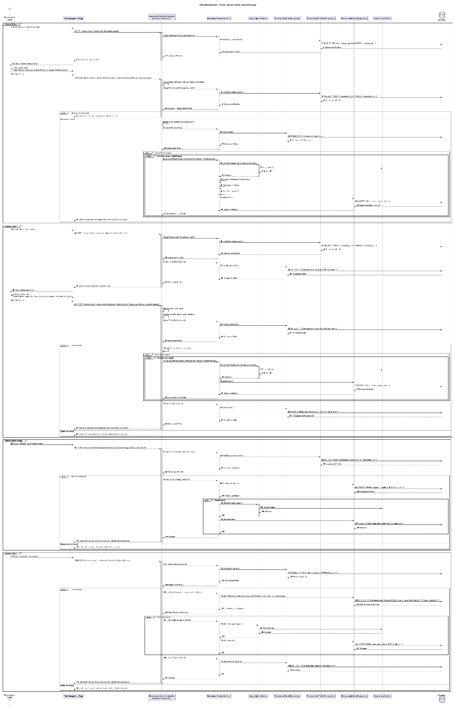

### d. Database Queries

List tables by restaurant:

SELECT id, restaurant_id, name, capacity, location, status, created_at, updated_at FROM restaurant_table WHERE restaurant_id = ? ORDER BY name ASC;

Unique name check (per restaurant):

SELECT 1 FROM restaurant_table WHERE restaurant_id = ? AND lower(name) = lower(?) LIMIT 1;

Create table:

INSERT INTO restaurant_table (restaurant_id, name, capacity, location, status, created_at, updated_at) VALUES (?, ?, ?, ?, ?, NOW(), NOW());

Load table by id:

SELECT id, restaurant_id, name, capacity, location, status FROM restaurant_table WHERE id = ? LIMIT 1;

Update table:

UPDATE restaurant_table SET name = ?, capacity = ?, location = ?, status = ?, updated_at = NOW() WHERE id = ?;

Prevent delete if future bookings exist:

SELECT 1 FROM bookings WHERE table_id = ? AND status <> 'CANCELLED' AND start_time > NOW() LIMIT 1;

Delete table:

DELETE FROM restaurant_table WHERE id = ?;

## 3.4 Menu/Dish Management

### a. Class Diagram

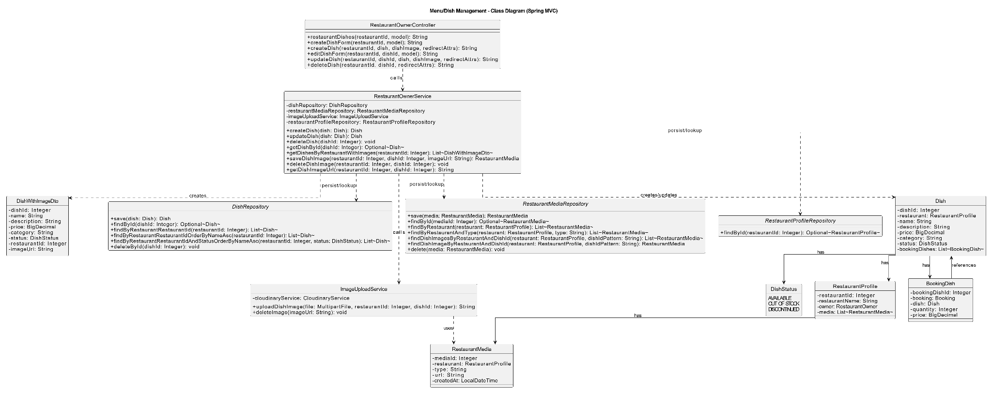

### b. Class Specifications

| DishController | | |
| --- | --- | --- |
| **No** | **Method** | **Description** |
| 1 | list(restaurantId, model) | Shows all dishes of a restaurant. |
| 2 | createForm(restaurantId, model) | Returns dish create form. |
| 3 | create(restaurantId, form, …) | Validates, creates dish, redirects with message. |
| 4 | editForm(id, model) | Loads dish and returns edit form. |
| 5 | update(id, form, …) | Validates and updates dish fields. |
| 6 | delete(id, …) | Deletes a dish (soft delete optional). |
| 7 | toggleStatus(id, …) | Switches ACTIVE/INACTIVE for visibility. |

| DishForm (DTO) | | | |
| --- | --- | --- | --- |
| **No** | **Field** | **Type** | **Description** |
| 1 | name | String | Unique per restaurant (case-insensitive). |
| 2 | description | String | Optional description. |
| 3 | price | BigDecimal | > 0. |
| 4 | category | String | e.g., Appetizer/Main/Dessert/Drink. |
| 5 | status | String | ACTIVE/INACTIVE. |
| 6 | imageUrl | String | Optional image. |

| DishService | | |
| --- | --- | --- |
| **No** | **Method** | **Description** |
| 1 | listByRestaurant(restaurantId) | Lists dishes for a restaurant. |
| 2 | create(restaurantId, form) | Checks unique name in restaurant; creates dish. |
| 3 | getById(id) | Loads dish or throws. |
| 4 | update(id, form) | Checks unique name on rename; updates fields. |
| 5 | delete(id) | Deletes dish (or marks inactive if soft delete). |
| 6 | toggleStatus(id) | Flips status ACTIVE/INACTIVE. |
| DishRepository | | |
| **No** | **Method** | **Description** |
| 1 | findByRestaurantId(r) | List dishes by restaurant. |
| 2 | findById(id) | Load dish. |
| 3 | existsByRestaurantIdAndNameIgnoreCase(r, name) | Unique name check per restaurant. |
| 4 | save(d) | Persist create/update. |
| 5 | deleteById(id) | Hard delete dish. |

### c. Sequence Diagram(s)

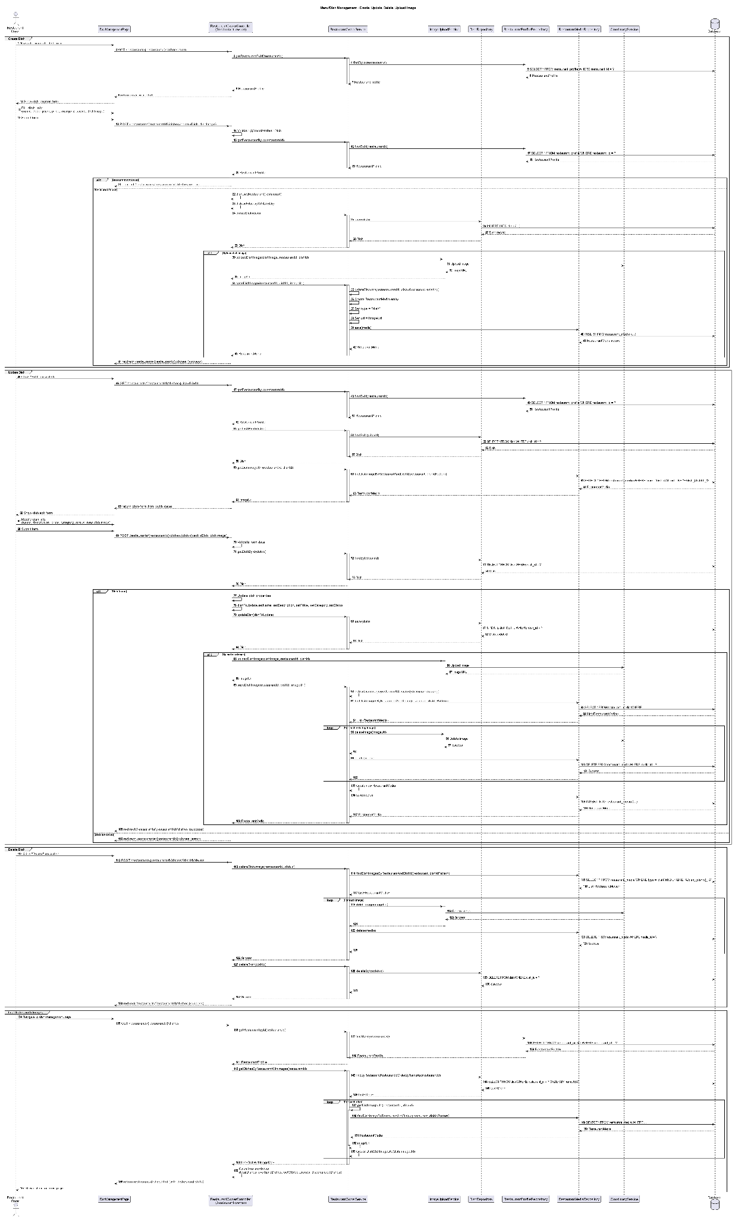

### d. Database Queries

List dishes by restaurant:

SELECT id, restaurant_id, name, description, price, category, status, image_url, created_at, updated_at FROM dish WHERE restaurant_id = ? ORDER BY name ASC;

Unique dish name check:

SELECT 1 FROM dish WHERE restaurant_id = ? AND lower(name) = lower(?) LIMIT 1;

Create dish:

INSERT INTO dish (restaurant_id, name, description, price, category, status, image_url, created_at, updated_at) VALUES (?, ?, ?, ?, ?, ?, ?, NOW(), NOW());

Load dish by id:

SELECT id, restaurant_id, name, description, price, category, status, image_url FROM dish WHERE id = ? LIMIT 1;

Update dish:

UPDATE dish SET name = ?, description = ?, price = ?, category = ?, status = ?, image_url = ?, updated_at = NOW() WHERE id = ?;

Delete dish:

DELETE FROM dish WHERE id = ?;

## 3.5 Media & Gallery

### a. Class Diagram

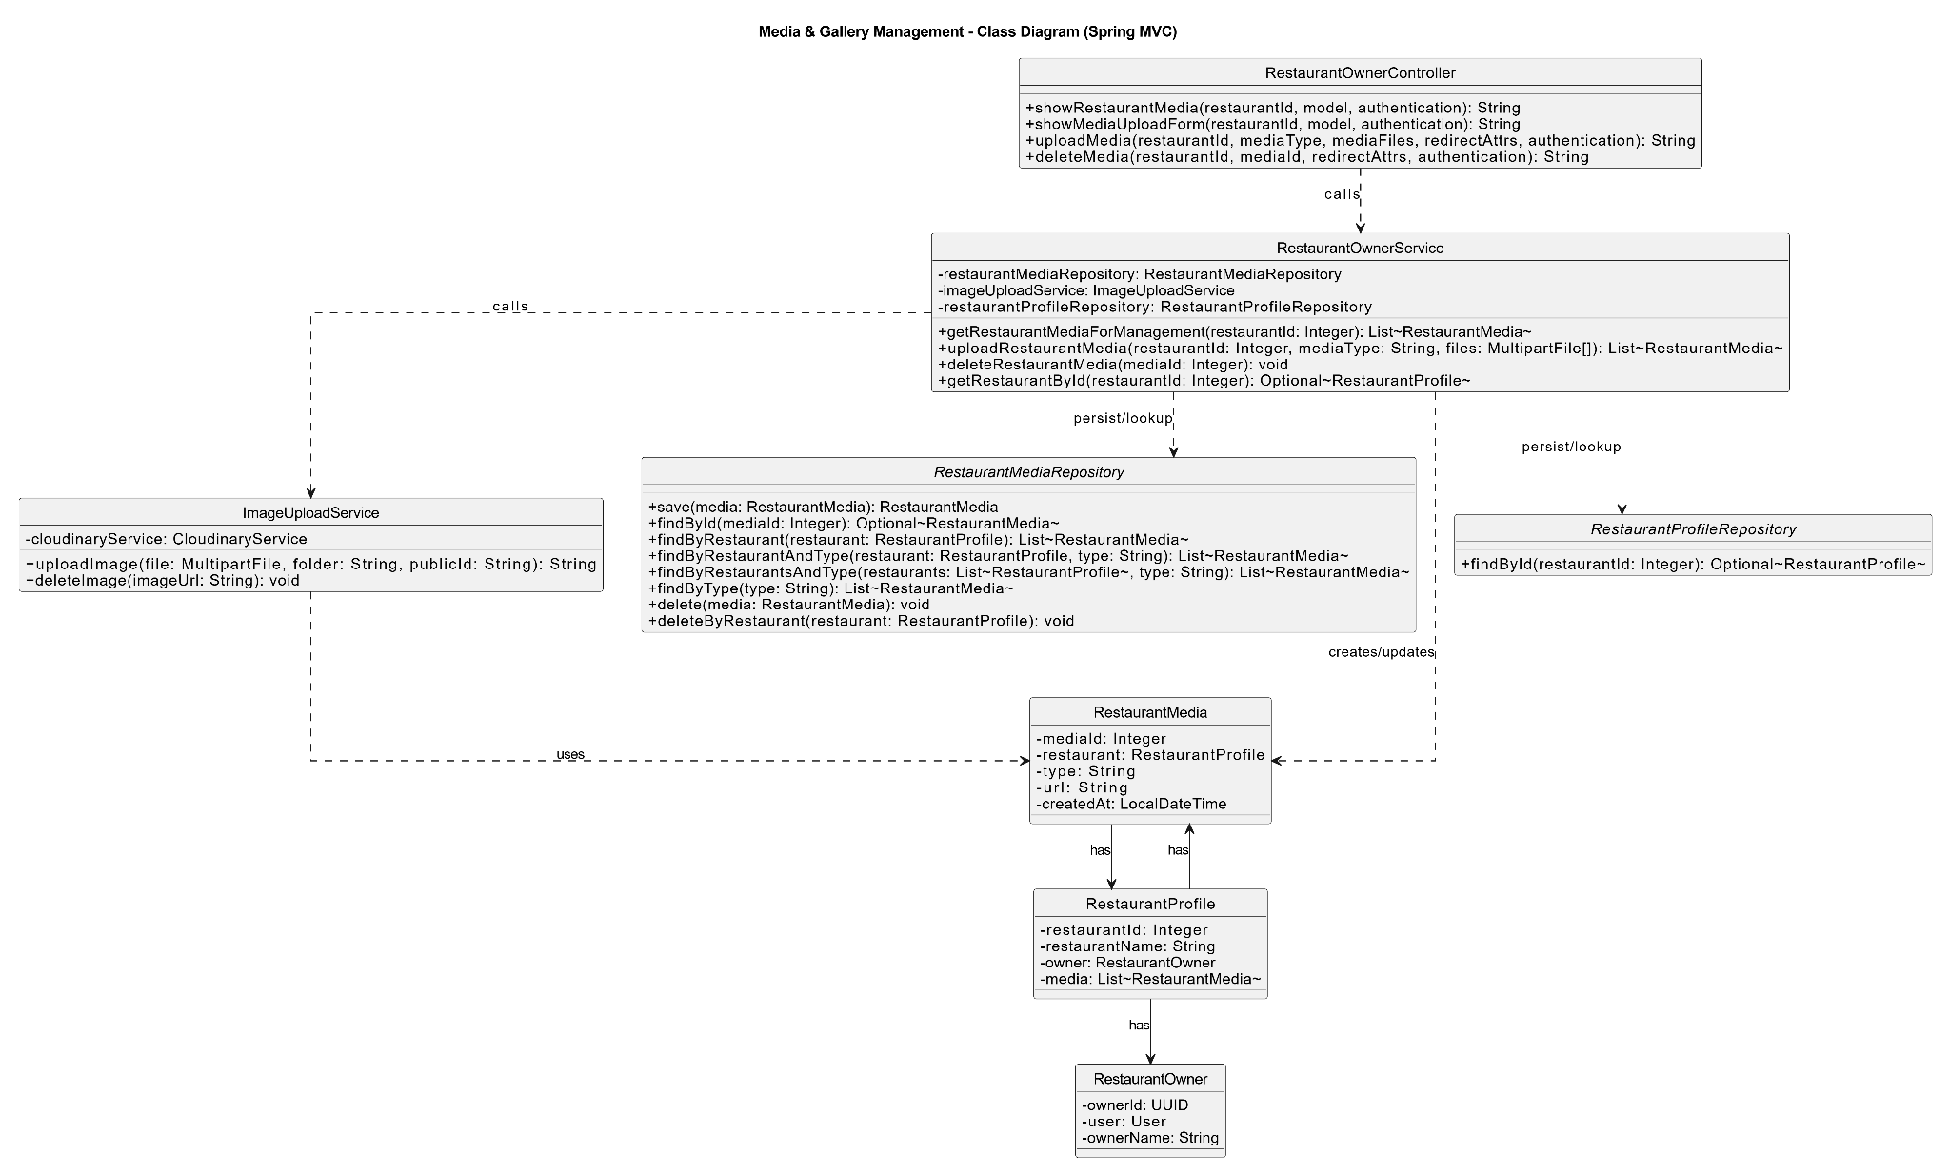

### b. Class Specifications

| **MediaController** | | |
| --- | --- | --- |
| **No** | **Method** | **Description** |
| 1 | list(restaurantId, model) | Loads media list and shows gallery page. |
| 2 | upload(restaurantId, form, …) | Validates files/type; delegates upload & persist; redirects with message. |
| 3 | delete(id, …) | Deletes a media item (storage + DB). |
| 4 | reorder(restaurantId, order, …) | Updates displayOrder in bulk for nicer gallery order. |

| MediaService | | |
| --- | --- | --- |
| **No** | **Method** | **Description** |
| 1 | listByRestaurant(restaurantId) | Returns gallery items ordered by displayOrder. |
| 2 | upload(restaurantId, form) | Uploads each file to storage (returns URL/publicId), creates RestaurantMedia, persists. |
| 3 | delete(mediaId) | Removes from storage (if publicId exists) and deletes DB row. |
| 4 | reorder(restaurantId, order) | Sets displayOrder according to provided IDs list. |
| CloudStorageService | | |
| **No** | **Method** | **Description** |
| 1 | upload(file, folder) | Uploads to provider (e.g., Cloudinary), returns accessible URL (and stores publicId). |
| 2 | delete(publicIdOrUrl) | Removes object from provider if applicable. |
| RestaurantMediaRepository | | |
| **No** | **Method** | **Description** |
| 1 | findByRestaurantIdOrderByDisplayOrderAsc | Fetches gallery ordered for rendering. |
| 2 | findById | Loads a single media item. |
| 3 | save / saveAll | Persists new or reordered items. |
| 4 | deleteById | Removes an item. |

### c. Sequence Diagram(s)

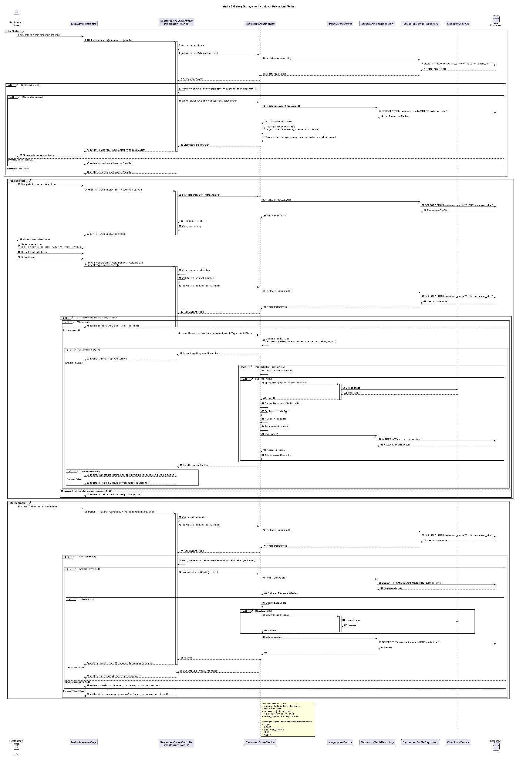

### d. Database Queries

List media ordered:

SELECT id, restaurant_id, url, public_id, type, caption, display_order, created_at FROM restaurant_media WHERE restaurant_id = ? ORDER BY display_order ASC, id ASC;

Insert media:

INSERT INTO restaurant_media (restaurant_id, url, public_id, type, caption, display_order, created_at) VALUES (?, ?, ?, ?, ?, ?, NOW());

Load single item:

SELECT id, restaurant_id, url, public_id, type, caption, display_order FROM restaurant_media WHERE id = ? LIMIT 1;

Delete media:

DELETE FROM restaurant_media WHERE id = ?;

Reorder media (batch; example form):

UPDATE restaurant_media SET display_order = ? WHERE id = ?; (repeat for each id in the new order)

# 4. Waitlist

## 4.1 Join/Leave Waitlist

### a. Class Diagram

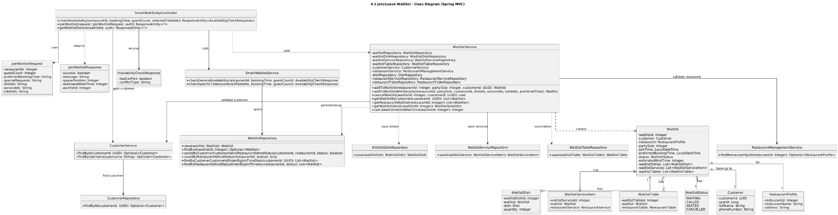

### b. Class Specifications

| WaitlistController | | |
| --- | --- | --- |
| **No** | **Method** | **Description** |
| 1 | list(restaurantId, model) | Shows active waitlist entries ordered by position. |
| 2 | join(form, bindingResult, redirectAttrs) | Validates; prevents duplicate active entry per customer; delegates join; flashes success. |
| 3 | leave(waitlistId, redirectAttrs) | Marks entry LEFT; reorders positions if needed; flashes success. |

| WaitlistService | | |
| --- | --- | --- |
| **No** | **Method** | **Description** |
| 1 | listActive(restaurantId) | Returns active entries ordered by position. |
| 2 | join(form) | Validates customer/restaurant; checks no active entry; assigns position = countActive + 1; saves; notifies. |
| 3 | leave(waitlistId) | Marks status=LEFT; compacts positions (shift down for those behind); notifies. |
| WaitlistRepository (key methods) | | |
| **No** | **Method** | **Description** |
| 1 | findActiveByRestaurantIdOrderByPositionAsc(r) | Lists active entries. |
| 2 | existsActiveByRestaurantIdAndCustomerId(r, c) | Prevent duplicate active entry. |
| 3 | countActiveByRestaurantId(r) | For next position. |
| 4 | deactivate(id) | Sets status=LEFT (or SERVED via other flow). |
| 5 | shiftPositionsDownFrom(restaurantId, position) | Decrease position for entries with position > given. |

### c. Sequence Diagram(s)

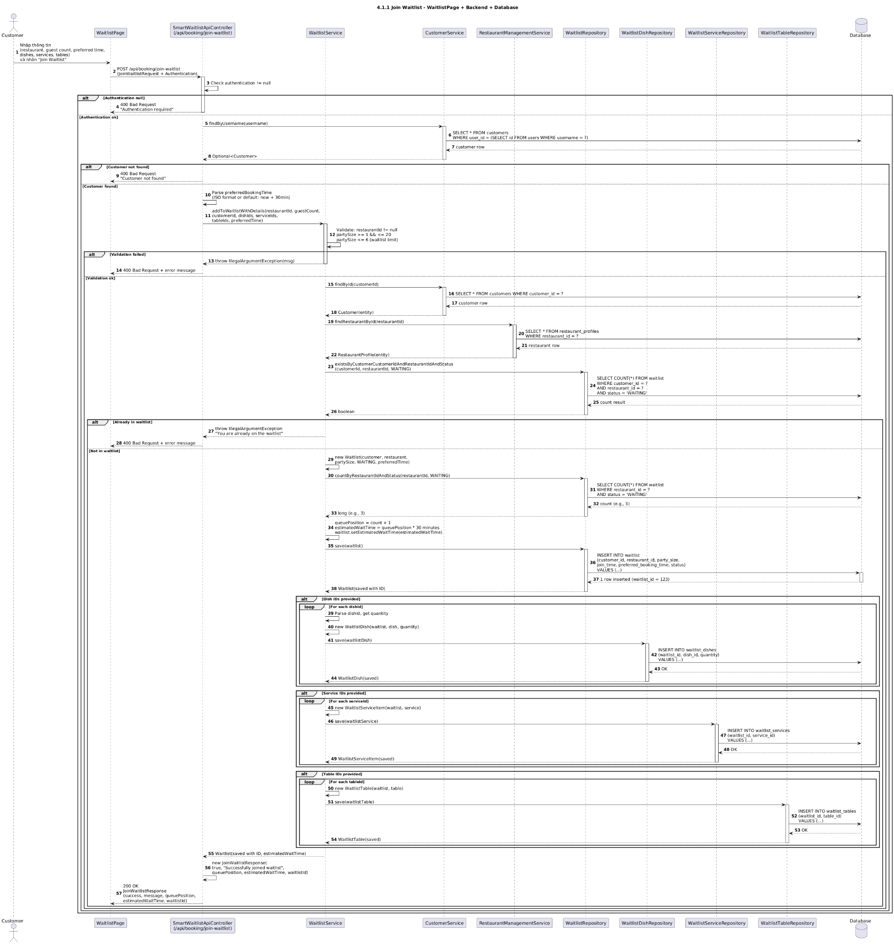

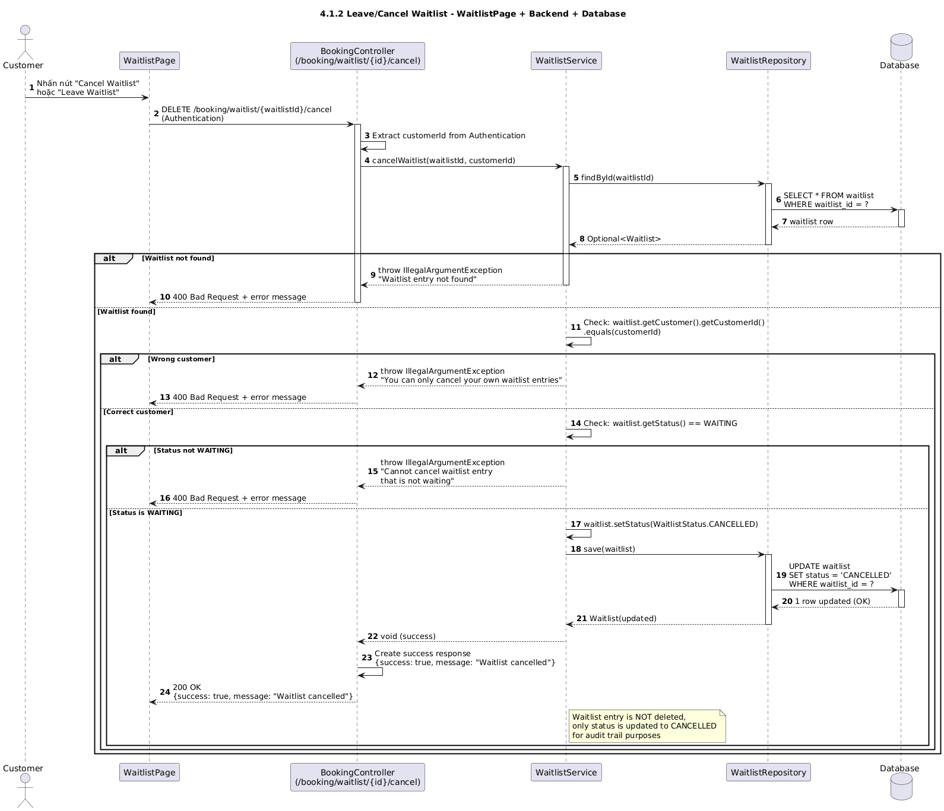

### d. Database Queries

List active entries (ordered): SELECT id, restaurant_id, customer_id, party_size, note, position, status, created_at FROM waitlist WHERE restaurant_id = ? AND status = 'ACTIVE' ORDER BY position ASC;

Duplicate active check: SELECT 1 FROM waitlist WHERE restaurant_id = ? AND customer_id = ? AND status = 'ACTIVE' LIMIT 1;

Count active: SELECT COUNT() FROM waitlist WHERE restaurant_id = ? AND status = 'ACTIVE';

Insert new entry: INSERT INTO waitlist (restaurant_id, customer_id, party_size, note, position, status, created_at, updated_at) VALUES (?, ?, ?, ?, ?, 'ACTIVE', NOW(), NOW());

Deactivate (leave): UPDATE waitlist SET status = 'LEFT', updated_at = NOW() WHERE id = ?;

Shift positions (compact after leave): UPDATE waitlist SET position = position - 1 WHERE restaurant_id = ? AND status = 'ACTIVE' AND position > ?;

## 4.2 Waitlist Prioritization

### a. Class Diagram

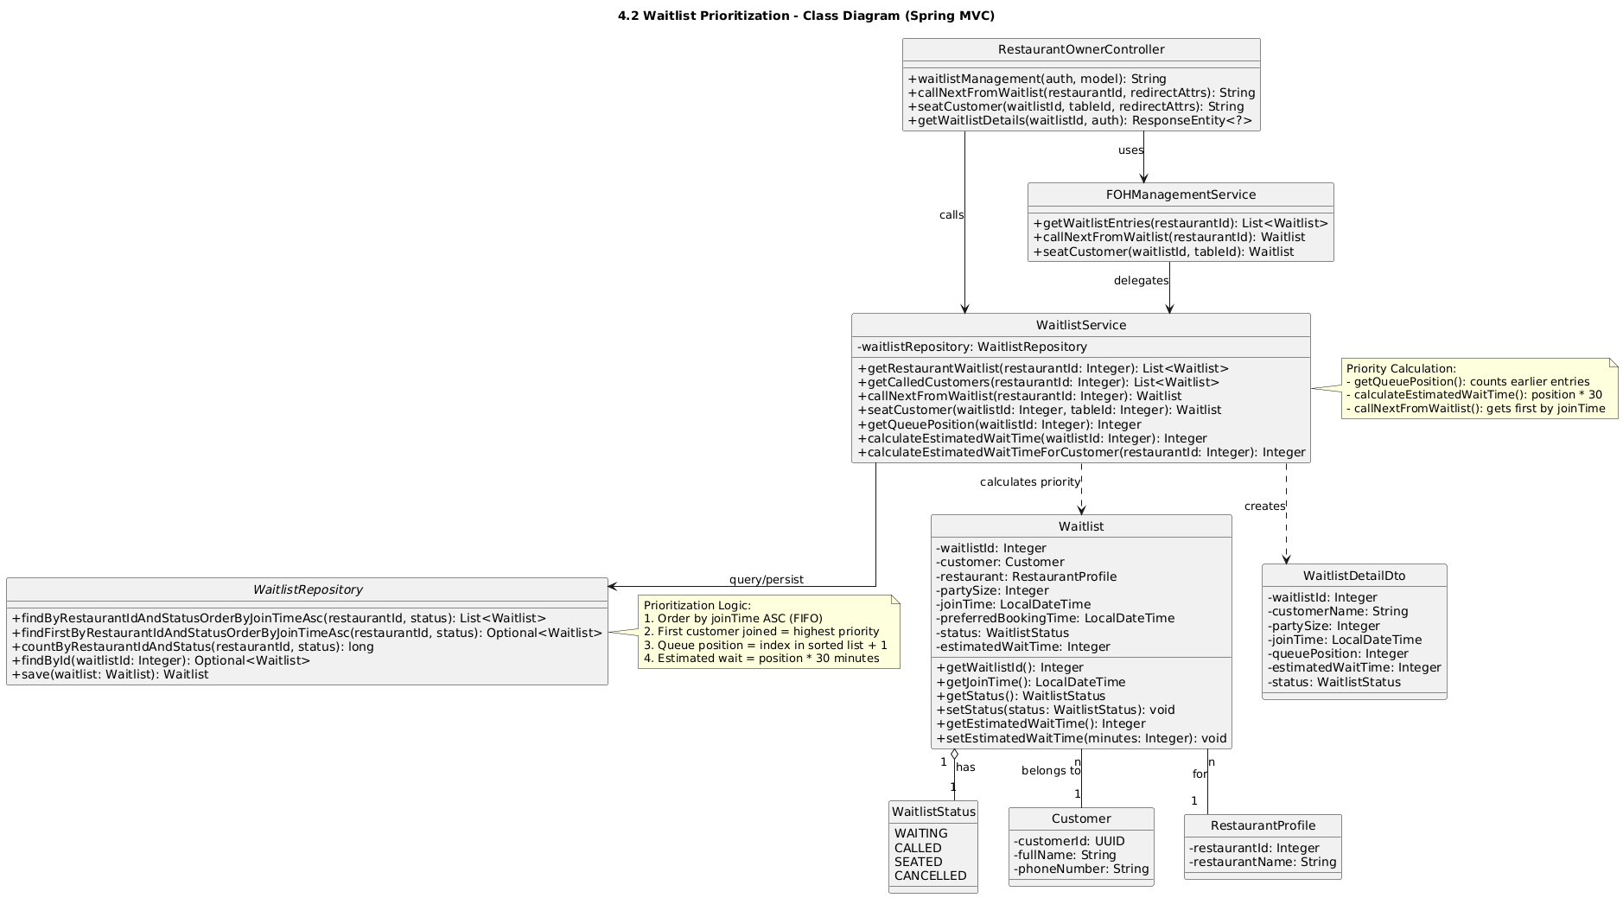

### b. Class Specifications

| WaitlistAdminController | | |
| --- | --- | --- |
| **No** | **Method** | **Description** |
| 1 | viewQueue(restaurantId, model) | Shows active queue ordered by position. |
| 2 | prioritize(request, redirectAttrs) | Routes action (PROMOTE/DEMOTE/TOP/BOTTOM/SET_POSITION) to service; flashes result. |
| 3 | bulkReorder(restaurantId, order, redirectAttrs) | Applies a supplied ordered list of waitlist IDs to positions. |

| WaitlistPrioritizationService | | |
| --- | --- | --- |
| **No** | **Method** | **Description** |
| 1 | promote(r, id) | Swap with previous (position-1) and shift range accordingly. |
| 2 | demote(r, id) | Swap with next (position+1). |
| 3 | moveToTop(r, id) | Shift [1..oldPos-1] down by +1; set id → 1. |
| 4 | moveToBottom(r, id) | Shift [oldPos+1..max] up by −1; set id → max. |
| 5 | setPosition(r, id, pos) | Move id to pos; shift intervening range ±1 accordingly. |
| 6 | bulkReorder(r, order) | Assign position by given list index; validate all IDs. |
| WaitlistRepository (prioritization) | | |
| **No** | **Method** | **Description** |
| 1 | findActiveByRestaurantIdOrderByPositionAsc | Current queue for rendering/validation. |
| 2 | findById | Load entry to move. |
| 3 | updatePosition(id, pos) | Set single entry’s position. |
| 4 | shiftRange(r, fromPos, toPos, delta) | Add delta (±1) to positions within range. |
| 5 | maxPosition(r) | Find bottom-most position. |
| NotificationService | | |
| **No** | **Method** | **Description** |
| 1 | notifyPriorityChange(r, id, reason) | Notifies staff/user a priority change occurred. |

### c. Sequence Diagram(s)

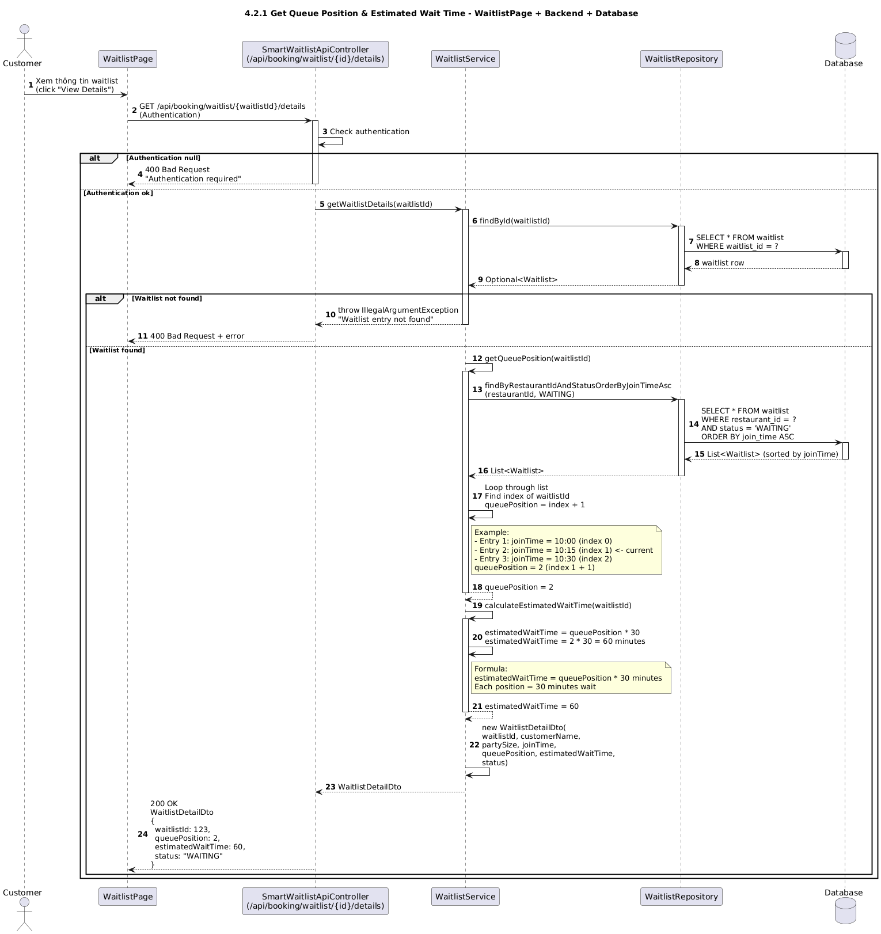

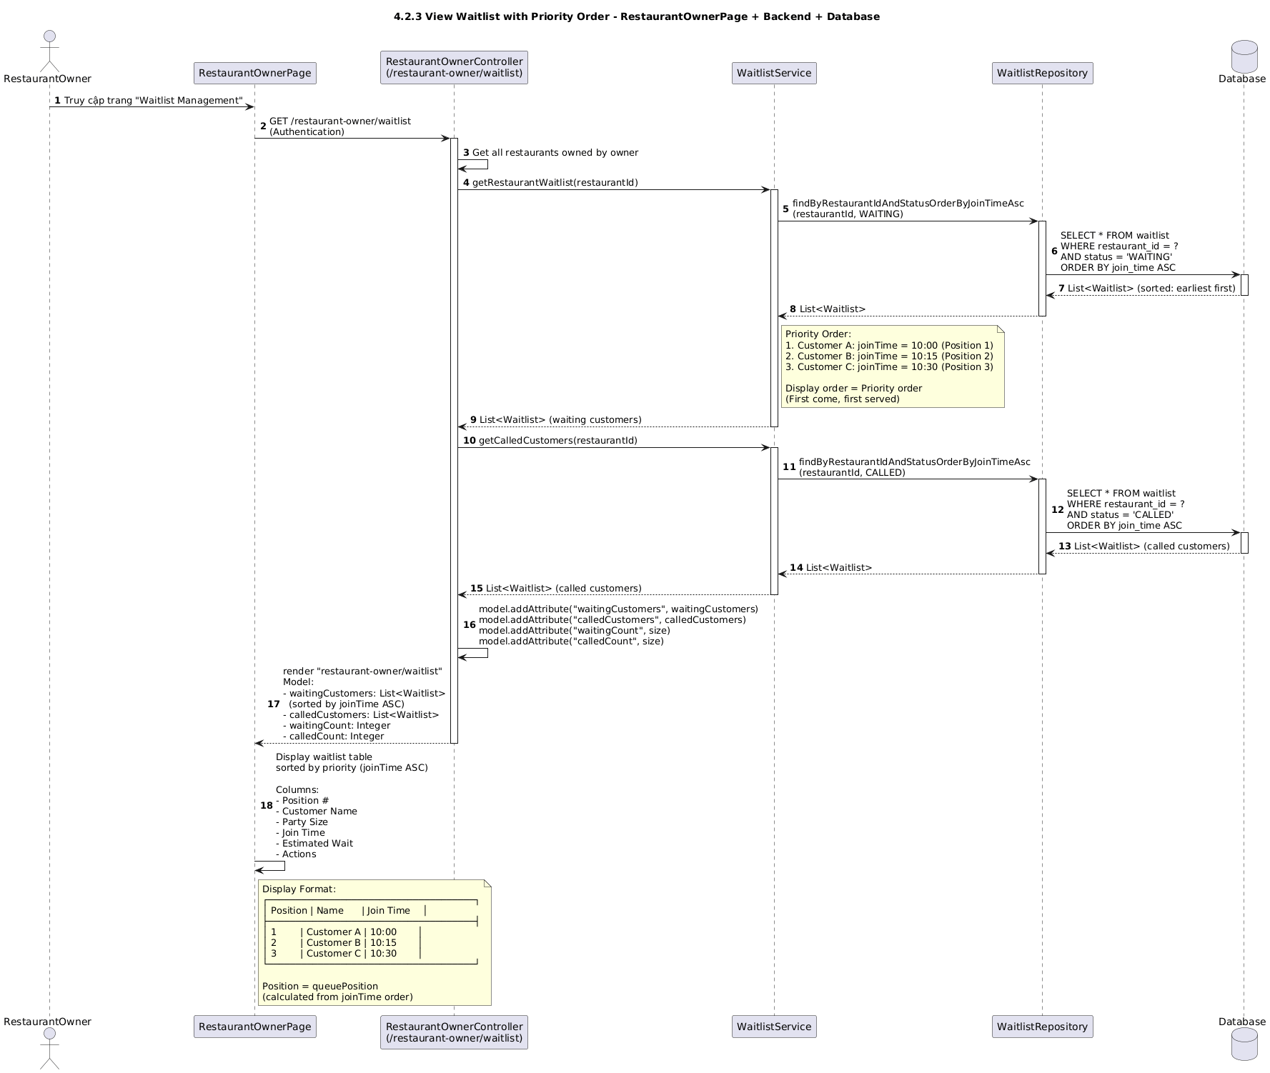

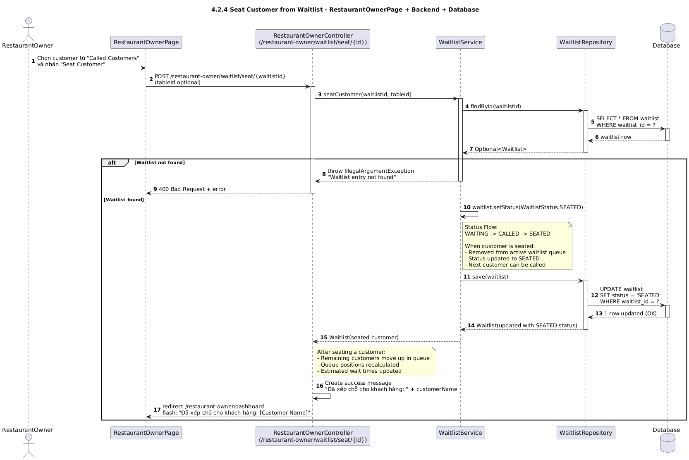

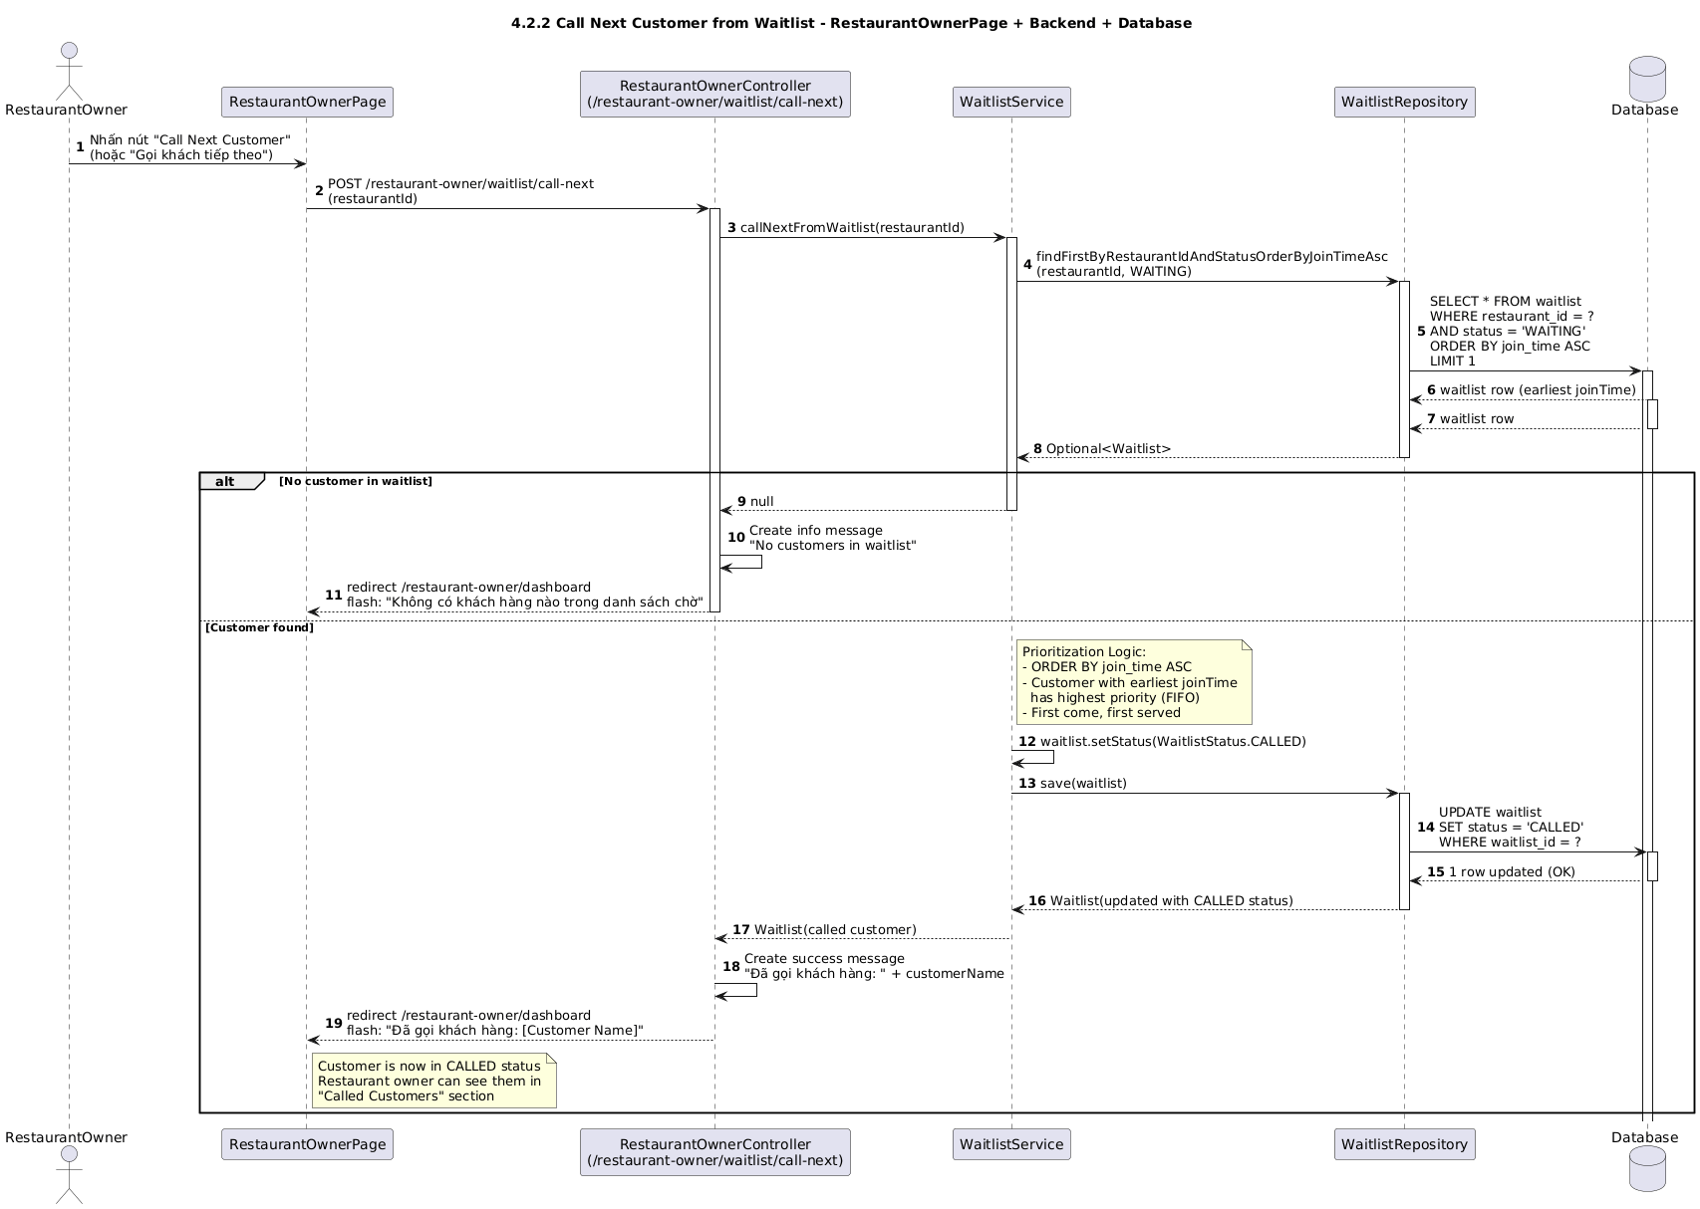

### d. Database Queries

Load active queue ordered:

SELECT id, position FROM waitlist WHERE restaurant_id = ? AND status = 'ACTIVE' ORDER BY position ASC;

Max position:

SELECT COALESCE(MAX(position), 0) FROM waitlist WHERE restaurant_id = ? AND status = 'ACTIVE';

Update single position:

UPDATE waitlist SET position = ?, updated_at = NOW() WHERE id = ?;

Shift a range up/down (sample):

UPDATE waitlist SET position = position + ? WHERE restaurant_id = ? AND status = 'ACTIVE' AND position BETWEEN ? AND ?;

Swap with previous/next (two updates):

UPDATE waitlist SET position = ? WHERE id = ?; (prev → oldPos)

UPDATE waitlist SET position = ? WHERE id = ?; (id → oldPos−1 or +1)

Bulk reorder (apply per id in list):

UPDATE waitlist SET position = ? WHERE id = ?; (repeat for each id with increasing position)

## 4.3 Notify When Ready

### a. Class Diagram

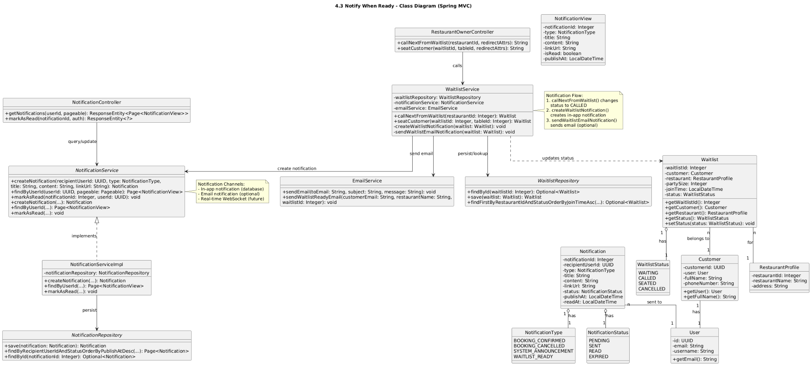

### b. Class Specifications

| WaitlistNotifyController | | |
| --- | --- | --- |
| **No** | **Method** | **Description** |
| 1 | notifyReady(waitlistId, redirectAttrs) | Triggers notification to the next-in-queue entry; flashes success/error. |
| 2 | markServed(waitlistId, redirectAttrs) | Marks entry SERVED after customer is seated; flashes success. |
| 3 | markNoResponse(waitlistId, redirectAttrs) | Marks notification as unanswered (still ACTIVE) or moves to end per policy; flashes notice. |
| WaitlistNotificationService | | |
| **No** | **Method** | **Description** |
| 1 | notifyWhenReady(waitlistId) | Validates ACTIVE; loads customer; sends via preferred channels; sets readyNotified=true and lastNotifiedAt=now; logs notification. |
| 2 | markServed(waitlistId) | Sets status=SERVED; saves. |
| 3 | markNoResponse(waitlistId) | Records “no response”; may requeue to bottom or leave in place based on policy; saves. |
| NotificationService | | |
| **No** | **Method** | **Description** |
| 1 | sendInApp(customerId, title, body) | Persists in-app notification and pushes via WebSocket if available. |
| 2 | sendEmail(email, subject, body) | Sends email; store status SENT/FAILED. |
| 3 | sendSMS(phone, body) | Sends SMS via provider; store status. |
| Repositories (key methods) | | |
| **Repo** | **Method** | **Description** |
| WaitlistRepository | findById/save | Load and update waitlist entry. |
| CustomerRepository | findById | Load contact info. |
| NotificationRepository | save | Store notification log. |

### c. Sequence Diagram(s)

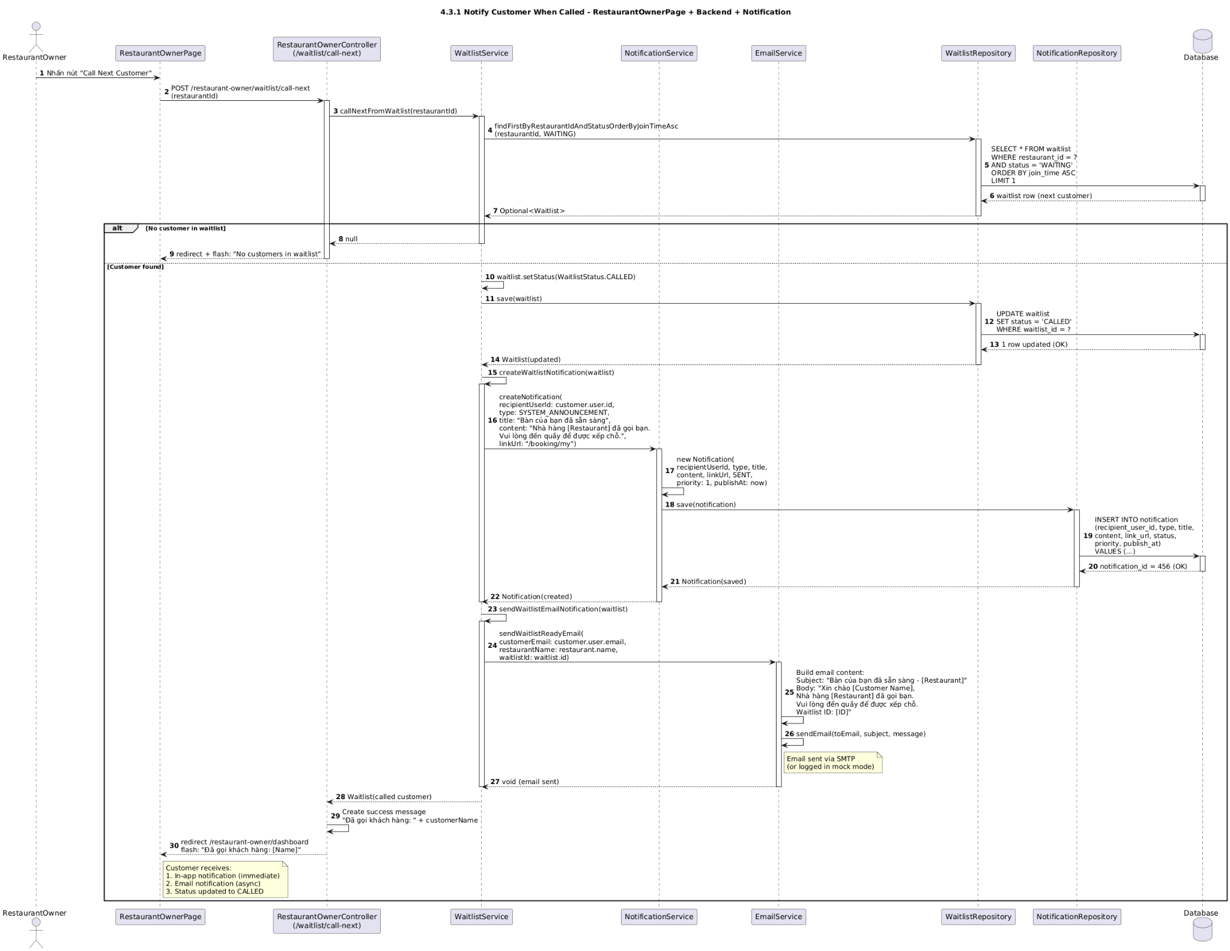

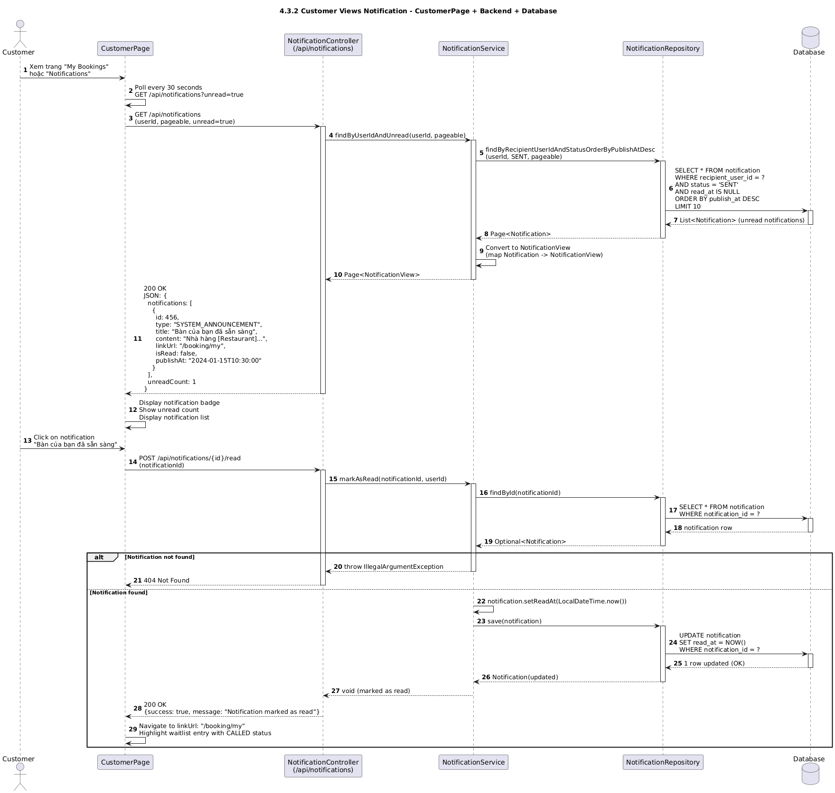

### d. Database Queries

Load waitlist entry:

SELECT id, restaurant_id, customer_id, party_size, position, status, ready_notified, last_notified_at FROM waitlist WHERE id = ? LIMIT 1;

Load customer contact:

SELECT id, email, phone_number, full_name, preferred_channel FROM customers WHERE id = ? LIMIT 1;

Insert notification log:

INSERT INTO notifications (user_id, title, body, type, status, created_at) VALUES (?, ?, ?, 'WAITLIST_READY', 'SENT', NOW());

Mark ready notified:

UPDATE waitlist SET ready_notified = TRUE, last_notified_at = NOW(), updated_at = NOW() WHERE id = ?;

Mark served:

UPDATE waitlist SET status = 'SERVED', updated_at = NOW() WHERE id = ?;

Mark no response (optionally move to bottom):

UPDATE waitlist SET updated_at = NOW() WHERE id = ?;

UPDATE waitlist SET position = position + 1 WHERE restaurant_id = ? AND status = 'ACTIVE' AND position BETWEEN ? AND ?;

UPDATE waitlist SET position = ? WHERE id = ?;

## 4.4 Seat Assignment

### a. Class Diagram

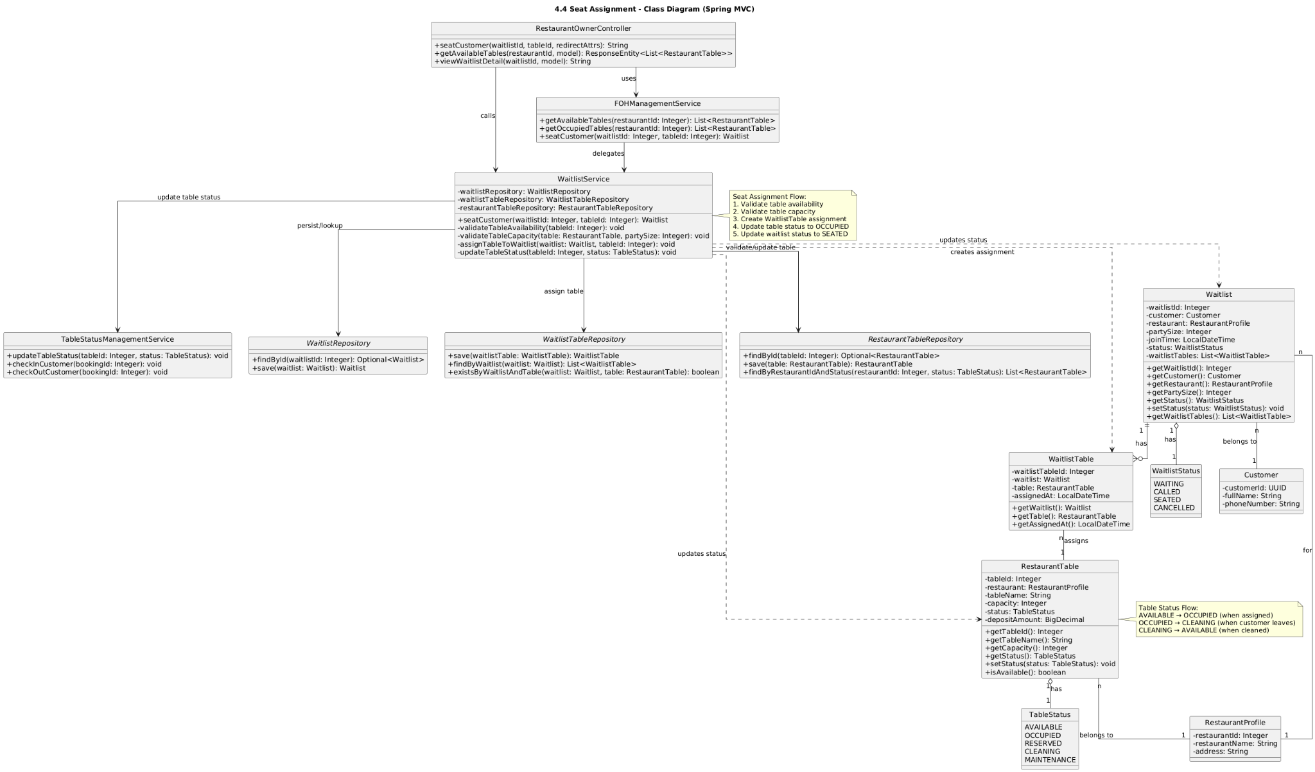

### b. Class Specifications

| SeatAssignmentController | | |
| --- | --- | --- |
| **No** | **Method** | **Description** |
| 1 | assign(restaurantId, form, …) | Validates form; routes to assignFromWaitlist/assignFromBooking; redirects with result. |
| 2 | release(tableId, …) | Closes active seating on the table (sets endedAt). |
| 3 | viewFloor(restaurantId, model) | Shows current floor tables and active seatings. |
| SeatAssignmentService | | |
| **No** | **Method** | **Description** |
| 1 | assignFromWaitlist(rId, tableId, waitlistId, partySize, note) | Asserts table free & capacity; opens seating; marks waitlist SERVED. |
| 2 | assignFromBooking(rId, tableId, bookingId, note) | Asserts table free & capacity (from booking.partySize); opens seating; sets booking status SEATED. |
| 3 | releaseTable(tableId) | Closes active seating record (sets endedAt = now). |
| 4 | currentSeating(tableId) | Returns active seating if any. |
| TableAvailabilityService | | |
| **No** | **Method** | **Description** |
| 1 | assertTableFree(tableId, at) | Throws if there is an active seating on table. |
| 2 | assertCapacity(tableId, partySize) | Throws if partySize > table.capacity or table inactive. |
| SeatingRepository | | |
| **No** | **Method** | **Description** |
| 1 | findActiveByTableId(tableId) | Returns active seating (endedAt is null). |
| 2 | save(seating) | Persists opening/closing seating. |
| 3 | closeActiveByTableId(tableId, endedAt) | Closes active seating atomically. |

### c. Sequence Diagram(s)

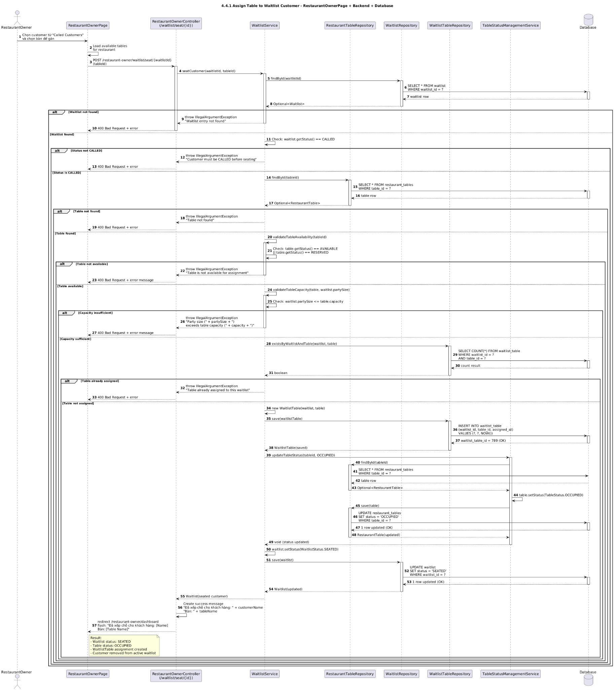

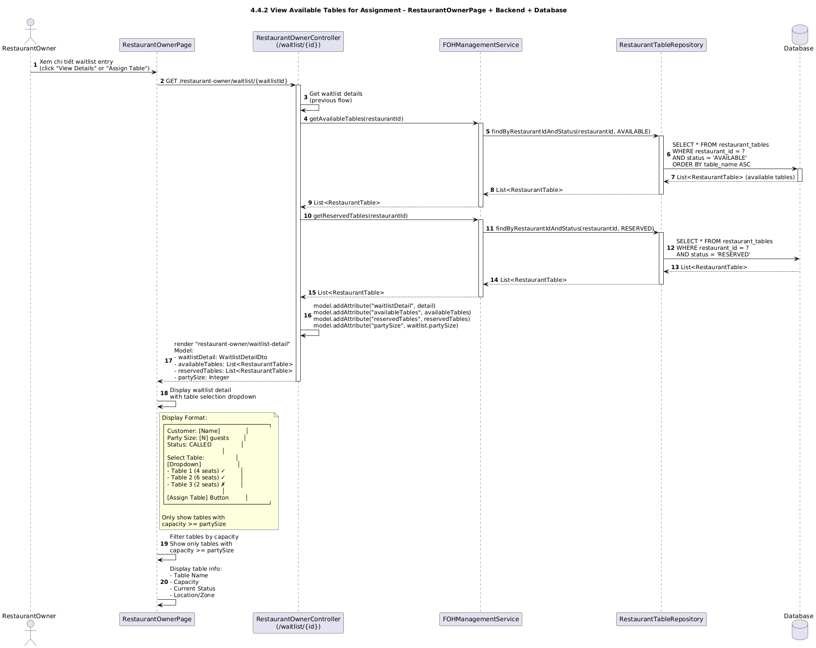

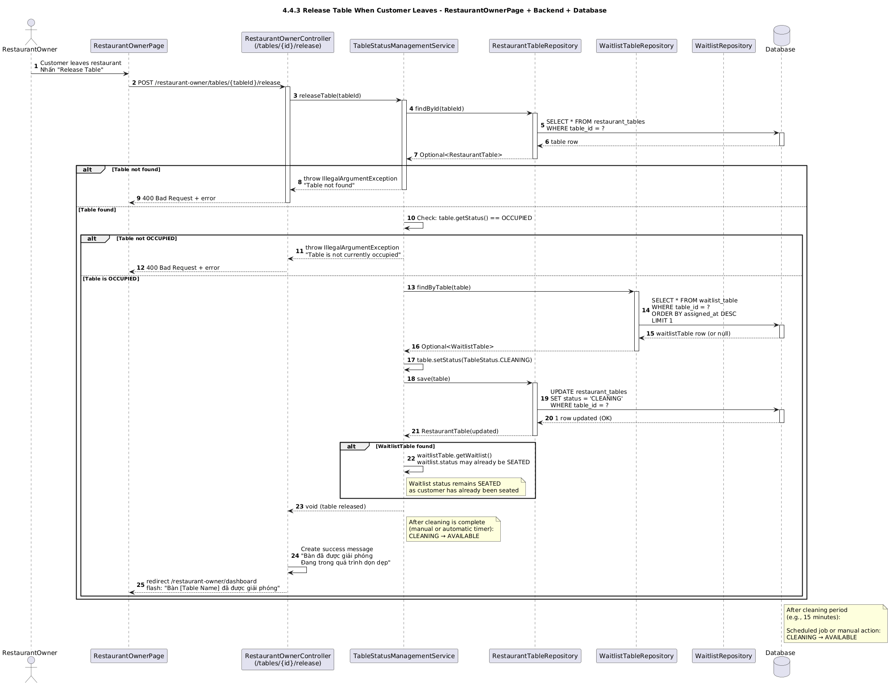

### d. Database Queries

Check active seating on table:

SELECT id, restaurant_id, table_id, source, source_id, party_size, started_at, ended_at FROM seating WHERE table_id = ? AND ended_at IS NULL LIMIT 1;

Open a seating:

INSERT INTO seating (restaurant_id, table_id, source, source_id, party_size, note, started_at) VALUES (?, ?, ?, ?, ?, ?, NOW());

Close active seating:

UPDATE seating SET ended_at = NOW() WHERE table_id = ? AND ended_at IS NULL;

Load table (for capacity/status):

SELECT id, restaurant_id, capacity, status FROM restaurant_table WHERE id = ? LIMIT 1;

Capacity assertion (app-level check); optional guard in SQL:

SELECT capacity FROM restaurant_table WHERE id = ?;

Mark booking seated:

UPDATE bookings SET status = 'SEATED', updated_at = NOW() WHERE id = ?;

Mark waitlist served:

UPDATE waitlist SET status = 'SERVED', updated_at = NOW() WHERE id = ?;

# 5. Payment & Withdrawal

## 5.1 Create Payment (PayOS)

### a. Class Diagram

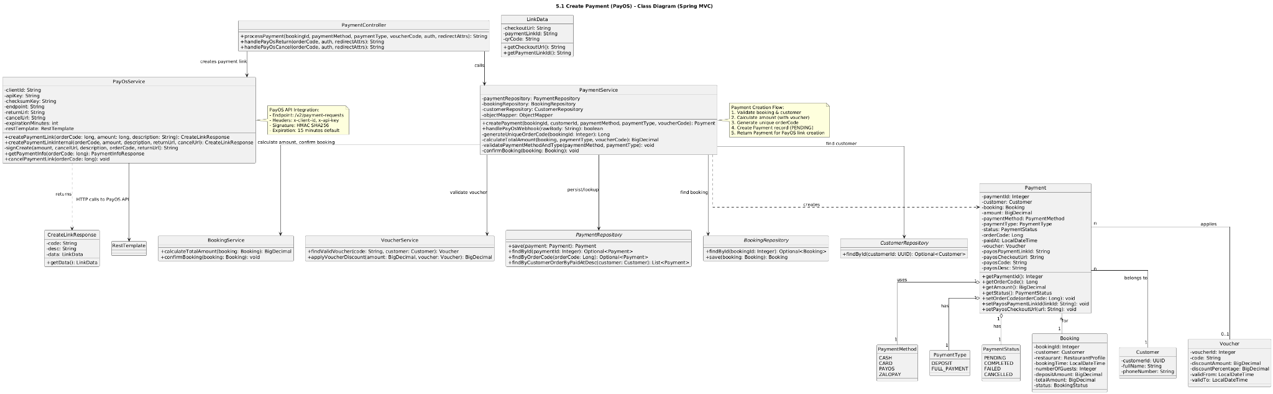

### b. Class Specifications

| PaymentController | | |
| --- | --- | --- |
| **No** | **Method** | **Description** |
| 1 | createPayment(form, bindingResult, redirectAttrs) | Validates input; calls PaymentService.createPayment; redirects to external checkoutUrl. |
| 2 | checkoutSuccess(orderCode, signature, model) | Verifies signature; calls markSuccess; renders success page. |
| 3 | checkoutCancel(orderCode, model) | Calls markCancelled; renders cancel page. |

| PaymentService | | |
| --- | --- | --- |
| **No** | **Method** | **Description** |
| 1 | createPayment(form) | Creates Payment with PENDING; builds PayOS request with signature; calls PayOSClient; stores checkoutUrl; returns it. |
| 2 | markSuccess(orderCode) | Loads payment by orderCode; sets status=SUCCESS; persists. |
| 3 | markCancelled(orderCode) | Sets status=CANCELLED for that orderCode. |
| PayOSClient | | |
| **No** | **Method** | **Description** |
| 1 | createPayment(req) | Calls PayOS API (POST /payments) with credentials and signature; returns checkoutUrl and orderCode. |
| PayOSSignatureGenerator | | |
| **No** | **Method** | **Description** |
| 1 | sign(params) | HMAC/Checksum per PayOS spec using checksumKey. |
| 2 | verify(params, signature) | Validates callback signature. |
| PaymentRepository | | |
| **No** | **Method** | **Description** |
| 1 | save(p) | Persists payment. |
| 2 | findByOrderCode(orderCode) | Loads payment for callbacks/redirects. |
| 3 | findByOrderId(orderId) | Prevent duplicate payments per order if needed. |
| 4 | updateStatusByOrderCode(orderCode, status) | Updates status. |
| Payment (Entity) | | |
| **Field** | **Type** | **Notes** |
| orderCode | String | Unique per provider session. |
| status | PaymentStatus | PENDING → SUCCESS/CANCELLED/FAILED. |
| provider | String | “PAYOS”. |
| checkoutUrl | String | Redirect target. |

### c. Sequence Diagram(s)

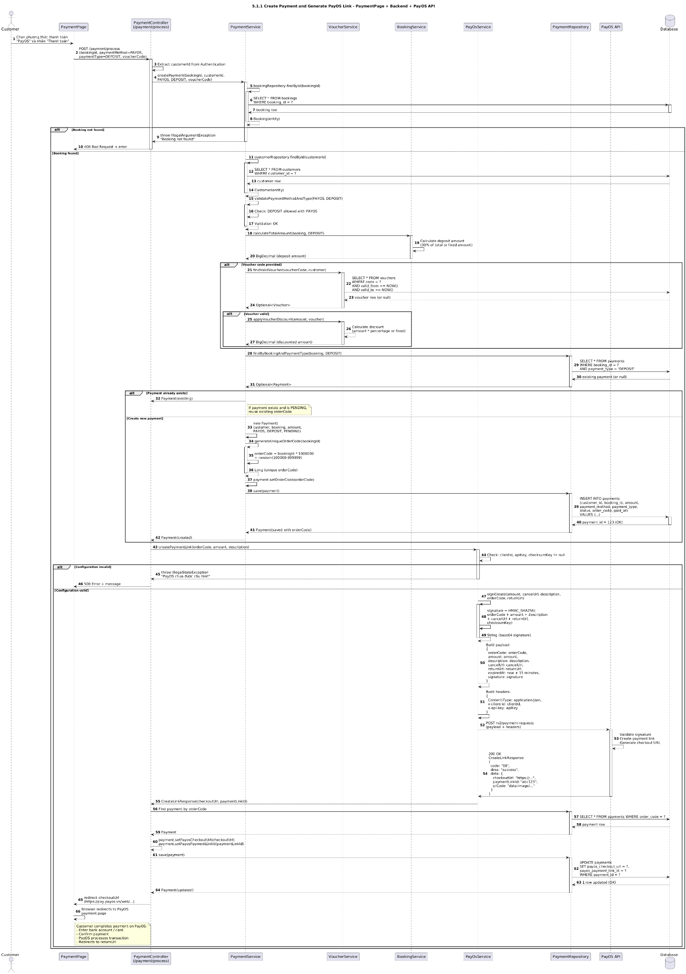

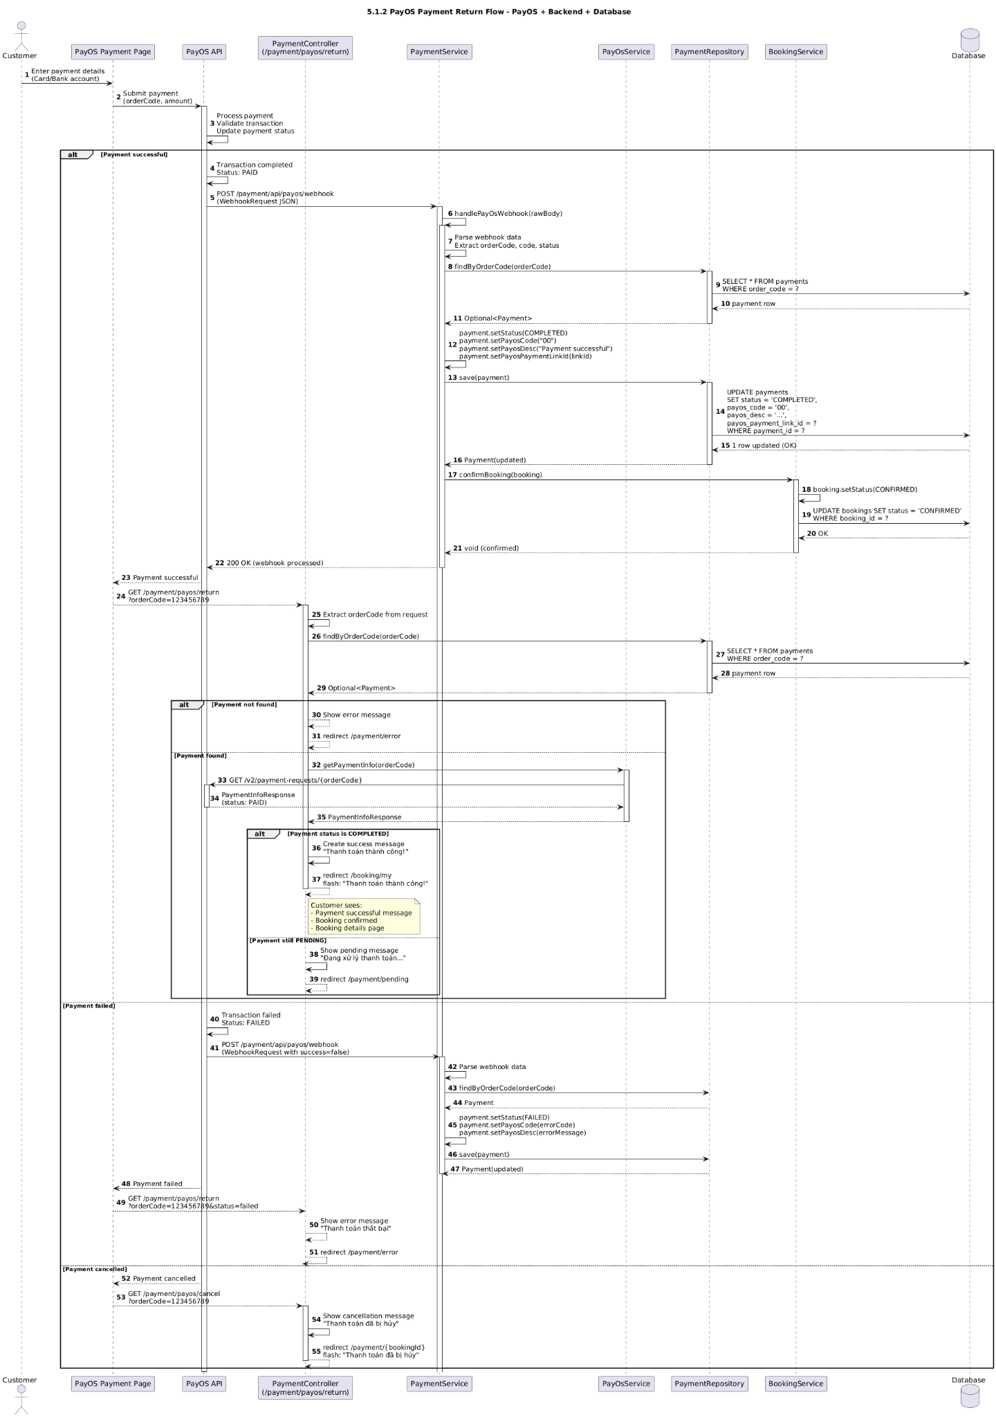

### d. Database Queries

d) Database Queries (copyable text) - Prevent duplicate payment for same order (optional): - SELECT 1 FROM payments WHERE order_id = ? AND status IN ('PENDING','SUCCESS') LIMIT 1;

- Insert new payment (PENDING): - INSERT INTO payments (order_id, order_code, amount, currency, status, provider, description, checkout_url, created_at, updated_at) VALUES (?, ?, ?, 'VND', 'PENDING', 'PAYOS', ?, ?, NOW(), NOW());

- Find by orderCode: - SELECT id, order_id, order_code, amount, currency, status, provider, description, checkout_url FROM payments WHERE order_code = ? LIMIT 1;

- Update status to SUCCESS: - UPDATE payments SET status = 'SUCCESS', updated_at = NOW() WHERE order_code = ?; - Update status to CANCELLED:

- UPDATE payments SET status = 'CANCELLED', updated_at = NOW() WHERE order_code = ?;

## 5.2 Payment Callback/Webhook

### a. Class Diagram

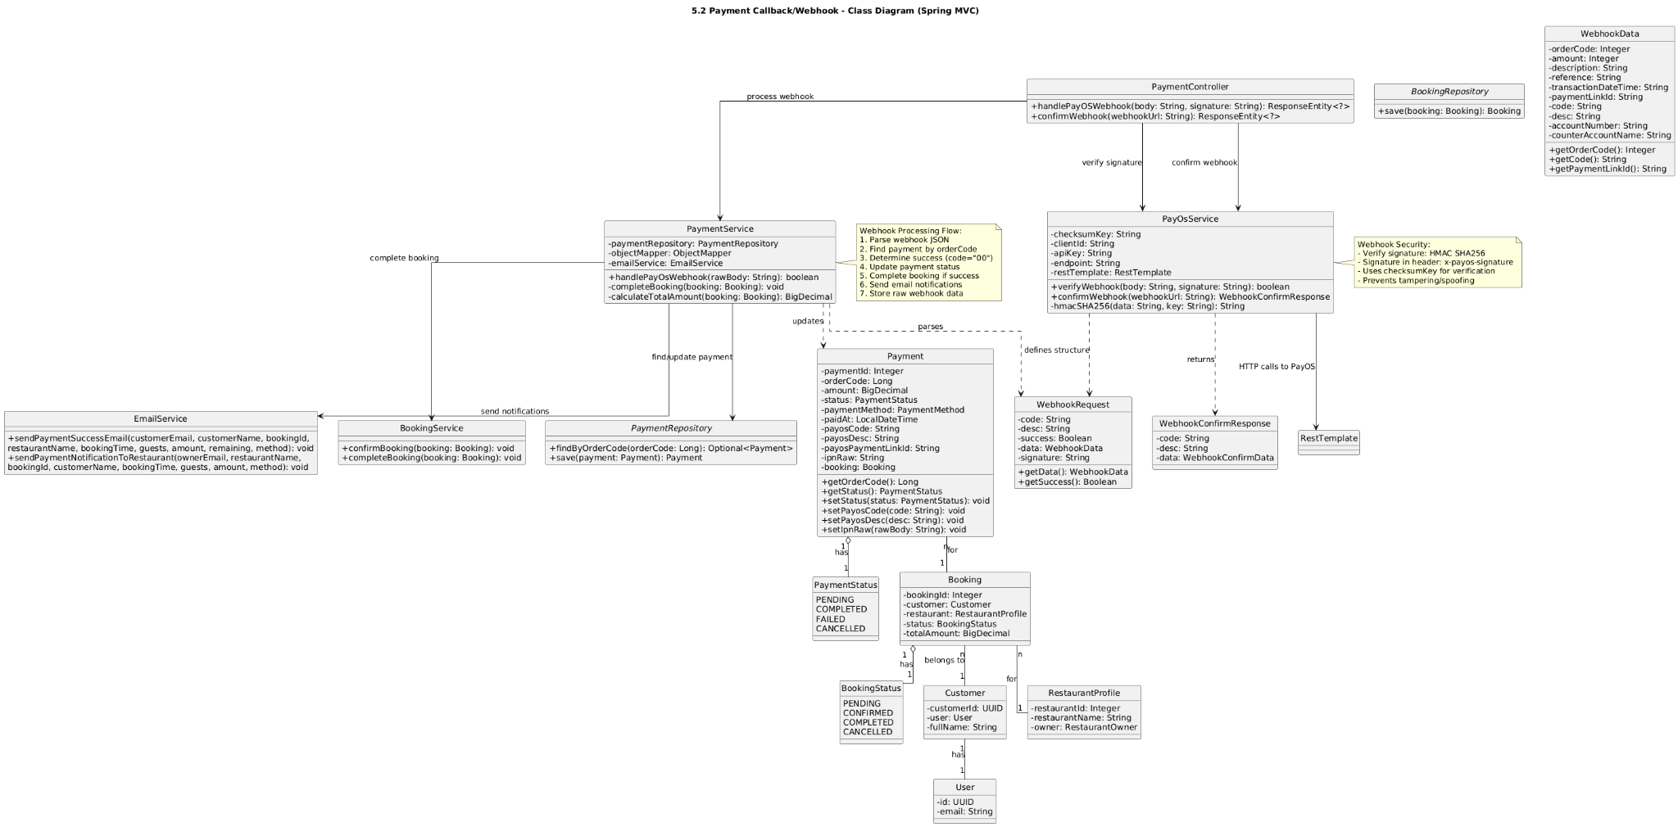

### b. Class Specifications

| PayOSWebhookController | | |
| --- | --- | --- |
| **No** | **Method** | **Description** |
| 1 | handleCallback(payload, signature) | Receives PayOS webhook POST; delegates to service; returns 200/400 based on verification and processing. |
| PaymentWebhookService | | |
| **No** | **Method** | **Description** |
| 1 | process(payload, signature) | Verifies signature; routes by payload.status to markSuccess/markCancelled/markFailed; appends audit always; idempotent (ignore if already terminal). |
| PayOSWebhookPayload (DTO) | | |
| **Field** | **Type** | **Description** |
| event | String | PayOS event key (e.g., payment.success). |
| orderCode | String | Merchant order code. |
| amount | Long | Amount in smallest unit. |
| transactionId | String | Provider transaction id. |
| status | String | SUCCESS/FAILED/CANCELLED. |
| timestamp | Long | Epoch ms. |
| extraData | String | Optional extra data. |
| PaymentService (used by webhook) | | |
| **No** | **Method** | **Description** |
| 1 | markSuccess(orderCode) | Set payment to SUCCESS if not terminal. |
| 2 | markFailed(orderCode) | Set payment to FAILED if not terminal. |
| 3 | markCancelled(orderCode) | Set payment to CANCELLED if not terminal. |
| 4 | appendAudit(orderCode, event, raw) | Persist audit row with raw payload. |
| PaymentRepository / PaymentAuditRepository | | |
| **Repo** | **Method** | **Description** |
| PaymentRepository | findByOrderCode / updateStatusByOrderCode | Load and update status atomically. |
| PaymentAuditRepository | save | Store webhook event payload for traceability. |

### c. Sequence Diagram(s)

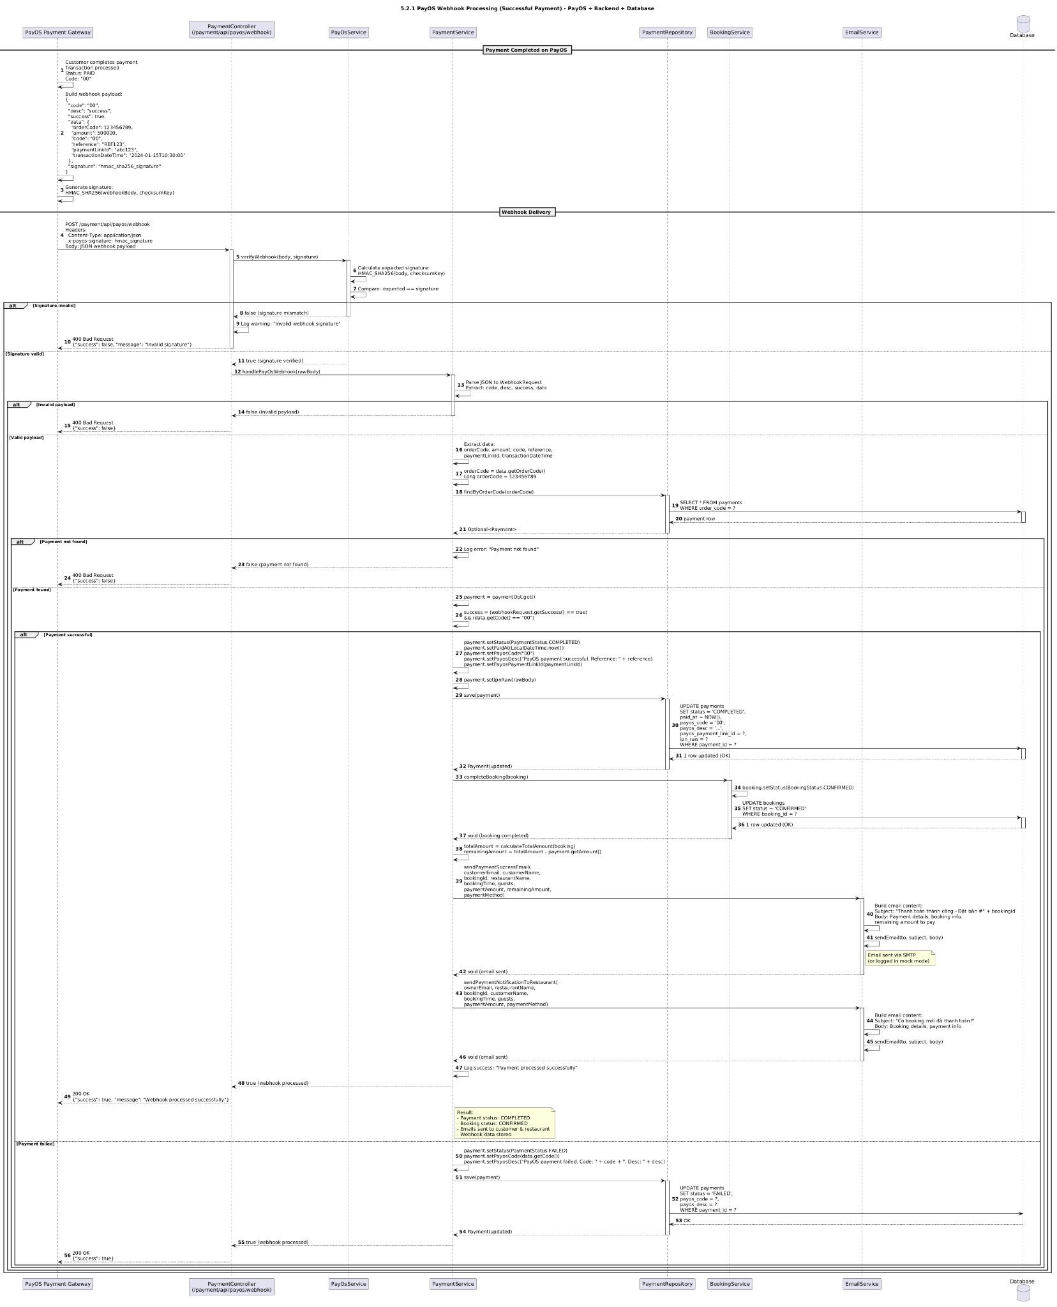

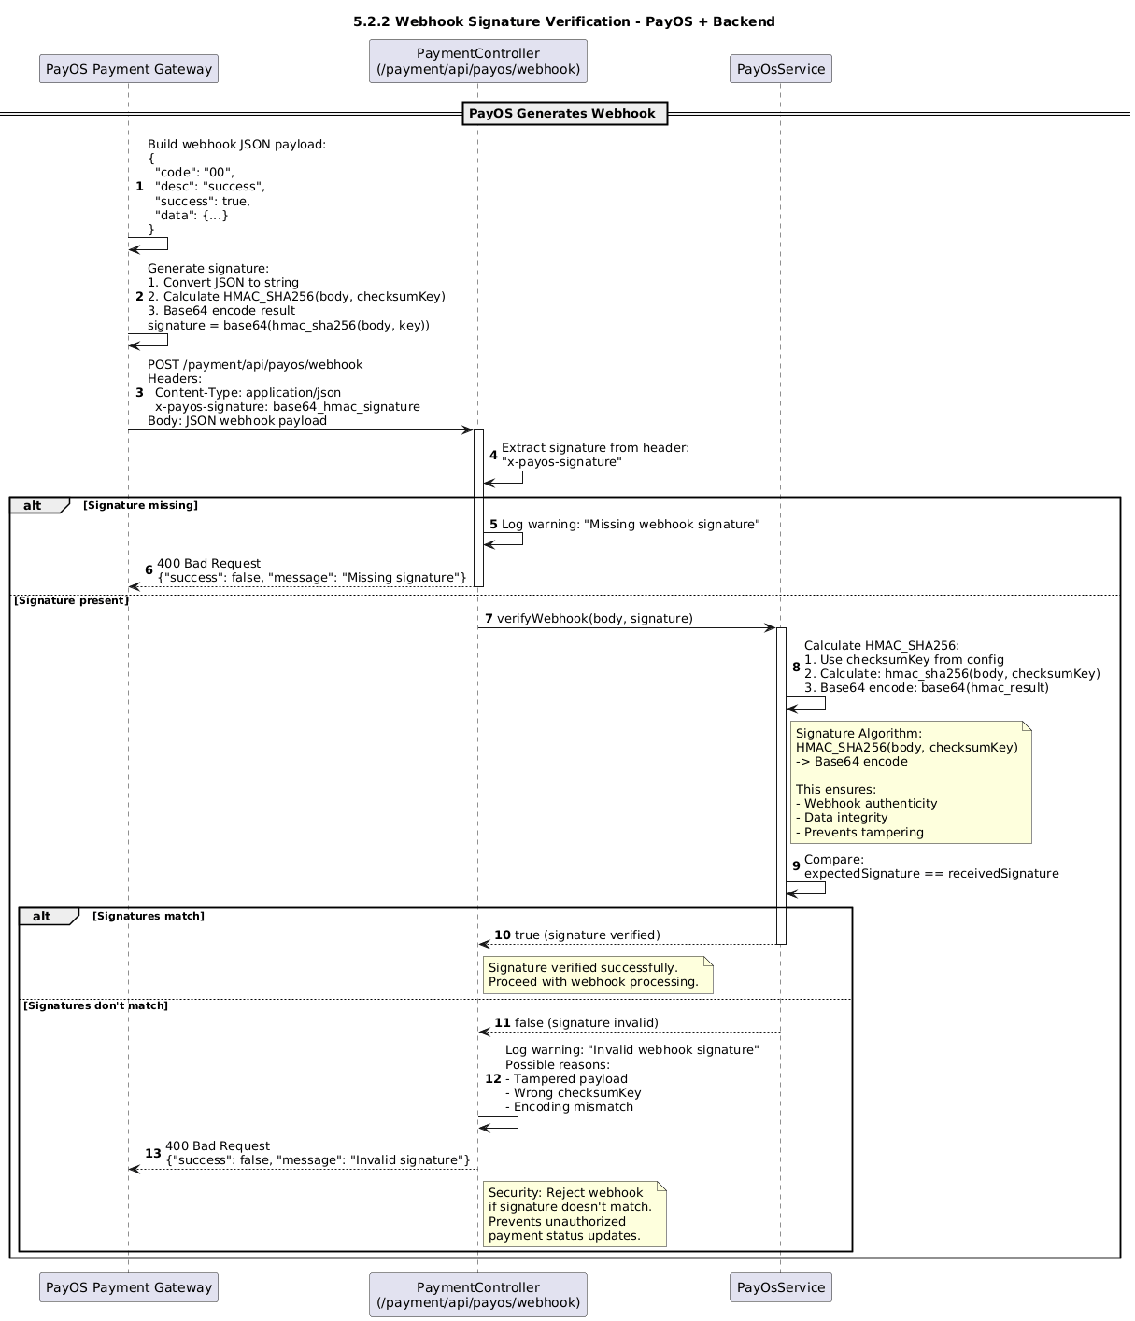

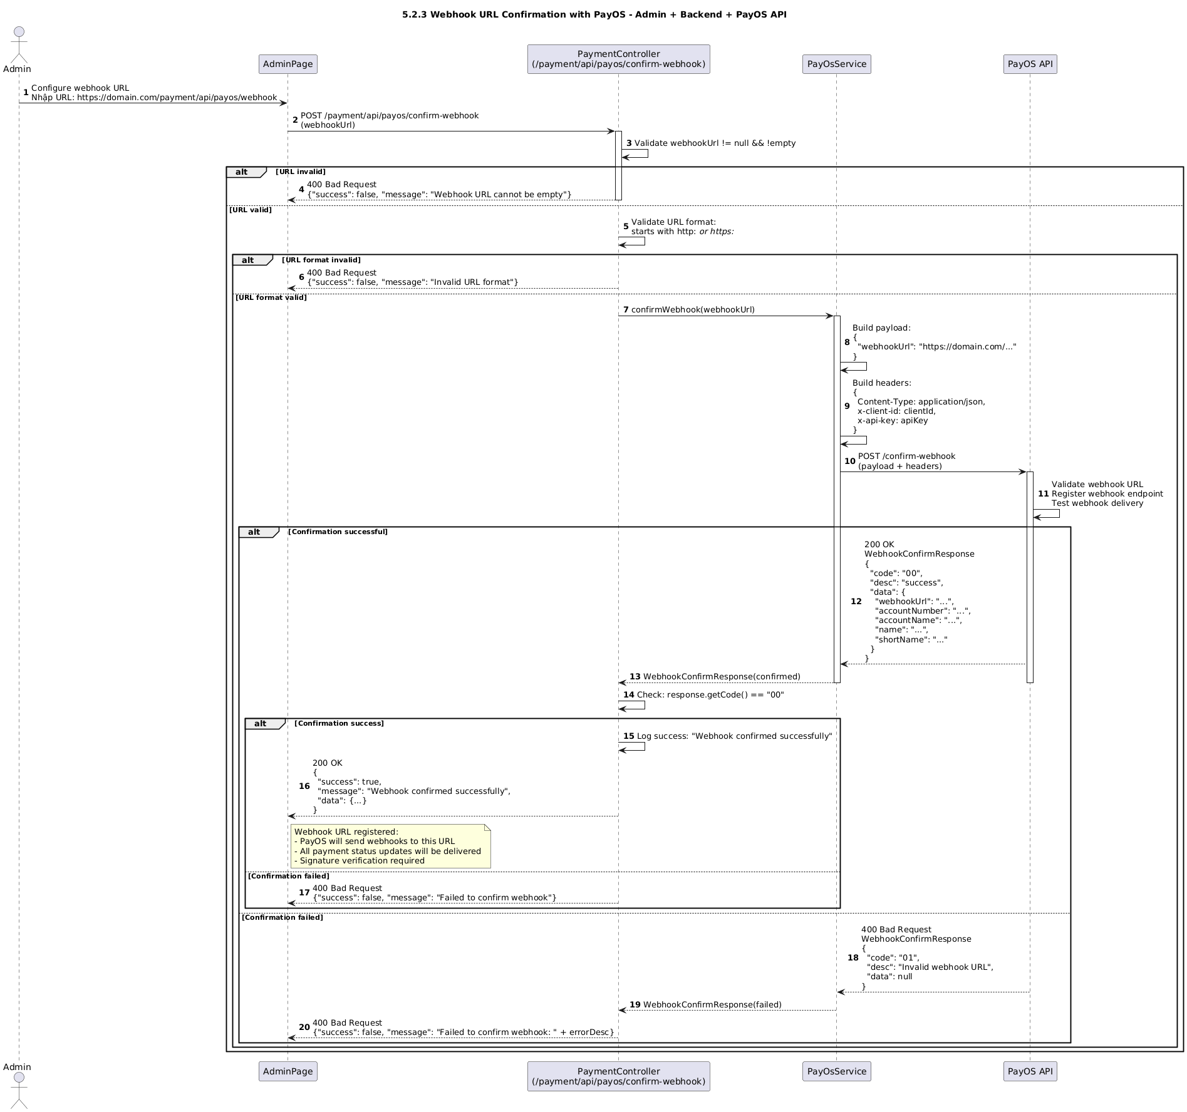

### d. Database Queries

Load payment by orderCode (optional idempotency read):

SELECT id, order_code, amount, status, provider FROM payments WHERE order_code = ? LIMIT 1;

Update status to SUCCESS (idempotent update):

UPDATE payments SET status = 'SUCCESS', updated_at = NOW() WHERE order_code = ? AND status IN ('PENDING','FAILED','CANCELLED');

Update status to CANCELLED:

UPDATE payments SET status = 'CANCELLED', updated_at = NOW() WHERE order_code = ? AND status IN ('PENDING','FAILED');

Update status to FAILED:

UPDATE payments SET status = 'FAILED', updated_at = NOW() WHERE order_code = ? AND status = 'PENDING';

Insert audit row:

INSERT INTO payment_audit (order_code, event, payload, created_at) VALUES (?, ?, ?, NOW());

## 5.3 Refund Handling

### a. Class Diagram

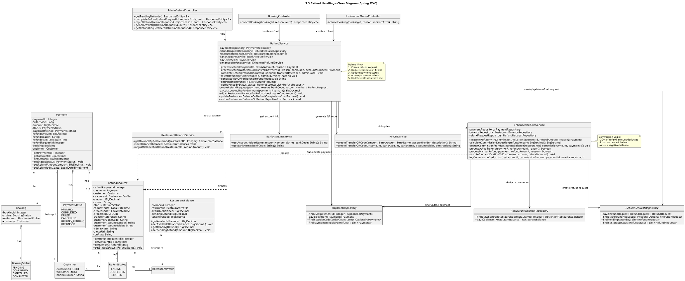

### b. Class Specifications

| RefundController | | |
| --- | --- | --- |
| **No** | **Method** | **Description** |
| 1 | requestRefund(form, bindingResult, redirectAttrs) | Validates; delegates to createRequest; redirects with result. |
| 2 | approve(id, redirectAttrs) | Approves and triggers provider refund; redirects with message. |
| 3 | reject(id, reason, redirectAttrs) | Marks request REJECTED with note; redirects. |
| 4 | detail(id, model) | Shows refund request details. |

| RefundRequestForm (DTO) | | | |
| --- | --- | --- | --- |
| **No** | **Field** | **Type** | **Description** |
| 1 | paymentId | Long | Payment to refund. |
| 2 | amount | BigDecimal | Amount to refund (<= captured amount - already refunded). |
| 3 | reason | String | Reason for refund. |

| RefundService | | |
| --- | --- | --- |
| **No** | **Method** | **Description** |
| 1 | createRequest(form) | Loads payment; validates refundable; creates PENDING RefundRequest. |
| 2 | approve(id) | Loads request; calls PayOSClient.createRefund; on success sets APPROVED, stores providerRefundId; calls PaymentService.markRefunded and appendAudit. |
| 3 | reject(id, reason) | Sets status=REJECTED with note. |
| PayOSClient | | |
| **No** | **Method** | **Description** |
| 1 | createRefund(orderCode, amount, reason) | Calls PayOS refund API with signed params; returns providerRefundId/status. |
| PaymentService (refund-related) | | |
| **No** | **Method** | **Description** |
| 1 | getById(paymentId) | Finds payment or throws. |
| 2 | markRefunded(orderCode, amount) | Increments refundedAmount; optionally set status if full refund. |
| 3 | appendAudit(orderCode, event, payload) | Stores audit record. |
| RefundRequestRepository | | |
| **No** | **Method** | **Description** |
| 1 | save(r) | Persist new or updated refund request. |
| 2 | findById(id) | Load refund request. |
| 3 | updateStatusById(id, status, note) | Update request status and note. |

### c. Sequence Diagram(s)

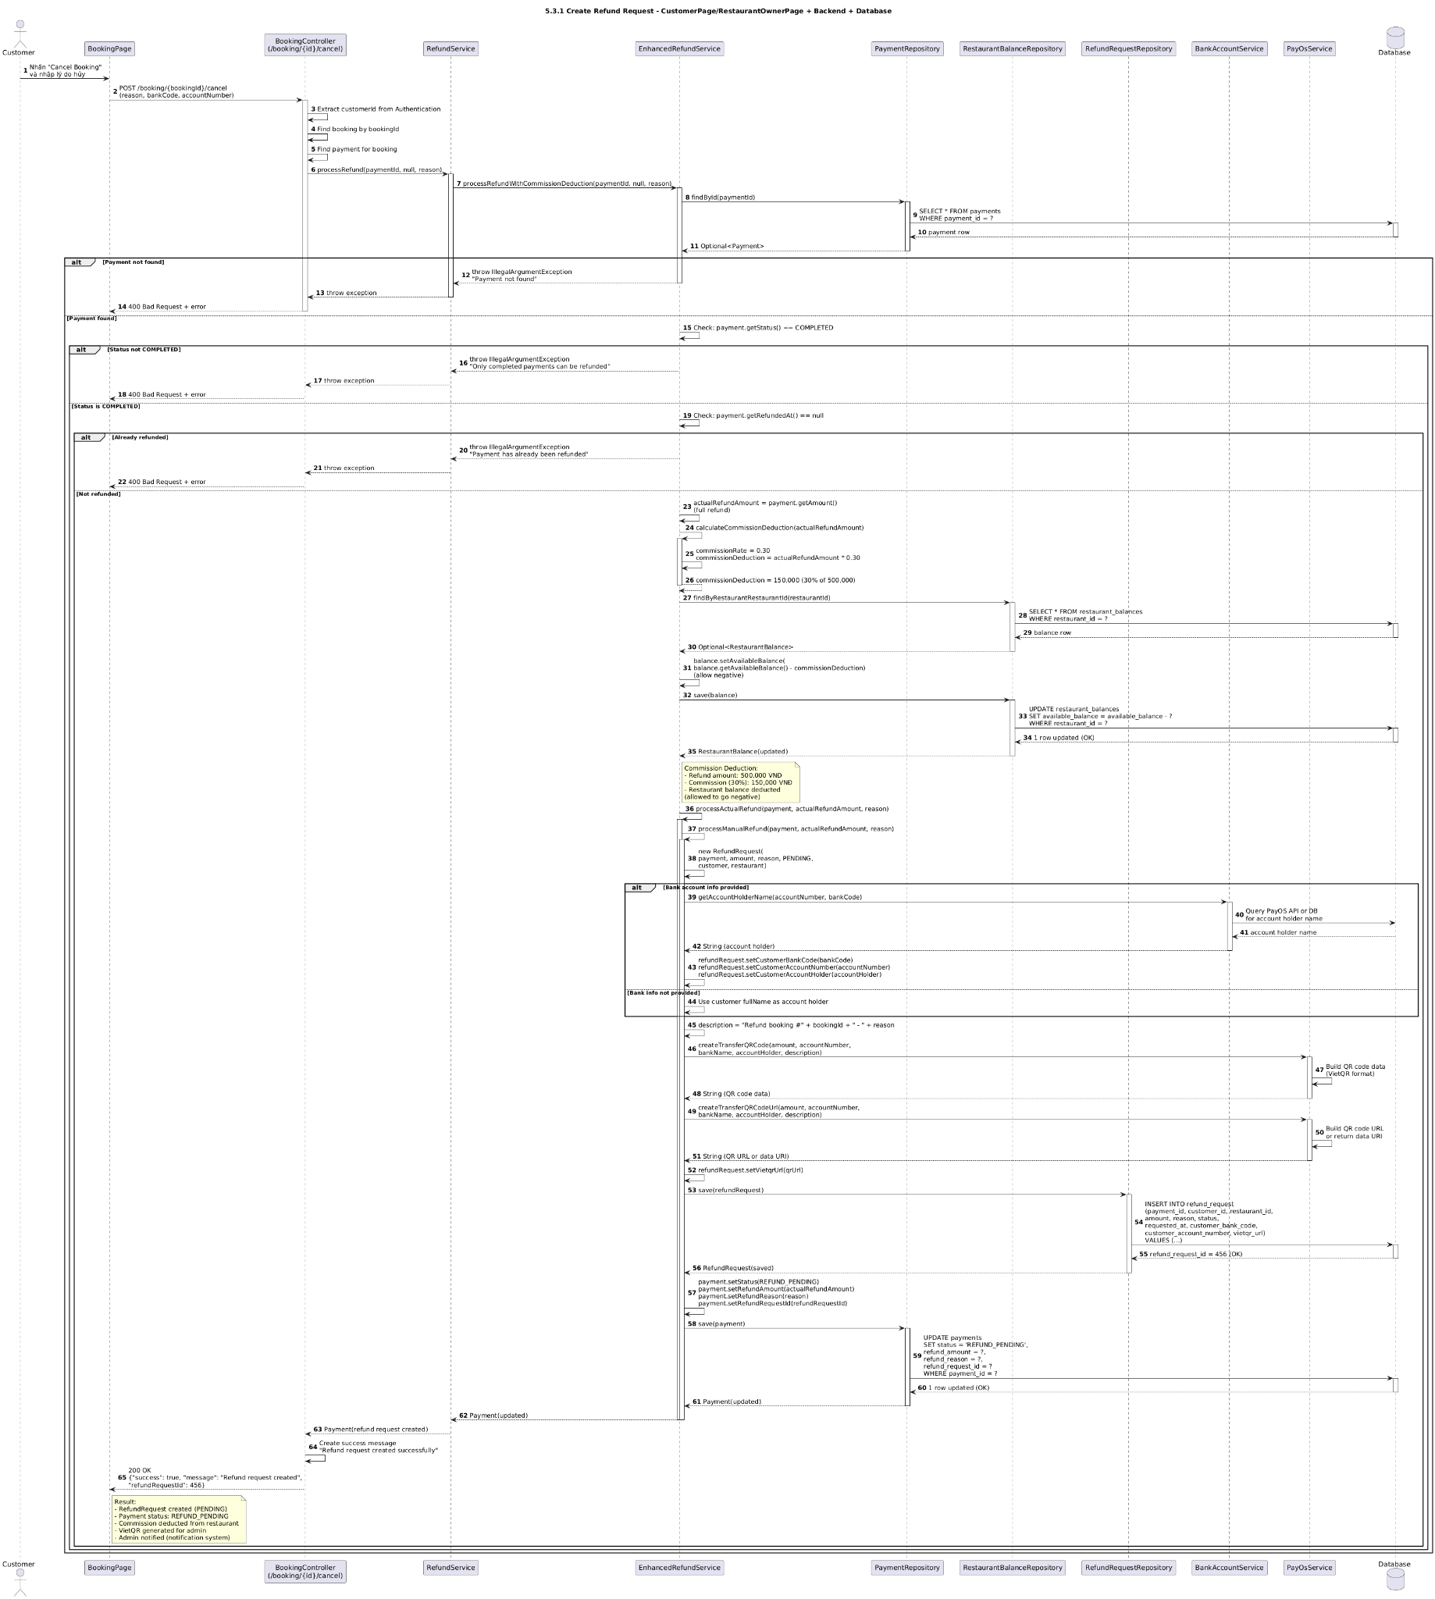

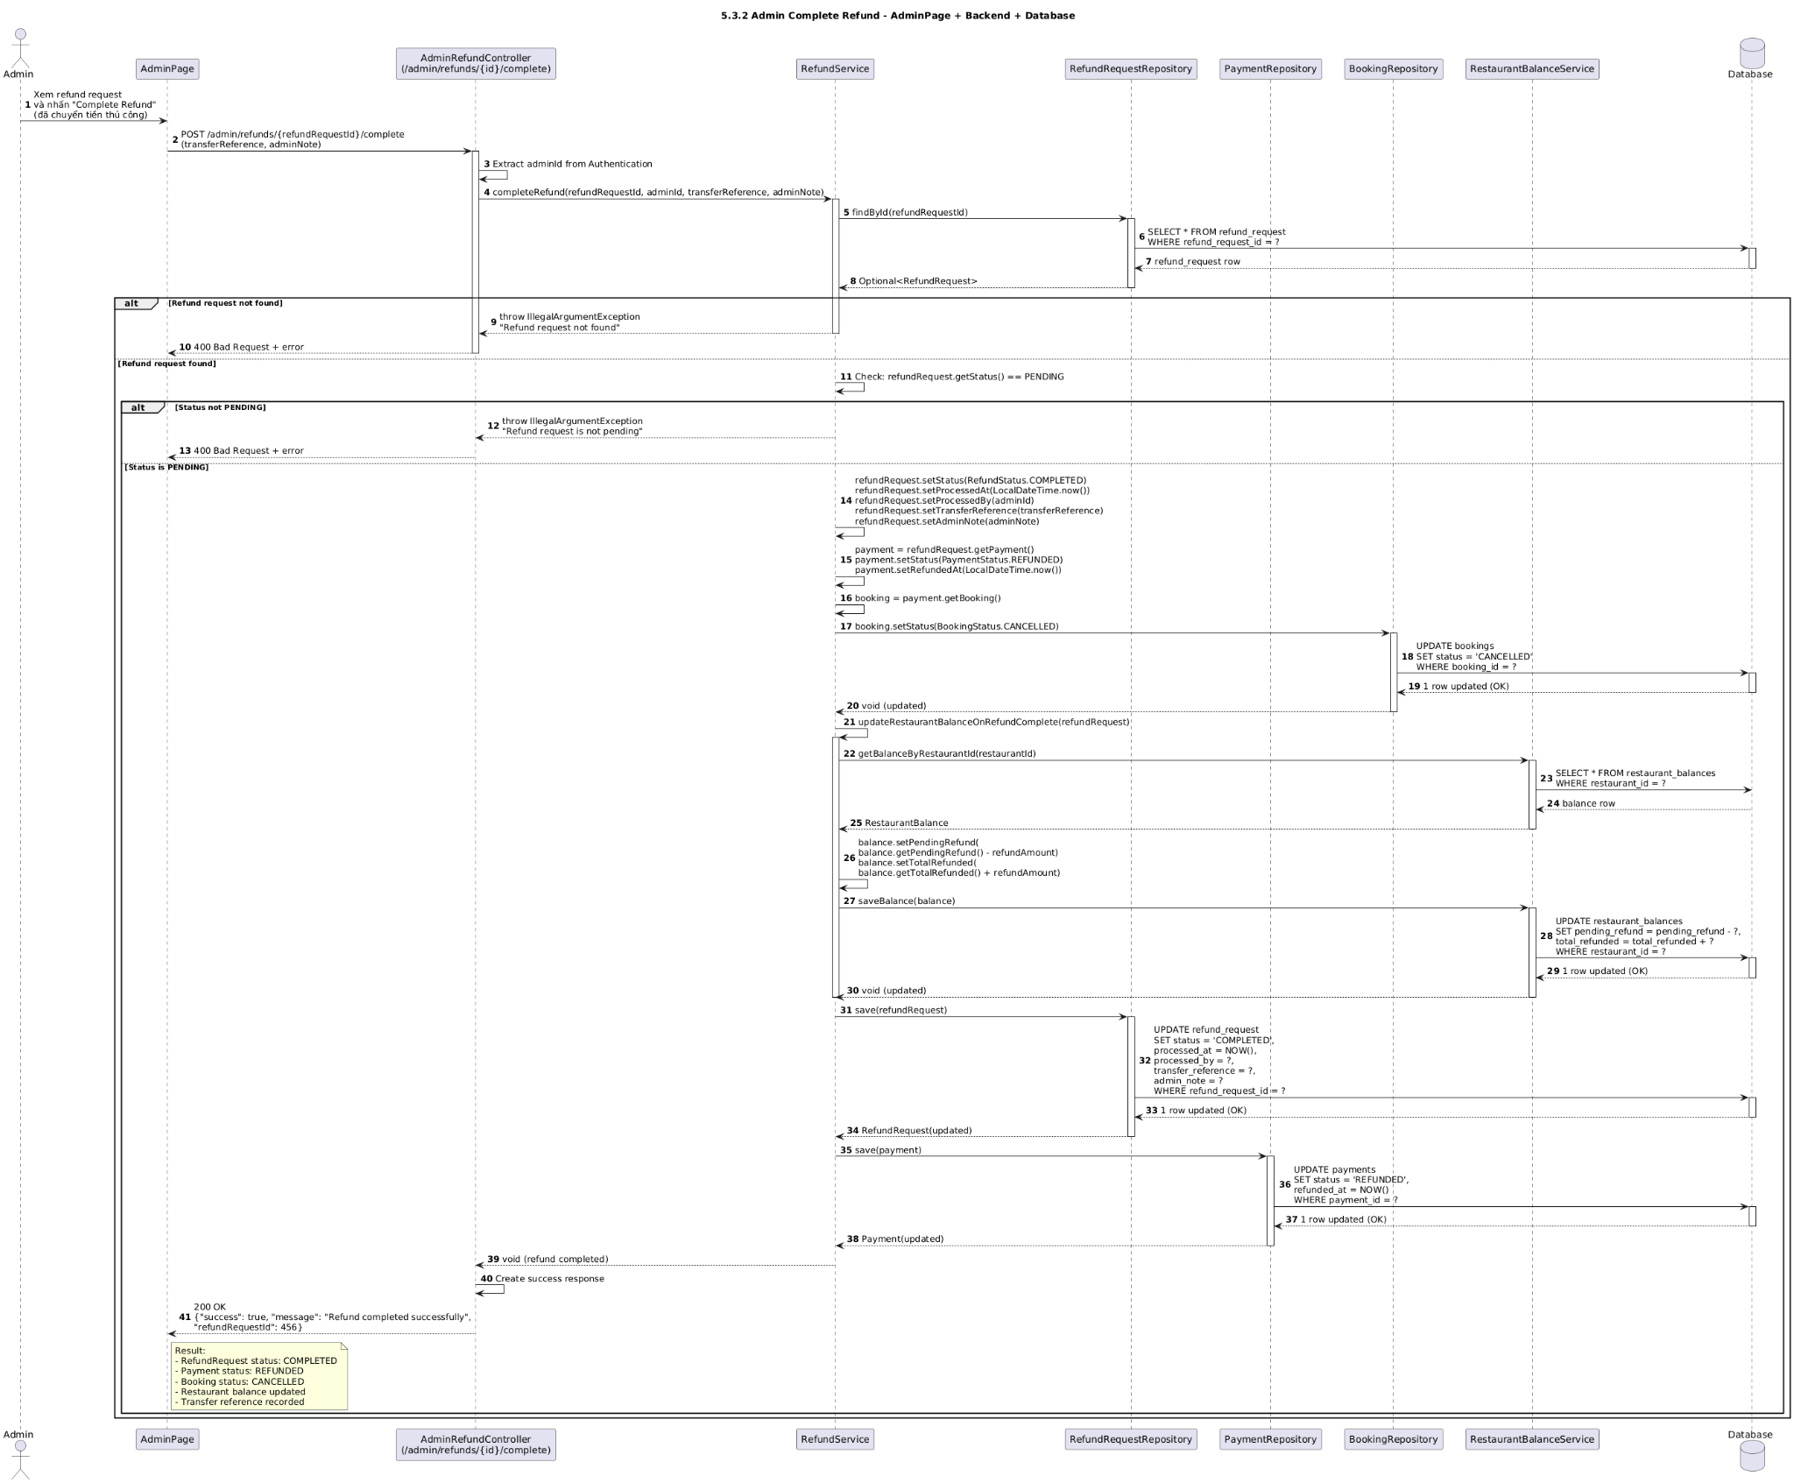

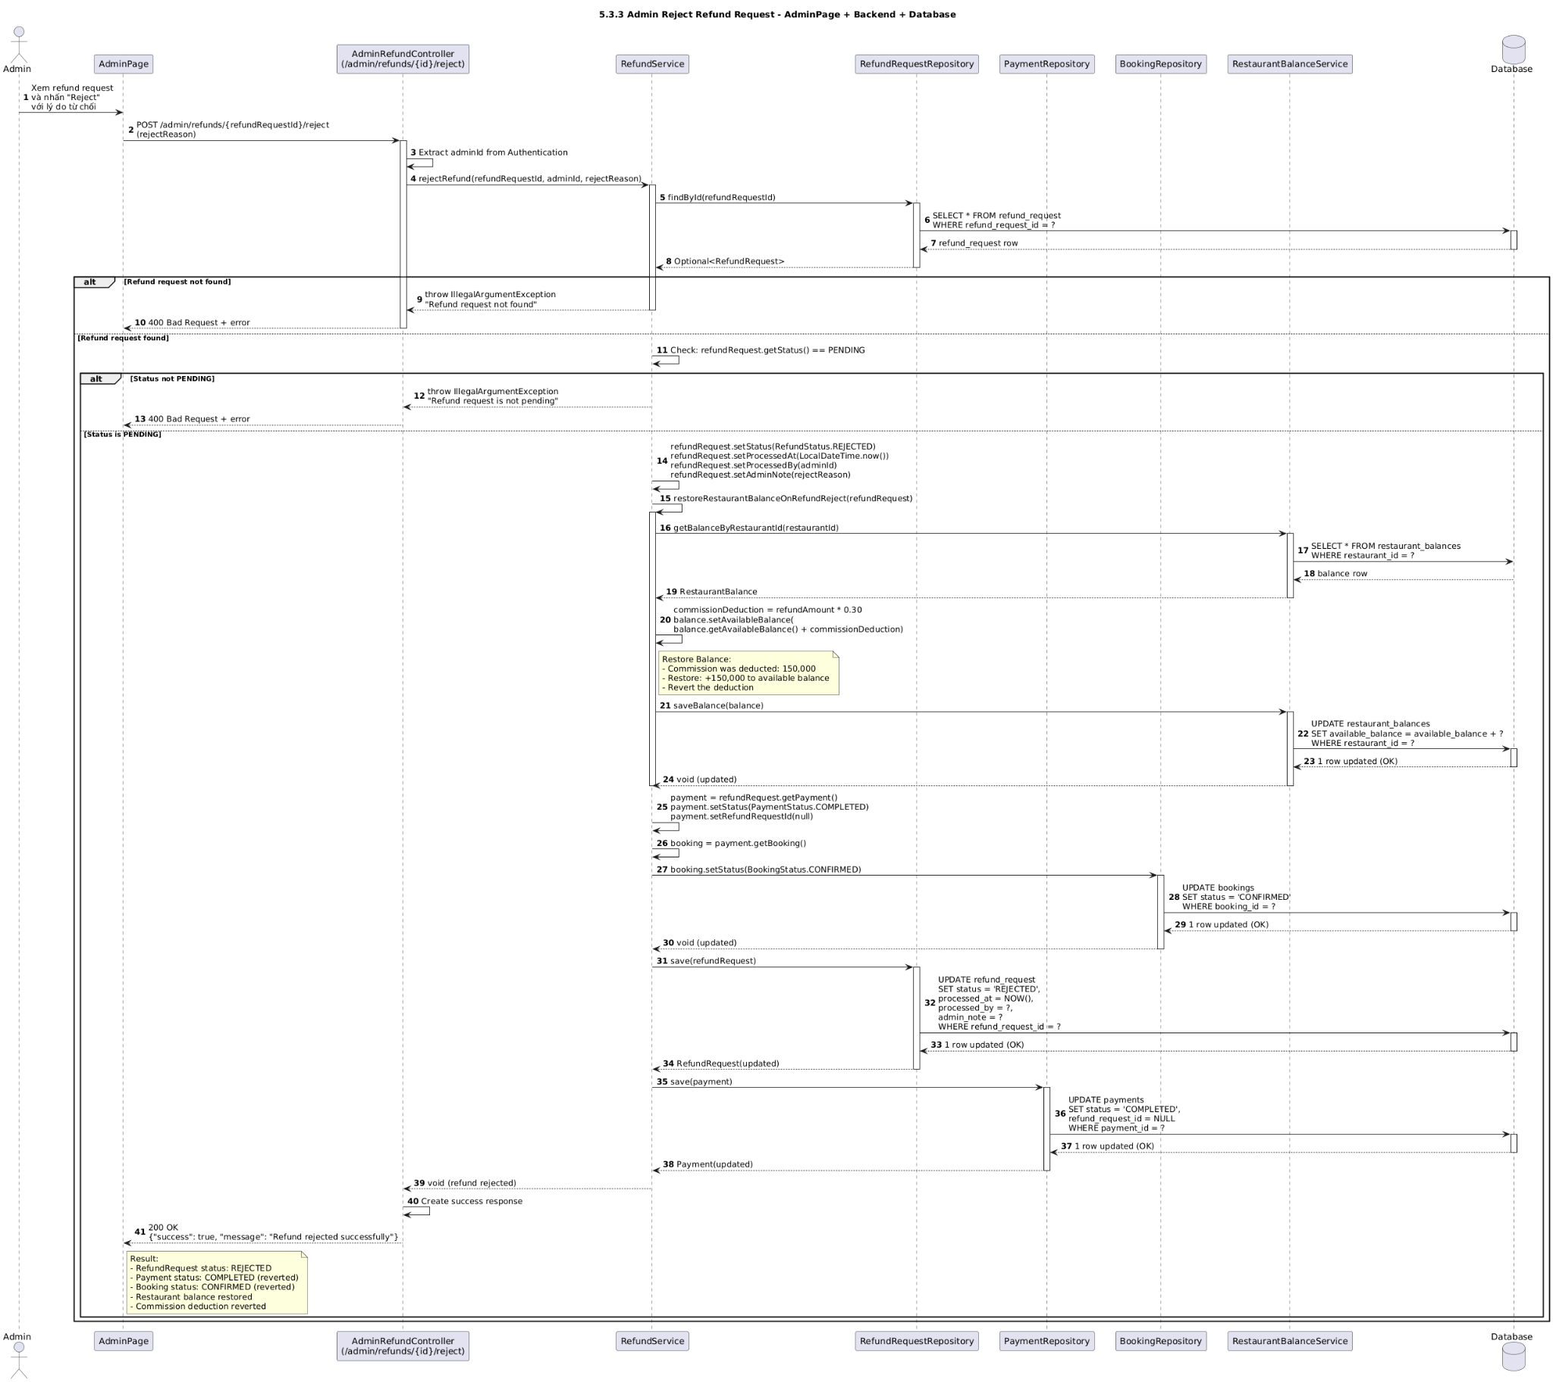

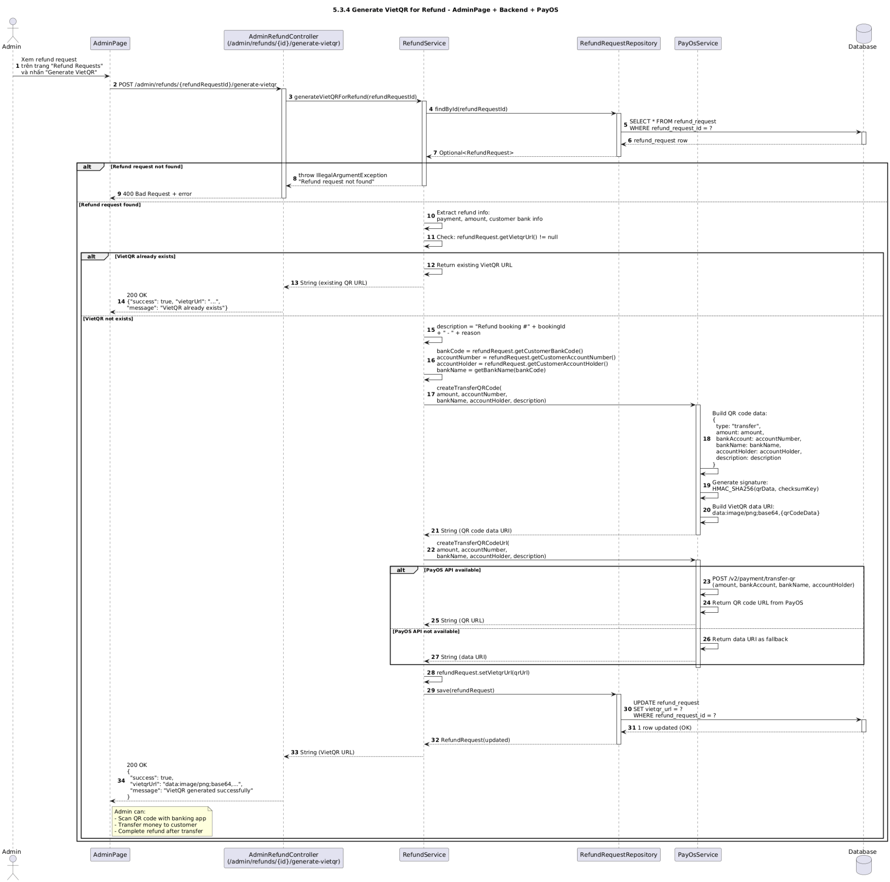

### d. Database Queries

Load payment:

SELECT id, order_id, order_code, amount, status, refunded_amount FROM payments WHERE id = ? LIMIT 1;

Create refund request (PENDING):

INSERT INTO refund_request (payment_id, order_code, amount, reason, status, created_at, updated_at) VALUES (?, ?, ?, ?, 'PENDING', NOW(), NOW());

Approve refund (after provider success):

UPDATE refund_request SET status = 'APPROVED', provider_refund_id = ?, updated_at = NOW() WHERE id = ? AND status = 'PENDING';

Reject refund:

UPDATE refund_request SET status = 'REJECTED', note = ?, updated_at = NOW() WHERE id = ? AND status = 'PENDING';

Increase refunded amount (atomic):

UPDATE payments SET refunded_amount = COALESCE(refunded_amount,0) + ?, updated_at = NOW() WHERE order_code = ?;

Optionally mark fully refunded:

UPDATE payments SET status = 'CANCELLED', updated_at = NOW() WHERE order_code = ? AND (COALESCE(refunded_amount,0) >= amount);

Insert payment audit:

INSERT INTO payment_audit (order_code, event, payload, created_at) VALUES (?, 'refund', ?, NOW());

## 5.4 Withdrawal Request

### a. Class Diagram

### b. Class Specifications

| WithdrawalController | | |
| --- | --- | --- |
| **No** | **Method** | **Description** |
| 1 | create(form, bindingResult, redirectAttrs) | Validates; delegates creation; flashes success/error. |
| 2 | approve(id, redirectAttrs) | Approves request: triggers payout and balance debit; flashes result. |
| 3 | reject(id, reason, redirectAttrs) | Marks request REJECTED with note; flashes result. |
| 4 | list(restaurantId, model) | Lists withdrawal requests for a restaurant. |
| 5 | detail(id, model) | Shows request detail. |
| WithdrawalForm (DTO) | | |
| **Field** | **Type** | **Description** |
| restaurantId | Long | Who withdraws. |
| amount | BigDecimal | Must be > 0 and ≤ available balance. |
| note | String | Optional note. |
| WithdrawalService | | |
| **No** | **Method** | **Description** |
| 1 | create(form) | Checks bank account verified; checks available balance; saves WithdrawalRequest with PENDING. |
| 2 | approve(id) | Loads request & bank account; calls PayoutService.transfer; on success, debits balance and sets APPROVED with providerRef; on failure sets FAILED. |
| 3 | reject(id, reason) | Sets REJECTED with note; no payout nor balance change. |
| PayoutService | | |
| **No** | **Method** | **Description** |
| 1 | transfer(bankAccount, amount, ref) | Calls provider API to transfer; returns provider reference and status. |
| BalanceService | | |
| **No** | **Method** | **Description** |
| 1 | getAvailableBalance(restaurantId) | Reads current available balance. |
| 2 | debit(restaurantId, amount, ref) | Decreases available; increases pendingPayout (or finalize directly depending on flow). |
| 3 | credit(restaurantId, amount, ref) | Increases available (used on reject/failed rollback if needed). |
| Repositories | | |
| **Repo** | **Method** | **Description** |
| WithdrawalRequestRepository | save/find/updateStatus | Persist and update workflow status. |
| RestaurantBankAccountRepository | findByRestaurantId | Resolve payout destination. |
| RestaurantBalanceRepository | findByRestaurantIdForUpdate/save | Atomic read-modify-write of balances. |

### c. Sequence Diagram(s)

### d. Database Queries

Load verified bank account:

SELECT id, restaurant_id, bank_code, account_number, account_holder, verified FROM restaurant_bank_account WHERE restaurant_id = ? LIMIT 1;

Read available balance (with lock for update in approval path):

SELECT id, restaurant_id, available, pending_payout FROM restaurant_balance WHERE restaurant_id = ? FOR UPDATE;

Create withdrawal request (PENDING):

INSERT INTO withdrawal_request (restaurant_id, amount, reason, status, note, created_at, updated_at) VALUES (?, ?, ?, 'PENDING', ?, NOW(), NOW());

Approve (after provider success):

UPDATE withdrawal_request SET status = 'APPROVED', provider_ref = ?, updated_at = NOW() WHERE id = ? AND status = 'PENDING';

UPDATE restaurant_balance SET available = available - ?, pending_payout = pending_payout + ?, updated_at = NOW() WHERE restaurant_id = ? AND available >= ?;

Reject:

UPDATE withdrawal_request SET status = 'REJECTED', note = ?, updated_at = NOW() WHERE id = ? AND status = 'PENDING';

Mark failed (provider error):

UPDATE withdrawal_request SET status = 'FAILED', note = ?, updated_at = NOW() WHERE id = ? AND status = 'PENDING';

List requests by restaurant:

SELECT id, restaurant_id, amount, status, note, provider_ref, created_at FROM withdrawal_request WHERE restaurant_id = ? ORDER BY created_at DESC;

## 5.5 Reconciliation Scheduler

### a. Class Diagram

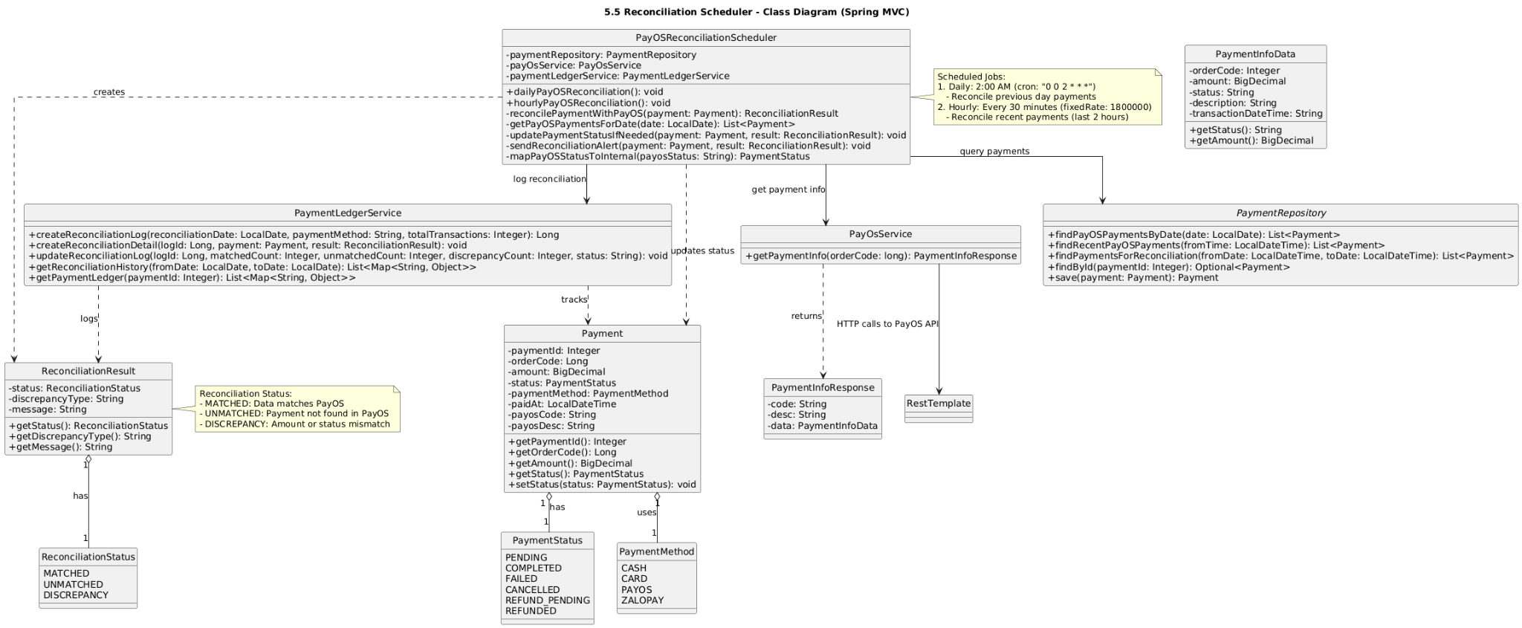

### b. Class Specifications

| PayOSReconciliationScheduler | | |
| --- | --- | --- |
| **No** | **Method** | **Description** |
| 1 | reconcilePendingPayments() | Cron-triggered; calls service to reconcile PENDING/unknown payments. |
| 2 | reconcilePendingRefunds() | Cron-triggered; reconciles PENDING refunds. |
| 3 | reconcileWithdrawals() | Cron-triggered; reconciles PENDING withdrawals/payouts. |
| ReconciliationService | | |
| **No** | **Method** | **Description** |
| 1 | reconcilePayments(since) | Batches PENDING payments; for each, calls PayOS query and marks SUCCESS/FAILED/CANCELLED; logs audit. |
| 2 | reconcileRefunds(since) | Batches PENDING refunds; queries provider; marks APPROVED/FAILED; stores provider refs. |
| 3 | reconcileWithdrawals(since) | Batches PENDING withdrawals; queries payout status; marks APPROVED/FAILED. |
| PayOSClient | | |
| **No** | **Method** | **Description** |
| 1 | queryPayment(orderCode) | Calls provider API to get latest payment status by orderCode. |
| 2 | queryRefund(providerRefundId) | Gets refund status. |
| 3 | queryPayout(providerRef) | Gets payout/withdrawal status. |

| Repositories | | |
| --- | --- | --- |
| **Repo** | **Method** | **Description** |
| PaymentRepository | findPendingSince/updateStatusByOrderCode | Slice pending payments; set status atomically. |
| RefundRequestRepository | findPendingSince/updateStatusById | Slice pending refunds; set status and providerRef. |
| WithdrawalRequestRepository | findPendingSince/updateStatusById | Slice pending withdrawals; set status and providerRef. |
| PaymentAuditRepository | save | Persist reconciliation logs. |

### c. Sequence Diagram(s)

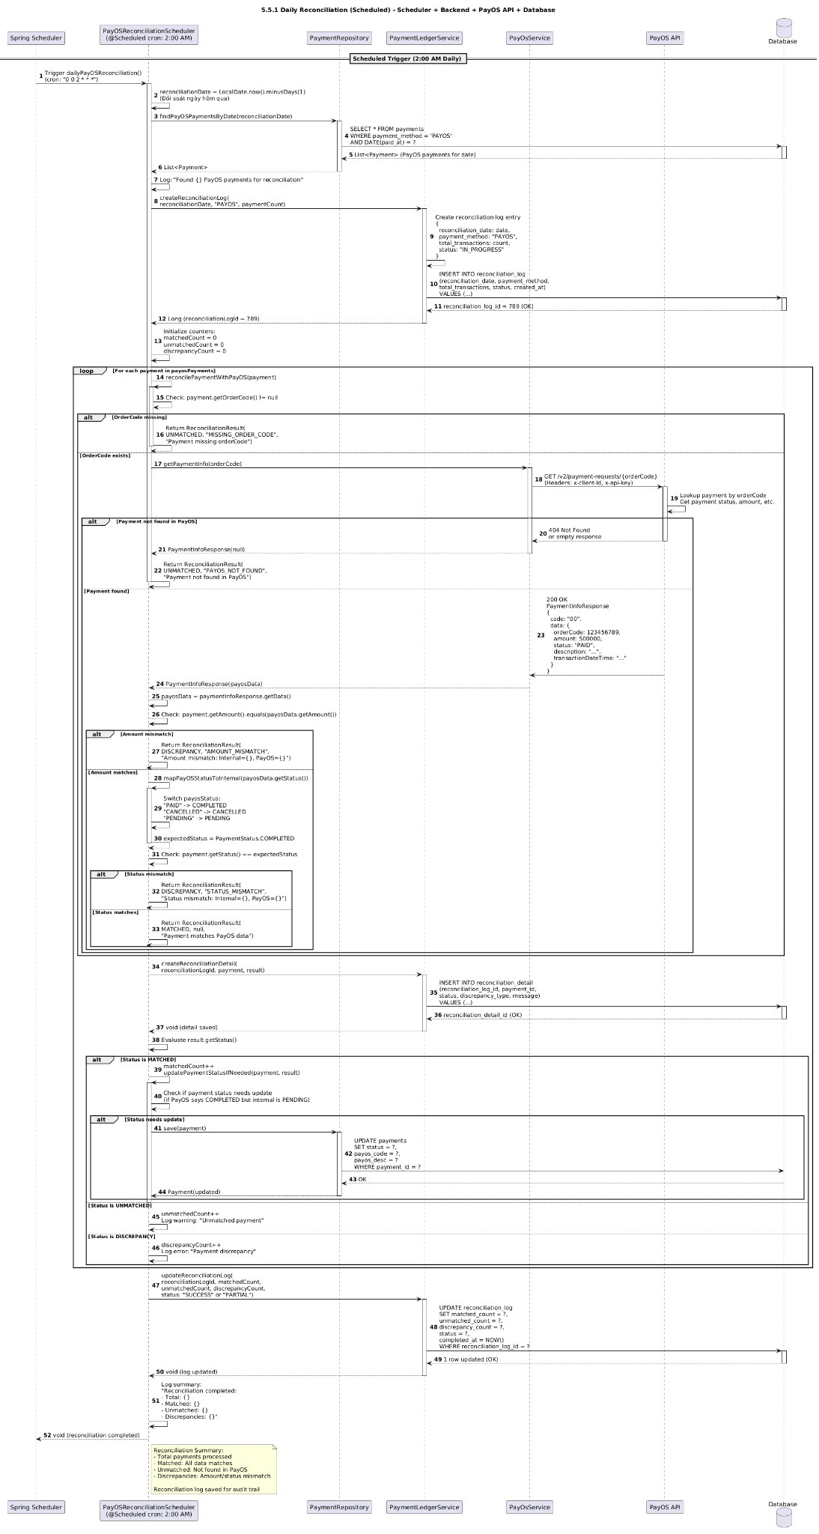

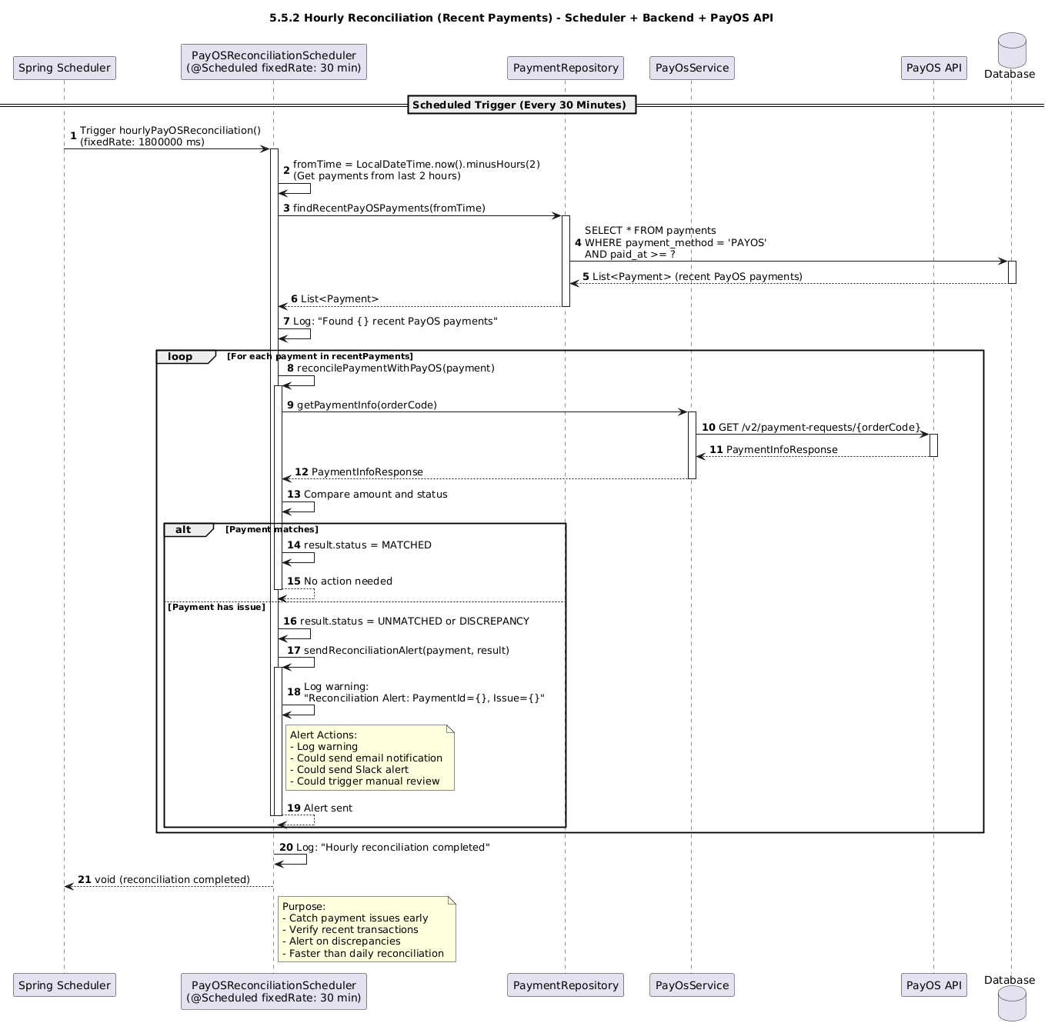

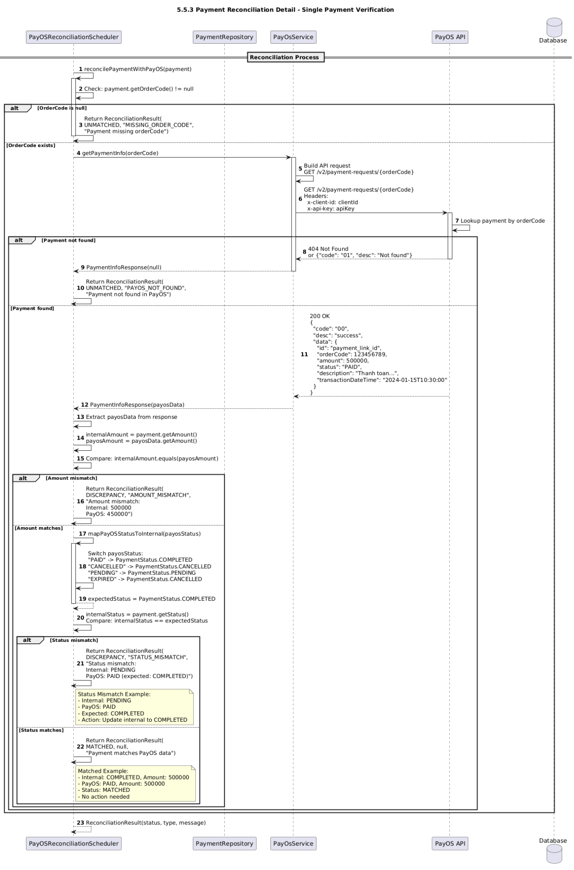

### d. Database Queries

Batch slice of pending payments:

SELECT id, order_code, status, created_at FROM payments WHERE status = 'PENDING' AND created_at >= ? ORDER BY created_at ASC LIMIT 100;

Update payment status (idempotent set):

UPDATE payments SET status = ?, updated_at = NOW() WHERE order_code = ? AND status <> ?;

Insert reconciliation audit:

INSERT INTO payment_audit (order_code, event, payload, created_at) VALUES (?, 'reconcile.payment', ?, NOW());

Batch slice of pending refunds:

SELECT id, order_code, provider_refund_id, status, created_at FROM refund_request WHERE status = 'PENDING' AND created_at >= ? ORDER BY created_at ASC LIMIT 100;

Update refund status:

UPDATE refund_request SET status = ?, provider_ref = COALESCE(?, provider_ref), updated_at = NOW() WHERE id = ? AND status = 'PENDING';

Batch slice of pending withdrawals:

SELECT id, restaurant_id, provider_ref, status, created_at FROM withdrawal_request WHERE status = 'PENDING' AND created_at >= ? ORDER BY created_at ASC LIMIT 100;

Update withdrawal status:

UPDATE withdrawal_request SET status = ?, updated_at = NOW() WHERE id = ? AND status = 'PENDING';

# 6. Notification & Chat

## 6.1 In-app Notifications

### a. Class Diagram

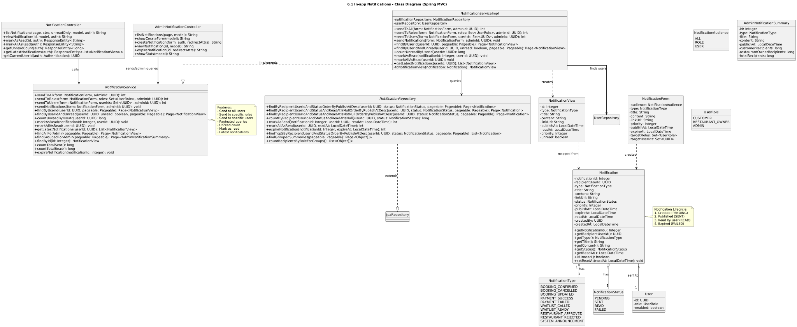

### b. Class Specifications

| NotificationController | | |
| --- | --- | --- |
| **No** | **Method** | **Description** |
| 1 | list(model) | Returns current user’s notifications (desc). |
| 2 | markRead(id) | Marks a notification as READ (ownership). |
| 3 | markAllRead() | Marks all current user notifications as READ. |
| NotificationService | | |
| **No** | **Method** | **Description** |
| 1 | listForCurrentUser() | Loads notifications by current userId, desc. |
| 2 | send(userId,type,title,body,refId) | Saves UNREAD notification, pushes WS event. |
| 3 | markRead(id) | Sets status=READ, readAt=now() for owned notification. |
| 4 | markAllRead(userId) | Bulk mark all UNREAD → READ with readAt=now(). |
| NotificationRepository | | |
| **No** | **Method** | **Description** |
| 1 | findByUserIdOrderByCreatedAtDesc(u) | List for UI. |
| 2 | findByIdAndUserId(id,u) | Ownership check. |
| 3 | save(n) | Persist a notification. |
| 4 | markAllReadByUserId(u) | Bulk update to READ. |
| NotificationPusher | | |
| **No** | **Method** | **Description** |
| 1 | push(userId,dto) | Sends WS/SSE payload to user channel. |

### c. Sequence Diagram(s)

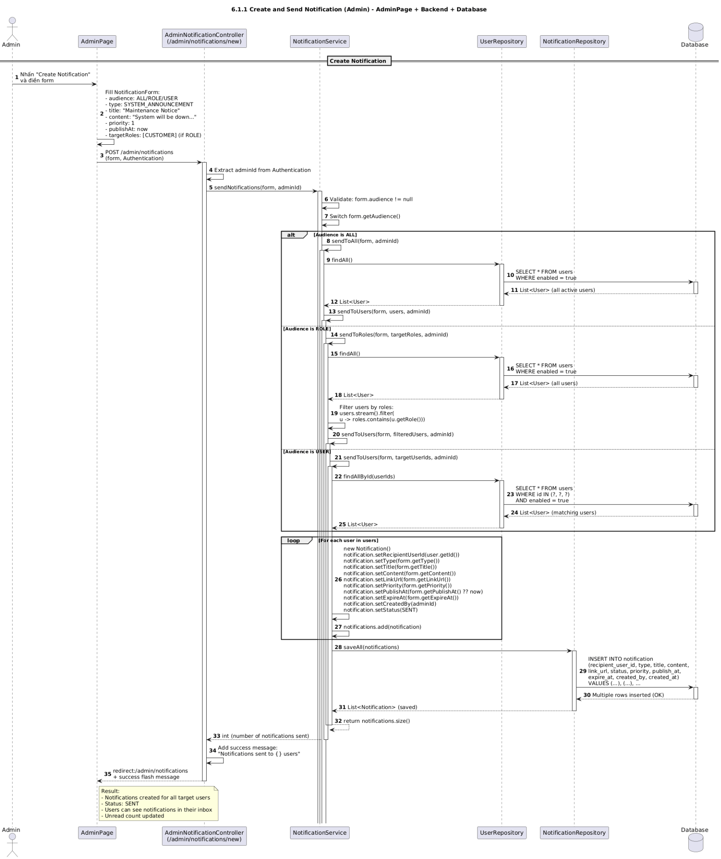

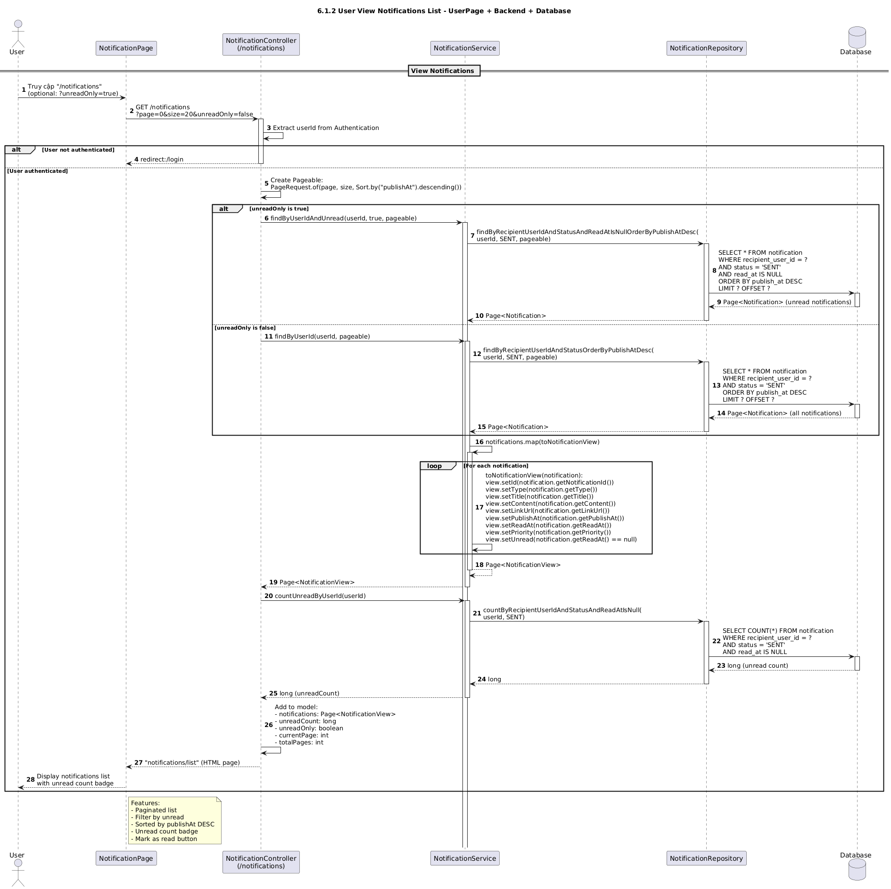

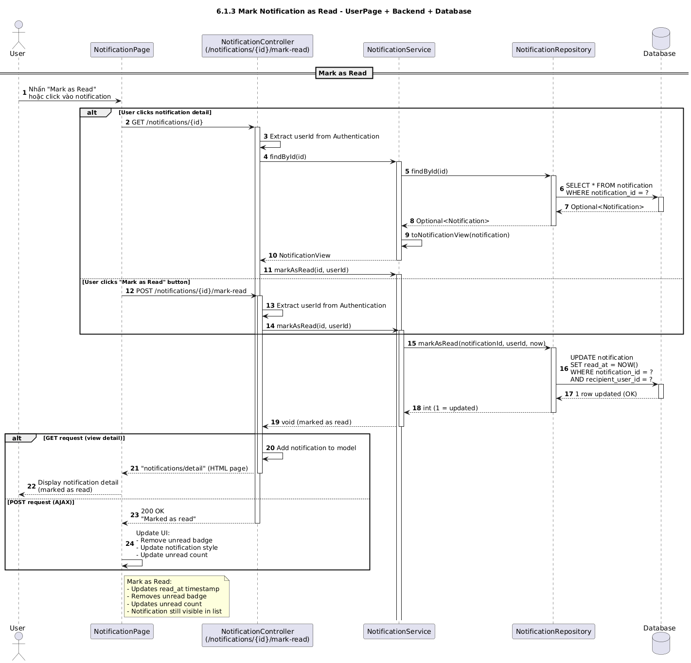

### d. Database Queries

List notifications: SELECT id, user_id, type, title, body, ref_id, status, created_at, read_at FROM notifications WHERE user_id = ? ORDER BY created_at DESC;

Insert notification: INSERT INTO notifications (user_id, type, title, body, ref_id, status, created_at) VALUES (?, ?, ?, ?, ?, 'UNREAD', NOW());

Find by id and user: SELECT id, user_id, status FROM notifications WHERE id = ? AND user_id = ? LIMIT 1;

Mark one read: UPDATE notifications SET status = 'READ', read_at = NOW() WHERE id = ? AND user_id = ?;

Mark all read: UPDATE notifications SET status = 'READ', read_at = NOW() WHERE user_id = ? AND status = 'UNREAD';

## 6.2 Email Notifications

### a. Class Diagram

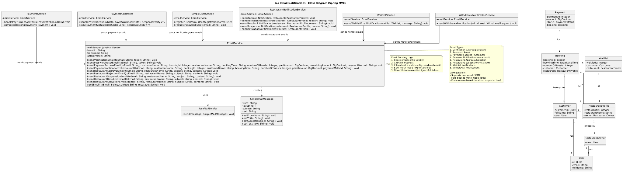

### b. Class Specifications

| EmailPreviewController | | |
| --- | --- | --- |
| **No** | **Method** | **Description** |
| 1 | preview(template, model) | Renders HTML from template+params for browser preview. |
| 2 | sendTest(to, template) | Sends a one-off test email using sample/default params. |
| EmailService | | |
| **No** | **Method** | **Description** |
| 1 | send(to, subject, bodyHtml) | Sends raw HTML and audits result. |
| 2 | sendTemplate(to, template, params) | Renders from template and sends; audits result. |
| 3 | render(template, params) | Loads template path and merges params (via TemplateRenderer). |
| TemplateRenderer | | |
| **No** | **Method** | **Description** |
| 1 | render(templatePath, params) | Applies params to template engine (Thymeleaf/Freemarker/Handlebars). |
| MailClient | | |
| **No** | **Method** | **Description** |
| 1 | send(to, subject, html) | Sends through provider (SMTP/SendGrid/Mailgun) and returns providerId. |
| EmailAuditRepository | | |
| **No** | **Method** | **Description** |
| 1 | save(audit) | Persists send outcome (SENT/FAILED, providerId, error). |
| EmailAudit (Entity) | | |
| **Field** | **Type** | **Notes** |
| to | String | Recipient email. |
| subject | String | Email subject. |
| template | String | Enum name or stored key. |
| status | String | SENT/FAILED. |
| providerId | String | Provider’s message id. |
| error | String | Failure diagnostic. |

### c. Sequence Diagram(s)

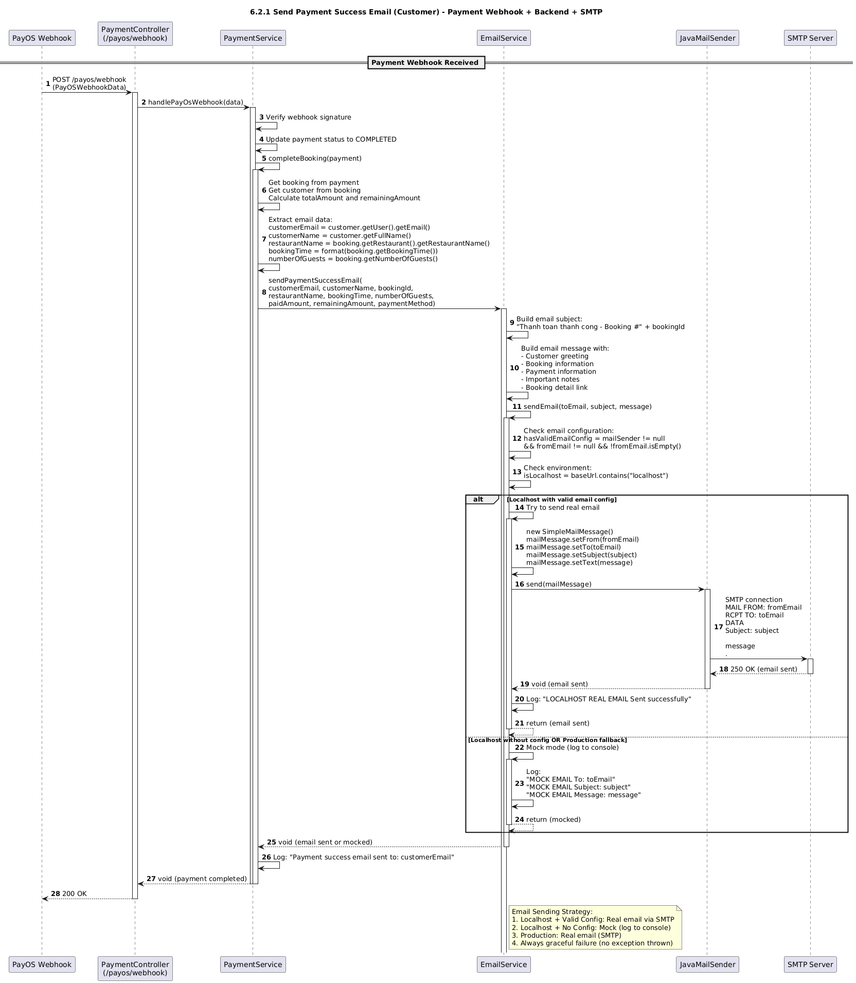

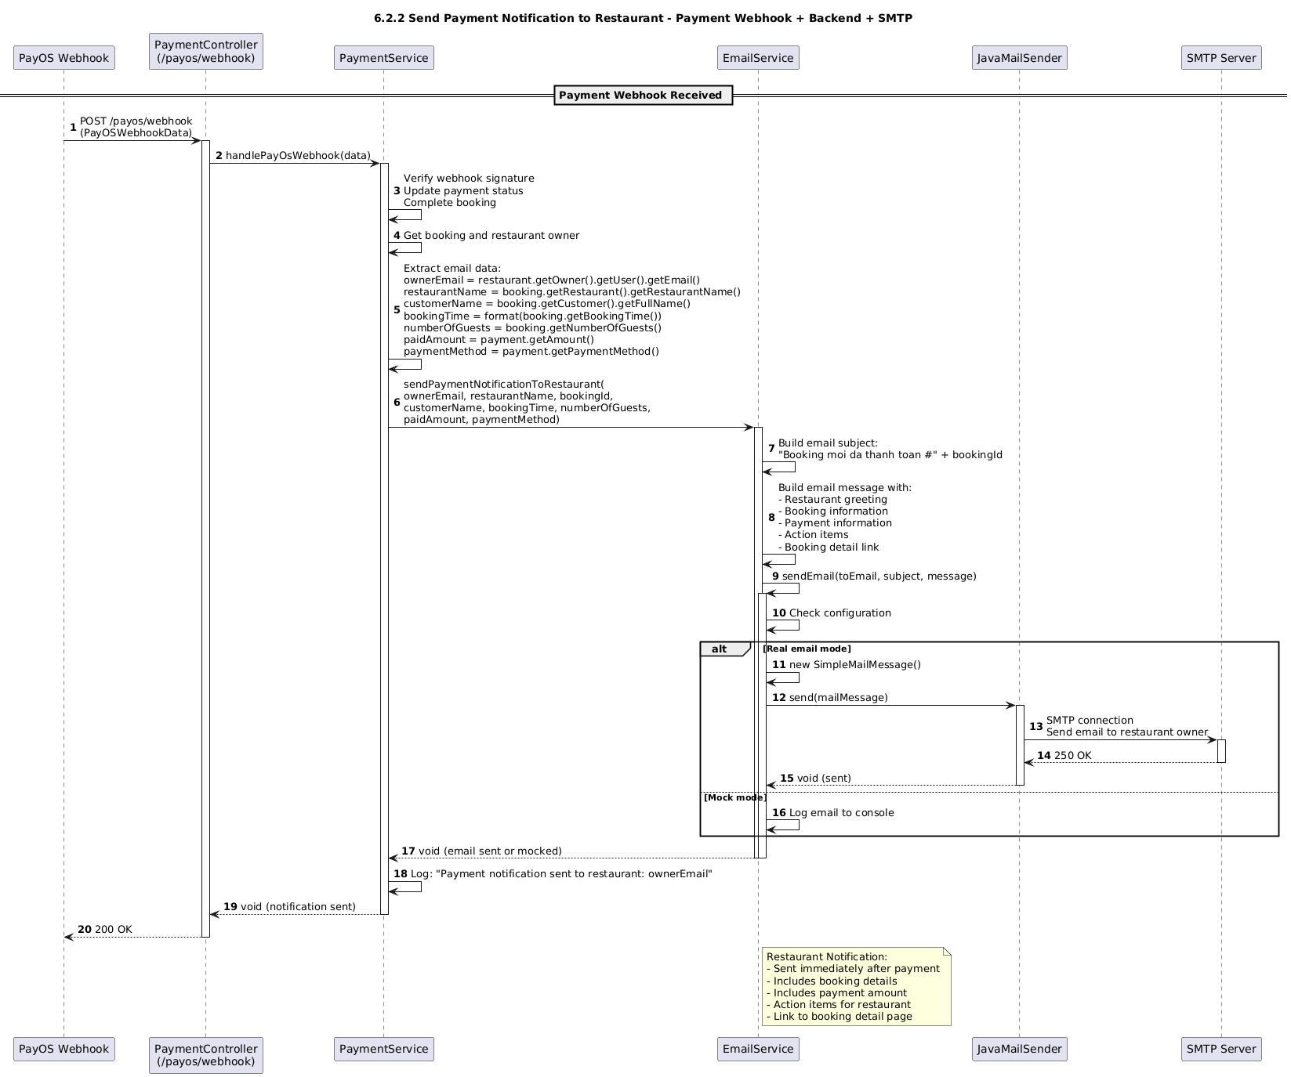

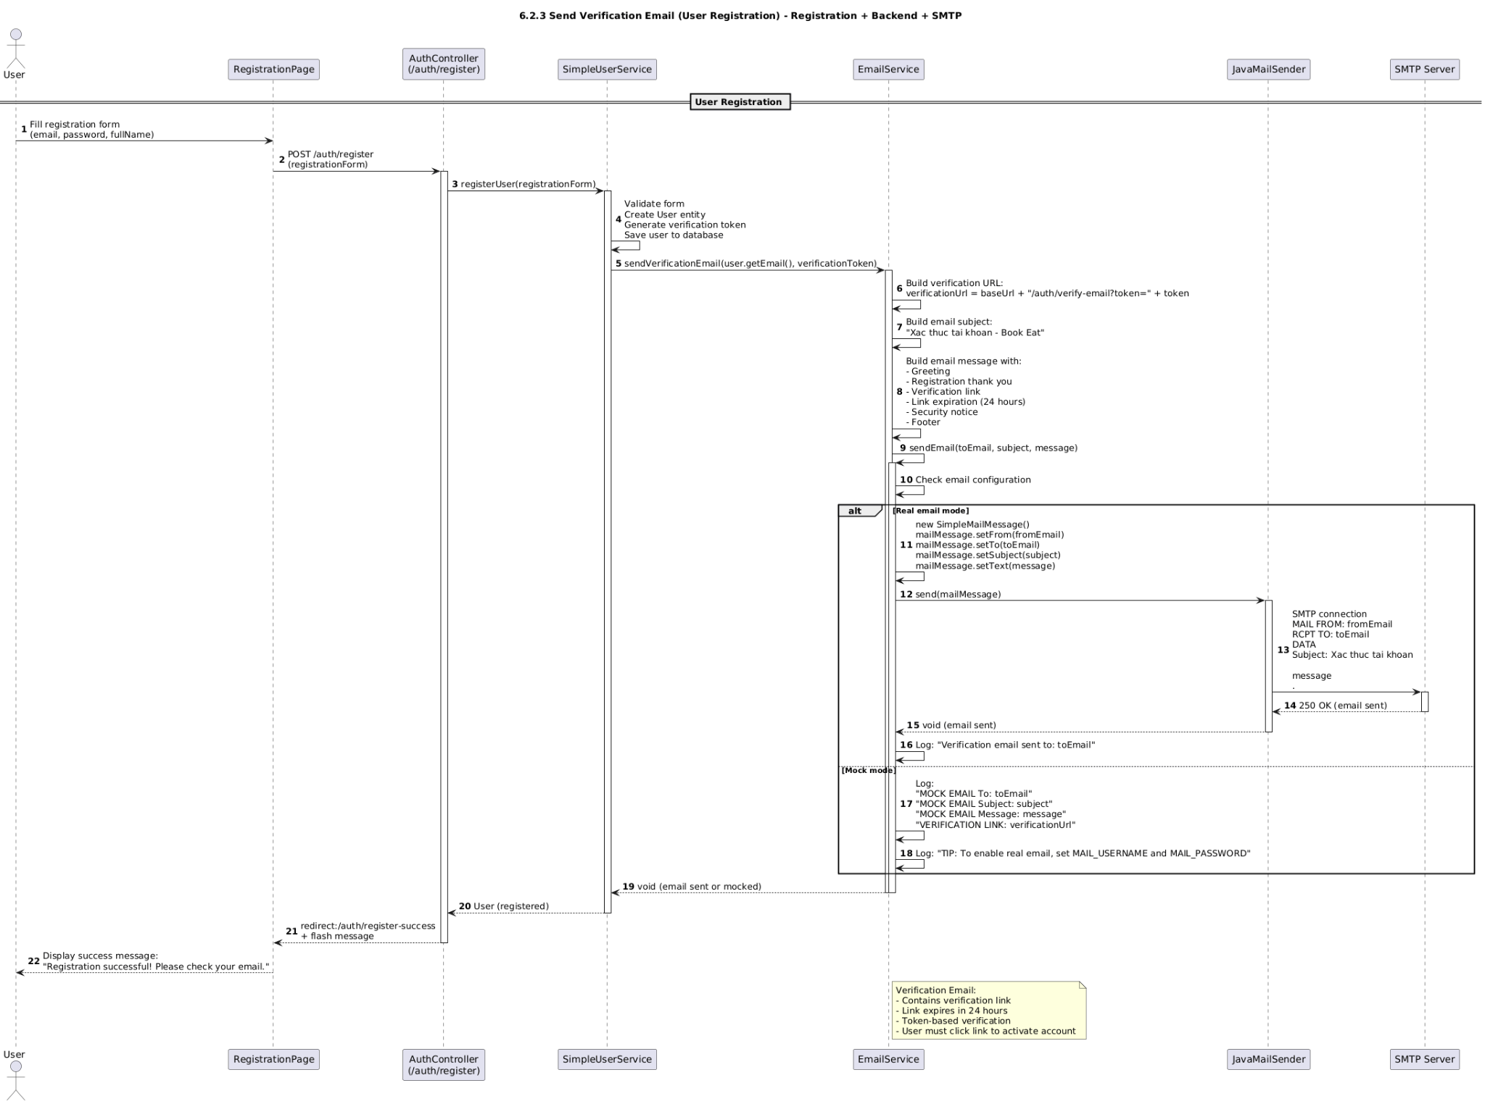

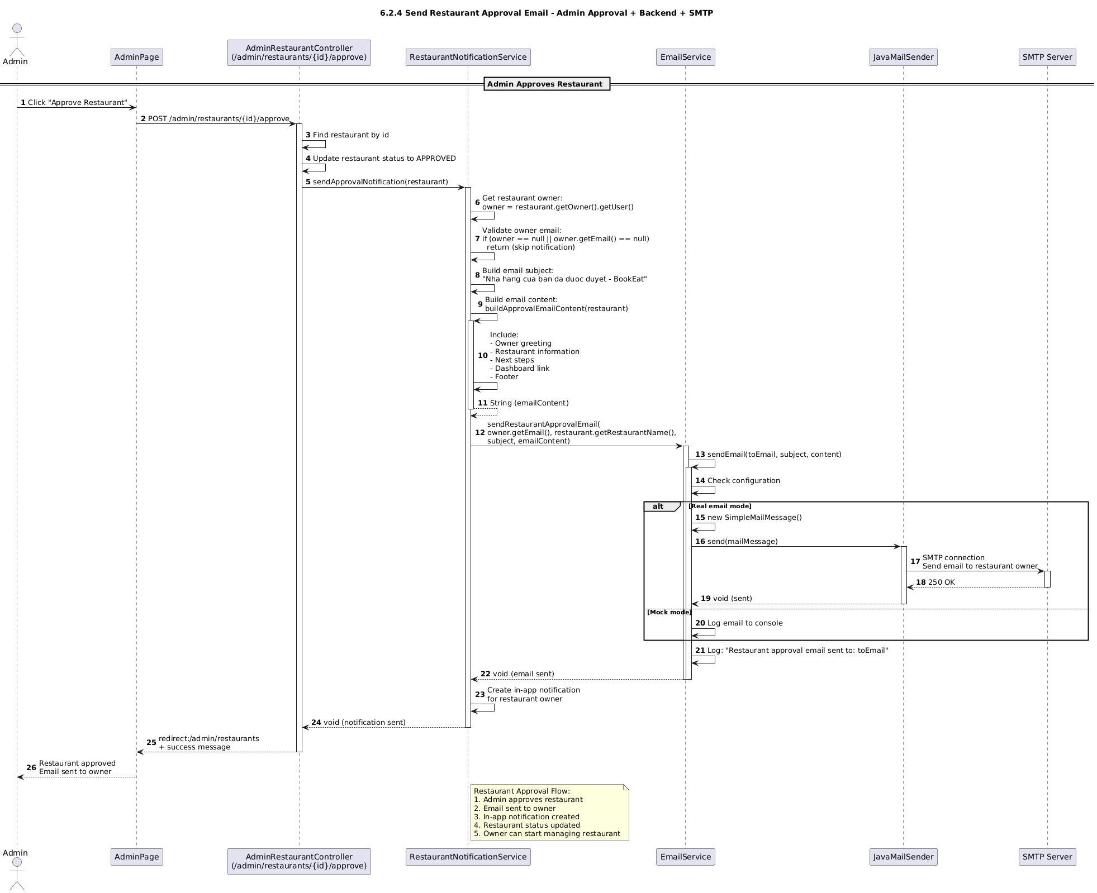

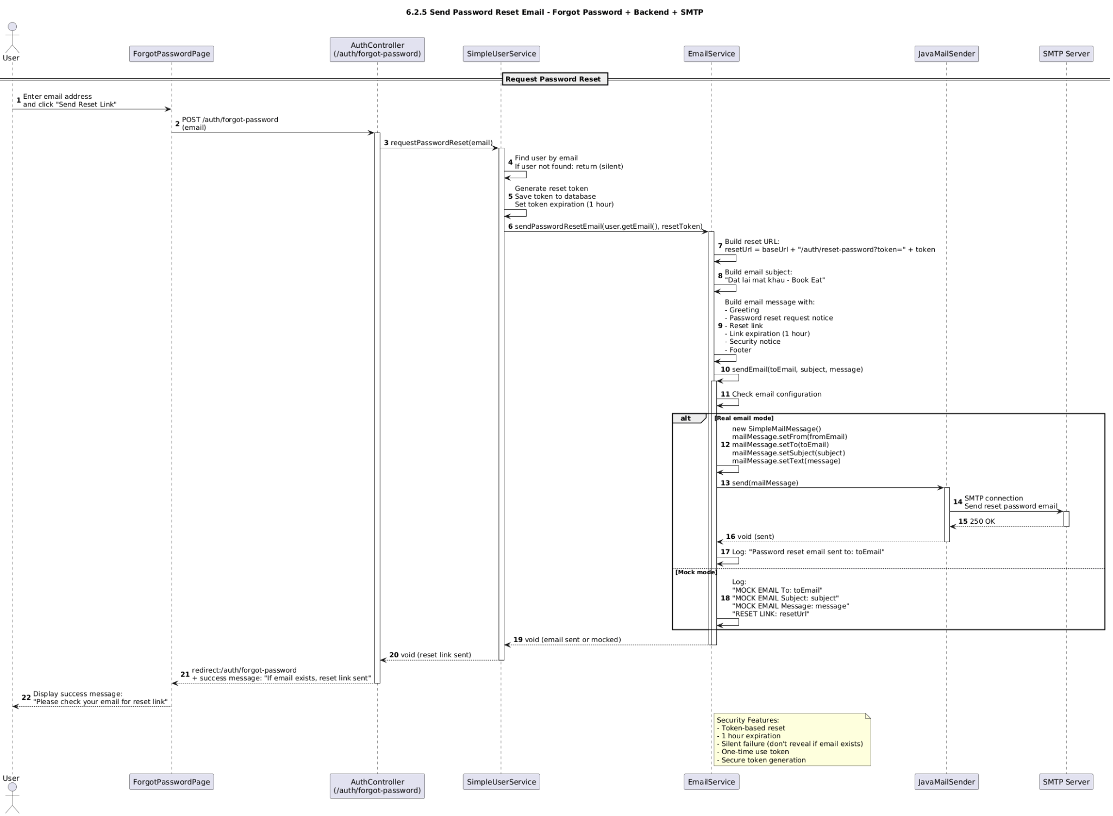

### d. Database Queries

Insert email audit (success):

INSERT INTO email_audit (recipient, subject, template, status, provider_id, error, created_at) VALUES (?, ?, ?, 'SENT', ?, NULL, NOW());

Insert email audit (failure):

INSERT INTO email_audit (recipient, subject, template, status, provider_id, error, created_at) VALUES (?, ?, ?, 'FAILED', NULL, ?, NOW());

List recent emails for a user:

SELECT id, recipient, subject, template, status, provider_id, error, created_at FROM email_audit WHERE recipient = ? ORDER BY created_at DESC LIMIT 50;

## 6.3 Chat Messaging

### a. Class Diagram

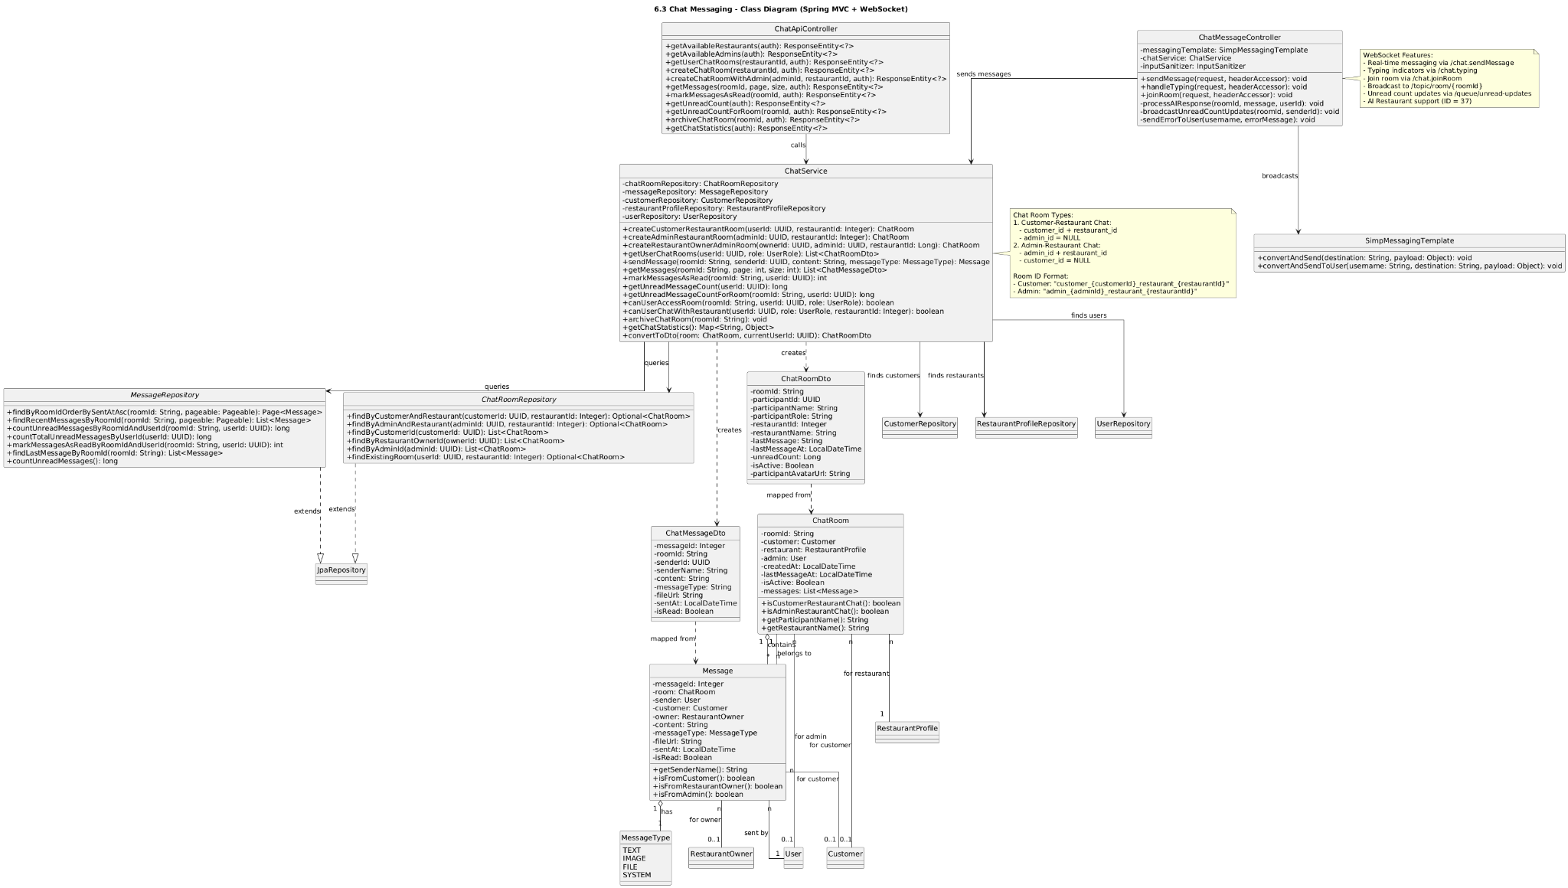

### b. Class Specifications

| ChatController | | |
| --- | --- | --- |
| **No** | **Method** | **Description** |
| 1 | openRoom(roomId, model) | Verifies user’s membership and returns chat UI for the room. |
| 2 | history(roomId, page, size) | Loads paged message history ordered by sentAt desc. |
| 3 | sendMessage(form) | Validates membership and content; delegates to service; emits WS event. |
| SendMessageForm (DTO) | | |
| **Field** | **Type** | **Description** |
| roomId | Long | Target room. |
| senderId | Long | Current user id. |
| content | String | Message body (escaped/sanitized). |
| type | MessageType | TEXT/IMAGE/SYSTEM. |
| ChatService | | |
| **No** | **Method** | **Description** |
| 1 | getRoom(roomId) | Loads a room or throws if not found. |
| 2 | history(roomId,page,size) | Returns latest messages page for infinite-scroll UI. |
| 3 | send(form) | Checks participant; sanitizes content; creates Message; persists; broadcasts. |
| Repositories | | |
| **Repo** | **Method** | **Description** |
| ChatRoomRepository | findById / existsParticipant | Resolve room and authorize. |
| MessageRepository | save / findByRoomIdOrderBySentAtDesc | Persist and page history. |
| ChatPusher | | |
| **No** | **Method** | **Description** |
| 1 | broadcast(roomId, messageDto) | Sends to WS topic /topic/rooms/{roomId}. |

### c. Sequence Diagram(s)

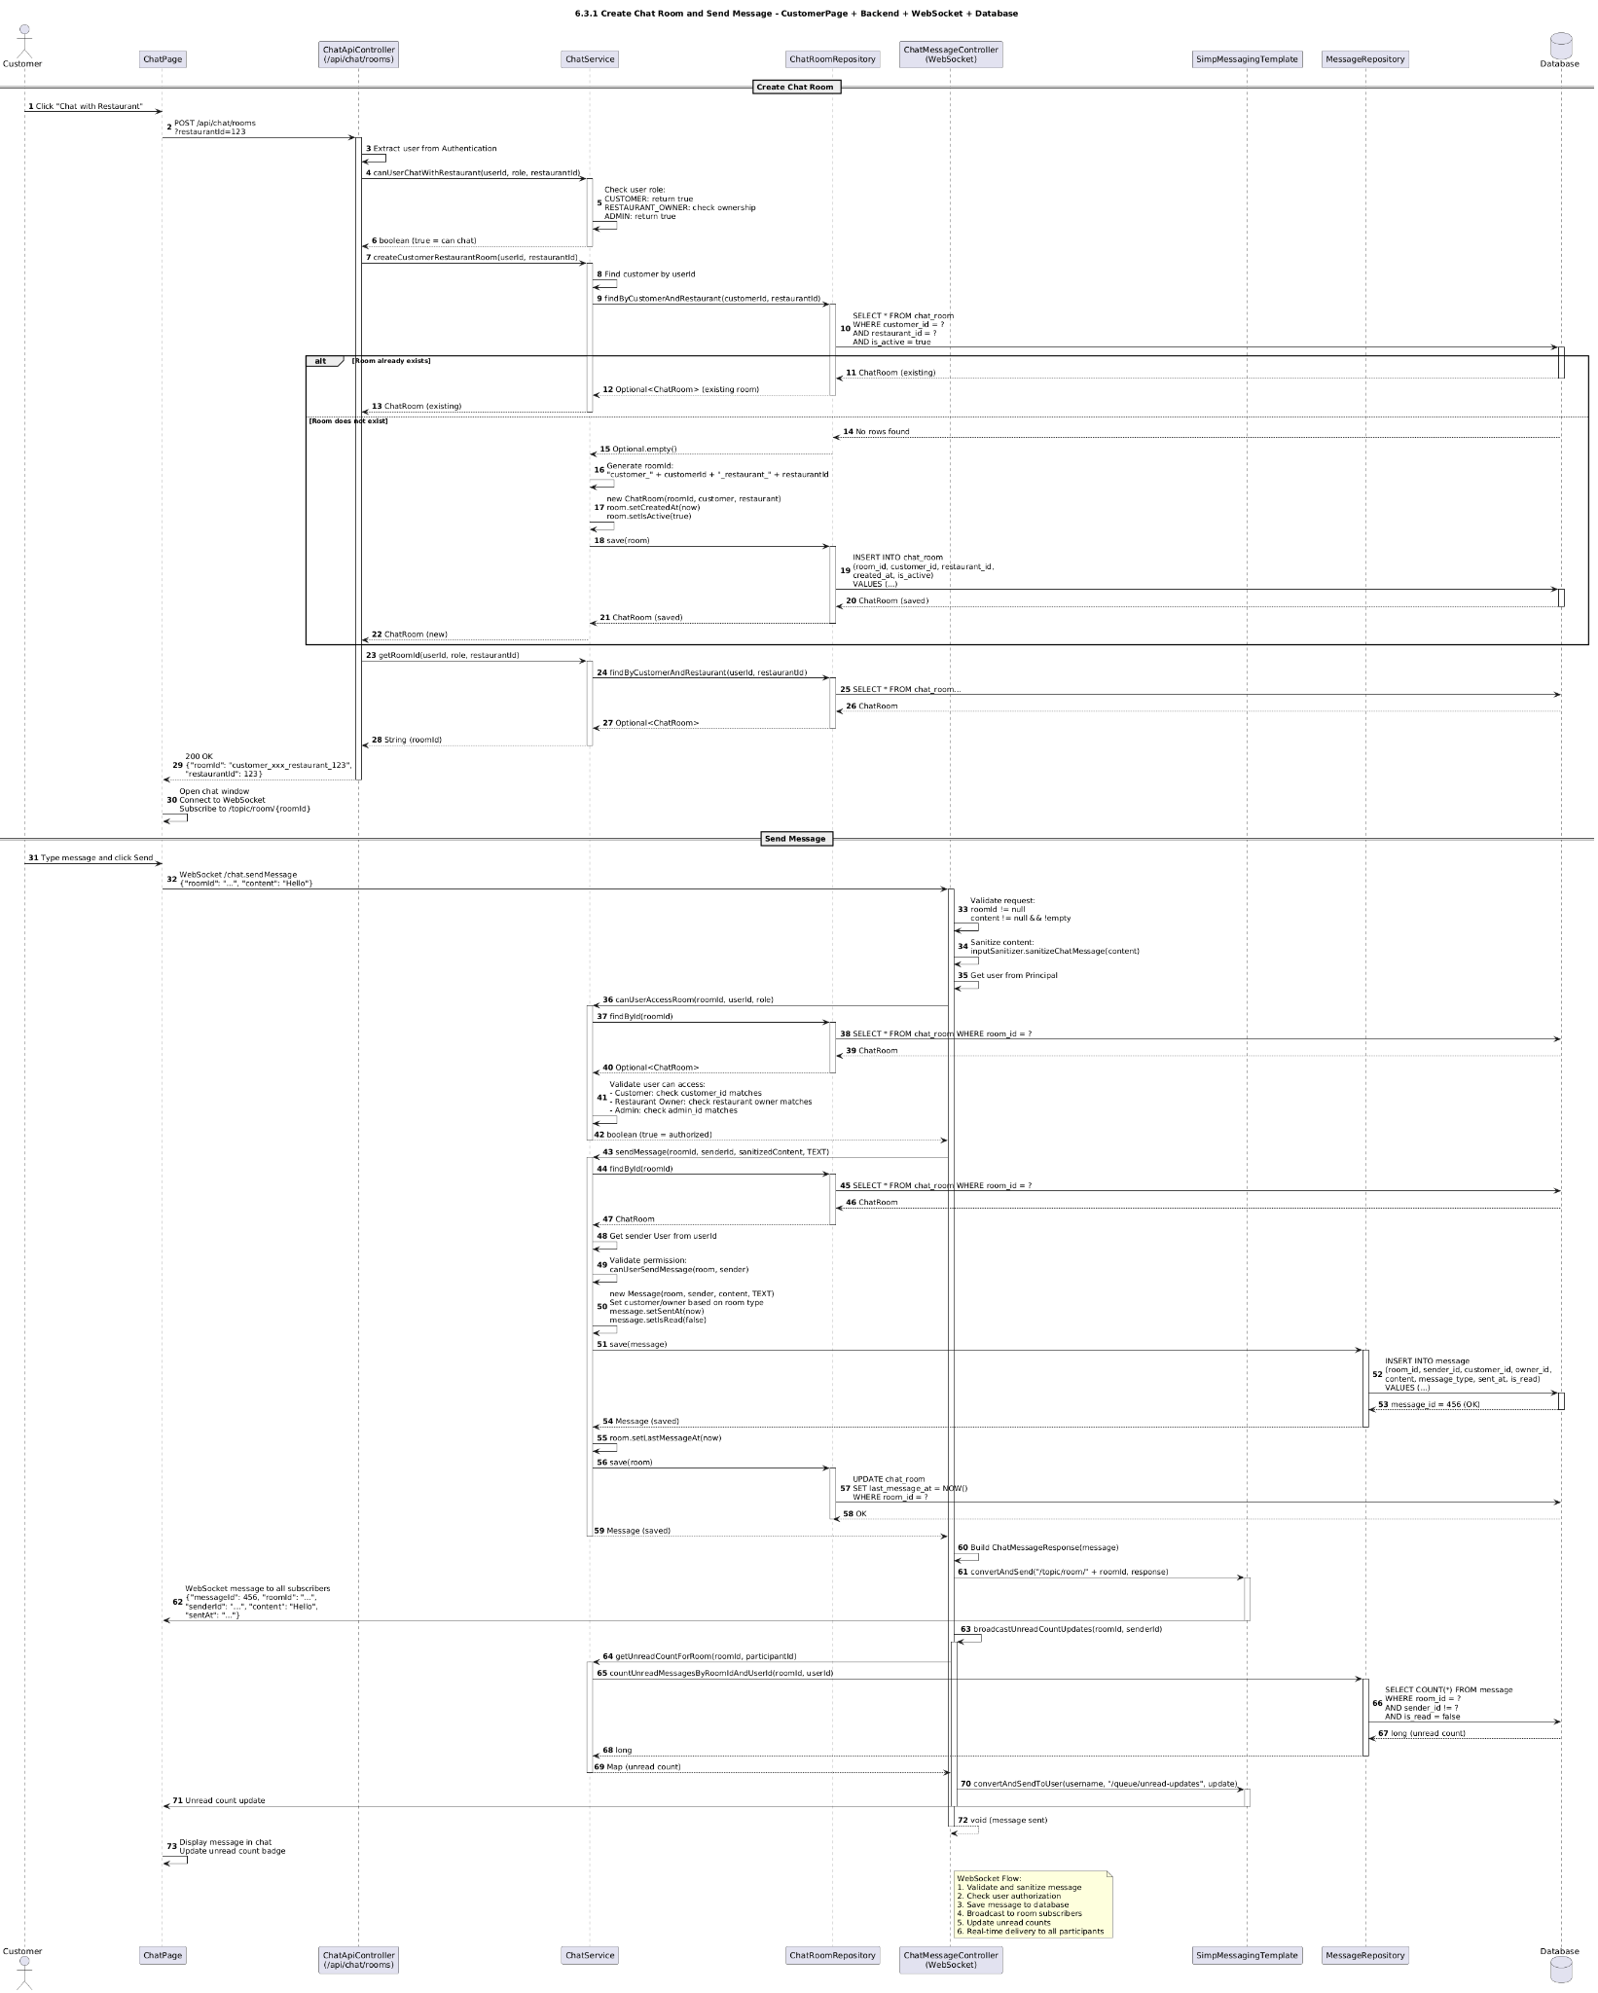

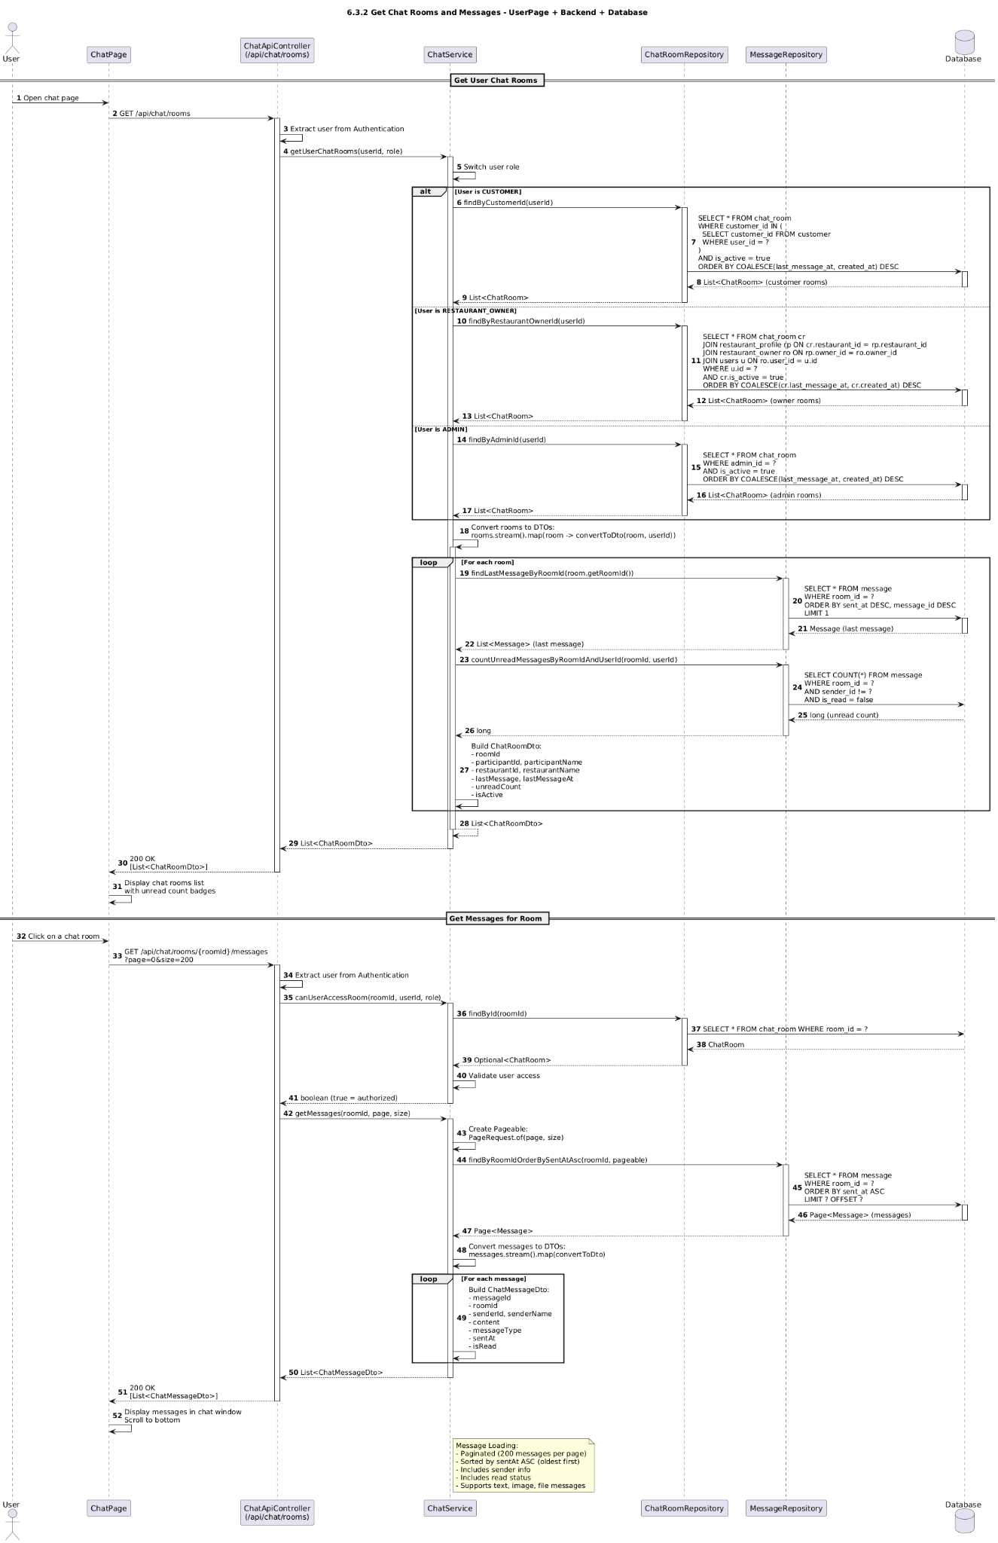

### 

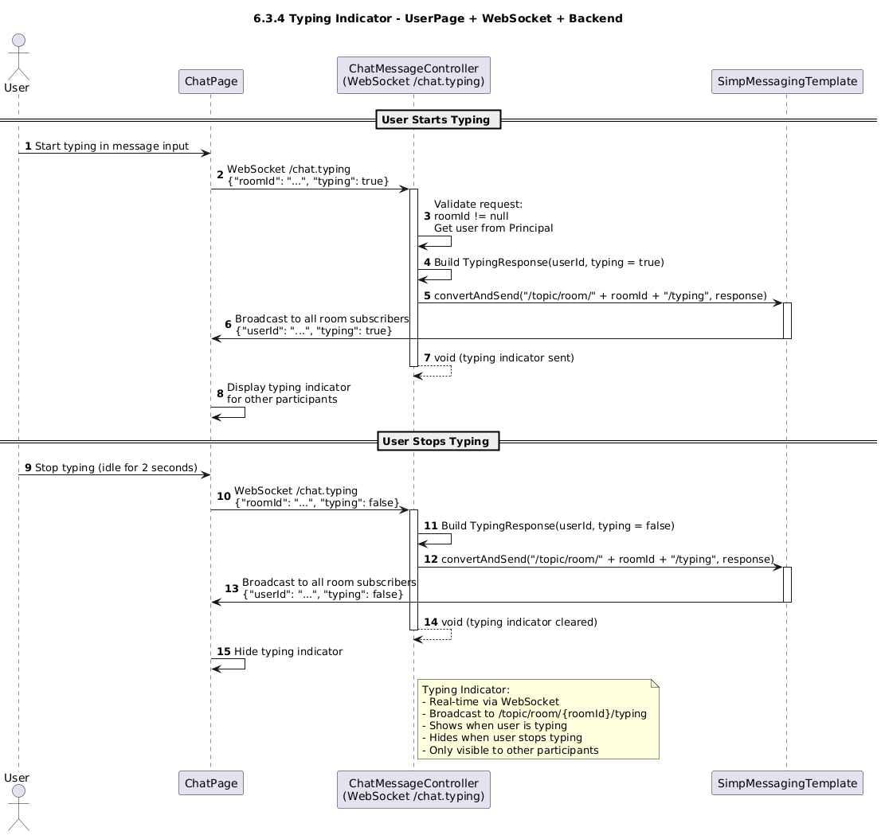

### d. Database Queries

Authorize participant:

SELECT 1 FROM chat_room_participant WHERE room_id = ? AND user_id = ? LIMIT 1;

Load room:

SELECT id, name, type, created_at FROM chat_room WHERE id = ? LIMIT 1;

Page history:

SELECT id, room_id, sender_id, content, type, sent_at

FROM message

WHERE room_id = ?

ORDER BY sent_at DESC

LIMIT ? OFFSET ?;

Insert message:

INSERT INTO message (room_id, sender_id, content, type, sent_at) VALUES (?, ?, ?, ?, NOW());

# 7. Review & Reporting

## 7.1 Write Review

### a. Class Diagram

### b. Class Specifications

### c. Sequence Diagram(s)

### d. Database Queries

## 7.2 Report Review

### a. Class Diagram

### b. Class Specifications

### c. Sequence Diagram(s)

### d. Database Queries

# 8. AI Recommendation

## 8.1 Personalized Dish/Restaurant Recommendation

### a. Class Diagram

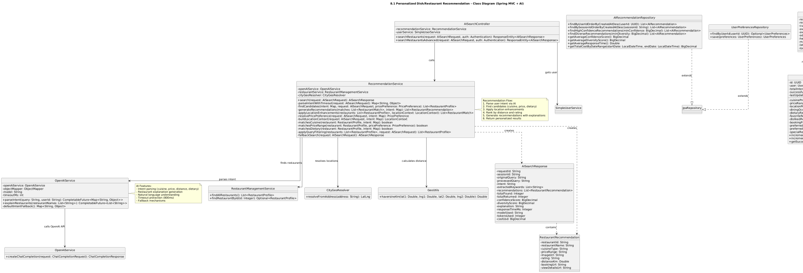

### b. Class Specifications

| AISearchController (Controller) — Attributes |||| | | | | |
| --- | --- | --- | --- | --- |
| No | Attribute | Type | Validation | Description |
| 1 | recommendationService | RecommendationService | @Autowired | Service for AI-powered recommendations |
| 2 | userService | SimpleUserService | @Autowired | Service for user management |
|  |  |  |  |  |
| AISearchController (Controller) — Methods || | | | | |
| No | Method | Description |  |  |
| 1 | searchRestaurants(AISearchRequest, Authentication): ResponseEntity | Handles POST /ai/search, gets userId from auth, calls recommendation service |  |  |
|  |  |  |  |  |
| AISearchRequest (DTO) — Attributes |||| | | | | |
| No | Attribute | Type | Validation | Description |
| 1 | query | String | @NotBlank, @Size(max=500) | User search query |
| 2 | userId | String | Optional | User ID for personalization |
| 3 | sessionId | String | Optional | Session ID for tracking |
| 4 | maxResults | Integer | default=5 | Maximum number of results |
| 5 | userLocation | String | Optional | User location (lat,lng or address) |
| 6 | preferredCuisines | List<String> | Optional | User preferred cuisine types |
| 7 | minPrice | Integer | Optional | Minimum price (VND) |
| 8 | maxPrice | Integer | Optional | Maximum price (VND) |
| 9 | maxDistance | Integer | Optional | Maximum distance in km |
| 10 | preferredDistricts | List<String> | Optional | Preferred districts/areas |
|  |  |  |  |  |
| AISearchResponse (DTO) — Attributes |||| | | | | |
| No | Attribute | Type | Validation | Description |
| 1 | originalQuery | String | Required | Original user query |
| 2 | recommendations | List<RestaurantRecommendation> | Required | List of recommended restaurants |
| 3 | totalFound | Integer | Required | Total number of matching restaurants |
| 4 | totalReturned | Integer | Required | Number of restaurants returned |
| 5 | confidenceScore | BigDecimal | Optional | AI confidence score (0-1) |
| 6 | diversityScore | BigDecimal | Optional | Diversity score (0-1) |
| 7 | explanation | String | Optional | Explanation of recommendation |
| 8 | responseTimeMs | Integer | Optional | Response time in milliseconds |
|  |  |  |  |  |
| AISearchResponse (DTO) — Methods || | | |  |  |
| No | Method | Description |  |  |
| 1 | isHighConfidence(): boolean | Returns true if confidence >= 0.8 |  |  |
| 2 | isDiverse(): boolean | Returns true if diversity >= 0.7 |  |  |
| 3 | hasRecommendations(): boolean | Returns true if has recommendations |  |  |
|  |  |  |  |  |
| RestaurantRecommendation (Nested DTO) — Attributes |||| | | | | |
| No | Attribute | Type | Validation | Description |
| 1 | restaurantId | String | Required | Restaurant ID |
| 2 | restaurantName | String | Required | Restaurant name |
| 3 | cuisineType | String | Optional | Cuisine type |
| 4 | priceRange | String | Optional | Price range or "Liên hệ" |
| 5 | imageUrl | String | Optional | Restaurant main image |
| 6 | rating | String | Optional | Average rating (formatted) |
| 7 | distanceKm | Double | Optional | Distance from user location (km) |
| 8 | bookingUrl | String | Optional | URL to booking page |
| 9 | viewDetailsUrl | String | Optional | URL to restaurant details |
|  |  |  |  |  |
| RecommendationService (Service) — Attributes |||| | | | | |
| No | Attribute | Type | Validation | Description |
| 1 | openAIService | OpenAIService | @Autowired | Service for OpenAI integration |
| 2 | restaurantService | RestaurantManagementService | @Autowired | Service for restaurant data |

| RecommendationService (Service) — Methods || | | |
| --- | --- | --- |
| No | Method | Description |
| 1 | search(AISearchRequest): AISearchResponse | Main search method: parse intent, find candidates, generate recommendations |
| 2 | parseIntentWithTimeout(AISearchRequest): Map | Calls OpenAI to parse user intent with timeout (800ms) |
| 3 | findCandidates(intent, request, preference): List<RestaurantProfile> | Filters restaurants by cuisine, price, dietary requirements |
| 4 | generateRecommendations(matches, intent): List | Generates recommendations with AI explanations |
| 5 | matchesCuisine(restaurant, intent): boolean | Checks if restaurant matches cuisine intent |
| 6 | matchesPriceRange(restaurant, preference): boolean | Checks if restaurant matches price range |
| 7 | applyLocationEnhancements(restaurants, context): List | Applies location filtering and sorting by distance |
| 8 | fallbackSearch(request): AISearchResponse | Fallback when AI fails, uses simple filtering |

| OpenAIService (Service) — Attributes |||| | | | | |
| --- | --- | --- | --- | --- |
| No | Attribute | Type | Validation | Description |
| 1 | openAiService | OpenAiService | @Autowired | OpenAI SDK service |
| 2 | model | String | #VALUE! | OpenAI model (default: gpt-4o-mini) |
| 3 | timeoutMs | int | #VALUE! | Timeout in milliseconds (default: 800) |

| OpenAIService (Service) — Methods || | | |
| --- | --- | --- |
| No | Method | Description |
| 1 | parseIntent(query, userId): CompletableFuture<Map> | Parses user query to extract cuisine, price_range, party_size, dietary requirements |
| 2 | explainRestaurants(names): CompletableFuture<List> | Generates explanations for why restaurants are recommended |

| AIRecommendation (Entity) — Attributes |||| | | | | |
| --- | --- | --- | --- | --- |
| No | Attribute | Type | Validation | Description |
| 1 | id | UUID | @Id, @GeneratedValue | Primary key |
| 2 | user | User | @ManyToOne | User who received recommendation |
| 3 | sessionId | String | max=100 | Session ID for tracking |
| 4 | queryText | String | @NotNull, TEXT | Original query text |
| 5 | queryType | QueryType | Enum | Type: SEARCH, CHAT, FILTER, BOOKING, EXPLORATION |
| 6 | intentAnalysis | String | JSONB | AI-parsed intent data |
| 7 | recommendations | String | JSONB | JSON array of recommendations |
| 8 | confidenceScore | BigDecimal | precision=3, scale=2 | AI confidence (0-1) |
| 9 | diversityScore | BigDecimal | precision=3, scale=2 | Diversity score (0-1) |
| 10 | userFeedback | UserFeedback | Enum | HELPFUL, NOT_HELPFUL, IRRELEVANT, ACCURATE, INACCURATE |
| 11 | responseTimeMs | Integer | Optional | Response time |
| 12 | apiCostUsd | BigDecimal | Optional | API cost |
| 13 | tokensUsed | Integer | Optional | Tokens used |
| 14 | modelUsed | String | max=100 | Model used (e.g., gpt-4) |
| 15 | createdAt | LocalDateTime | @CreationTimestamp | Creation time |

| AIRecommendation (Entity) — Methods || | | |
| --- | --- | --- |
| No | Method | Description |
| 1 | isHighConfidence(): boolean | Returns true if confidenceScore >= 0.8 |
| 2 | isDiverse(): boolean | Returns true if diversityScore >= 0.7 |
| 3 | hasUserFeedback(): boolean | Returns true if userFeedback is not null |
| 4 | isPositiveFeedback(): boolean | Returns true if feedback is HELPFUL or ACCURATE |
|  |  |  |
| AIRecommendationRepository (Repository) — Methods || | | |
| No | Method | Description |
| 1 | findByUserIdOrderByCreatedAtDesc(userId): List | Finds all recommendations for a user |
| 2 | findHighConfidenceRecommendations(minConfidence): List | Finds recommendations with confidence >= threshold |
| 3 | findDiverseRecommendations(minDiversity): List | Finds recommendations with diversity >= threshold |
| 4 | findPositiveFeedbackRecommendations(): List | Finds recommendations with HELPFUL or ACCURATE feedback |
| 5 | getAverageConfidenceScore(): BigDecimal | Calculates average confidence score |
| 6 | getAverageDiversityScore(): BigDecimal | Calculates average diversity score |
| 7 | getTotalCostByDateRange(start, end): BigDecimal | Gets total API cost in date range |

### c. Sequence Diagram(s)

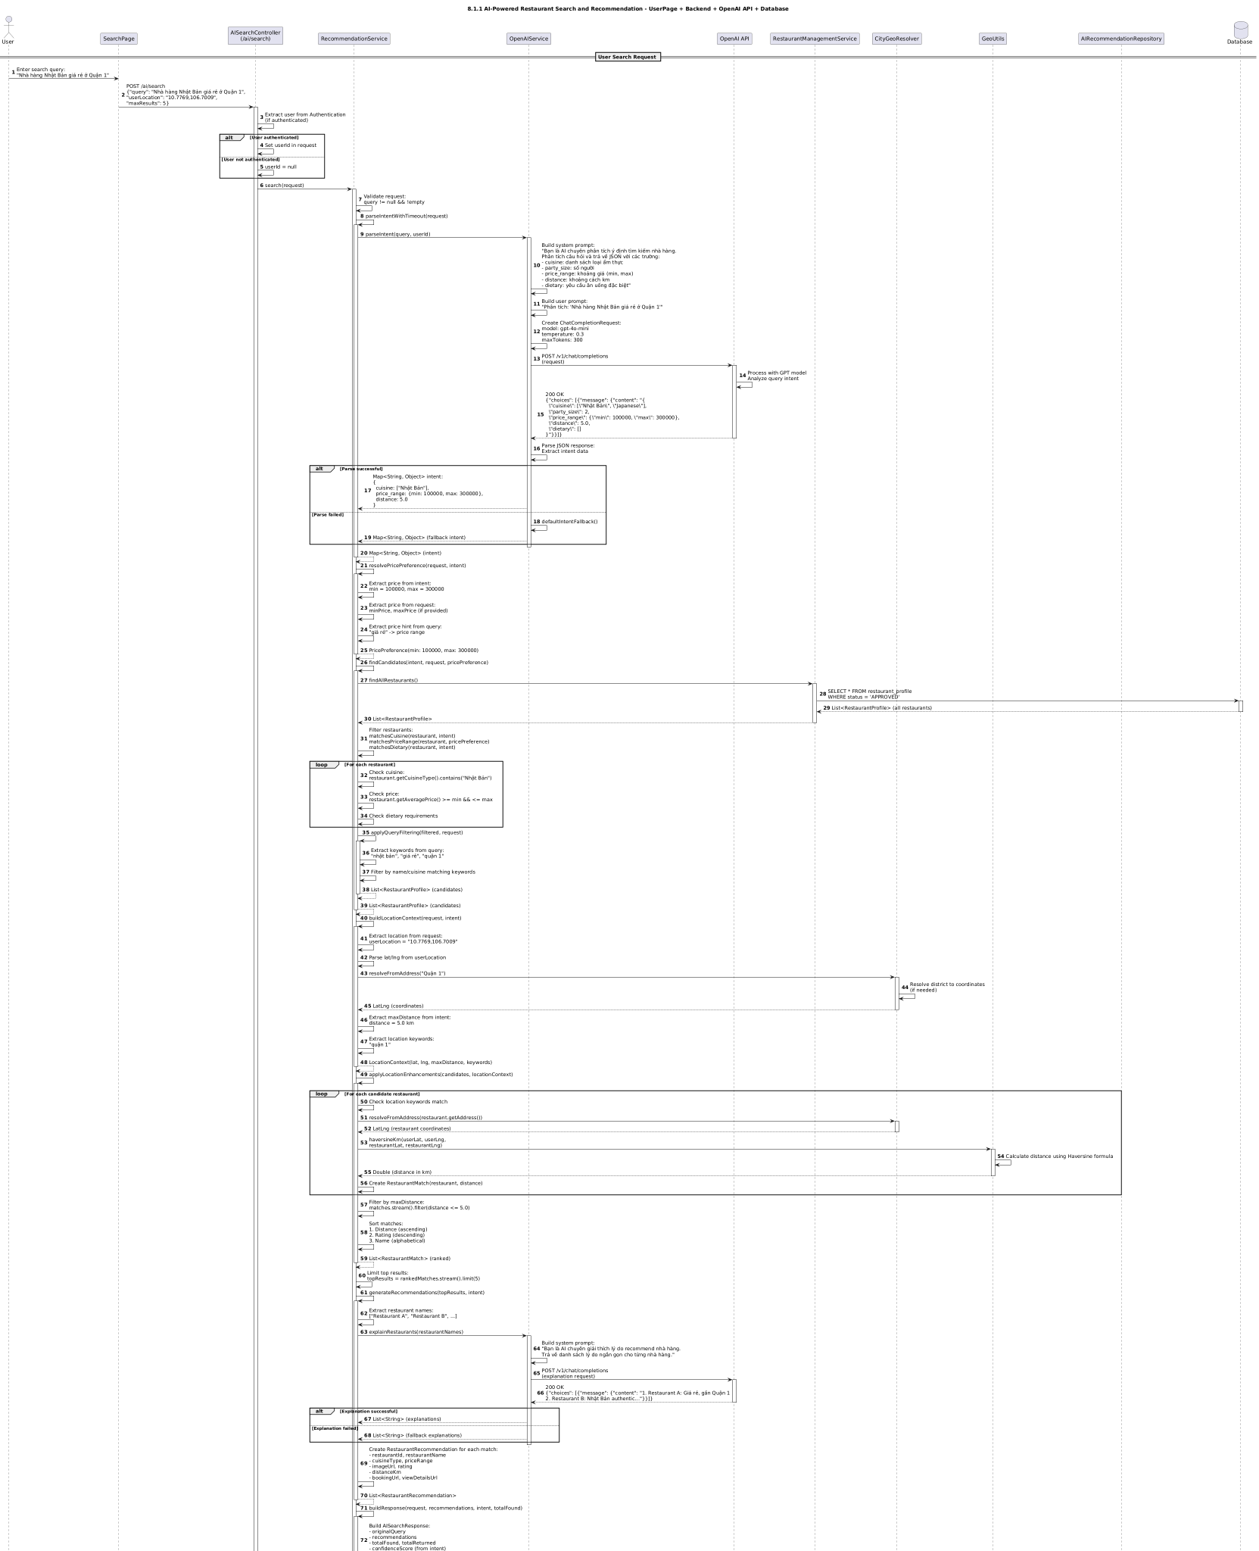

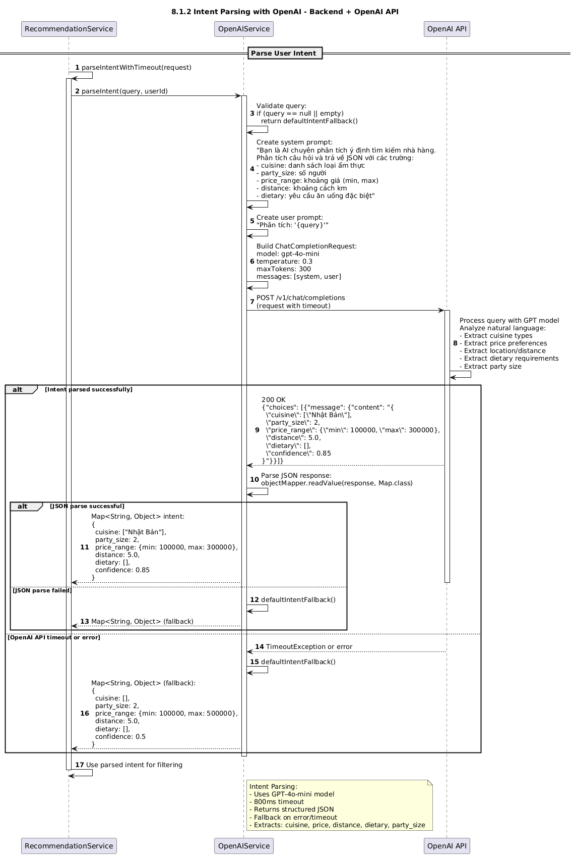

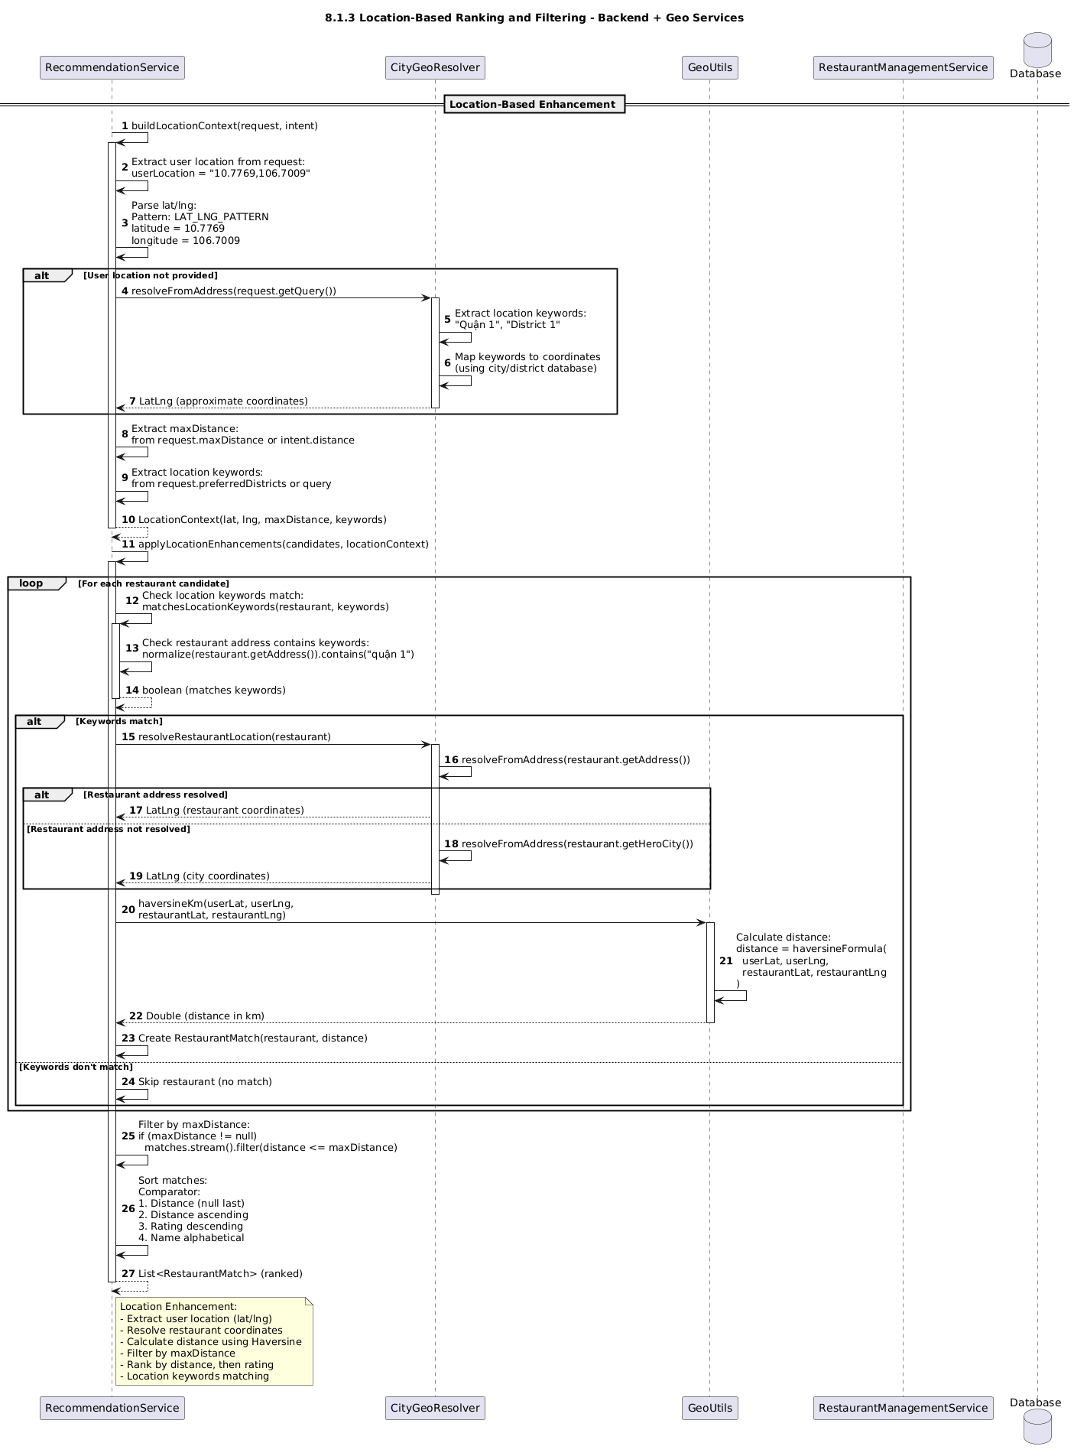

### 

### d. Database Queries

Find all approved restaurants

SELECT * FROM restaurant_profile WHERE approval_status = 'APPROVED';

Filter restaurants by cuisine

SELECT * FROM restaurant_profile WHERE LOWER(cuisine_type) LIKE LOWER(?) AND approval_status = 'APPROVED';

Filter restaurants by price range

SELECT * FROM restaurant_profile WHERE average_price BETWEEN ? AND ? AND approval_status = 'APPROVED';

Filter restaurants by location keywords

SELECT * FROM restaurant_profile WHERE LOWER(address) LIKE LOWER(?) OR LOWER(hero_city) LIKE LOWER(?) AND approval_status = 'APPROVED';

Insert AI recommendation

INSERT INTO ai_recommendations (id, user_id, session_id, query_text, query_type, source, language, intent_analysis, extracted_keywords, context_data, recommendations, confidence_score, diversity_score, response_time_ms, api_cost_usd, tokens_used, model_used, created_at) VALUES (?, ?, ?, ?, ?, ?, ?, ?, ?, ?, ?, ?, ?, ?, ?, ?, ?, ?);

Find recommendations by user

SELECT * FROM ai_recommendations WHERE user_id = ? ORDER BY created_at DESC;

Find high confidence recommendations

SELECT * FROM ai_recommendations WHERE confidence_score >= ? ORDER BY confidence_score DESC;

Find diverse recommendations

SELECT * FROM ai_recommendations WHERE diversity_score >= ? ORDER BY diversity_score DESC;

Find recommendations with positive feedback

SELECT * FROM ai_recommendations WHERE user_feedback IN ('HELPFUL', 'ACCURATE') ORDER BY created_at DESC;

Get average confidence score

SELECT AVG(confidence_score) FROM ai_recommendations;

Get average diversity score

SELECT AVG(diversity_score) FROM ai_recommendations;

Get total API cost by date range

SELECT SUM(api_cost_usd) FROM ai_recommendations WHERE created_at BETWEEN ? AND ?;

Get average response time

SELECT AVG(response_time_ms) FROM ai_recommendations;

Get popular queries

SELECT query_text, COUNT() as count FROM ai_recommendations GROUP BY query_text ORDER BY count DESC LIMIT 10;

Delete old recommendations

DELETE FROM ai_recommendations WHERE created_at < ?;

### 

### 

|  | | |
| --- | --- | --- |
|  |  |  |
|  |  |  |
|  |  |  |
|  |  |  |
|  | | |
|  |  |  |
|  |  |  |
|  |  |  |
|  |  |  |
|  |  |  |

### 

# 9. Security & Rate Limiting

## 9.1 Authentication & Authorization

### a. Class Diagram

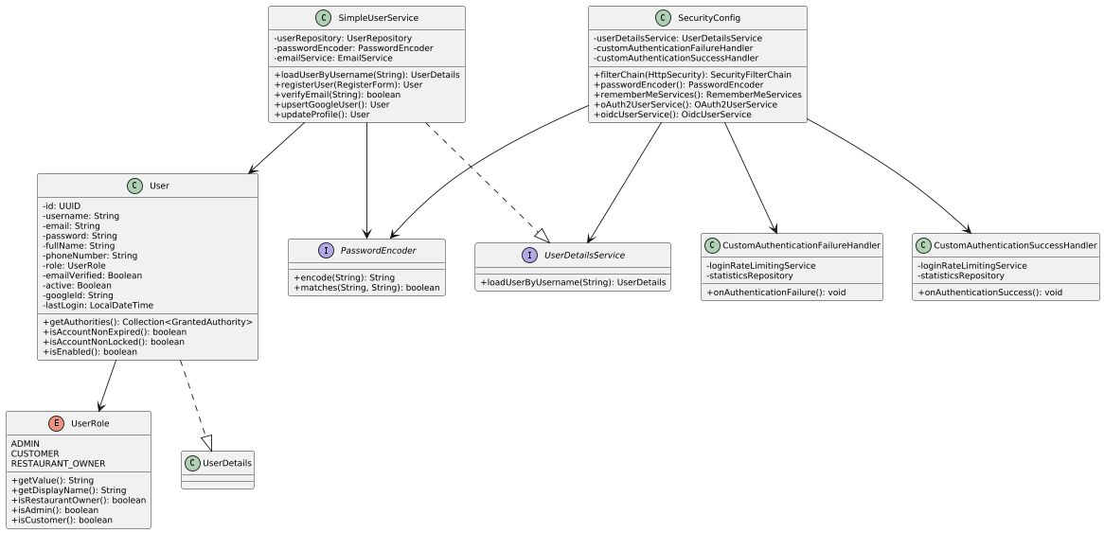

### b. Class Specifications

| SecurityConfig (Configuration) — Methods | | |
| --- | --- | --- |
| No | Method | Description |
| 1 | filterChain(HttpSecurity): SecurityFilterChain | Configures security filter chain with authorization rules |
| 2 | passwordEncoder(): PasswordEncoder | Creates BCryptPasswordEncoder bean |
| 3 | persistentTokenRepository(): PersistentTokenRepository | Configures JDBC token repository for remember-me |
| 4 | rememberMeServices(): RememberMeServices | Configures remember-me functionality (30 days validity) |
| 5 | oAuth2UserService(SimpleUserService): OAuth2UserService | Handles OAuth2 login (Google) for non-OIDC |
| 6 | oidcUserService(SimpleUserService): OidcUserService | Handles OIDC login (Google) with openid scope |
|  |  |  |
| SecurityConfig — Authorization Rules | | |
| No | Path Pattern | Access Rule |
| 1 | /css/, /js/, /images/, /uploads/ | permitAll (public resources) |
| 2 | /login, /, /about, /contact, /restaurants/ | permitAll (public pages) | | 3 | /auth/register, /auth/verify-email, /auth/forgot-password | permitAll (authentication pages) | | 4 | /admin/ | hasRole("ADMIN") - Admin only |
| 5 | /restaurant-owner/ | hasRole("RESTAURANT_OWNER") - Restaurant owner only | | 6 | /booking/, /notifications/ | authenticated() - Logged in users | | 7 | /api/admin/ | hasRole("ADMIN") |
| 8 | anyRequest() | authenticated() - Default requires login |

| User (Entity) — Attributes | | | | |
| --- | --- | --- | --- | --- |
| No | Attribute | Type | Validation | Description |
| 1 | id | UUID | @Id, @GeneratedValue | Primary key |
| 2 | username | String | @NotBlank, @Size(3-50), unique | Login username |
| 3 | email | String | @Email, @NotBlank, unique | User email address |
| 4 | password | String | @NotBlank, @Size(min=8) | BCrypt hashed password |
| 5 | fullName | String | @NotBlank | Full name of user |
| 6 | phoneNumber | String | @Pattern(Vietnamese phone), max=15 | Phone number |
| 7 | role | UserRole | @Enumerated(STRING), @NotNull | User role (ADMIN, CUSTOMER, RESTAURANT_OWNER) |
| 8 | emailVerified | Boolean | default=false | Email verification status |
| 9 | emailVerificationToken | String | Optional | Token for email verification |
| 10 | passwordResetToken | String | Optional | Token for password reset |
| 11 | passwordResetTokenExpiry | LocalDateTime | Optional | Expiry time for reset token |
| 12 | googleId | String | Optional | Google OAuth ID |
| 13 | active | Boolean | default=true | Account active status |
| 14 | lastLogin | LocalDateTime | Optional | Last login timestamp |
| 15 | createdAt | LocalDateTime | @CreatedDate, auto | Account creation time |
| 16 | updatedAt | LocalDateTime | @LastModifiedDate, auto | Last update time |

| User (Entity) — UserDetails Methods | | |
| --- | --- | --- |
| No | Method | Description |
| 1 | getAuthorities(): Collection<GrantedAuthority> | Returns role as "ROLE_" + role.getValue().toUpperCase() |
| 2 | getPassword(): String | Returns hashed password |
| 3 | getUsername(): String | Returns username |
| 4 | isAccountNonExpired(): boolean | Always returns true |
| 5 | isAccountNonLocked(): boolean | Returns true if email is verified |
| 6 | isCredentialsNonExpired(): boolean | Always returns true |
| 7 | isEnabled(): boolean | Returns active status |
|  |  |  |
| UserRole (Enum) — Constants | | |
| No | Constant | Description |
| 1 | ADMIN ("admin") | Administrator with full access |
| 2 | CUSTOMER ("customer") | Regular customer user |
| 3 | RESTAURANT_OWNER ("restaurant_owner") | Restaurant owner user |
|  |  |  |
| UserRole (Enum) — Methods | | |
| No | Method | Description |
| 1 | getValue(): String | Returns lowercase role value for database |
| 2 | getDisplayName(): String | Returns Vietnamese display name |
| 3 | isRestaurantOwner(): boolean | Checks if role is RESTAURANT_OWNER |
| 4 | isAdmin(): boolean | Checks if role is ADMIN |
| 5 | isCustomer(): boolean | Checks if role is CUSTOMER |
|  |  |  |
| SimpleUserService (Service) — Methods | |  |
|  |  |  |
| SimpleUserService (Service) — Methods | | |
| No | Method | Description |
| 1 | loadUserByUsername(String): UserDetails | Loads user by username for Spring Security |
| 2 | registerUser(RegisterForm, UserRole): User | Registers new user with role |
| 3 | verifyEmail(String): boolean | Verifies email using token |
| 4 | upsertGoogleUser(String, String, String): User | Creates or updates Google OAuth user |
| 5 | updateProfile(UUID, ProfileEditForm): User | Updates user profile |
| 6 | changePassword(UUID, String, String): void | Changes user password |
| 7 | requestPasswordReset(String): void | Initiates password reset process |
| 8 | resetPassword(String, String): boolean | Resets password using token |
|  |  |  |
| CustomAuthenticationSuccessHandler — Methods | | |
| No | Method | Description |
| 1 | onAuthenticationSuccess(): void | Handles successful authentication, resets rate limit, updates stats |
|  |  |  |
| CustomAuthenticationFailureHandler — Methods | | |
| No | Method | Description |
| 1 | onAuthenticationFailure(): void | Handles failed authentication, checks rate limit, updates stats |

### c. Sequence Diagram(s)

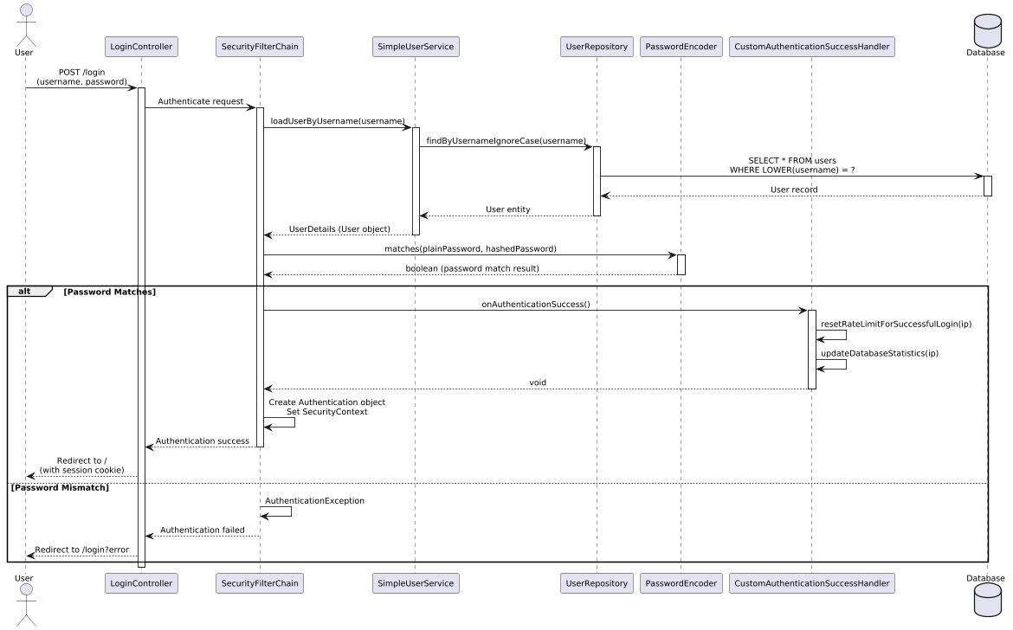

Sequence 1: User Login with Form Authentication

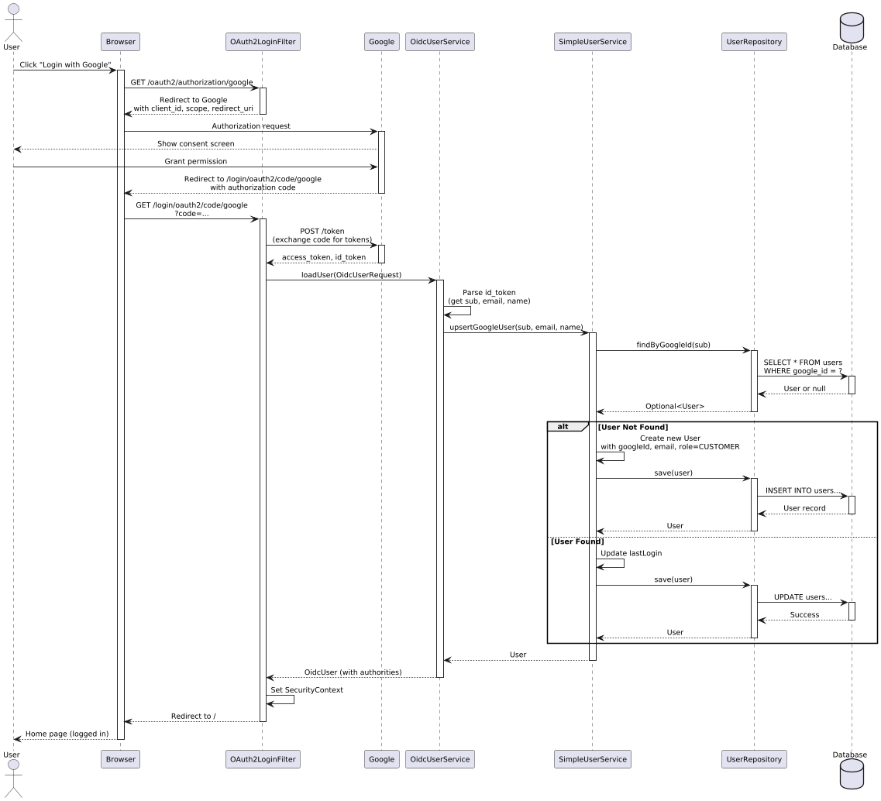Sequence 2: OAuth2 Google Login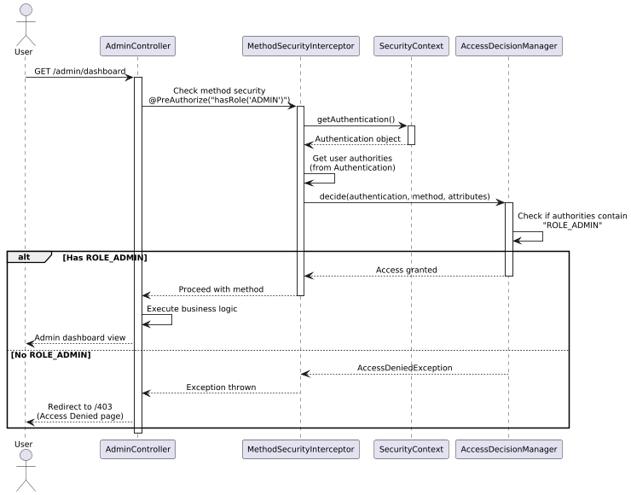

Sequence 3: Authorization Check with @PreAuthorize

### d. Database Queries

Load user by username (for authentication)

SELECT * FROM users WHERE LOWER(username) = LOWER(?) LIMIT 1;

Load user by email

SELECT * FROM users WHERE LOWER(email) = LOWER(?) LIMIT 1;

Check if username exists

SELECT 1 FROM users WHERE LOWER(username) = LOWER(?) LIMIT 1;

Check if email exists

SELECT 1 FROM users WHERE LOWER(email) = LOWER(?) LIMIT 1;

Find user by Google ID

SELECT * FROM users WHERE google_id = ?;

Insert new user

INSERT INTO users (id, username, email, password, full_name, phone_number, role, email_verified, email_verification_token, active, created_at, updated_at) VALUES (?, ?, ?, ?, ?, ?, ?, ?, ?, ?, ?, ?);

Update user last login

UPDATE users SET last_login = ?, updated_at = ? WHERE id = ?;

Verify email

SELECT * FROM users WHERE email_verification_token = ?;

UPDATE users SET email_verified = true, email_verification_token = NULL, updated_at = ? WHERE id = ?;

Update password

UPDATE users SET password = ?, updated_at = ? WHERE id = ?;

Set password reset token

UPDATE users SET password_reset_token = ?, password_reset_token_expiry = ?, updated_at = ? WHERE email = ?;

Reset password by token

SELECT * FROM users WHERE password_reset_token = ? AND password_reset_token_expiry > ?;

UPDATE users SET password = ?, password_reset_token = NULL, password_reset_token_expiry = NULL, updated_at = ? WHERE id = ?;

Find users by role

SELECT * FROM users WHERE role = ? ORDER BY created_at DESC;

Count active users by role

SELECT COUNT() FROM users WHERE role = ? AND active = true;

Create remember-me token (JdbcTokenRepository)

INSERT INTO persistent_logins (username, series, token, last_used) VALUES (?, ?, ?, ?);

Update remember-me token

UPDATE persistent_logins SET token = ?, last_used = ? WHERE series = ?;

Delete remember-me token

DELETE FROM persistent_logins WHERE username = ?;

# 10. Admin Management

## 10.1 Manage Users

### a. Class Diagram

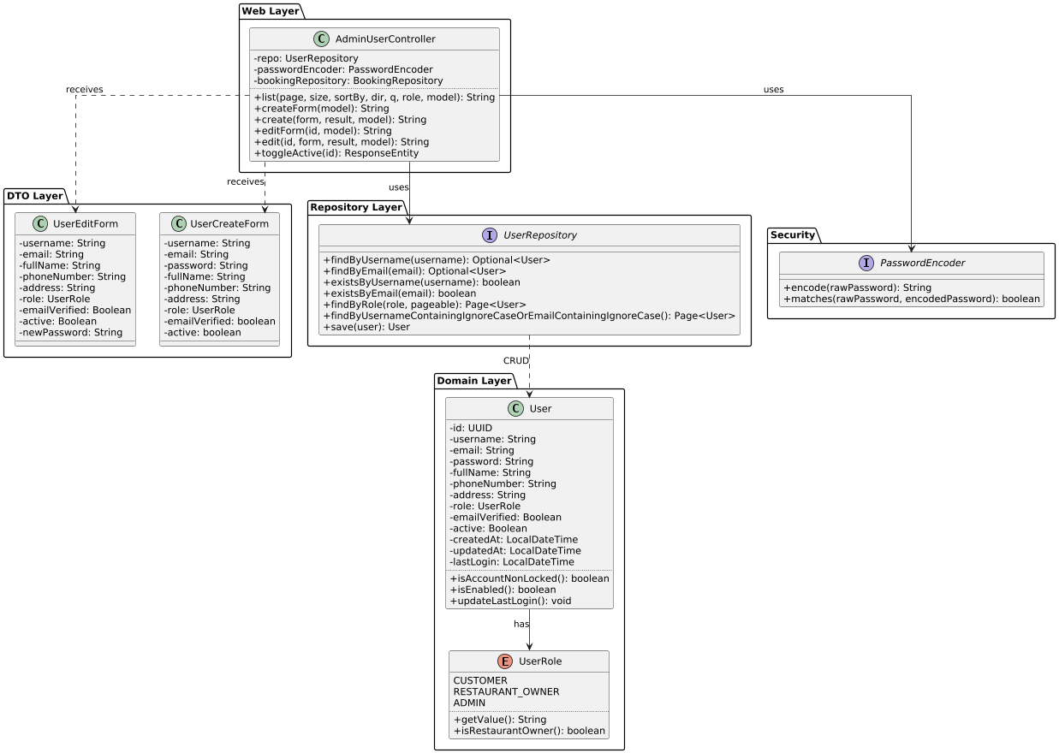

### b. Class Specifications

### 

| **AdminUserController** | | |
| --- | --- | --- |
| **No** | **Method** | **Description** |
| 1 | list(page, size, sortBy, dir, q, role, model) | Displays paginated user list with search/filter by role or keyword (GET /admin/users) |
| 2 | createForm(model) | Returns user creation form (GET /admin/users/create) |
| 3 | create(form, result, model) | Creates new user, validates uniqueness, encodes password (POST /admin/users/create) |
| 4 | editForm(id, model) | Returns user edit form with existing data (GET /admin/users/{id}/edit) |
| 5 | edit(id, form, result, model) | Updates user, validates uniqueness (excluding current), optionally updates password (POST /admin/users/{id}) |
| 6 | toggleActive(id) | Toggles user active/inactive status (POST /admin/users/{id}/toggle-active) |

### 

| **User (Entity) — Attributes** | | | |
| --- | --- | --- | --- |
| **No** | **Attribute** | **Type** | **Description** |
| 1 | id | UUID | Primary key, auto-generated |
| 2 | username | String | Unique, 3-50 chars, required |
| 3 | email | String | Unique, valid email format, required |
| 4 | password | String | Encrypted (BCrypt), min 8 chars |
| 5 | fullName | String | Full name, required |
| 6 | phoneNumber | String | Optional, max 15 chars, Vietnamese format (03/05/07/08/09 + 8 digits) |
| 7 | address | String | Optional, max 500 chars |
| 8 | profileImageUrl | String | URL to profile image |
| 9 | role | UserRole | CUSTOMER / RESTAURANT_OWNER / ADMIN |
| 10 | emailVerified | Boolean | Email verification status (default: false) |
| 11 | emailVerificationToken | String | Token for email verification |
| 12 | passwordResetToken | String | Token for password reset |
| 13 | passwordResetTokenExpiry | LocalDateTime | Expiry time for reset token |
| 14 | googleId | String | Google OAuth ID (if registered via Google) |
| 15 | active | Boolean | Account active status (default: true) |
| 16 | createdAt | LocalDateTime | Audit timestamp (auto-set) |
| 17 | updatedAt | LocalDateTime | Audit timestamp (auto-update) |
| 18 | lastLogin | LocalDateTime | Last login timestamp |
| 19 | deletedAt | LocalDateTime | Soft delete timestamp |

| **UserRole (Enum)** | |
| --- | --- |
| **Value** | **Description** |
| CUSTOMER | Regular customer who can make bookings |
| RESTAURANT_OWNER | Restaurant owner who manages restaurants |
| ADMIN | System administrator with full access |

| **UserCreateForm (DTO) — Attributes** | | | | |
| --- | --- | --- | --- | --- |
| **No** | **Attribute** | **Type** | **Validation** | **Description** |
| 1 | username | String | @NotBlank, @Size(3-50) | Username for login |
| 2 | email | String | @NotBlank, @Email | Email address |
| 3 | password | String | @NotBlank, @Size(min=6) | Plain text password (will be encrypted) |
| 4 | fullName | String | @NotBlank | Full name |
| 5 | phoneNumber | String | Optional | Phone number |
| 6 | address | String | Optional | Address |
| 7 | role | UserRole | Required | User role (default: CUSTOMER) |
| 8 | emailVerified | boolean | - | Email verification status |
| 9 | active | boolean | - | Active status (default: true) |

| **UserEditForm (DTO) — Attributes** | | | | |
| --- | --- | --- | --- | --- |
| **No** | **Attribute** | **Type** | **Validation** | **Description** |
| 1 | username | String | @NotBlank, @Size(3-50) | Username (can be changed) |
| 2 | email | String | @NotBlank, @Email | Email (can be changed) |
| 3 | fullName | String | @NotBlank | Full name |
| 4 | phoneNumber | String | Optional | Phone number |
| 5 | address | String | Optional | Address |
| 6 | role | UserRole | Required | User role |
| 7 | emailVerified | Boolean | - | Email verification status |
| 8 | active | Boolean | - | Active status |
| 9 | newPassword | String | Optional | New password (only if user wants to change) |

| UserRepository | | |
| --- | --- | --- |
| No | Method | Description |
| 1 | findByUsername(username) | Finds user by username |
| 2 | findByEmail(email) | Finds user by email |
| 3 | existsByUsername(username) | Checks if username already exists |
| 4 | existsByEmail(email) | Checks if email already exists |
| 5 | findByRole(role, pageable) | Finds users by role with pagination |
| 6 | findByUsernameContainingIgnoreCaseOrEmailContainingIgnoreCase(q, q, pageable) | Searches users by username or email |
| 7 | save(user) | Persists or updates user |
| 8 | findById(id) | Finds user by ID |

### c. Sequence Diagram(s)

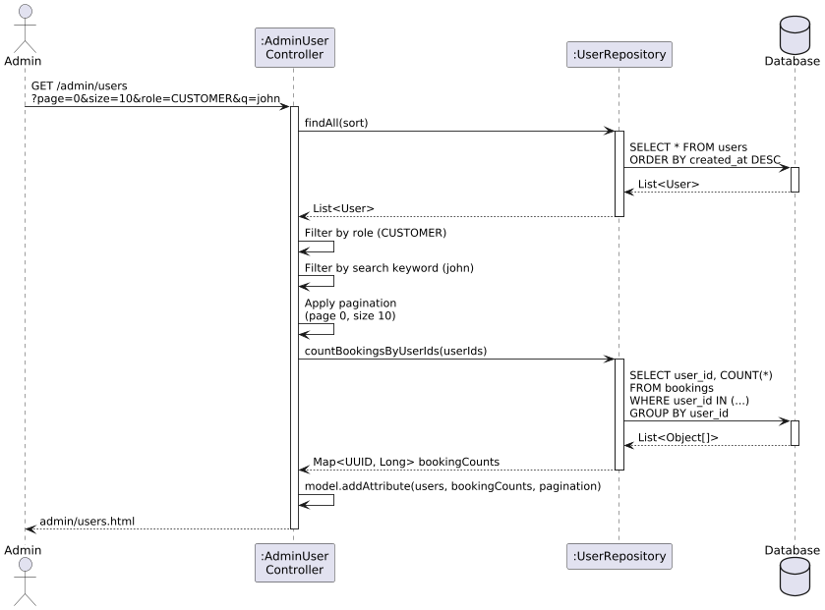

**Sequence Diagram 11.1.1:** List Users with Pagination/Filter

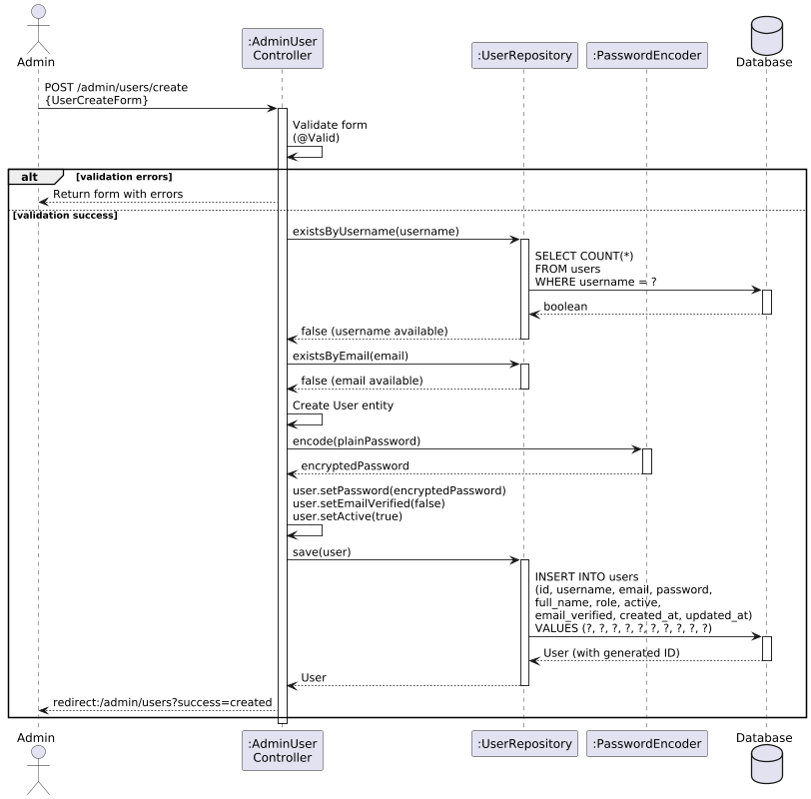**Sequence Diagram 11.1.2:** Create User

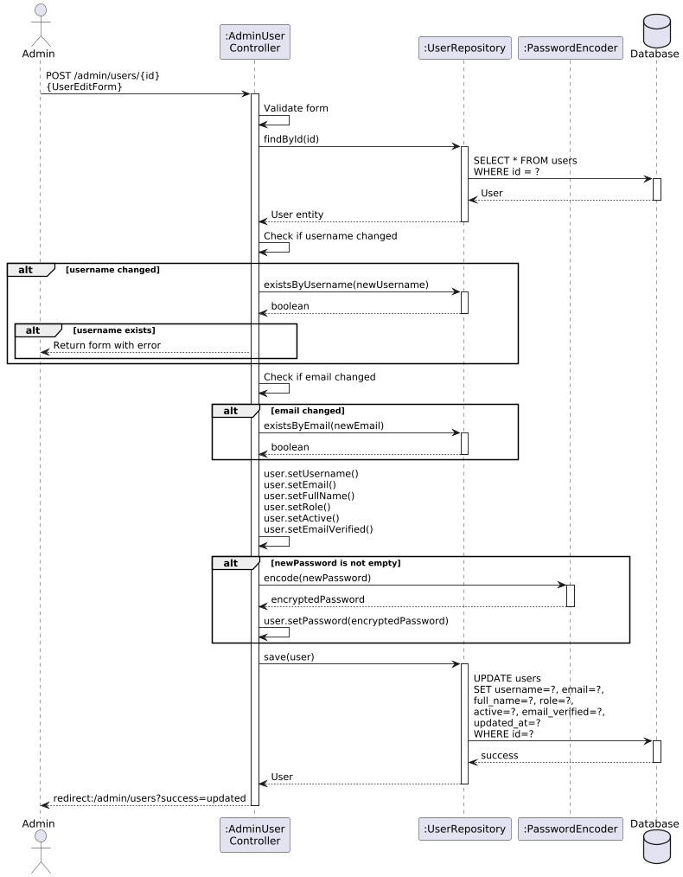

**Sequence Diagram 11.1.3:** Edit User

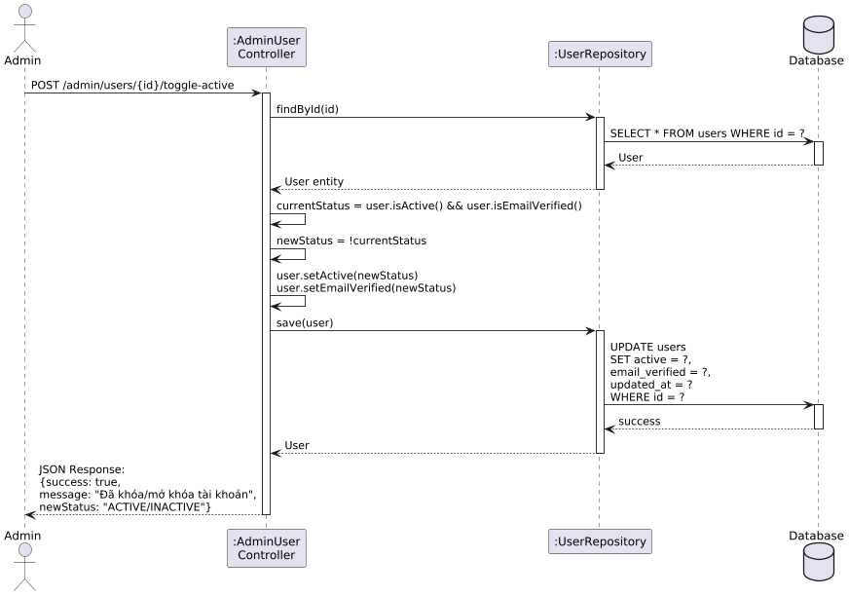

**Sequence Diagram 11.1.4:** Toggle User Active Status

### d. Database Queries

Check exist email

SELECT 1 FROM users WHERE lower(email) = lower(?) LIMIT 1;

Check exist username

SELECT 1 FROM users WHERE lower(username) = lower(?) LIMIT 1;

Create new user (khái quát, JPA sẽ sinh SQL tương ứng)

INSERT INTO users (id, username, email, password, full_name, phone_number, address, role, email_verified, active, created_at, updated_at) VALUES (?, ?, ?, ?, ?, ?, ?, ?, false, true, CURRENT_TIMESTAMP, CURRENT_TIMESTAMP);

Find user by ID

SELECT id, username, email, password, full_name, phone_number, address, role, email_verified, active, created_at, updated_at, last_login FROM users WHERE id = ?;

Update user (excluding password)

UPDATE users SET username = ?, email = ?, full_name = ?, phone_number = ?, address = ?, role = ?, email_verified = ?, active = ?, updated_at = CURRENT_TIMESTAMP WHERE id = ?;

Update user password

UPDATE users SET password = ?, updated_at = CURRENT_TIMESTAMP WHERE id = ?;

Get all users with pagination and sorting

SELECT * FROM users WHERE deleted_at IS NULL ORDER BY created_at DESC LIMIT ? OFFSET ?;

Filter users by role

SELECT * FROM users WHERE role = ? AND deleted_at IS NULL ORDER BY created_at DESC;

Search users by username or email

SELECT * FROM users WHERE (LOWER(username) LIKE LOWER(CONCAT('%', ?, '%')) OR LOWER(email) LIKE LOWER(CONCAT('%', ?, '%'))) AND deleted_at IS NULL ORDER BY created_at DESC;

Count bookings by user IDs

SELECT customer.user_id, COUNT(b.booking_id) as booking_count FROM bookings b JOIN customers customer ON b.customer_id = customer.customer_id WHERE customer.user_id IN (?, ?, ?, ...) GROUP BY customer.user_id;

Toggle user active status

UPDATE users SET active = ?, email_verified = ?, updated_at = CURRENT_TIMESTAMP WHERE id = ?;

Soft delete user

UPDATE users SET deleted_at = CURRENT_TIMESTAMP, updated_at = CURRENT_TIMESTAMP WHERE id = ?;

Find active users by role

SELECT * FROM users WHERE role = ? AND active = true AND email_verified = true AND deleted_at IS NULL;

## 10.2 Manage Restaurants

### a. Class Diagram

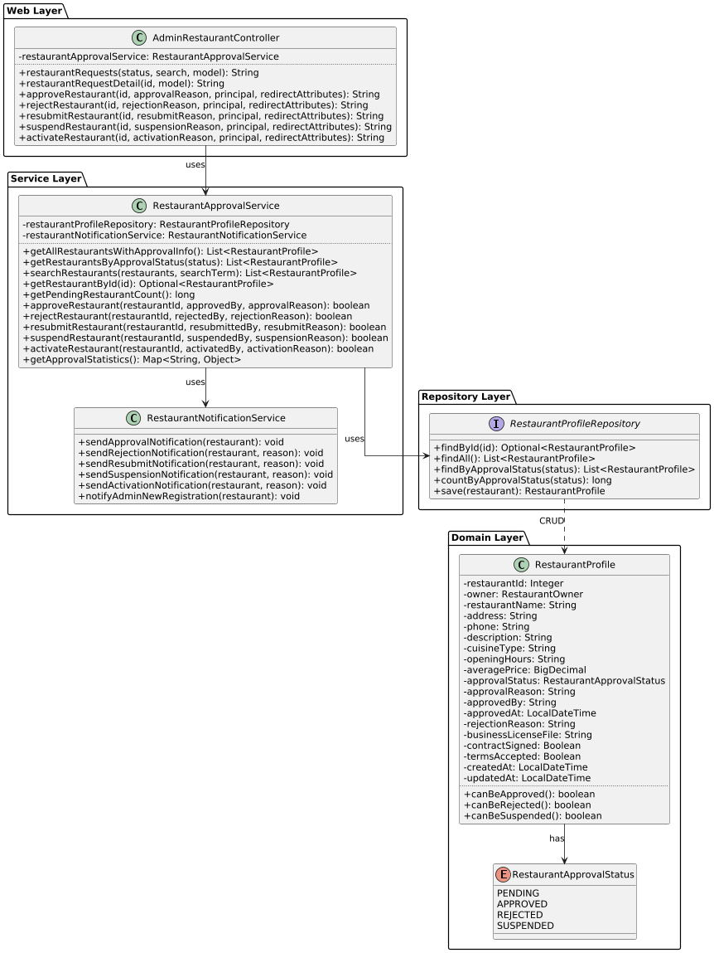

### b. Class Specifications

| AdminRestaurantController | | |
| --- | --- | --- |
| No | Method | Description |
| 1 | restaurantRequests(status, search, model) | Displays restaurant approval list with filter by status (PENDING/APPROVED/REJECTED/SUSPENDED) and search (GET /admin/restaurant/requests) |
| 2 | restaurantRequestDetail(id, model) | Shows restaurant detail for approval decision (GET /admin/restaurant/requests/{id}) |
| 3 | approveRestaurant(id, approvalReason, principal, redirectAttributes) | Approves restaurant, changes status to APPROVED, sends notification (POST /admin/restaurant/approve/{id}) |
| 4 | rejectRestaurant(id, rejectionReason, principal, redirectAttributes) | Rejects restaurant with reason, changes status to REJECTED (POST /admin/restaurant/reject/{id}) |
| 5 | resubmitRestaurant(id, resubmitReason, principal, redirectAttributes) | Resets REJECTED restaurant back to PENDING for owner to edit (POST /admin/restaurant/resubmit/{id}) |
| 6 | suspendRestaurant(id, suspensionReason, principal, redirectAttributes) | Suspends active restaurant (APPROVED → SUSPENDED) (POST /admin/restaurant/suspend/{id}) |
| 7 | activateRestaurant(id, activationReason, principal, redirectAttributes) | Reactivates suspended restaurant (SUSPENDED → APPROVED) (POST /admin/restaurant/activate/{id}) |

| RestaurantApprovalService | | |
| --- | --- | --- |
| No | Method | Description |
| 1 | getAllRestaurantsWithApprovalInfo() | Returns all restaurants with approval information |
| 2 | getRestaurantsByApprovalStatus(status) | Filters restaurants by approval status |
| 3 | searchRestaurants(restaurants, searchTerm) | Searches by restaurant name, address, cuisine type, or owner username |
| 4 | getRestaurantById(id) | Finds restaurant by ID |
| 5 | getPendingRestaurantCount() | Counts restaurants with PENDING status |
| 6 | getApprovedRestaurantCount() | Counts restaurants with APPROVED status |
| 7 | getRejectedRestaurantCount() | Counts restaurants with REJECTED status |
| 8 | getSuspendedRestaurantCount() | Counts restaurants with SUSPENDED status |
| 9 | approveRestaurant(restaurantId, approvedBy, approvalReason) | Approves restaurant, updates status, sends email notification |
| 10 | rejectRestaurant(restaurantId, rejectedBy, rejectionReason) | Rejects restaurant with reason, sends notification |
| 11 | resubmitRestaurant(restaurantId, resubmittedBy, resubmitReason) | Resets REJECTED restaurant to PENDING for resubmission |
| 12 | suspendRestaurant(restaurantId, suspendedBy, suspensionReason) | Suspends restaurant (APPROVED → SUSPENDED) |
| 13 | activateRestaurant(restaurantId, activatedBy, activationReason) | Reactivates restaurant (SUSPENDED → APPROVED) |
| 14 | getApprovalStatistics() | Returns approval statistics (total, pending, approved, rejected, suspended counts and percentages) |

| RestaurantProfile (Entity) — Attributes | | | | |
| --- | --- | --- | --- | --- |
| 1 | restaurantId | Integer | Auto-generated | Primary key |
| 2 | owner | RestaurantOwner | @ManyToOne, required | Restaurant owner (foreign key) |
| 3 | restaurantName | String | @NotBlank, @Size(max=255) | Restaurant name |
| 4 | address | String | @Size(max=500) | Full address |
| 5 | phone | String | @Size(max=20) | Contact phone number |
| 6 | description | String (TEXT) | - | Detailed description |
| 7 | cuisineType | String | @Size(max=100) | Type of cuisine (e.g., Vietnamese, Italian) |
| 8 | openingHours | String | @Size(max=100) | Operating hours |
| 9 | averagePrice | BigDecimal | @DecimalMin(0.0) | Average price per person |
| 10 | approvalStatus | RestaurantApprovalStatus | Enum, required | PENDING / APPROVED / REJECTED / SUSPENDED |
| 11 | approvalReason | String (TEXT) | - | Reason for approval |
| 12 | approvedBy | String | - | Admin username who approved/rejected |
| 13 | approvedAt | LocalDateTime | - | Approval/rejection timestamp |
| 14 | rejectionReason | String (TEXT) | - | Reason for rejection |
| 15 | businessLicenseFile | String | - | Path to uploaded business license document |
| 16 | contractSigned | Boolean | Default: false | Contract signature status |
| 17 | termsAccepted | Boolean | Default: false | Terms of service acceptance |
| 18 | createdAt | LocalDateTime | Auto-set | Restaurant creation timestamp |
| 19 | updatedAt | LocalDateTime | Auto-update | Last update timestamp |

### c. Sequence Diagram(s)

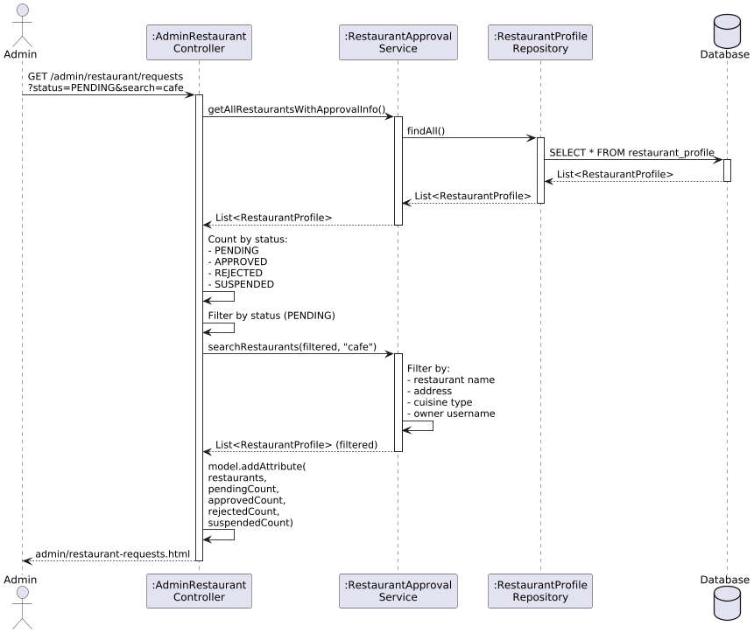

**Sequence Diagram 11.2.1:** List Restaurant Requests with Filter



**Sequence Diagram 11.2.2:** Approve Restaurant



**Sequence Diagram 11.2.3:** Reject Restaurant

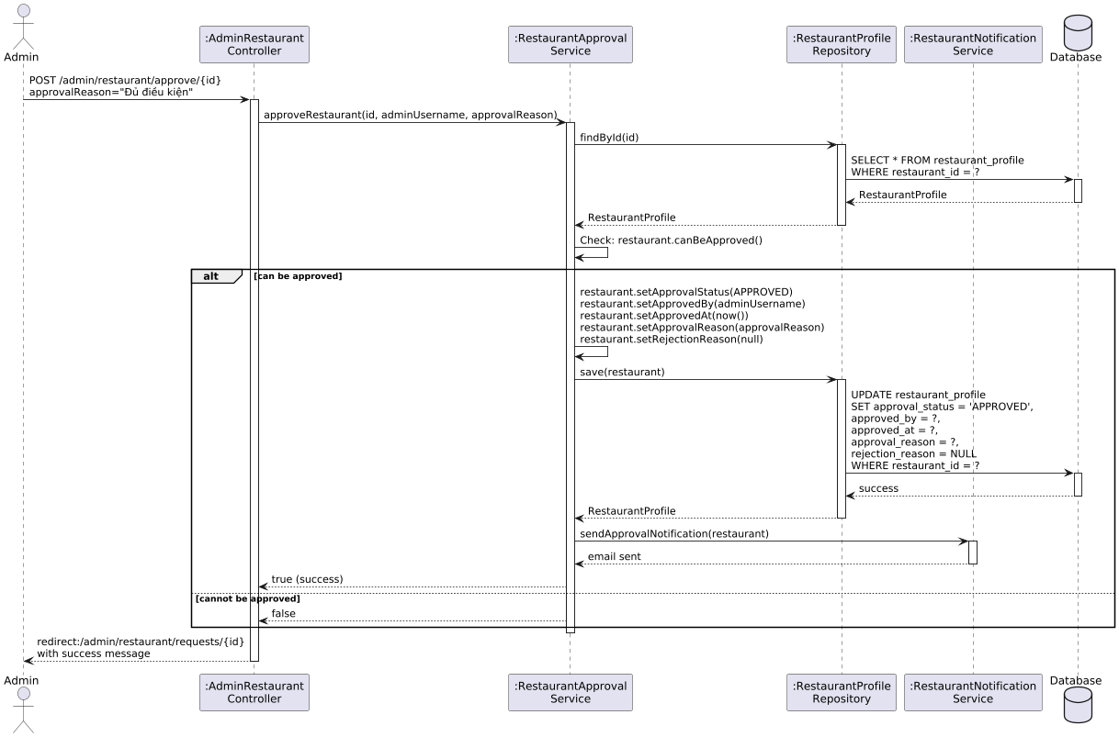

**Sequence Diagram 11.2.4:** Suspend Restaurant

### d. Database Queries

Get all restaurants with approval info

SELECT * FROM restaurant_profile ORDER BY created_at DESC;

Get restaurants by approval status

SELECT * FROM restaurant_profile WHERE approval_status = ?;

Count restaurants by approval status

SELECT COUNT() FROM restaurant_profile WHERE approval_status = ?;

Find restaurant by ID

SELECT restaurant_id, owner_id, restaurant_name, address, phone, description, cuisine_type, opening_hours, average_price, approval_status, approval_reason, approved_by, approved_at, rejection_reason, business_license_file, contract_signed, terms_accepted, created_at, updated_at FROM restaurant_profile WHERE restaurant_id = ?;

Approve restaurant

UPDATE restaurant_profile SET approval_status = 'APPROVED', approved_by = ?, approved_at = CURRENT_TIMESTAMP, approval_reason = ?, rejection_reason = NULL, updated_at = CURRENT_TIMESTAMP WHERE restaurant_id = ?;

Reject restaurant

UPDATE restaurant_profile SET approval_status = 'REJECTED', approved_by = ?, approved_at = CURRENT_TIMESTAMP, rejection_reason = ?, approval_reason = NULL, updated_at = CURRENT_TIMESTAMP WHERE restaurant_id = ?;

Resubmit restaurant (REJECTED → PENDING)

UPDATE restaurant_profile SET approval_status = 'PENDING', approved_by = NULL, approved_at = NULL, approval_reason = NULL, rejection_reason = NULL, updated_at = CURRENT_TIMESTAMP WHERE restaurant_id = ? AND approval_status = 'REJECTED';

Suspend restaurant

UPDATE restaurant_profile SET approval_status = 'SUSPENDED', approved_by = ?, approved_at = CURRENT_TIMESTAMP, approval_reason = ?, updated_at = CURRENT_TIMESTAMP WHERE restaurant_id = ?;

Activate restaurant (SUSPENDED → APPROVED)

UPDATE restaurant_profile SET approval_status = 'APPROVED', approved_by = ?, approved_at = CURRENT_TIMESTAMP, approval_reason = ?, updated_at = CURRENT_TIMESTAMP WHERE restaurant_id = ? AND approval_status = 'SUSPENDED';

Search restaurants by name/address/cuisine/owner

SELECT r.* FROM restaurant_profile r LEFT JOIN restaurant_owner ro ON r.owner_id = ro.owner_id LEFT JOIN users u ON ro.user_id = u.id WHERE LOWER(r.restaurant_name) LIKE LOWER(CONCAT('%', ?, '%')) OR LOWER(r.address) LIKE LOWER(CONCAT('%', ?, '%')) OR LOWER(r.cuisine_type) LIKE LOWER(CONCAT('%', ?, '%')) OR LOWER(u.username) LIKE LOWER(CONCAT('%', ?, '%'));

Get approval statistics (all counts)

SELECT approval_status, COUNT() as count FROM restaurant_profile GROUP BY approval_status;

Get pending restaurants count

SELECT COUNT() FROM restaurant_profile WHERE approval_status = 'PENDING';

Get approved restaurants count

SELECT COUNT() FROM restaurant_profile WHERE approval_status = 'APPROVED';

Get rejected restaurants count

SELECT COUNT() FROM restaurant_profile WHERE approval_status = 'REJECTED';

Get suspended restaurants count

SELECT COUNT() FROM restaurant_profile WHERE approval_status = 'SUSPENDED';

## 10.3 Dashboard & KPIs

### a. Class Diagram

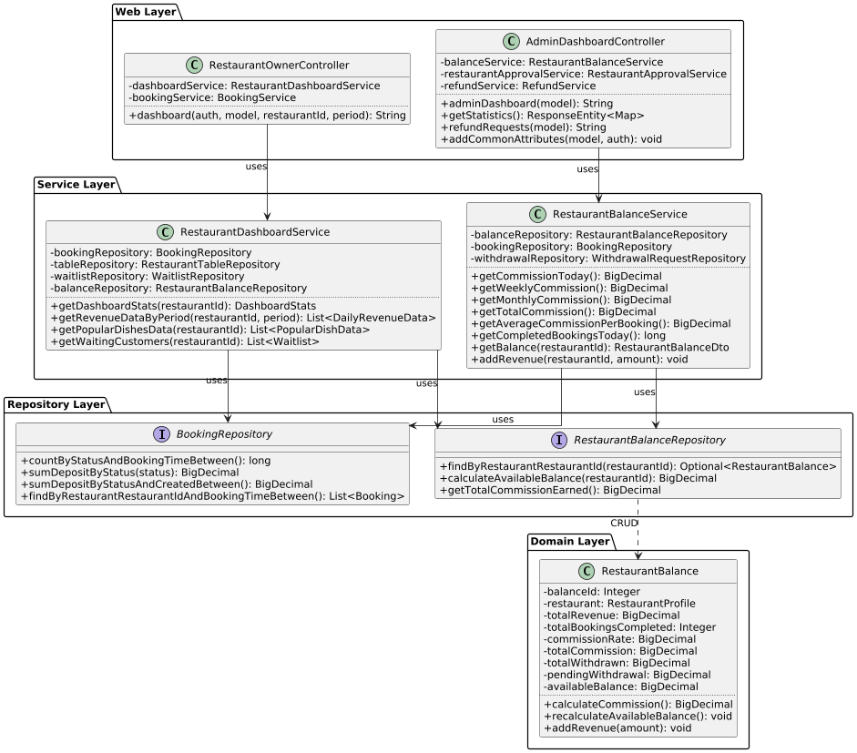

### b. Class Specifications

| **AdminDashboardController** | | |
| --- | --- | --- |
| No | Method | Description |
| 1 | adminDashboard(model) | Returns admin dashboard view with commission KPIs (today, weekly, monthly, total), completed bookings count (GET /admin/dashboard) |
| 2 | getStatistics() | Returns JSON API with real-time statistics: commissions, bookings, pending restaurants, pending refunds (GET /admin/api/statistics) |
| 3 | refundRequests(model) | Returns refund management view with pending/completed/rejected requests and statistics (GET /admin/refund-requests) |
| 4 | addCommonAttributes(model, auth) | Adds common attributes (pending restaurant count) to all admin pages via @ModelAttribute |

| **RestaurantOwnerController** | | |
| --- | --- | --- |
| No | Method | Description |
| 1 | dashboard(auth, model, restaurantId, period) | Returns restaurant owner dashboard with KPIs: today's bookings/revenue, table status, waitlist, charts (GET /restaurant-owner/dashboard) |

| **RestaurantBalanceService** | | |
| --- | --- | --- |
| No | Method | Description |
| 1 | getCommissionToday() | Calculates total admin commission earned today (30% of completed bookings' deposit) |
| 2 | getWeeklyCommission() | Calculates total admin commission for last 7 days |
| 3 | getMonthlyCommission() | Calculates total admin commission for current month |
| 4 | getTotalCommission() | Calculates total admin commission from all time completed bookings |
| 5 | getAverageCommissionPerBooking() | Calculates average commission per completed booking |
| 6 | getCompletedBookingsToday() | Counts completed bookings today |
| 7 | getCommissionRate() | Returns default commission rate (30%) |
| 8 | getBalance(restaurantId) | Returns RestaurantBalanceDto with all financial metrics for restaurant |
| 9 | addRevenue(restaurantId, amount) | Adds revenue when booking is completed, updates balance and recalculates |

| **RestaurantDashboardService** | | |
| --- | --- | --- |
| No | Method | Description |
| 1 | getDashboardStats(restaurantId) | Returns DashboardStats DTO with today's bookings, revenue, table status, waitlist count, balance info |
| 2 | getRevenueDataByPeriod(restaurantId, period) | Returns daily/weekly/monthly revenue data for charts (period: "week", "month", "year") |
| 3 | getPopularDishesData(restaurantId) | Returns top 5 popular dishes by quantity sold in last 30 days |
| 4 | getWaitingCustomers(restaurantId) | Returns list of customers in WAITING status on waitlist |
| 5 | calculatePercentageChanges(stats, restaurantId) | Calculates percentage changes compared to yesterday for bookings, revenue, tables |

| **RestaurantBalance (Entity) — Attributes** | | | | |
| --- | --- | --- | --- | --- |
| No | Attribute | Type | Validation | Description |
| 1 | balanceId | Integer | Auto-generated | Primary key |
| 2 | restaurant | RestaurantProfile | @OneToOne, required | Restaurant reference (foreign key) |
| 3 | totalRevenue | BigDecimal | Default: 0 | Total revenue from all completed bookings |
| 4 | totalBookingsCompleted | Integer | Default: 0 | Total number of completed bookings |
| 5 | commissionRate | BigDecimal | Default: 30.00 | Commission rate percentage (30%) |
| 6 | commissionType | CommissionType | Enum | PERCENTAGE or FIXED |
| 7 | commissionFixedAmount | BigDecimal | Default: 15000 | Fixed amount per booking if FIXED type |
| 8 | totalCommission | BigDecimal | Calculated | Total commission paid to admin (calculated field) |
| 9 | totalWithdrawn | BigDecimal | Default: 0 | Total amount withdrawn by restaurant |
| 10 | pendingWithdrawal | BigDecimal | Default: 0 | Amount currently locked in pending withdrawals |
| 11 | pendingRefund | BigDecimal | Default: 0 | Amount locked for pending refunds |
| 12 | availableBalance | BigDecimal | Calculated | Formula: totalRevenue - totalCommission - totalWithdrawn - pendingWithdrawal - pendingRefund |
| 13 | lastCalculatedAt | LocalDateTime | Auto-set | Timestamp of last balance calculation |
| 14 | lastWithdrawalAt | LocalDateTime | - | Timestamp of last successful withdrawal |
| 15 | updatedAt | LocalDateTime | Auto-update | Last update timestamp |

| **DashboardStats (DTO) — Attributes** | | | | |
| --- | --- | --- | --- | --- |
| No | Attribute | Type | Validation | Description |
| 1 | todayBookings | int | - | Total bookings today |
| 2 | todayCompletedBookings | int | - | Completed bookings today |
| 3 | todayPendingBookings | int | - | Pending bookings today |
| 4 | totalTables | int | - | Total tables in restaurant |
| 5 | availableTables | int | - | Tables with AVAILABLE status |
| 6 | occupiedTables | int | - | Tables with OCCUPIED status |
| 7 | waitingCustomers | int | - | Customers in waitlist (WAITING status) |
| 8 | todayRevenue | BigDecimal | - | Revenue today from completed bookings |
| 9 | totalRevenue | BigDecimal | - | Total revenue from restaurant_balance |
| 10 | availableBalance | BigDecimal | - | Available balance after commission/withdrawals |
| 11 | totalCompletedBookings | int | - | Total completed bookings (all time) |
| 12 | bookingChangePercent | double | - | % change compared to yesterday |
| 13 | revenueChangePercent | double | - | % change compared to yesterday |
| 14 | availableTableChangePercent | double | - | % change compared to yesterday |
| 15 | occupiedTableChangePercent | double | - | % change compared to yesterday |

| **BookingRepository (Dashboard Methods)** | | |
| --- | --- | --- |
| No | Method | Description |
| 1 | countByStatusAndBookingTimeBetween(status, start, end) | Counts completed bookings in date range |
| 2 | sumDepositByStatus(status) | Sums total deposit amount by status |
| 3 | sumDepositByStatusAndCreatedBetween(status, start, end) | Sums deposit amount by status and creation date range |
| 4 | findByRestaurantRestaurantIdAndBookingTimeBetween(id, start, end) | Finds bookings by restaurant ID and booking time range |
| 5 | findByRestaurantRestaurantIdOrderByBookingTimeDesc(id) | Finds recent bookings with eager loading (customer, tables) |

### c. Sequence Diagram(s)

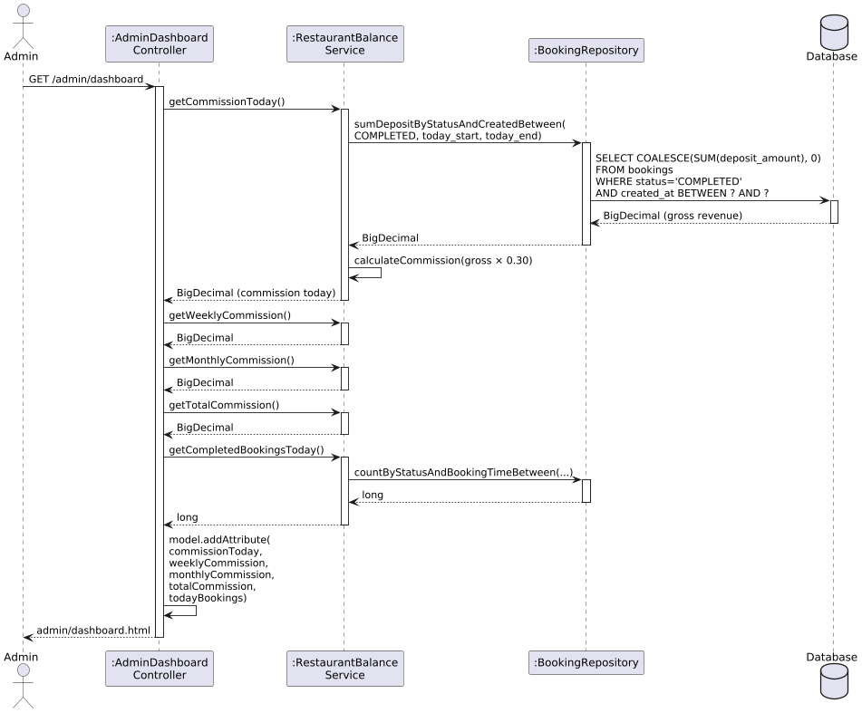

**Sequence Diagram 11.3.1:** Admin Dashboard Load

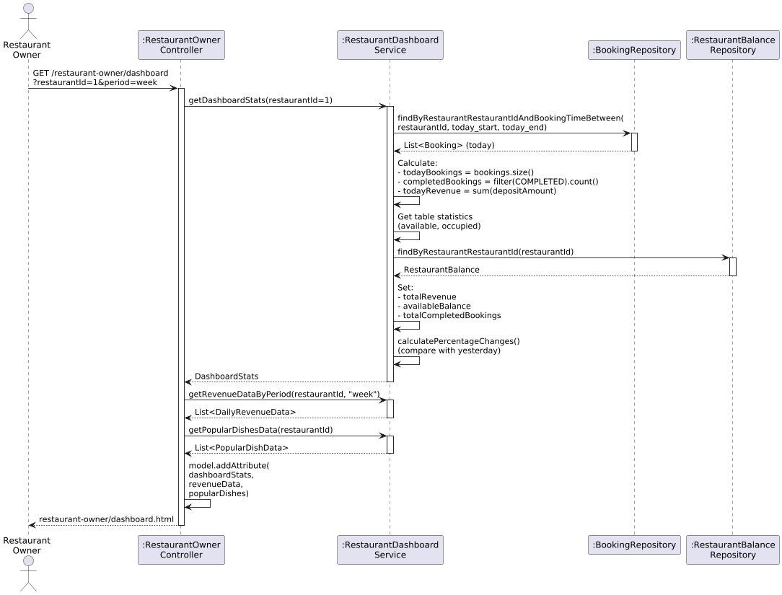

**Sequence Diagram 11.3.2:** Restaurant Owner Dashboard Load

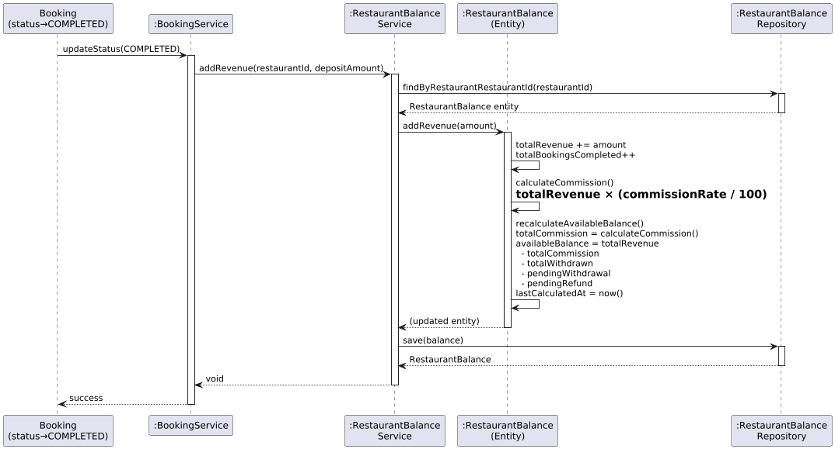

**Sequence Diagram 11.3.3:** Revenue Calculation When Booking Completed

### d. Database Queries

Get commission today (Admin Dashboard)

SELECT COALESCE(SUM(deposit_amount), 0) FROM bookings WHERE status = 'COMPLETED' AND created_at >= CURRENT_DATE AND created_at < CURRENT_DATE + INTERVAL '1 day';

Calculate commission from gross revenue

Commission = gross_revenue × 0.30

Get weekly commission

SELECT COALESCE(SUM(deposit_amount), 0) FROM bookings WHERE status = 'COMPLETED' AND created_at >= CURRENT_DATE - INTERVAL '7 days' AND created_at < CURRENT_DATE + INTERVAL '1 day';

Get monthly commission

SELECT COALESCE(SUM(deposit_amount), 0) FROM bookings WHERE status = 'COMPLETED' AND created_at >= DATE_TRUNC('month', CURRENT_DATE) AND created_at < CURRENT_DATE + INTERVAL '1 day';

Get total commission (all time)

SELECT COALESCE(SUM(deposit_amount), 0) FROM bookings WHERE status = 'COMPLETED';

Count completed bookings today

SELECT COUNT() FROM bookings WHERE status = 'COMPLETED' AND booking_time >= CURRENT_DATE AND booking_time < CURRENT_DATE + INTERVAL '1 day';

Get average commission per booking

SELECT COALESCE(SUM(deposit_amount), 0) / NULLIF(COUNT(), 0) FROM bookings WHERE status = 'COMPLETED';

Get restaurant dashboard stats (today's bookings)

SELECT * FROM bookings WHERE restaurant_id = ? AND booking_time >= CURRENT_DATE AND booking_time < CURRENT_DATE + INTERVAL '1 day';

Get restaurant balance

SELECT balance_id, restaurant_id, total_revenue, total_bookings_completed, commission_rate, commission_type, total_commission, total_withdrawn, pending_withdrawal, pending_refund, available_balance, last_calculated_at FROM restaurant_balance WHERE restaurant_id = ?;

Calculate available balance (PostgreSQL Function)

CREATE OR REPLACE FUNCTION calculate_available_balance(p_restaurant_id INTEGER) RETURNS NUMERIC AS $$ BEGIN RETURN (SELECT total_revenue - total_commission - total_withdrawn - pending_withdrawal - COALESCE(pending_refund, 0) FROM restaurant_balance WHERE restaurant_id = p_restaurant_id); END; $$ LANGUAGE plpgsql;

Update balance when booking completed

UPDATE restaurant_balance SET total_revenue = total_revenue + ?, total_bookings_completed = total_bookings_completed + 1, total_commission = (total_revenue + ?) * commission_rate / 100, available_balance = (total_revenue + ?) - ((total_revenue + ?) * commission_rate / 100) - total_withdrawn - pending_withdrawal - COALESCE(pending_refund, 0), last_calculated_at = CURRENT_TIMESTAMP, updated_at = CURRENT_TIMESTAMP WHERE restaurant_id = ?;

Get revenue data by period (last 7 days)

SELECT DATE(booking_time) as date, COALESCE(SUM(deposit_amount), 0) as revenue, COUNT() as booking_count FROM bookings WHERE restaurant_id = ? AND status = 'COMPLETED' AND booking_time >= CURRENT_DATE - INTERVAL '7 days' GROUP BY DATE(booking_time) ORDER BY date;

Get popular dishes (top 5 last 30 days)

SELECT d.name, COALESCE(SUM(bd.quantity), 0) as quantity_sold, d.price FROM dishes d LEFT JOIN booking_dishes bd ON d.dish_id = bd.dish_id LEFT JOIN bookings b ON bd.booking_id = b.booking_id WHERE d.restaurant_id = ? AND b.booking_time >= CURRENT_DATE - INTERVAL '30 days' GROUP BY d.dish_id, d.name, d.price HAVING SUM(bd.quantity) > 0 ORDER BY quantity_sold DESC LIMIT 5;

Get yesterday's bookings for percentage comparison

SELECT * FROM bookings WHERE restaurant_id = ? AND booking_time >= CURRENT_DATE - INTERVAL '1 day' AND booking_time < CURRENT_DATE;

Get table statistics

SELECT COUNT() as total, SUM(CASE WHEN status = 'AVAILABLE' THEN 1 ELSE 0 END) as available, SUM(CASE WHEN status = 'OCCUPIED' THEN 1 ELSE 0 END) as occupied FROM restaurant_tables WHERE restaurant_id = ?;

Get waiting customers count

SELECT COUNT() FROM waitlist WHERE restaurant_id = ? AND status = 'WAITING';

Get total commission earned (all restaurants)

SELECT COALESCE(SUM(total_commission), 0) FROM restaurant_balance;

…